Introduction

The PhotonVision LabVIEW library provides utility functions to read, decode, and interpret data sent from PhotonVision application.
The library source code, package build specifications, and test package can be found here https://github.com/jsimpso81/PhotonVisionLabVIEW

Function Help

Each VI includes help that can be accessed using the standard LabVIEW help toggle (Ctrl H).
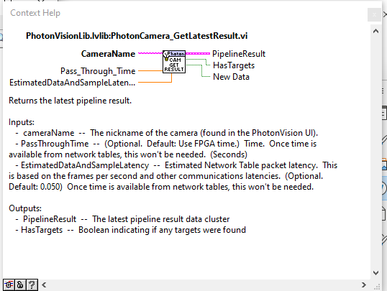

Function Examples

Many of the functions have examples that can be found under the LabVIEW "Find examples..." function. (Help -> Find Examples...). The function examples are easiest to find when "Directory Structure" is selected.

