Abhinav Suri

Feb 20 2014

AP Chem 6,7

Partner: James Cuellar

Thiosulfate Lab

Purpose: To determine the order of reaction for Sodium thiosulfate in hydrochloric acid.

Introduction:

Sodium Thiosulfate has many practical uses in the modern world of today especially in the field of medicine. Researchers at the Washington University of Medicine managed to effectively administer doses of sodium thiosulfate to treat calcific uremic arteriopathy, a disease which causes artery blockage through the calcification of the small arteries. Sodium Thiosulfate was found to increase the solubility of calcium by 100,000 fold. Sodium Thiosulfate also has use as a fixative in photography and can act as a water purifying agent as well as a nitrogen exhaust neutralizer.

<http://clinicaltrials.gov/show/NCT00568399>

<http://www.drugs.com/cons/sodium-thiosulfate-intravenous.html>

Procedure:

Practice Shakedown:

1. Fill two 1x8 strips with 3 drops of water in each well with the micropipette.
2. 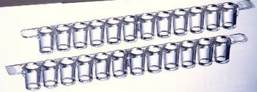Carefully turn over one of the well strips onto the other strip, making sure to align the strips.
3. Mix the water by holding the stacked strips in an elevated position and quickly accelerating them downwards and “apply the brakes”. The water from the top well should be in the bottom well now.
4. Move on to the next part of the experiment once you have perfected this technique.

Lab:

1. Add reagents in two strips named Strip A and Strip B respectively. Refer to the table to see exact amounts to be put in each strip. All reagents should be transferred with micropipettes.

|  |  |  |  |
| --- | --- | --- | --- |
| Well Number | Strip A | Strip B | |
| Drops of 0.15 M Na2S2O3 | Drops of 1M HCl | Drops of water |
| 1 | 10 | 2 | 0 |
| 2 | 9 | 2 | 1 |
| 3 | 8 | 2 | 2 |
| 4 | 7 | 2 | 3 |
| 5 | 6 | 2 | 4 |
| 6 | 5 | 2 | 5 |
| 7 | 4 | 2 | 6 |
| 8 | 3 | 2 | 7 |

1. Trace the 1x8 strip onto a piece of paper and number the wells on the paper from 1 through 8 corresponding with the table above. Place the strip above the traced pattern.
2. Using the technique described in the practice shakedown, mix the contents of both of the strips.
3. Using a stopwatch, record the time it takes for the numbers on the paper to “disappear” or the solution to become nearly opaque.
4. Rinse each strip with distilled water and remove any excess materials with a pipe cleaner.

Data:

|  |  |  |  |
| --- | --- | --- | --- |
| Well | Drops of Thiosulfate | Time | 1/ Time |
| 1 | 10 | 32.39 | 0.031 |
| 2 | 9 | 34.02 | 0.029 |
| 3 | 8 | 42.54 | 0.024 |
| 4 | 6 | 43.70 | 0.023 |
| 5 | 5 | 50.27 | 0.020 |
| 6 | 4 | 59.33 | 0.017 |
| 7 | 3 | 75.49 | 0.013 |
| 8 | 2 | 97.99 | 0.010 |

Time vs. Number of Drops of Thiosulfate:

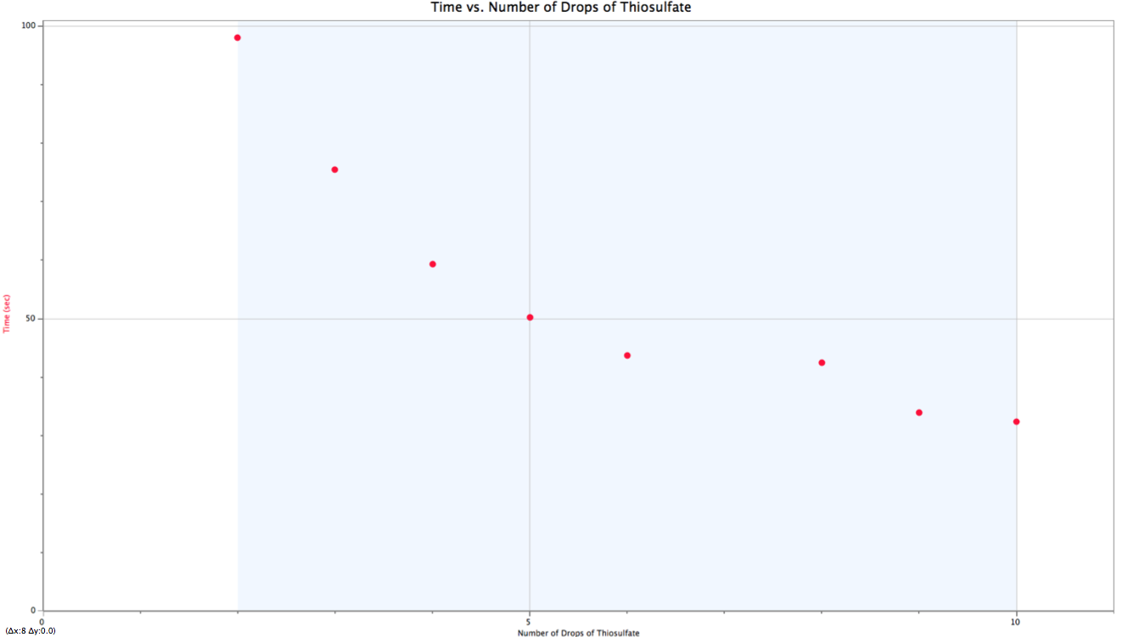

1/Time vs. Number of Drops of Thiosulfate

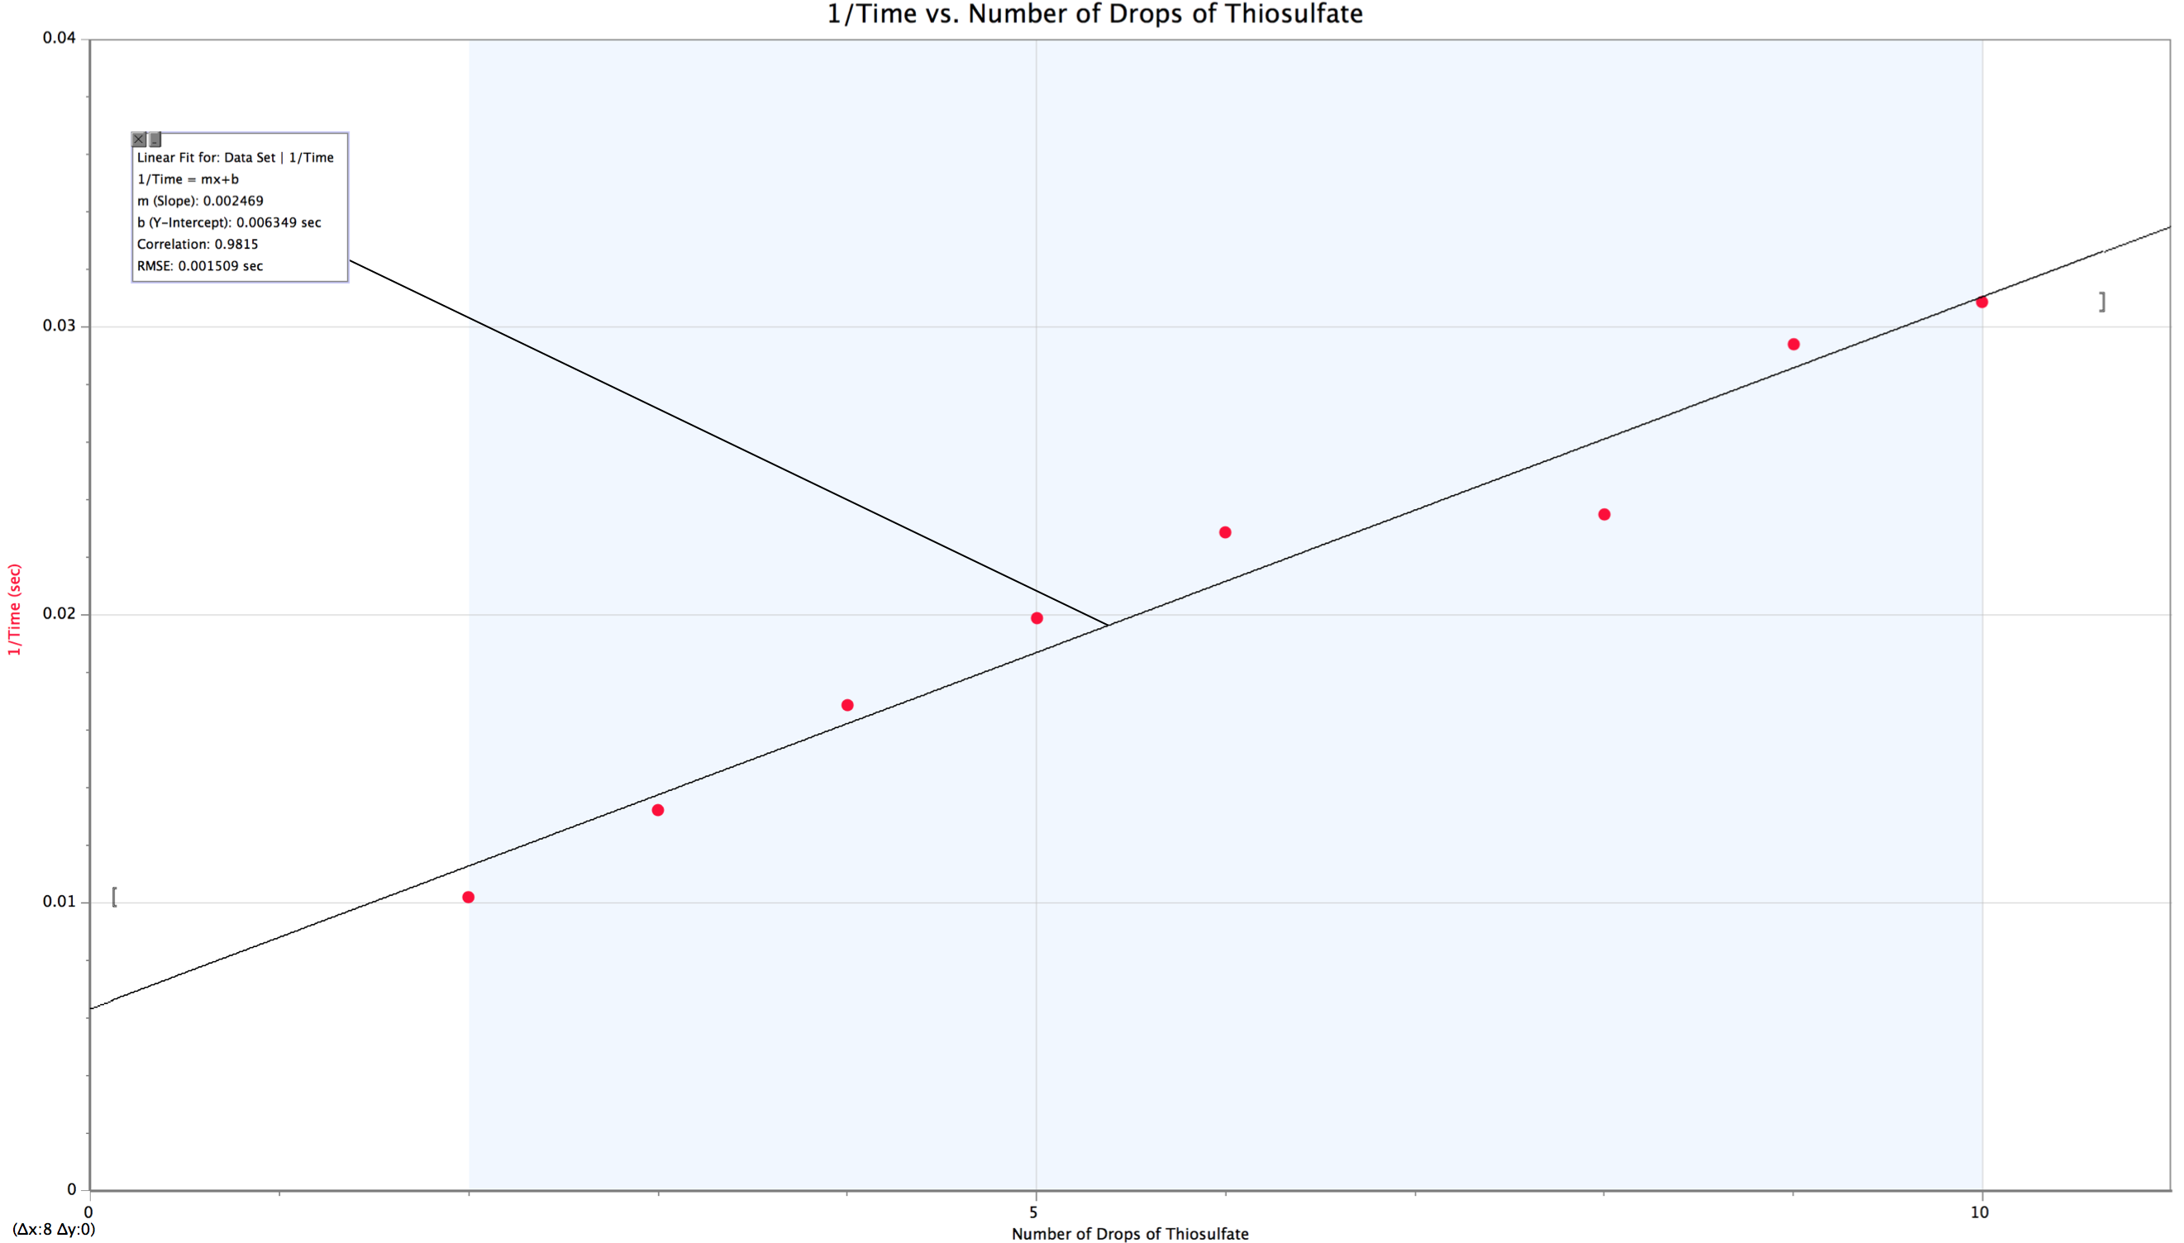

Equation of line from Graph #2:

$$y=0.002469x+.006349 \\ R Value=0.9815 \\ \frac{1}{Time}\left(seconds\right)=0.002469*\left(\# Drops of Thiosulfate\right)+0.006349$$

Questions:

1. Based on the equation of the line, the reaction is a first order of reaction with respect to thiosulfate since the second graph has a linear slope.
2. The rate law for the reaction is as follows: $$Rate=k{[{Na}_{2}S_{2}O_{3}]}^{1}$$

Conclusion:

By observing the reaction of sodium thiosulfate in hydro chloric acid, we were effectively able to determine the order of the reaction with respect to sodium thiosulfate with reasonable accuracy. Possible sources of error in this lab were mainly caused by human error. With the relative quickness of the reactions in succession, some of the time measurements could have been inaccurate. Additionally, a few drops of reagents could have not reacted if they stuck to the tops of the wells. Overall, the errors only impacted the preciseness minimally and we still managed to see the general linear trend in graph #2 which established the reaction as first-order.