HW3

Fan Li

1. Spike plots
   1. Histogram of filtered data

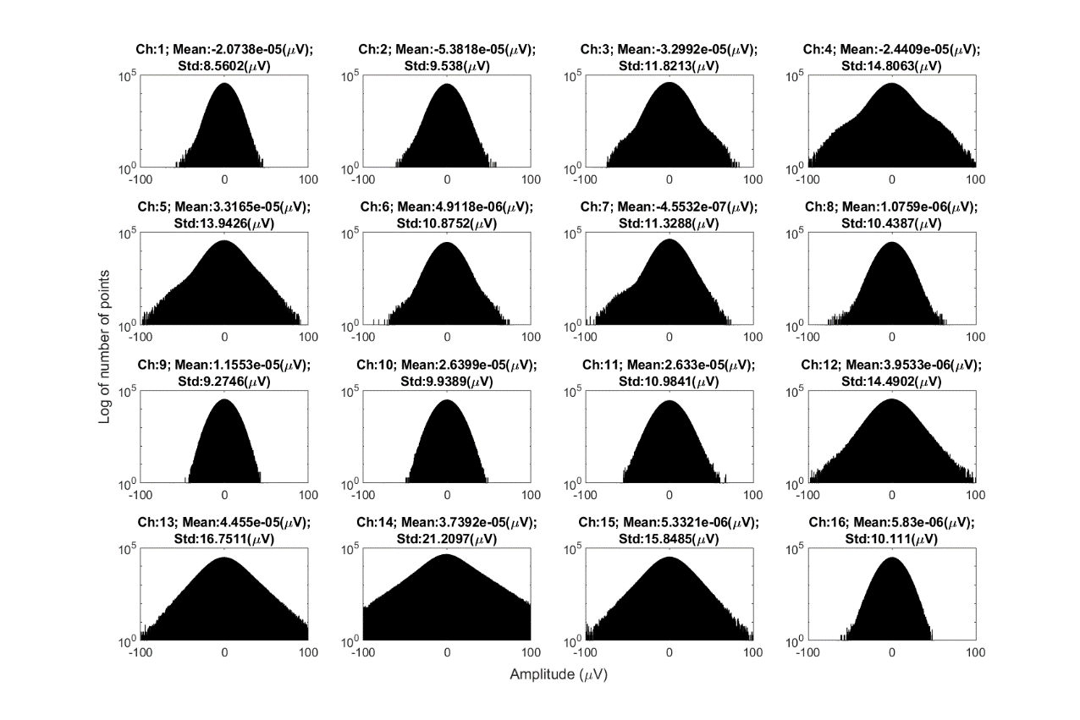

Figure : Histogram of filtered data (channel 1 - 16) with mean and standard deviation value in the subtitles. Filter: cutoff frequencies: 300 – 5000 Hz, 2nd order Butterworth

* 1. Plot the pile plots of all the snippets for each channel (first 100 action potentials)

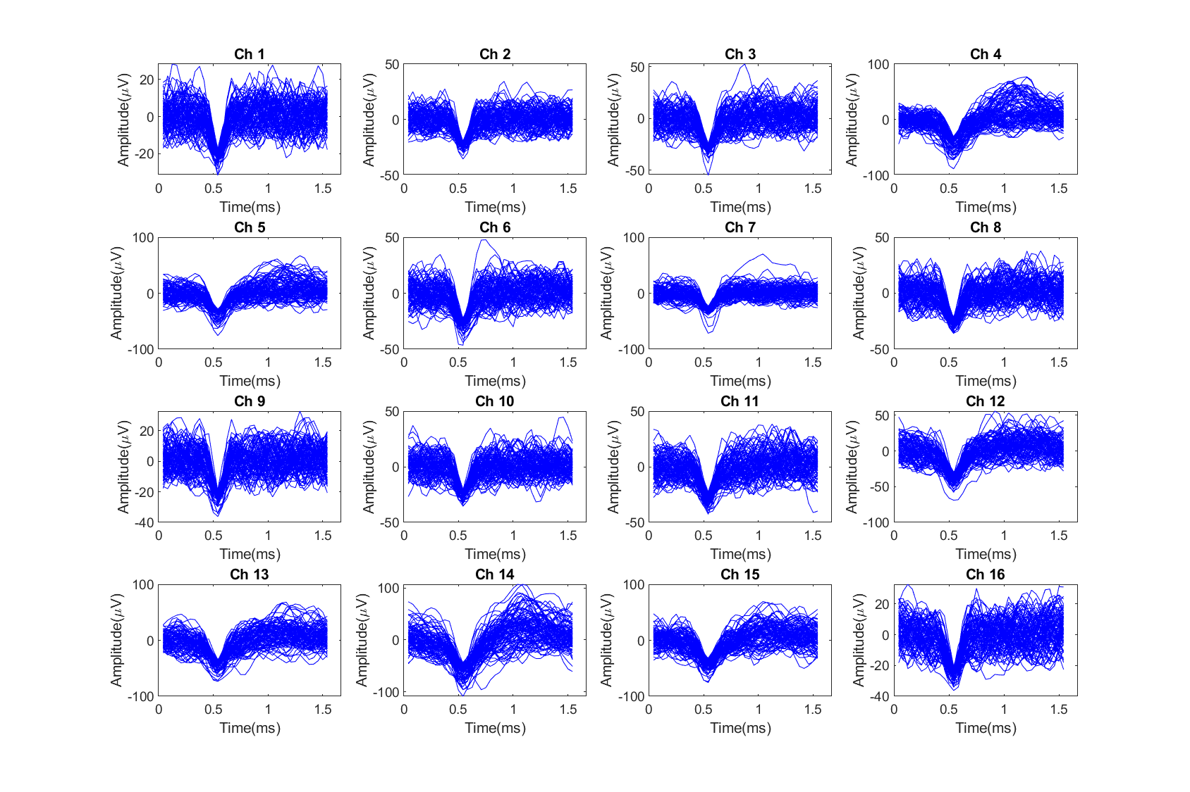

Figure : Pile plots of all the snippets for each channel (first 100 action potentials are selected for each channel to speed up generation of the figure). Waveforms are aligned at their minimum amplitude. Window size of snippet is 37 or roughly 1.5 ms.

* 1. Plot another histogram of the data for each channel and report the channel #, mean, and std (label units) in each subplot title

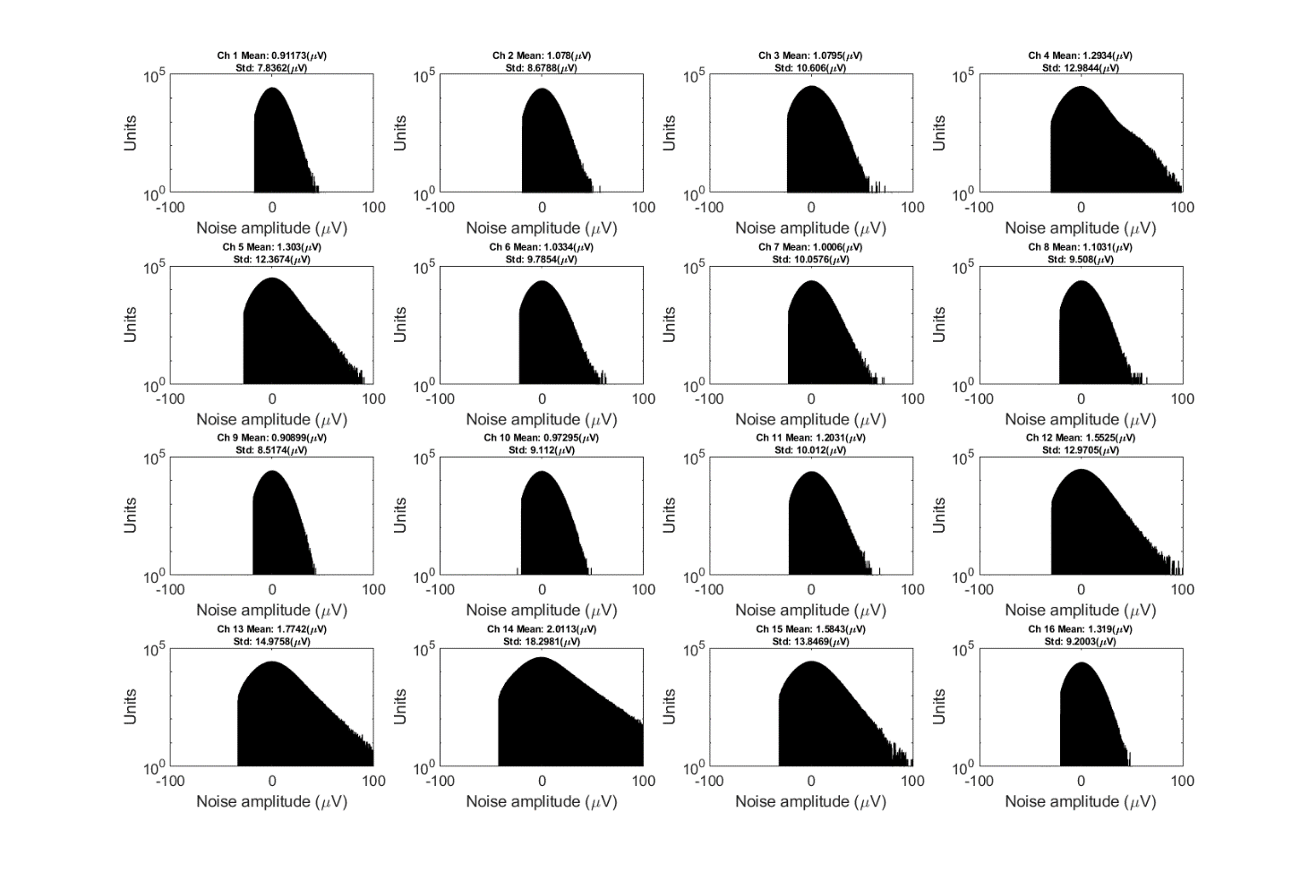

Figure : Histogram of the non-spike data for each channel with mean and std in the subtitles. Note that the histograms appear more Gaussian. Filter: cutoff frequencies: 300 – 5000 Hz, 2nd order Butterworth. Window size of snippet is 37 or roughly 1.5 ms.

* 1. Plot a 3-10 second window of each channel and report the channel #, detection threshold in microvolts, and the voltage of the noisefloor (2std). Plot the threshold and comment on if the threshold is too high or too low or just about right.

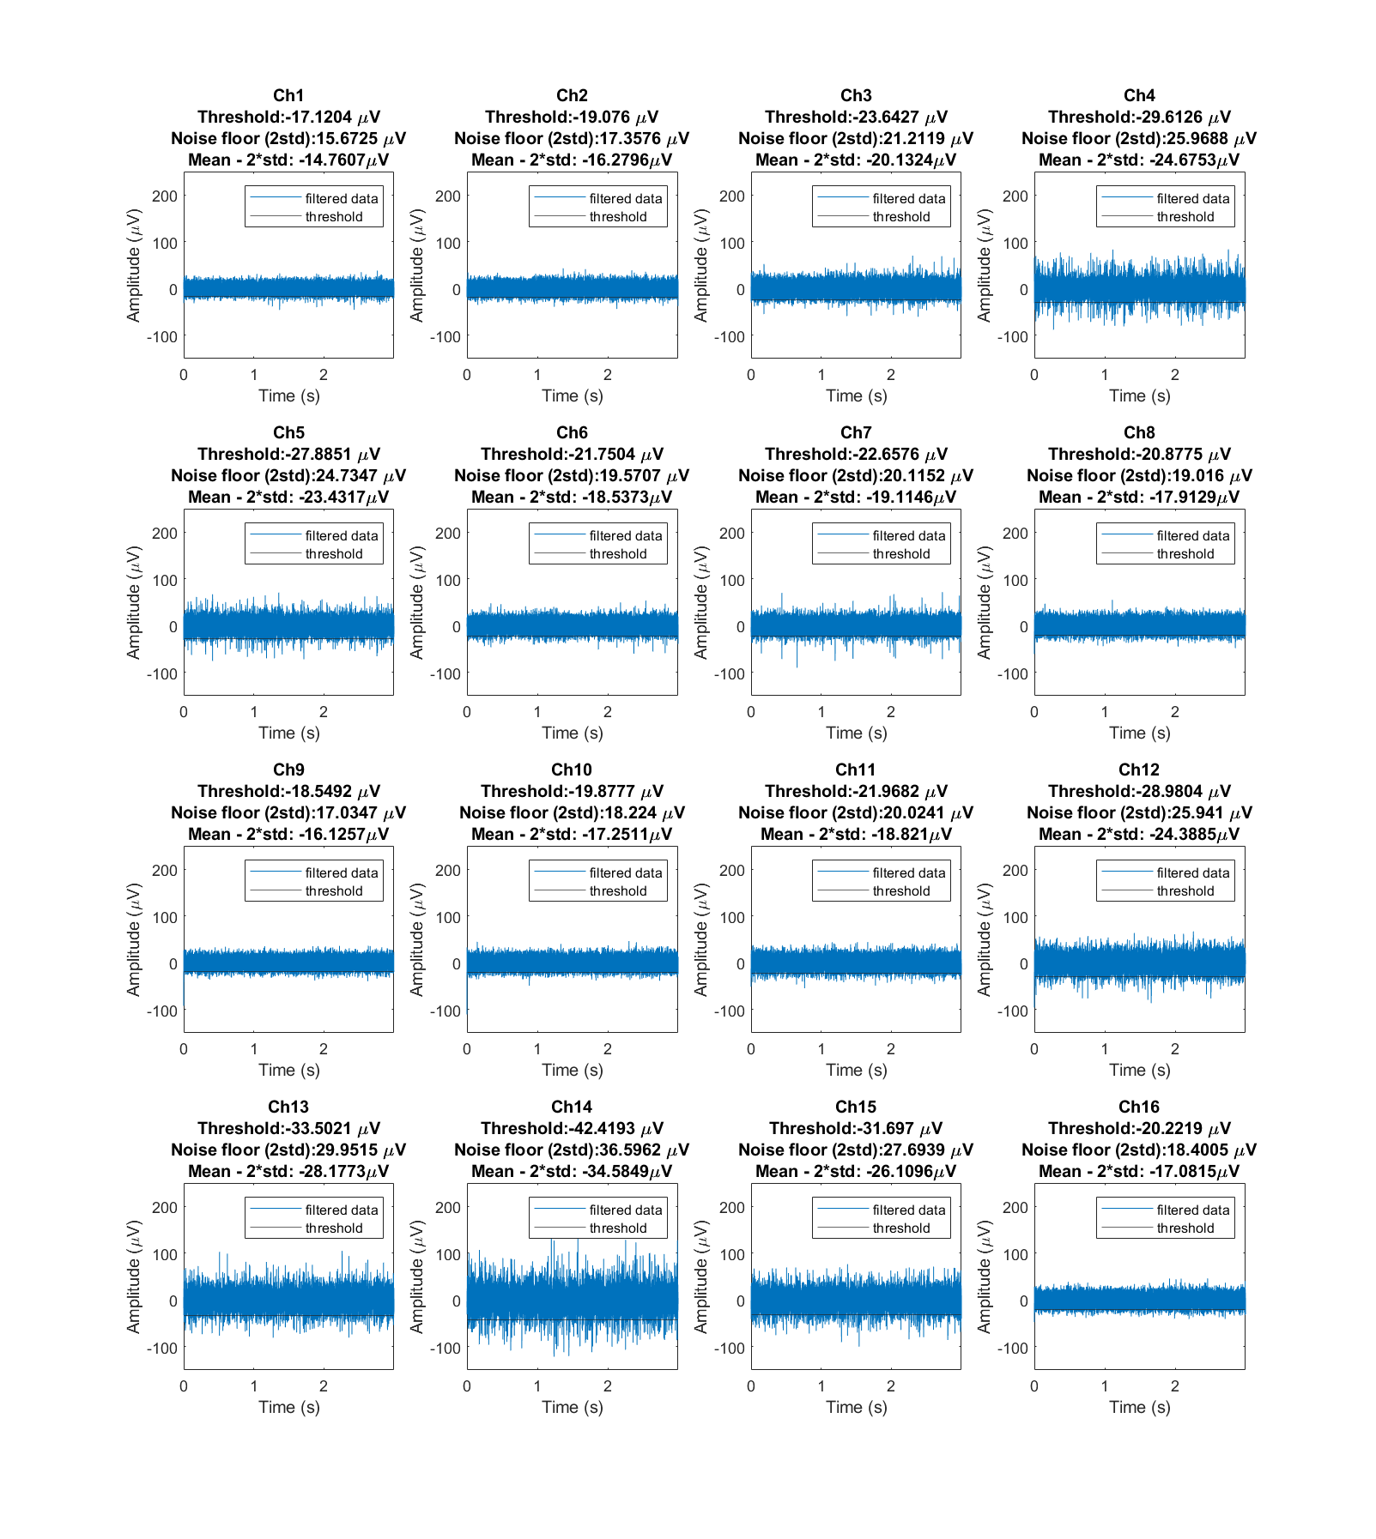

Figure : 3-10 second window of the filtered data with detection threshold and noise floor (2std) in subtitles in blue and threshold line for spike detection in black. Filter: cutoff frequencies: 300 – 5000 Hz, 2nd order Butterworth. Window size of snippet is 37 or roughly 1.5 ms.

* 1. Comments on if the threshold is too high or too low or just about right.

Answer: If we allow 99.90 % noise to be eliminated, then the threshold is working quite well but may be a little bit too tight because the (mean-2\*std ) of the non-spike data is higher than the threshold, which means they are not converging yet and the real threshold value should be between threshold value and (mean-2\*std ) with the assumption that 99.90 % noise to be eliminated.