#1 Scatterplots for each variable:

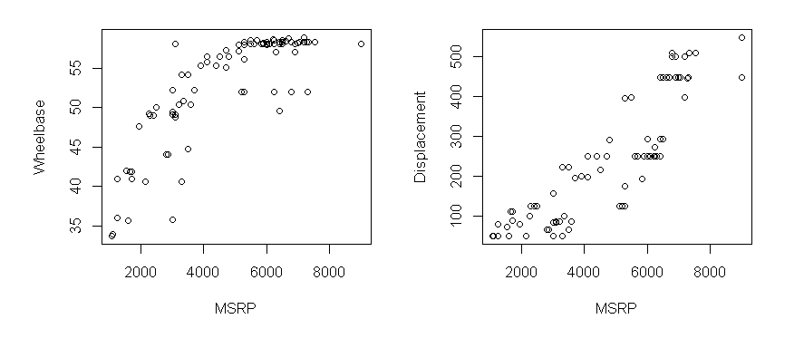

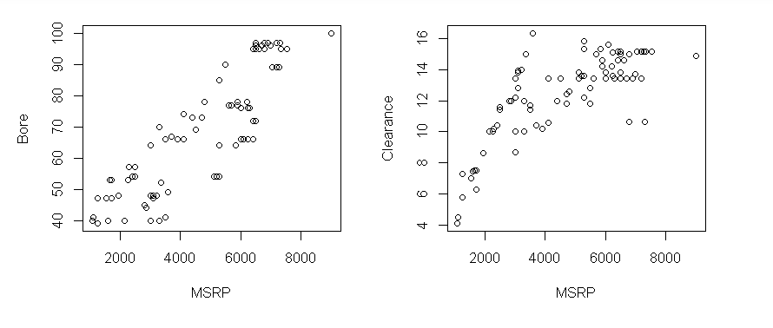

#2

Fitted Model: MSRP = 6.72Displacement + 38.92Bore + 423.03

R Square: .7566

Adjusted R Square: .7512

Interpretation: One unit increase in displacement increases the MSRP by 6.72 and one unit increase in Bore increases the MSRP by 38.92.

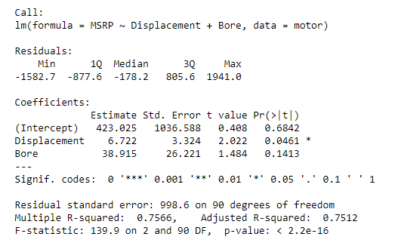

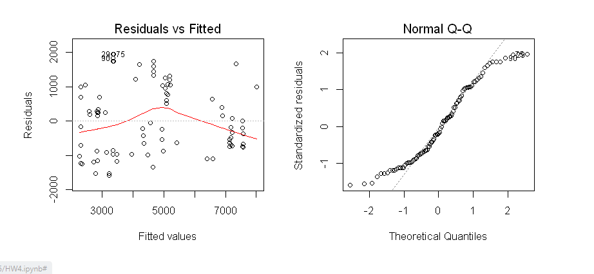#3

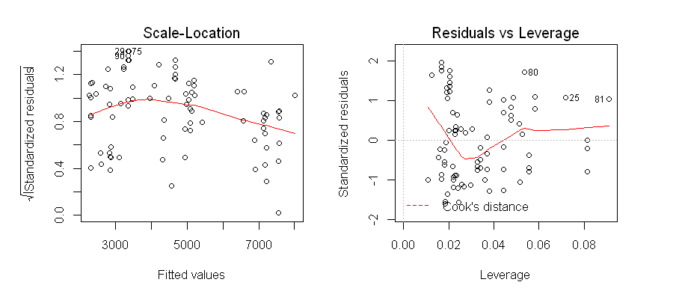

The residuals seem to have an equal spread with no clear pattern making the linearity assumption complete. The Normal Q-Q plot also displays that the residuals are normally distributed and therefore the normality assumption is complete. The scale-location plot shows mostly a horizontal line meaning that the residuals are equally spread along the ranges of predictors. The residuals vs leverage plot shows a balance of residuals and leverage, may need further information on this portion.

#4

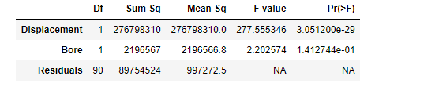

The P values for both Displacement and Bore are less than .05 alpha showing that these variables are statistically significant.

#5

Using Wheelbase and Clearance as predictor variables in the multiple regression function provides slightly different results.

Fitted Model: MSRP = 159.18Wheelbase + 216.34Clearance – 6385.52

R Square: .6879

Adjusted R Square: .681

Interpretation: One unit increase in Wheelbase increases the MSRP by 159.18 and one unit increase in Clearance increases the MSRP by 216.34.

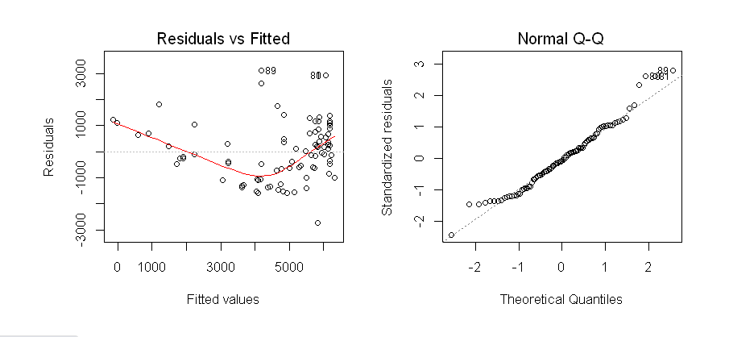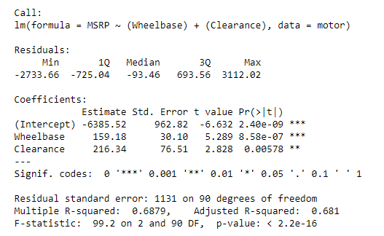

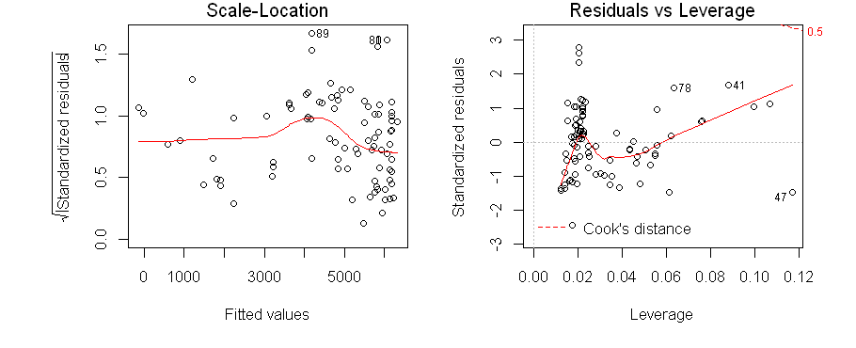

The residuals seem to have a not so equal spread with somewhat of a curved pattern making the linearity assumption questionable.. The Normal Q-Q plot also displays that the residuals are normally distributed and therefore the normality assumption is complete. The scale-location plot shows mostly a horizontal line meaning that the residuals are equally spread along the ranges of predictors. The residuals vs leverage plot shows a balance of residuals and leverage, may need further information on this portion.

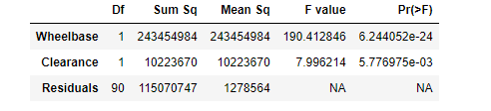

The P values for both Wheelbase and Clearance are less than .05 alpha showing that these variables are statistically significant.

**CODE USED:**

#1

par(mfrow = c(2,2))

plot(motor$MSRP, motor$Wheelbase, xlab = 'MSRP', ylab = 'Wheelbase')

plot(motor$MSRP, motor$Displacement, xlab = 'MSRP', ylab = 'Displacement')

plot(motor$MSRP, motor$Bore, xlab = 'MSRP', ylab = 'Bore')

plot(motor$MSRP, motor$Clearance, xlab = 'MSRP', ylab = 'Clearance')

#2

imod <- lm(MSRP ~ Displacement+Bore, data= motor)

summary(imod)

#3

par(mfrow = c(2,2))

plot(imod)

#4

anova(imod)

#5

imod2 <- lm(MSRP ~ (Wheelbase) + (Clearance), data= motor)

summary(imod2)

par(mfrow = c(2,2))

plot(imod2)

anova(imod2)