1.

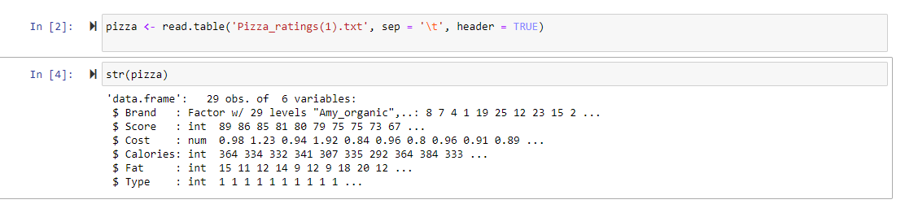

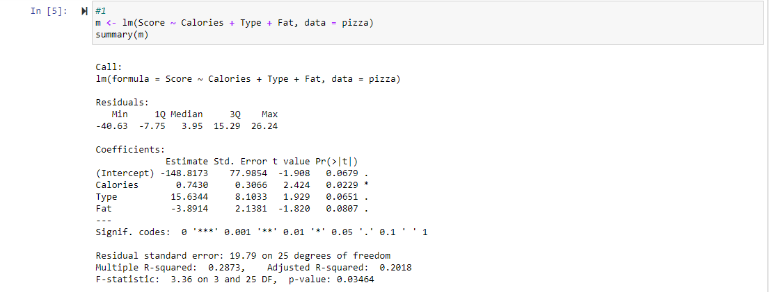

The coefficient of Type is 15.63, meaning that cheese pizzas on average scored about 15.6 points greater than pepperoni after including calories and fat.

The p-value of the coefficient for Type is 0.0651. We fail to reject H0 and its insignificant based on the alpha value of .5.

2.



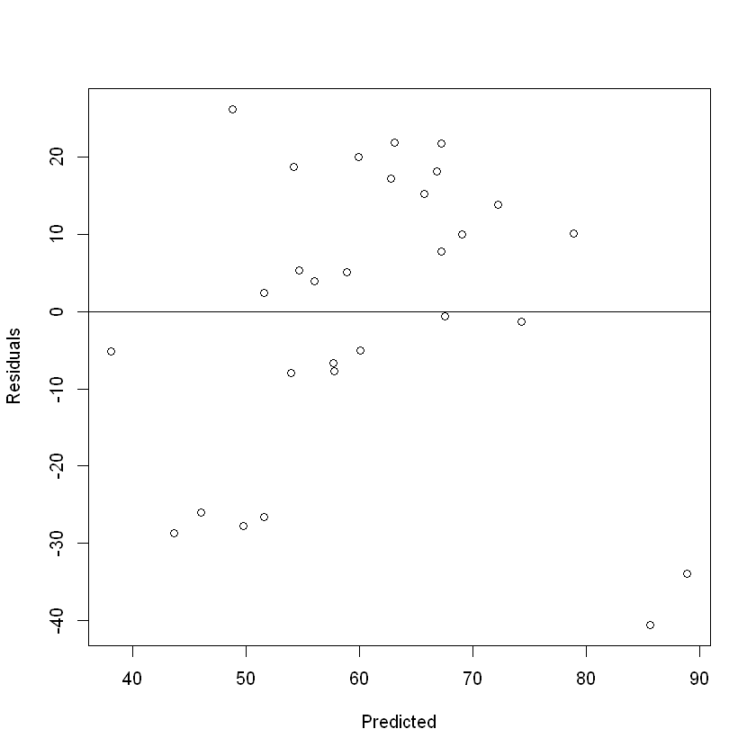





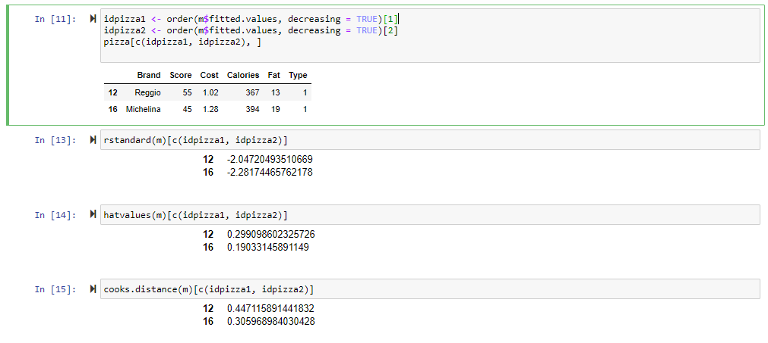

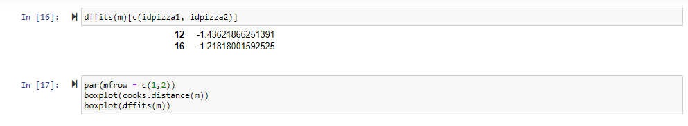

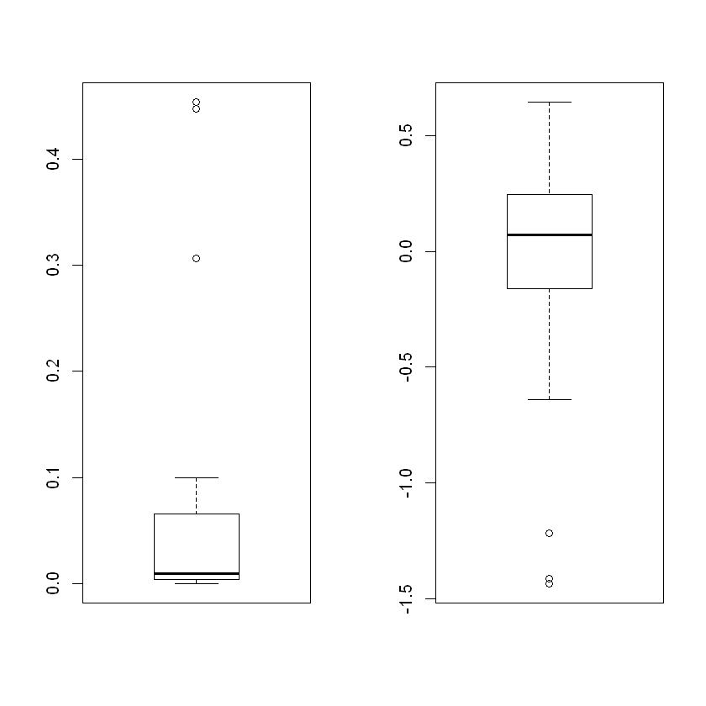

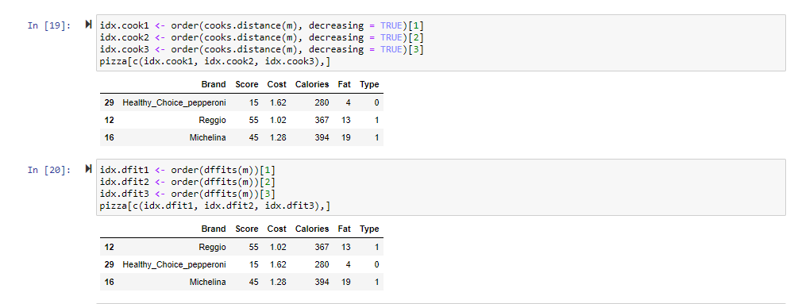

We can see some unusual points in the bottom right of the residual plot in Reggio and Michelina. Both pizzas are estimated to have high scores but are more than 30 points lower than estimated.

The standardized residuals are -2.047 and -2.282, leverages are 0.299 and 0.19, distances are 0.447 and 0.306, and DFFITS are -1.436 and -1.218. From the boxplots of Cook’s distances and DFFITS measures, Reggio and Michelina pizzas look like outliers.

Both are influential from the boxplots; we see there are 3 points. Besides Reggio and Michelina pizzas, the Healthy Choice pepperoni pizza is also one.

3.

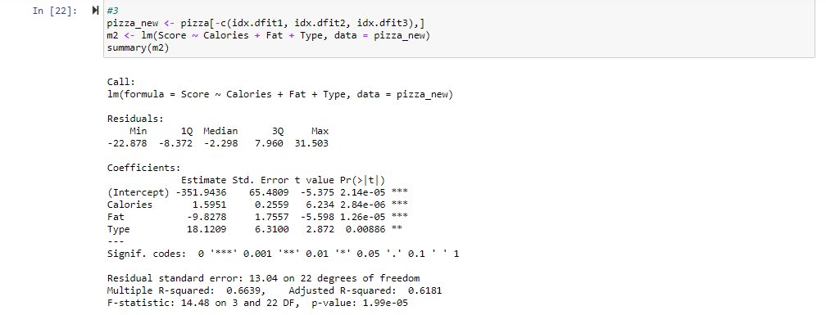



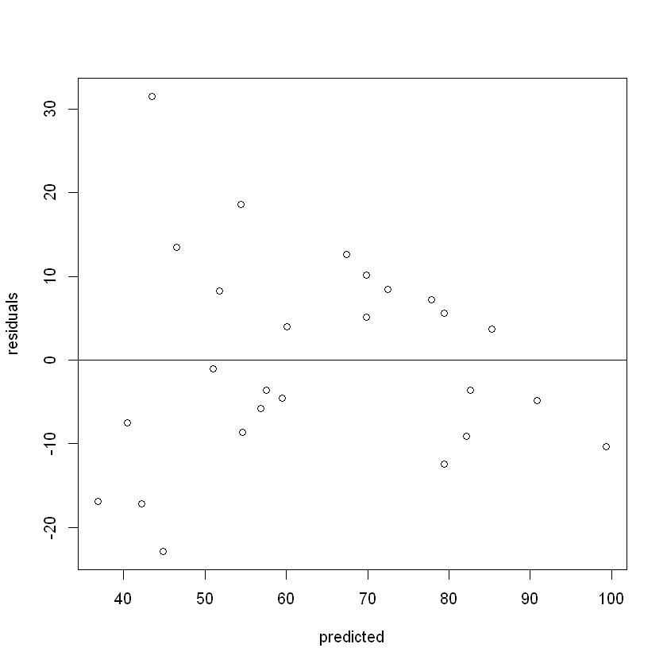



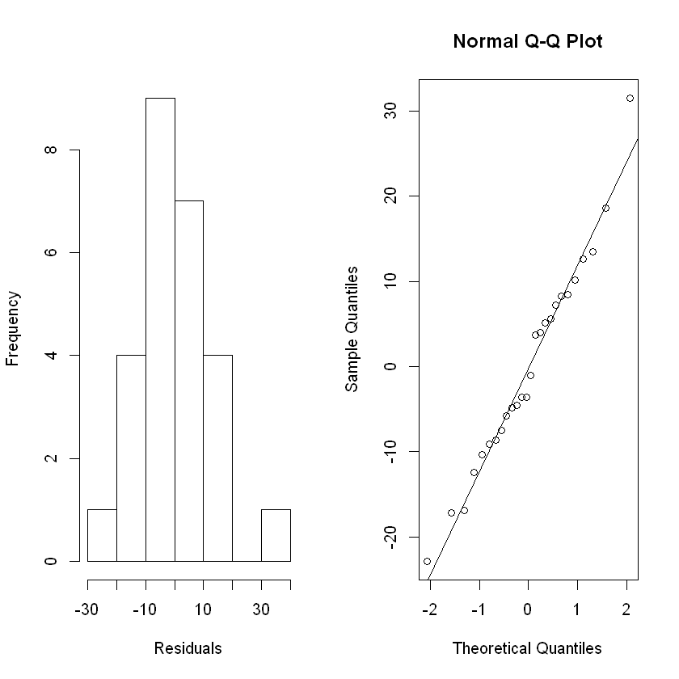

The second model seems to be more accurate than the previous. It has a larger R^2 value, more significant F test, and more significant t-tests.

4.



Yes, there exists a serious collinearity in the model because those two variables are highly correlated (r = 0.94603).

5.

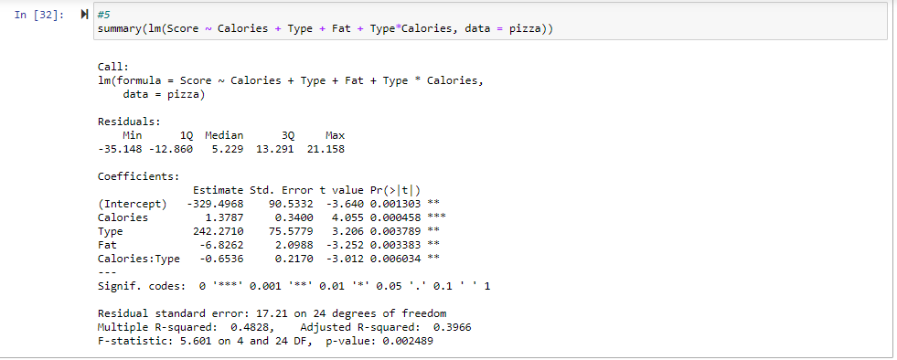

The coefficient of interaction term is -0.65. It means that holding Fat fixed the difference in scores between cheese pizzas and pepperoni pizzas decreases by 0.65 points when Calories increases by 1 unit.