HW #6

Jatinder Singh

STA 4155

12/14/2020

#1

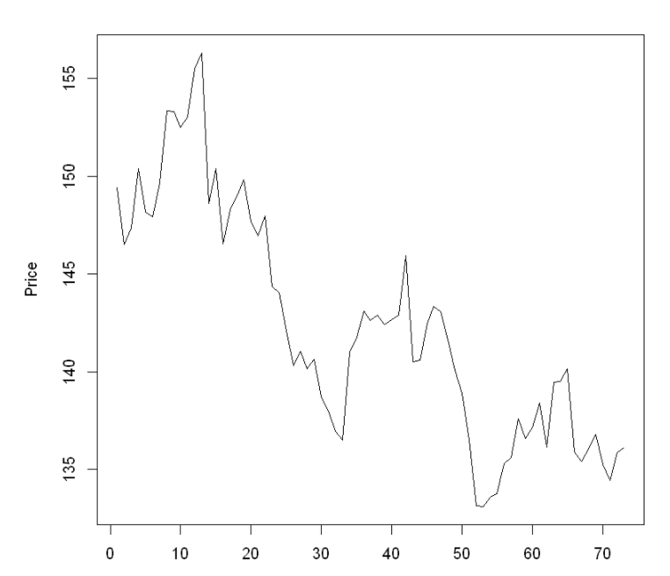

It is evident that as time has increased the overall price of coffee has decreased, this is due to advanced farming techniques, larger supply chains, and more efficient distribution processes.

#2

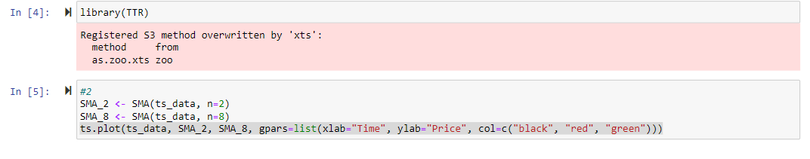

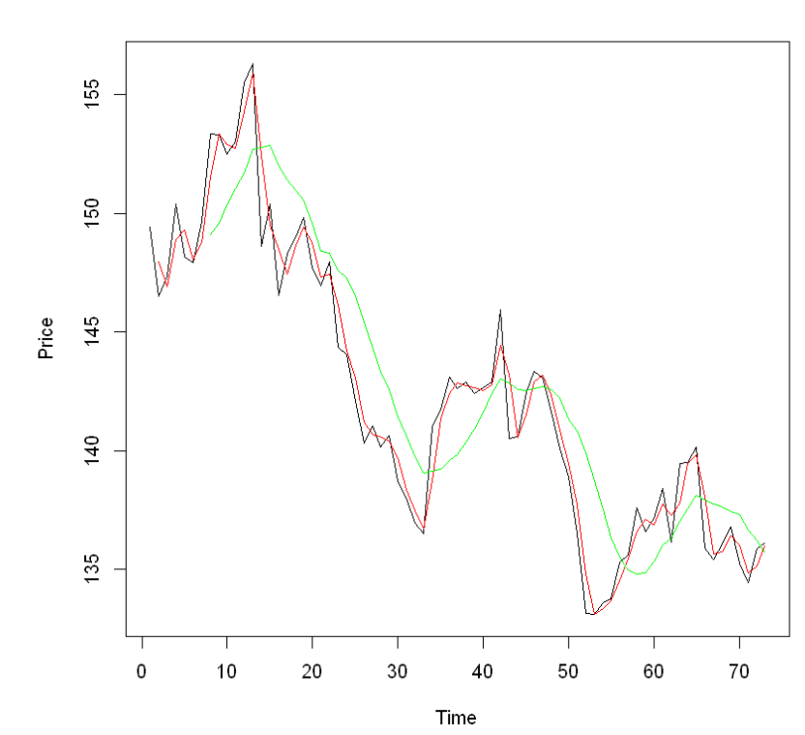

#3



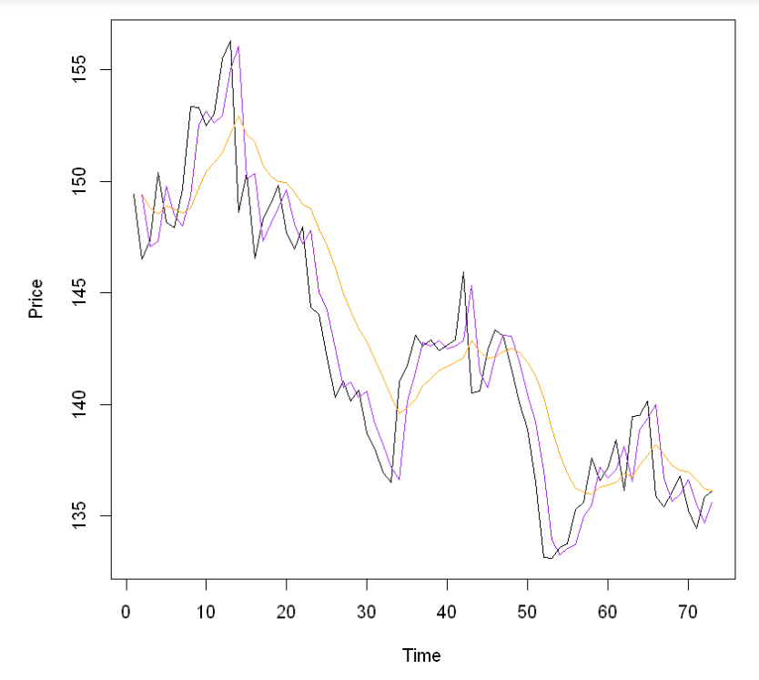

#4

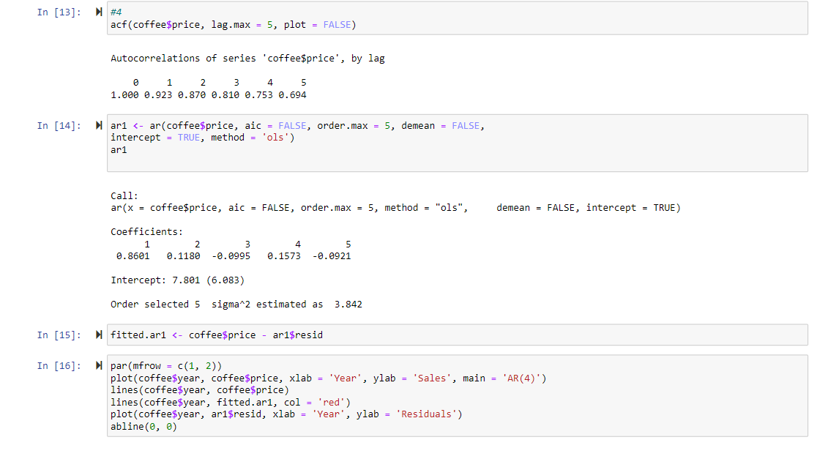

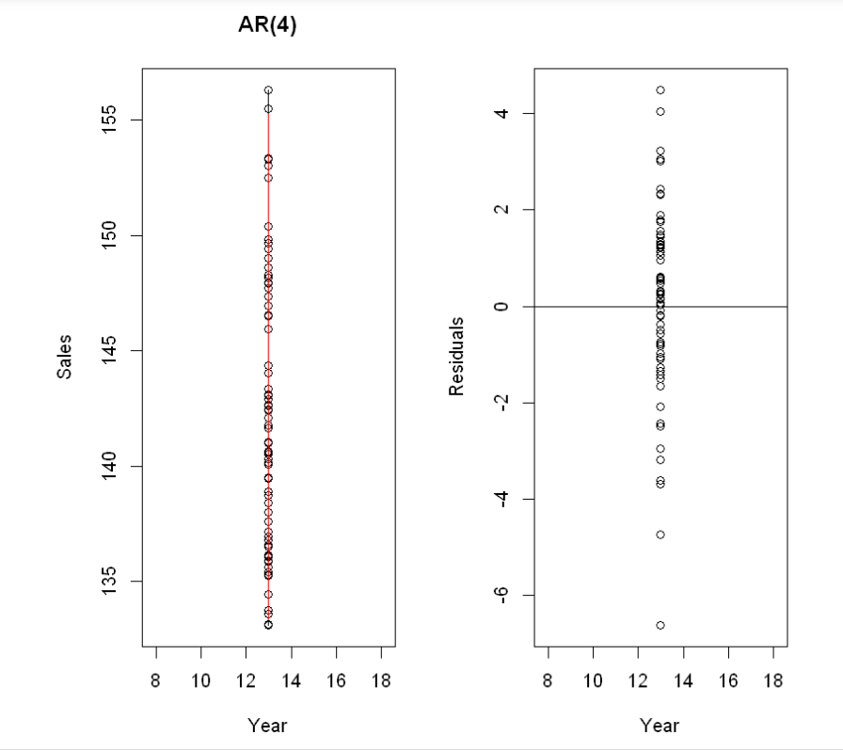

It depends on each lag very differently.

#5

138.90-130/138.90 * 100 = **.65%**