Finding a perfect place in New York to open a new restaurant

**Introduction**

We have received a business request to help our customer to decide where to open a new restaurant. Customer posses already several restaurants all around the USA. Its characteristic is a very high quality of food and not the cheapest price.

**Background**

New York has a lot of all kind of restaurants. We can easily find an italian, indian mexican or chinease food. There’s even much more if you’d like to look for it. Everyone can open a new place, but customers they have their own habits. Thus, it is very important to increase chances to succeed with this investment. Not only food is important. Not only cuisine. One of very important feature is to decide where to open this place. So its location.

**Problem**

Finding the best location to open a new Indian restaurant with a good quality food in New York.

**Data acquisition and cleaning**

We have used following data sources:

1.New York City data that contains list Boroughs, Neighbourhoods along with their latitude and longitude. Data source : <https://cocl.us/new_york_dataset>

2.Data source : Foursquare API

3.Data source with New York Borough boundaries: <https://data.cityofnewyork.us/City-Government/BoroughBoundaries/tqmj-j8zm>

First we needed to check how many neighbourhoods New York has. The answer is 306. Thus, it’s a lot to choose from.

Then we have check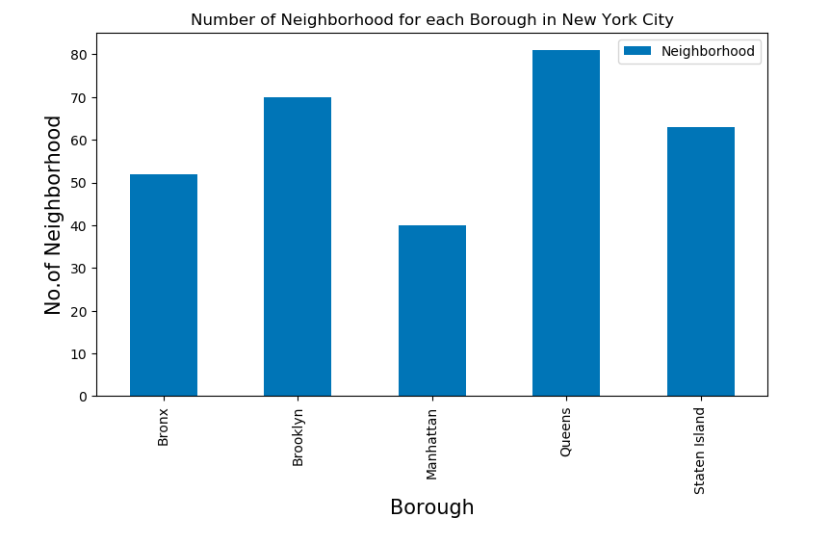ed how many indian restaurants we can find in New York. 146 to be exact. Following graph illustrates the distribution among boroughs.

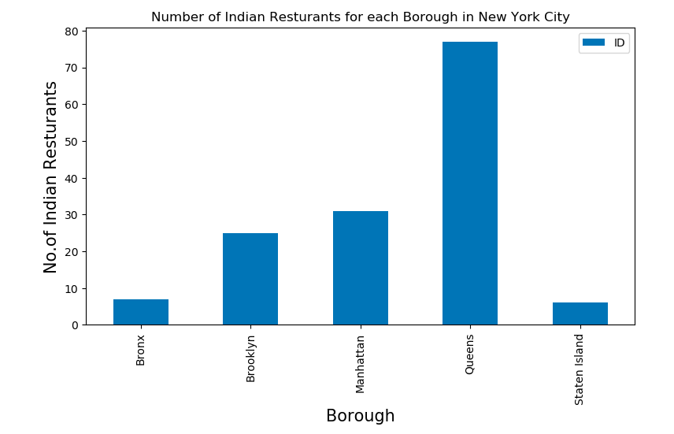

We have checked as well which restaurants poses the highest ranking. That’s because we know that our customer’s restaurant is with a high food quality. This way we know with which we can compete.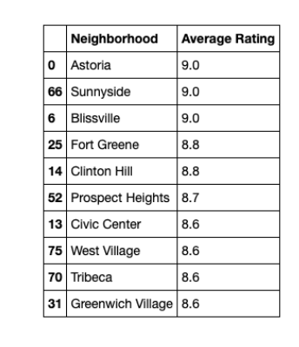

Then we checked the distribution based on average rating for each Borough. This way we can decide where is the lowest average quality of a food among Indian restaurants. That can help us to find some possible propositions.

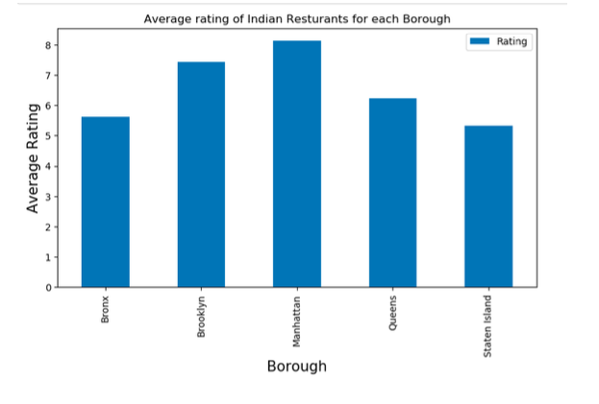

**Conclusions**

Our recommendation based on the analysis for location to open an Indian restaurant is following:

* Astoria (Queens)
* Bissvile (Queens)
* Civic Center (Manhattan)