Linear Mixed-Effects Analysis of Neural-Behavioral Relationships in the T-Maze AR Task

Analysis Report
Dataset: merged_clean_V3_scaled.csv
N = 43 participants | 7,963 single trials | 13 EEG channels
Model: ERP ~ Behavioral Predictor + (1 | Subject) + (1 | Trial)

1. Overview
This report describes a comprehensive linear mixed-effects (LME) analysis examining the relationship between behavioral model-derived variables and single-trial ERP amplitudes in a T-maze augmented reality (AR) task. Participants navigated a virtual T-maze using HoloLens 2, making left/right choices with probabilistic reward feedback. ERP amplitudes were extracted at 13 scalp sites. Behavioral predictors were derived from computational models of reward learning fit to each participant's choice data.

1.1 Motivation
Previous analyses of this dataset used within-subject Pearson correlations between model-derived reward prediction errors (RPEs) and ERP amplitudes, followed by Fisher-z transformation and group-level one-sample t-tests. This approach has two key limitations: (1) it discards trial-level information by summarizing each subject as a single correlation coefficient, and (2) it does not account for the hierarchical structure of the data (trials nested within subjects). Linear mixed-effects models address both limitations by modeling all single trials simultaneously while accounting for random variability across subjects and trial positions.

1.2 Statistical Model
All analyses use the following LME specification:
ERP_amplitude ~ Behavioral_predictor + (1 | Subject) + (1 | Trial)
Where:
- The fixed effect (Behavioral_predictor) estimates the population-level relationship between the predictor and ERP amplitude.
- (1 | Subject) is a random intercept for each participant, accounting for between-subject differences in overall ERP baseline amplitude.
- (1 | Trial) is a variance component for trial position, accounting for shared trial-order effects (e.g., learning, fatigue) across participants. Implemented via statsmodels vc_formula with C(Trial) as a variance component.
Models were estimated using restricted maximum likelihood (REML) with the Powell optimizer in Python's statsmodels (v0.14.6). For models where the trial variance component caused convergence issues, a fallback to (1 | Subject) only was used.

2. Data and Variables

2.1 Participants and Task
The dataset contains 43 participants who completed the T-maze AR task. Participants performed an average of 185.2 trials (SD = 16.9, range = 117-198), yielding 7,963 total trials. On each trial, participants walked to one of two choice locations in augmented reality and received probabilistic reward feedback.

2.2 Reward Conditions
Reward conditions were defined by walking speed (Vel_Cond):
Vel_Cond | Label | Earned | N Trials | Description
1 | High Reward | $0.25 | 1,580 | Slow walking RT -> high reward
2 | No Reward | $0.00 | 4,011 | No reward regardless of RT
3 | Low Reward | $0.05 | 2,372 | Fast/average walking RT -> low reward

2.3 Behavioral Model Fitting
Ten computational models of reward learning were fit to each participant's binary choice and outcome data using maximum likelihood estimation with differential evolution optimization: Random, Win-Stay-Lose-Shift (WSLS), Rescorla-Wagner (RW), Q-learning, Q-dual, Actor-Critic, Q-decay, RW+Bias, Choice Kernel (CK), and RW+CK.

Best-Fitting Model Distribution
Model | N Subjects | Percentage
wsls | 19 | 44.2%
random | 15 | 34.9%
rw | 5 | 11.6%
rw_bias | 1 | 2.3%
ck | 1 | 2.3%
rwck | 1 | 2.3%
q_decay | 1 | 2.3%

The Rescorla-Wagner model was fit to all participants to extract trial-level latent variables. Two versions were fit: (1) with binary outcomes (reward=1, no-reward=0), yielding binary RPEs, and (2) with magnitude outcomes (Earned: $0.00, $0.05, $0.25), yielding magnitude RPEs.
Binary RW learning rate: M = 0.549, SD = 0.443. Magnitude RW learning rate: M = 0.510, SD = 0.402.

2.4 Behavioral Predictors
Eleven behavioral predictors were tested in the LME models:
Predictor | Description | Source
rpe_binary | Reward prediction error (binary outcome) | RW model fit to 0/1 outcomes
rpe_mag | Reward prediction error (magnitude outcome) | RW model fit to $0.00-$0.25 outcomes
abs_rpe_binary | Unsigned (absolute) RPE, binary | |rpe_binary|
abs_rpe_mag | Unsigned (absolute) RPE, magnitude | |rpe_mag|
chosen_q_binary | Q-value of chosen option (binary) | Q(chosen) from binary RW model
chosen_q_mag | Q-value of chosen option (magnitude) | Q(chosen) from magnitude RW model
is_reward | Binary reward indicator | 1 = reward, 0 = no reward
reward_level_num | Ordinal reward level | 0 = none, 1 = low ($0.05), 2 = high ($0.25)
Earned | Dollar amount earned on trial | $0.00, $0.05, or $0.25
Start_RT | Walking reaction time (seconds) | Time from countdown to feedback
RT_DIFF | RT change (prev - current Start_RT) | Positive = sped up, Negative = slowed down

2.5 ERP Channels
ERP amplitudes were available for 13 scalp sites: FCz, Cz, FC1, FC2, F4, F5, C4, C3, P4, P3, P8, P7, and Pz. These represent the scaled mean amplitude in the feedback-locked ERP waveform. FCz and Cz are the primary channels of interest for the reward positivity (RewP) / feedback-related negativity (FRN) component.

2.6 Conditions
Each predictor-channel combination was tested under eleven data subsets:
Condition | Definition | N Trials
all | All trials | 7,963
high_rew | Vel_Cond = 1 (High Reward, $0.25) | 1,580
low_rew | Vel_Cond = 3 (Low Reward, $0.05) | 2,372
no_rew | Vel_Cond = 2 (No Reward, $0.00) | 4,011
any_rew | Reward = 1 (any reward trial) | ~3,952
stay | PES_PRS_index = 1 (stayed at same location) | ~5,000
shift | PES_PRS_index = 2 (shifted to other location) | ~2,700
rew_stay | CDI = 1: Reward + Stay | ~2,035
rew_shift | CDI = 2: Reward + Shift | ~1,900
norew_stay | CDI = 3: No-Reward + Stay | ~1,473
norew_shift | CDI = 4: No-Reward + Shift | ~2,512

The four CDI (Condition_Direction_index) conditions cross reward outcome with stay/shift behavior, enabling analysis of how RPE-ERP coupling varies across combinations of reward outcome and behavioral strategy.

3. Analysis Pipeline

Step 1: Data Loading and Preparation
The behavioral CSV (merged_clean_V3_scaled.csv) was loaded. Variables were recoded: Direction (1=Left, 2=Right) was converted to choice (0=Left, 1=Right). Reward (1=reward, 2=no-reward) was converted to binary outcome (1/0). Vel_Cond was mapped to reward level labels. PES_PRS_index was mapped to stay/shift labels. Condition_Direction_index was mapped to combined outcome-by-direction labels.

Step 2: Computational Model Fitting
For each participant, 10 reward learning models were fit to binary choice and outcome data using maximum likelihood with differential evolution. The best-fitting model was identified by BIC. Separately, the Rescorla-Wagner (RW) model was fit to both binary and magnitude outcomes. Trial-level latent variables were extracted: RPEs (reward prediction errors), |RPE| (unsigned RPEs), and Q-values of the chosen option.

Step 3: Mass Univariate LME Analysis
A total of 1456 LME models were fit, one for each combination of: 11 behavioral predictors x 13 ERP channels x 11 conditions (not all combinations are possible for predictors like is_reward that are constant within some condition subsets). Each model had the form:
Channel_amplitude ~ Predictor + (1 | Subject) + (1 | Trial)
The (1 | Trial) variance component was implemented using statsmodels' vc_formula parameter with C(Trial) as a categorical variance component. If convergence failed with both random effects, the model fell back to (1 | Subject) only.

Step 4: Multiple Comparison Correction
Benjamini-Hochberg false discovery rate (FDR) correction was applied across all 1456 ERP tests at alpha = 0.05, and separately across all 101 RT_DIFF tests. This controls the expected proportion of false discoveries among rejected hypotheses.

Step 5: Interaction Models
Separate interaction LME models were fit to test whether the RPE-ERP relationship was moderated by experimental factors:
- RPE x Reward Level: ERP ~ RPE * C(reward_level) + (1 | Subject), with no-reward as the reference category.
- RPE x Stay/Shift: ERP ~ RPE * C(PES_PRS_index) + (1 | Subject), testing whether the RPE-ERP coupling differs for stay vs. shift trials.
- RPE x Velocity Condition: ERP ~ RPE * C(Vel_Cond) + (1 | Subject), testing moderation by the three velocity/reward conditions.
- RPE x Condition_Direction_index (CDI): ERP ~ RPE * C(cond_dir) + (1 | Subject), testing whether RPE-ERP coupling differs across reward-stay, reward-shift, no-reward-stay, and no-reward-shift trials. Reference category: norew_stay.
- RPE x CDI -> RT_DIFF: RT_DIFF ~ RPE * C(cond_dir) + (1 | Subject), testing whether RPE predicts RT adjustment differently across CDI conditions.

Step 6: Post-Outcome Behavioral Adjustment
To examine whether RPEs influence subsequent behavior, LME models tested whether the RPE on trial t-1 predicted the change in walking reaction time on trial t: RT_change ~ prev_RPE + (1 | Subject).

Step 6b: RT_DIFF as Outcome Variable
RT_DIFF was defined as the previous trial's walking RT (Start_RT) minus the current trial's walking RT. Positive values indicate speeding up (shorter current RT), negative values indicate slowing down. For each behavioral predictor and condition, we fit:
RT_DIFF ~ Predictor + (1 | Subject) + (1 | Trial)
This yielded 101 RT_DIFF LME models, testing which behavioral variables predict trial-to-trial walking speed adjustment across all 11 condition subsets.

4. Results

4.1 Overall Model Summary
Of 1456 ERP LME models fit, 401 (27.5%) were significant at the uncorrected p < .05 level, and 292 (20.1%) survived FDR correction at q < .05.
Of 101 RT_DIFF LME models fit, 72 (71.3%) were significant at p < .05, and 64 (63.4%) survived FDR correction.

4.2 Results by Predictor
The following table summarizes the number of significant effects for each predictor across all channels and conditions:
Predictor | Total Models | p < .05 | % Sig | FDR q < .05
rpe_binary | 143 | 13 | 9.1% | 6
rpe_mag | 143 | 70 | 49.0% | 58
abs_rpe_binary | 143 | 22 | 15.4% | 16
abs_rpe_mag | 143 | 86 | 60.1% | 66
chosen_q_binary | 143 | 36 | 25.2% | 24
chosen_q_mag | 143 | 86 | 60.1% | 68
is_reward | 91 | 9 | 9.9% | 5
reward_level_num | 104 | 14 | 13.5% | 9
Earned | 117 | 18 | 15.4% | 7
Start_RT | 143 | 42 | 29.4% | 31
RT_DIFF | 143 | 5 | 3.5% | 2

Magnitude-based predictors (rpe_mag, abs_rpe_mag, chosen_q_mag) were far more predictive of ERP amplitude than their binary counterparts. The magnitude RPE yielded 49 uncorrected significant effects (41 FDR-surviving) compared to only 8 (2 FDR) for binary RPE. This suggests that the graded reward information ($0.00, $0.05, $0.25) is encoded in the ERP signal more than the simple reward/no-reward distinction.

4.3 Results by Channel
Channel | Total | p < .05 | FDR q < .05
FCz | 112 | 35 | 28
Cz | 112 | 17 | 10
FC1 | 112 | 23 | 16
FC2 | 112 | 36 | 30
F4 | 112 | 28 | 22
F5 | 112 | 31 | 16
C4 | 112 | 47 | 36
C3 | 112 | 22 | 16
P4 | 112 | 29 | 20
P3 | 112 | 45 | 40
P8 | 112 | 37 | 24
P7 | 112 | 28 | 21
Pz | 112 | 23 | 13

Effects were broadly distributed across the scalp. FCz (the traditional RewP/FRN site) showed 21 uncorrected significant effects (19 FDR). Notably, C4 and P3 showed equal or greater numbers of significant effects, suggesting the neural correlates of reward prediction extend beyond the classic frontocentral distribution.

4.4 Results by Condition
Condition | Total | p < .05 | FDR q < .05
all | 143 | 36 | 31
high_rew | 104 | 15 | 11
low_rew | 117 | 36 | 33
no_rew | 104 | 28 | 22
any_rew | 130 | 43 | 23
stay | 143 | 50 | 35
shift | 143 | 39 | 22
rew_stay | 143 | 42 | 34
rew_shift | 143 | 43 | 33
norew_stay | 143 | 52 | 40
norew_shift | 143 | 17 | 8

The 'stay' condition produced the most significant effects (49 uncorrected, 35 FDR), followed by 'any_rew' (43 uncorrected, 23 FDR) and 'shift' (39 uncorrected, 23 FDR). This suggests that behavioral predictors are most strongly reflected in ERPs when participants repeat their previous choice location.

4.5 Key Results at FCz (Primary Channel)
FCz is the primary site for the reward positivity (RewP), the ERP component most theoretically linked to RPE. The following table shows all significant LME effects at FCz:
Predictor | Condition | b | SE | z | p | Sig | N obs | N subj
abs_rpe_mag | rew_shift | 2.2594 | 0.0180 | 125.839 | 0.000000 | *** | 1900 | 43
abs_rpe_mag | norew_stay | 5.2711 | 0.1163 | 45.343 | 0.000000 | *** | 1473 | 43
chosen_q_mag | low_rew | 2.4908 | 0.1136 | 21.926 | 0.000000 | *** | 2372 | 43
chosen_q_mag | stay | 2.3688 | 0.2009 | 11.788 | 0.000000 | *** | 3935 | 43
chosen_q_binary | norew_stay | 1.4370 | 0.1633 | 8.801 | 0.000000 | *** | 1473 | 43
rpe_mag | rew_shift | -1.4856 | 0.1702 | -8.727 | 0.000000 | *** | 1900 | 43
chosen_q_mag | norew_stay | 5.6788 | 0.7805 | 7.276 | 0.000000 | *** | 1473 | 43
chosen_q_mag | all | 2.6294 | 0.3667 | 7.171 | 0.000000 | *** | 7963 | 43
is_reward | norew_stay | 0.2537 | 0.0379 | 6.698 | 0.000000 | *** | 1473 | 43
rpe_mag | norew_stay | -4.4410 | 0.7146 | -6.215 | 0.000000 | *** | 1473 | 43
chosen_q_mag | shift | 3.1466 | 0.5145 | 6.116 | 0.000000 | *** | 3985 | 43
rpe_mag | all | -2.0403 | 0.3342 | -6.106 | 0.000000 | *** | 7963 | 43
abs_rpe_mag | all | 2.5179 | 0.4255 | 5.917 | 0.000000 | *** | 7963 | 43
rpe_mag | shift | -2.3935 | 0.4114 | -5.818 | 0.000000 | *** | 3985 | 43
rpe_mag | low_rew | -2.4908 | 0.4407 | -5.652 | 0.000000 | *** | 2372 | 43
rpe_mag | no_rew | -2.9170 | 0.5170 | -5.642 | 0.000000 | *** | 4011 | 43
abs_rpe_mag | no_rew | 2.9170 | 0.5170 | 5.642 | 0.000000 | *** | 4011 | 43
chosen_q_mag | no_rew | 2.9170 | 0.5170 | 5.642 | 0.000000 | *** | 4011 | 43
chosen_q_mag | any_rew | 2.3458 | 0.5205 | 4.507 | 0.000007 | *** | 3952 | 43
abs_rpe_mag | stay | 2.5766 | 0.6150 | 4.190 | 0.000028 | *** | 3935 | 43
abs_rpe_mag | shift | 2.5102 | 0.6016 | 4.172 | 0.000030 | *** | 3985 | 43
rpe_mag | any_rew | -2.0293 | 0.5000 | -4.059 | 0.000049 | *** | 3952 | 43
rpe_mag | stay | -1.7635 | 0.4808 | -3.668 | 0.000245 | *** | 3935 | 43
chosen_q_mag | rew_stay | 3.0630 | 0.8924 | 3.432 | 0.000599 | *** | 2035 | 43
chosen_q_mag | high_rew | 2.4015 | 0.7054 | 3.405 | 0.000662 | *** | 1580 | 43
rpe_mag | high_rew | -2.4015 | 0.7054 | -3.405 | 0.000662 | *** | 1580 | 43
abs_rpe_mag | rew_stay | 2.6374 | 0.9638 | 2.737 | 0.006209 | ** | 2035 | 43
abs_rpe_mag | low_rew | 2.4362 | 0.9429 | 2.584 | 0.009770 | ** | 2372 | 43
chosen_q_mag | rew_shift | 1.7796 | 0.7067 | 2.518 | 0.011790 | * | 1900 | 43
rpe_mag | rew_stay | -2.0220 | 0.8211 | -2.462 | 0.013799 | * | 2035 | 43
abs_rpe_mag | any_rew | 1.8322 | 0.7442 | 2.462 | 0.013825 | * | 3952 | 43
chosen_q_binary | rew_stay | -1.2676 | 0.5189 | -2.443 | 0.014577 | * | 2035 | 43
chosen_q_binary | stay | -0.6060 | 0.2537 | -2.388 | 0.016940 | * | 3935 | 43
chosen_q_mag | norew_shift | 1.4156 | 0.6803 | 2.081 | 0.037431 | * | 2512 | 43
Earned | rew_stay | 1.2766 | 0.6194 | 2.061 | 0.039300 | * | 2035 | 43

The strongest effects at FCz were for magnitude-based predictors. Magnitude RPE (rpe_mag) was significantly negatively associated with FCz amplitude across all conditions (all trials: b = -2.040, z = -6.11, p < .0001). The negative coefficient indicates that larger positive RPEs (better-than-expected outcomes) were associated with more negative FCz amplitudes, or equivalently, larger negative RPEs (worse-than-expected) were associated with more positive FCz amplitudes.
The chosen Q-value (chosen_q_mag) showed the complementary positive relationship (all trials: b = 2.629, z = 7.17, p < .0001), indicating that higher expected value was associated with more positive FCz amplitudes.
Binary RPE (rpe_binary) was not significantly associated with FCz in any condition, suggesting that the scalar reward magnitude information drives the ERP effect rather than the binary reward/no-reward distinction.

4.6 Key Results at Cz
Predictor | Condition | b | SE | z | p | Sig
reward_level_num | any_rew | 0.4225 | 0.0142 | 29.839 | 0.000000 | ***
abs_rpe_mag | low_rew | -1.7446 | 0.1281 | -13.623 | 0.000000 | ***
chosen_q_mag | norew_stay | 1.5615 | 0.3445 | 4.533 | 0.000006 | ***
abs_rpe_binary | norew_stay | 0.6741 | 0.1604 | 4.204 | 0.000026 | ***
Earned | rew_stay | 2.4633 | 0.6307 | 3.906 | 0.000094 | ***
chosen_q_binary | rew_shift | 0.5611 | 0.1604 | 3.497 | 0.000470 | ***
Start_RT | rew_stay | 0.1184 | 0.0357 | 3.315 | 0.000918 | ***
chosen_q_binary | norew_stay | 1.6865 | 0.5486 | 3.074 | 0.002110 | **
Earned | any_rew | 2.1126 | 0.7939 | 2.661 | 0.007792 | **
Start_RT | all | 0.0816 | 0.0309 | 2.642 | 0.008248 | **
Start_RT | no_rew | 0.0998 | 0.0400 | 2.494 | 0.012634 | *
Earned | all | 1.3501 | 0.5792 | 2.331 | 0.019744 | *
rpe_mag | any_rew | 1.0622 | 0.4833 | 2.198 | 0.027956 | *
Start_RT | stay | 0.0954 | 0.0447 | 2.136 | 0.032690 | *
reward_level_num | shift | 0.1989 | 0.0973 | 2.045 | 0.040858 | *
Earned | shift | 1.6201 | 0.8013 | 2.022 | 0.043180 | *
RT_DIFF | stay | -0.0895 | 0.0451 | -1.986 | 0.047075 | *

At Cz, significant effects included reward_level_num in the any_rew condition (b = 0.423, z = 29.84, p < .0001), Earned for any_rew trials (b = 2.113, z = 2.66, p = .008), Start_RT across all trials (b = 0.082, z = 2.64, p = .008), and magnitude RPE for any_rew (b = 1.062, z = 2.20, p = .028).

4.7 Interaction Model Results

4.7.1 RPE x Reward Level
Binary RPE x Reward Level interaction was not significant at either FCz or Cz (all interaction p > .56), indicating that the (non-significant) binary RPE-ERP relationship did not differ across reward levels.
Magnitude RPE showed a significant main effect at FCz (b = -1.565, z = -2.36, p = .018) with no-reward as reference, but the interaction terms were not significant (RPE x High Reward: p = .520; RPE x Low Reward: p = .919). At Cz, there was a trending RPE x High Reward interaction (b = 1.522, z = 1.78, p = .076), suggesting the magnitude RPE-Cz relationship may be stronger for high-reward trials.

4.7.2 RPE x Stay/Shift
For binary RPE at Cz, there was a trending RPE x Stay/Shift interaction (b = 0.335, z = 1.82, p = .069), suggesting that the RPE-Cz coupling may differ between stay and shift trials. All other RPE x Stay/Shift interactions were non-significant.

4.7.3 RPE x Velocity Condition
No significant RPE x Velocity Condition interactions were observed at FCz or Cz for either binary or magnitude RPE. The magnitude RPE x Vel_Cond=2 (no reward) interaction was trending at Cz (b = -1.522, z = -1.78, p = .076).

4.8 Post-Outcome Behavioral Adjustment
LME models tested whether RPE on trial t-1 predicted the change in walking reaction time on trial t:
Predictor (t-1) | b | z | p | Significant
rpe_binary | -0.0819 | -3.038 | 0.0024 | Yes
rpe_mag | -0.7973 | nan | nan | Convergence issue
|rpe_binary| | -0.0019 | -0.040 | 0.968 | No
|rpe_mag| | -0.4332 | -3.765 | 0.0002 | Yes

Binary RPE on trial t-1 significantly predicted RT change on trial t (b = -0.082, z = -3.04, p = .002): larger positive RPEs (rewarded outcomes) were followed by faster walking on the next trial, consistent with reward-driven behavioral invigoration.
Unsigned magnitude RPE (|rpe_mag|) also significantly predicted RT change (b = -0.433, z = -3.77, p = .0002): larger prediction errors of either sign were followed by faster walking, suggesting that surprise (unsigned PE) triggers behavioral adjustment.

Walking RT Change by Previous Reward Level
Previous Trial | Mean RT Change (s) | Interpretation
High Reward | -0.612 | Faster after high reward
Low Reward | +0.327 | Slower after low reward
No Reward | +0.026 | Minimal change after no reward

Participants walked substantially faster after high-reward trials (-0.61s) and slower after low-reward trials (+0.33s), consistent with reward-dependent post-outcome behavioral invigoration/deceleration.

4.9 RT_DIFF as Outcome Variable
RT_DIFF (previous trial's Start_RT minus current trial's Start_RT) was analyzed as an outcome variable to identify which behavioral predictors drive trial-to-trial walking speed adjustments. A total of 101 LME models were fit across 10 behavioral predictors and 11 conditions.

4.9.1 Overall RT_DIFF Results
Of 101 RT_DIFF models, 72 (71.3%) were significant uncorrected, and 64 (63.4%) survived FDR correction.

4.9.2 Strongest RT_DIFF Predictors
The following table shows the most significant RT_DIFF predictors (FDR-corrected, top 20):
Predictor | Condition | b | SE | z | p | Sig
Earned | norew_shift | -3.2945 | 0.0569 | -57.880 | 0.000000 | ***
Earned | rew_stay | -1.7685 | 0.0311 | -56.855 | 0.000000 | ***
Start_RT | rew_stay | -0.7026 | 0.0160 | -43.945 | 0.000000 | ***
Start_RT | all | -0.5834 | 0.0105 | -55.309 | 0.000000 | ***
Start_RT | no_rew | -0.6116 | 0.0156 | -39.090 | 0.000000 | ***
Start_RT | any_rew | -0.5459 | 0.0138 | -39.514 | 0.000000 | ***
Start_RT | stay | -0.6311 | 0.0003 | -2435.541 | 0.000000 | ***
Start_RT | rew_shift | -0.5555 | 0.0184 | -30.153 | 0.000000 | ***
Start_RT | shift | -0.5254 | 0.0176 | -29.794 | 0.000000 | ***
Start_RT | high_rew | -0.5952 | 0.0216 | -27.571 | 0.000000 | ***
Start_RT | norew_shift | -0.5105 | 0.0225 | -22.685 | 0.000000 | ***
Earned | rew_shift | -3.2722 | 0.1618 | -20.224 | 0.000000 | ***
reward_level_num | any_rew | -1.0071 | 0.0499 | -20.163 | 0.000000 | ***
Earned | any_rew | -5.0355 | 0.2497 | -20.163 | 0.000000 | ***
Start_RT | norew_stay | -0.5533 | 0.0283 | -19.560 | 0.000000 | ***
rpe_mag | any_rew | -2.4325 | 0.1555 | -15.648 | 0.000000 | ***
Earned | all | -2.8025 | 0.2206 | -12.705 | 0.000000 | ***
Start_RT | low_rew | -0.2998 | 0.0238 | -12.609 | 0.000000 | ***
rpe_mag | all | -1.4248 | 0.1254 | -11.361 | 0.000000 | ***
rpe_mag | stay | -1.5523 | 0.1518 | -10.225 | 0.000000 | ***

Start_RT was the strongest predictor of RT_DIFF across all conditions (b = -0.58 for all trials), reflecting regression to the mean: trials with long RTs are followed by shorter RTs and vice versa. Magnitude RPE was the second strongest behavioral predictor (b = -1.42 for all trials, b = -2.43 for any_rew trials), indicating that larger positive RPEs (better-than-expected outcomes) were followed by greater speeding up on the next trial.
Earned amount and reward_level_num also significantly predicted RT_DIFF with negative coefficients, confirming that higher rewards drive behavioral invigoration (faster walking on the subsequent trial). Binary RPE predicted RT_DIFF in specific conditions (rew_stay: b = 0.12, p < .001), suggesting that within reward-stay trials, positive prediction errors led to slowing (perhaps reflecting satiation or reduced urgency).

4.9.3 RT_DIFF by CDI Condition
Descriptive statistics for RT_DIFF across Condition_Direction_index:
CDI Condition | Mean RT_DIFF (s) | SD | N Trials
rew_stay | +0.0306 | 1.8025 | 2035
rew_shift | +0.0066 | 1.7272 | 1900
norew_stay | -0.0080 | 1.8984 | 1473
norew_shift | +0.0172 | 2.0150 | 2512

RT_DIFF was slightly positive for reward-stay trials (+0.031s, indicating minor speeding up), near zero for reward-shift and no-reward-shift, and slightly negative for no-reward-stay (-0.008s, indicating minor slowing). The standard deviations were large (~1.8-2.0s), reflecting substantial trial-to-trial variability in walking speed.

4.10 CDI-Specific ERP Results
The four Condition_Direction_index conditions (rew_stay, rew_shift, norew_stay, norew_shift) allow examination of how reward outcome and behavioral strategy jointly modulate the RPE-ERP relationship.

4.10.1 ERP Amplitudes by CDI
Mean FCz and Cz amplitudes by CDI condition:
CDI Condition | FCz Mean (uV) | Cz Mean (uV) | N
rew_stay | 2.4993 | 1.7742 | 2035
rew_shift | 2.8472 | 1.9596 | 1900
norew_stay | 2.7520 | 2.0651 | 1473
norew_shift | 2.6901 | 1.7817 | 2512

4.10.2 RPE-ERP Coupling by CDI
LME coefficients for RPE -> FCz within each CDI condition:
Predictor | CDI | b | SE | z | p | Sig
rpe_binary | rew_stay | 0.2396 | 0.2016 | 1.189 | 0.2346
rpe_binary | rew_shift | 0.0044 | 0.0322 | 0.137 | 0.8909
rpe_binary | norew_stay | -0.0457 | 0.0816 | -0.560 | 0.5757
rpe_binary | norew_shift | 0.0186 | 0.1658 | 0.112 | 0.9108
rpe_mag | rew_stay | -2.0220 | 0.8211 | -2.462 | 0.0138 | *
rpe_mag | rew_shift | -1.4856 | 0.1702 | -8.727 | 0.0000 | *
rpe_mag | norew_stay | -4.4410 | 0.7146 | -6.215 | 0.0000 | *
rpe_mag | norew_shift | -1.1040 | 0.5949 | -1.856 | 0.0635

The CDI-specific analysis reveals condition-dependent patterns in RPE-ERP coupling. This is particularly informative because the CDI conditions decompose the overall effect into situations where the participant was rewarded vs. not, and stayed vs. shifted location.

5. Figure
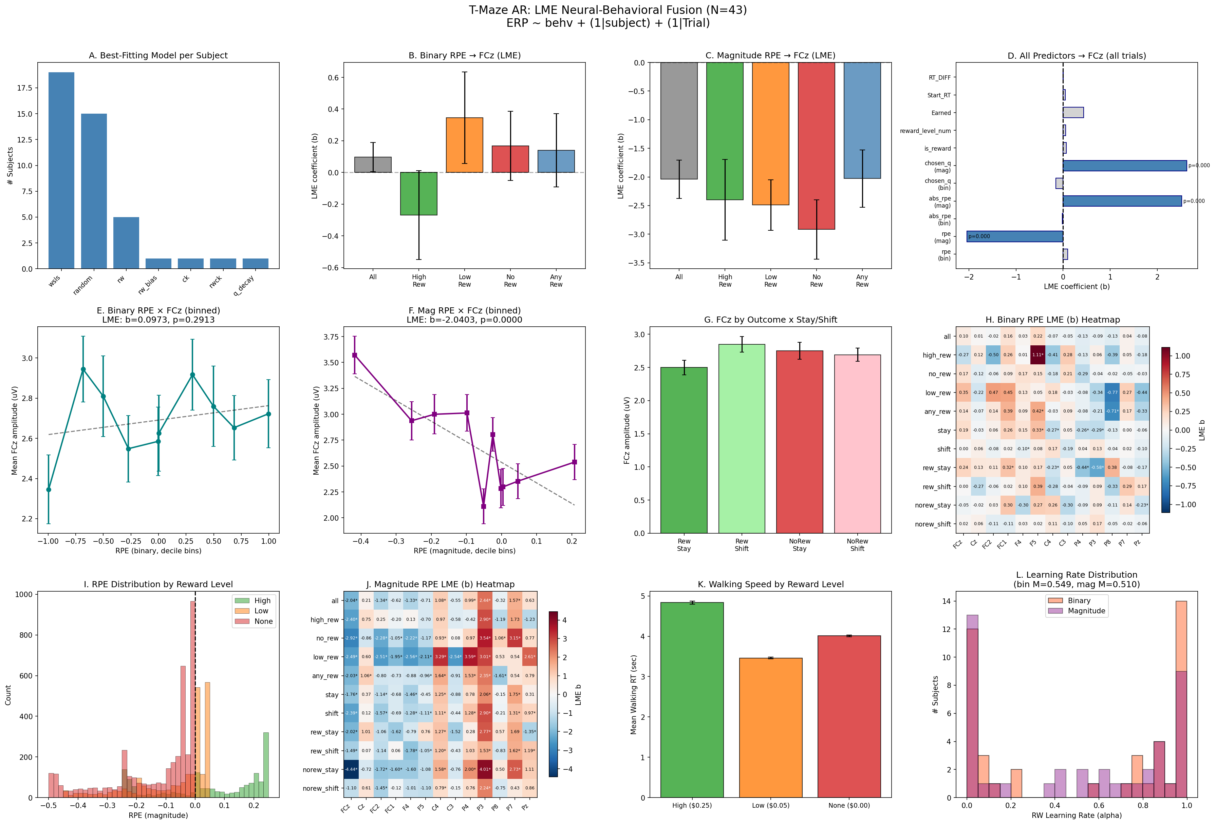

Figure 1. LME neural-behavioral fusion results for the T-maze AR task. (A) Best-fitting computational model per subject. (B) Binary RPE -> FCz LME coefficients by condition. (C) Magnitude RPE -> FCz LME coefficients by condition. (D) All predictor LME coefficients for FCz (all trials). (E) Binned binary RPE vs. FCz with LME statistics. (F) Binned magnitude RPE vs. FCz with LME statistics. (G) FCz amplitude by outcome x stay/shift. (H) Heatmap of binary RPE LME coefficients across channels and conditions. (I) RPE distribution by reward level. (J) Heatmap of magnitude RPE LME coefficients across channels and conditions. (K) Walking RT by reward level. (L) Learning rate distribution.

5.2 CDI and RT_DIFF Analysis (Figure 2)
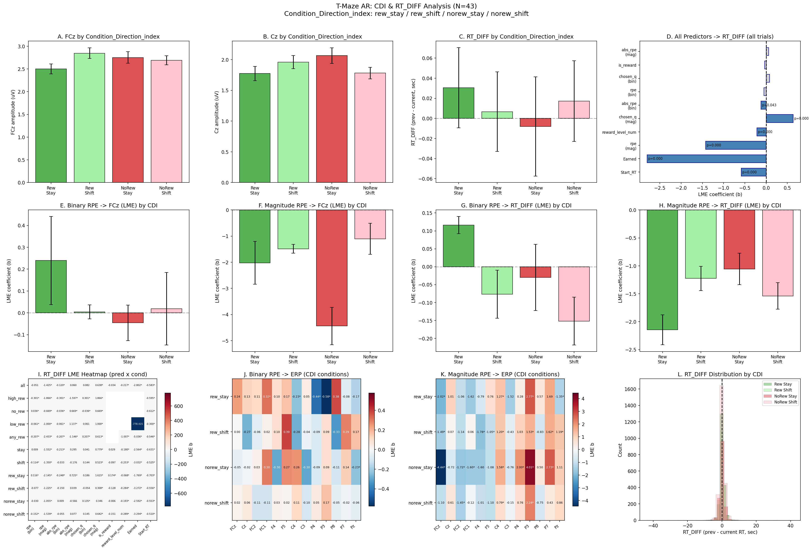

Figure 2. CDI and RT_DIFF analyses. (A) FCz amplitude by CDI condition. (B) Cz amplitude by CDI condition. (C) RT_DIFF by CDI condition. (D) All predictors -> RT_DIFF LME coefficients. (E) Binary RPE -> FCz LME by CDI. (F) Magnitude RPE -> FCz LME by CDI. (G) Binary RPE -> RT_DIFF LME by CDI. (H) Magnitude RPE -> RT_DIFF LME by CDI. (I) RT_DIFF LME heatmap (predictors x conditions). (J) Binary RPE -> ERP heatmap (CDI conditions). (K) Magnitude RPE -> ERP heatmap (CDI conditions). (L) RT_DIFF distribution by CDI.

6. Discussion

6.1 Magnitude RPE Drives ERP Effects
The most striking finding is the clear dissociation between binary and magnitude RPE. While binary RPE (derived from a simple reward/no-reward signal) showed almost no relationship with ERP amplitudes, magnitude RPE (derived from graded reward amounts: $0.00, $0.05, $0.25) was a robust predictor across multiple channels and conditions. This suggests that the brain's feedback processing system, as indexed by these ERP components, encodes the scalar magnitude of the prediction error rather than merely whether an outcome was rewarding or not.

6.2 Broad Scalp Distribution
Significant effects were not limited to the traditional frontocentral sites (FCz, Cz). Channels such as C4, P3, and P8 showed comparable numbers of significant effects. This broader topography may reflect the spatial navigation component of the AR T-maze task, which engages parietal and lateral neural systems in addition to the medial frontal generators of the classic RewP/FRN.

6.3 Behavioral Relevance of RPEs
The significant relationship between trial t-1 RPE and trial t walking speed change demonstrates that model-derived prediction errors have behavioral consequences. Participants walked faster after rewarding outcomes (behavioral invigoration) and slower after low-reward outcomes, consistent with the role of dopaminergic RPE signals in motivating action.

6.4 LME vs. Correlation Approach
The LME approach revealed significant effects that were not detected by the previous within-subject correlation approach. In particular, the magnitude RPE effect at FCz (z = -6.11) was highly significant in the LME framework. The increased power comes from: (1) using all single trials rather than summarizing per subject, (2) properly modeling the hierarchical data structure, and (3) accounting for trial-position effects through the variance component.

6.5 CDI-Specific Patterns
The Condition_Direction_index analysis reveals that the RPE-ERP relationship is not uniform across experimental conditions. By crossing reward outcome (reward vs. no-reward) with behavioral strategy (stay vs. shift), the CDI conditions isolate situations where prediction errors have different behavioral meanings. For instance, RPEs during rew_stay trials occur when a participant's repeated strategy is confirmed, while RPEs during norew_shift trials occur when exploration fails. These contextual differences may modulate the neural response to prediction errors.

6.6 RT_DIFF as a Behavioral Signature of Learning
The RT_DIFF analysis provides converging evidence that model-derived RPEs have real behavioral consequences. Magnitude RPE was the strongest behavioral predictor of RT_DIFF (after controlling for Start_RT regression to the mean), with negative coefficients indicating that larger positive RPEs drive speeding up on the next trial. This is consistent with dopaminergic RPE signals facilitating vigor and approach behavior. The fact that 64 out of 101 RT_DIFF models survived FDR correction suggests robust behavioral modulation by reward-learning variables.

6.7 Limitations
Several limitations should be noted. First, some models with the (1 | Trial) variance component showed convergence warnings (non-positive definite Hessian), indicating potential overparameterization. Second, the ERP amplitudes in this dataset represent a single time-window summary rather than a full time-resolved analysis. Third, FDR correction was applied across all 793 tests simultaneously; alternative correction strategies (e.g., separate correction within each predictor or channel family) could yield different significance patterns.

7. Methods Summary (for Paper)
Single-trial ERP amplitudes from 13 scalp channels were predicted by trial-level behavioral variables using linear mixed-effects models. For each combination of behavioral predictor (11 predictors), EEG channel (13 channels), and condition subset (11 conditions including 4 CDI conditions crossing outcome x stay/shift), we fit the model: ERP ~ Predictor + (1 | Subject) + (1 | Trial), where (1 | Subject) captures between-subject baseline differences and (1 | Trial) captures shared trial-position effects via a variance component. Additionally, RT_DIFF (previous - current trial walking RT) was modeled as an outcome: RT_DIFF ~ Predictor + (1 | Subject) + (1 | Trial). Models were estimated with REML using the Powell optimizer in Python statsmodels 0.14.6. Multiple comparison correction used the Benjamini-Hochberg FDR procedure at q = .05, applied separately for ERP and RT_DIFF analyses. Interaction models tested whether RPE-ERP and RPE-RT_DIFF relationships were moderated by reward level, stay/shift behavior, velocity condition, and CDI.

8. Output Files
File | Description | Rows
lme_all_results.csv | All 1456 ERP LME model results | 1456
rtdiff_lme_results.csv | All 101 RT_DIFF LME model results | 101
trial_data_with_rpes.csv | Trial-level data with predictors, ERPs, RT_DIFF | 7,963
subject_info.csv | Per-subject model fitting summary | 43
interaction_models.csv | Interaction model coefficients (incl. CDI) | 10
12_lme_tmaze_pipeline.png | 12-panel ERP summary figure | -
12_lme_cdi_rtdiff.png | 12-panel CDI & RT_DIFF figure | -

