|  |  |  |  |
| --- | --- | --- | --- |
| **Principal Component** | **Eigenvalue** | **Variance Explained** | **Proportion of Variance** |
| 1 | 2.8745881 | 51.29023% | 51.29023% |
| 2 | 1.6598467 | 29.61604% | 80.90627% |
| 3 | 0.6514201 | 11.62305% | 92.52932% |
| 4 | 0.2393515 | 4.27066% | 96.79998% |
| 5 | 0.1036724 | 1.84979% | 98.64977% |
| 6 | 0.0667204 | 1.19047% | 99.84024% |
| 7 | 0.0078705 | 0.14043% | 99.98067% |
| 8 | 0.0010826 | 0.01932% | 99.99998% |
| 9 | 0.0000009 | 0.00002% | 100.00000% |

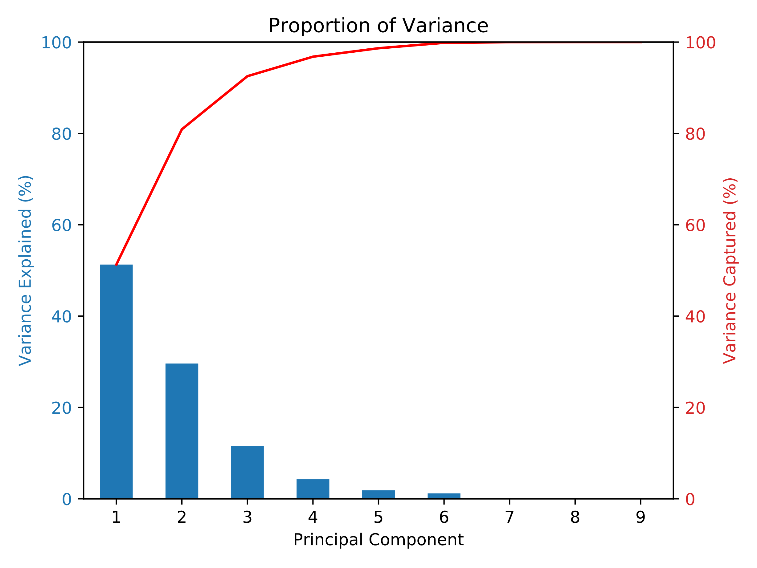

3 PCs capture ≈ 93%