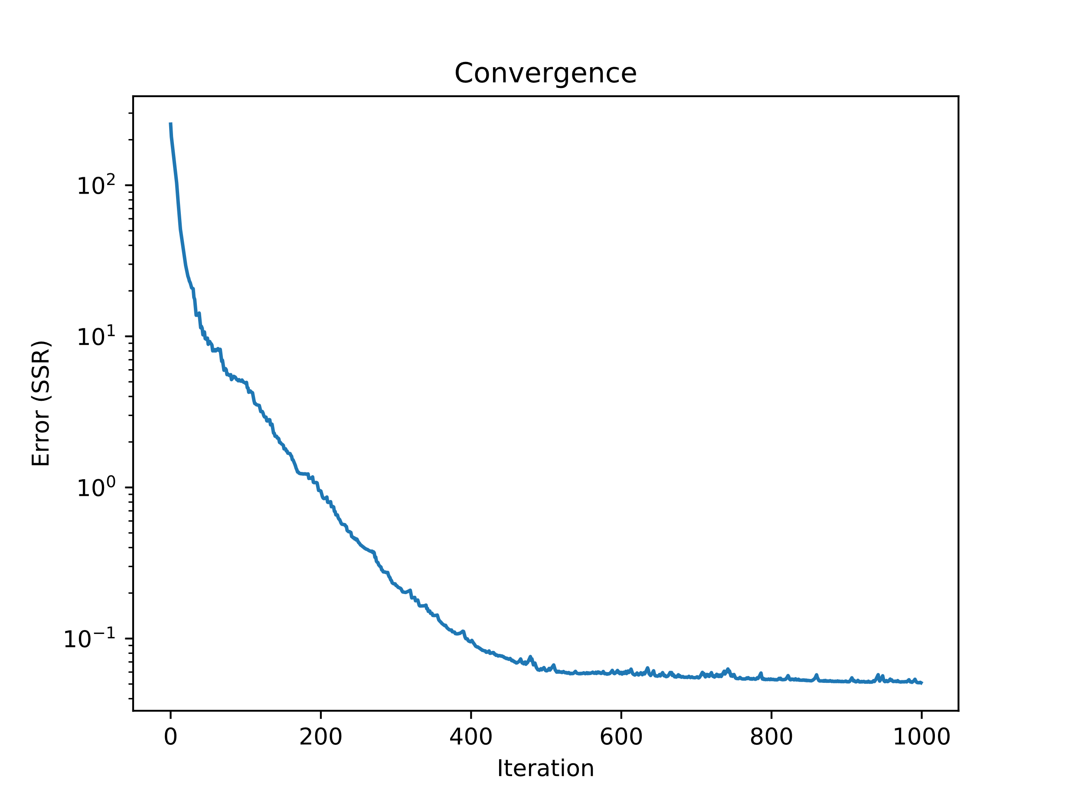

In addition to convergence plot, report the final weight vectors and predicted y value for each example:

Final weights connecting input to hidden layer:

w1 = [0.36792316 1.02124575 -1.01329279]

w2 = [0.35880968 -1.01485589 1.0140397 ]

Final weights connecting hidden layer to output:

v = [23.82327079 -20.08466214 -20.08443503]

0 XOR 0 = 0 | y = 0.13

0 XOR 1 = 1 | y = 0.89

1 XOR 0 = 1 | y = 0.88

1 XOR 1 = 0 | y = 0.09

With the final weights, calculate and report the values z1 and z2 for each example in the dataset:

x1 x2 z1 z2

0 0 0.590957 0.588752

0 1 0.344034 0.797840

1 0 0.800460 0.341628

1 1 0.592878 0.588555

Use the values z1 and z2 associated with examples (0,0) and (0,1) to calculate the bias of a decision boundary with equal margins for the 2 classes. Report the margins and include a plot of feature space with the decision boundary and location of features associated with examples in the dataset:

Wrote code to perform the calculations (ref: hw7, page 2).

Bias = -1.161

