1. The ordering I chose to use was most skilled domains to least skilled domains so that with a quick glance you can see my strengths and weaknesses. However, using the order from the instructions is important for standardizing the charts for consistency.

**My Ordering:**

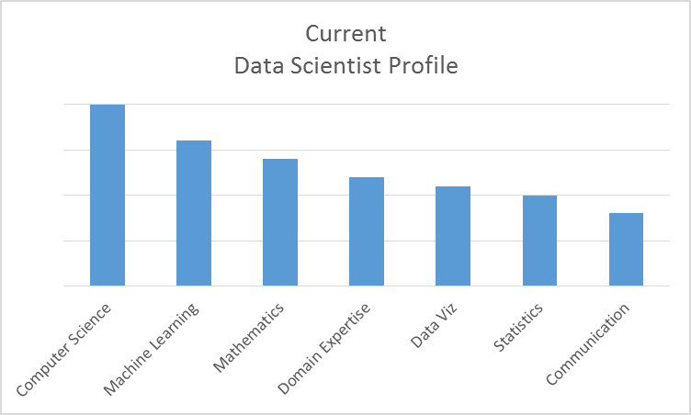

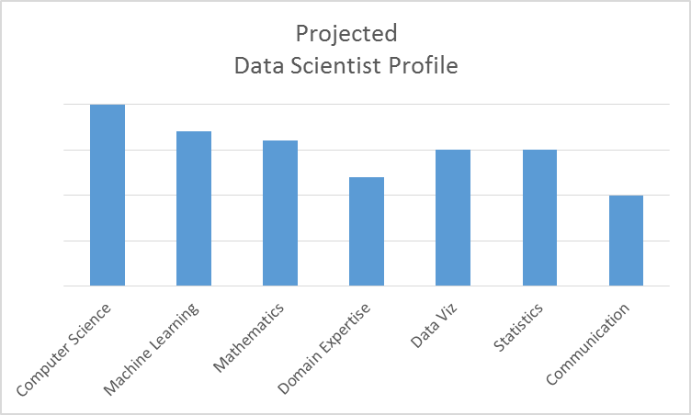

**Instruction’s Ordering:**

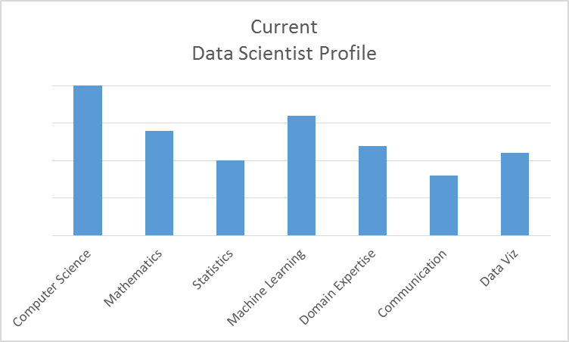

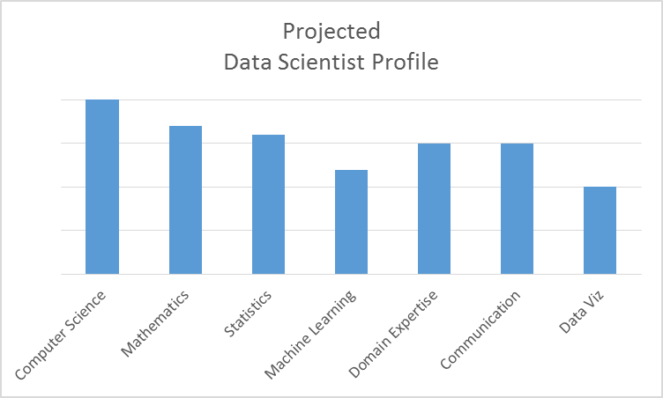

1. The domain expertise bucket should be dropped because it is too vague to be helpful. Additionally, we could consider merging mathematics and statistics into a single bucket since there is so much overlap between the two.
2. Using a pie chart seemed more logical for depicting relative skill levels for an individual and it makes the ordering of the domains question irrelevant. However, I do understand how using the bar chart is helpful for creating teams with complementary skills as depicted in Figure 1-3 from the book.

**Alternative Visualization:**

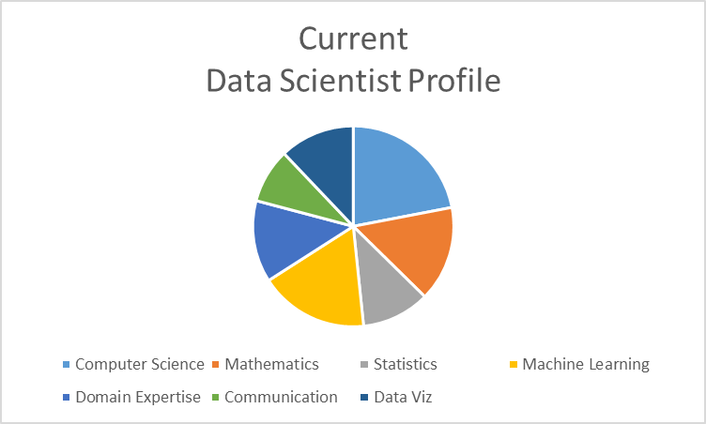

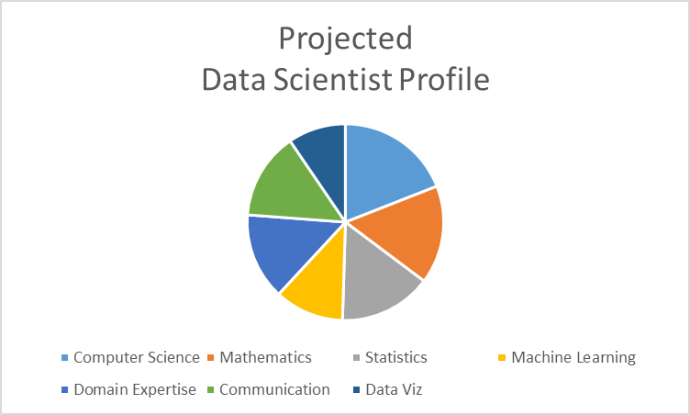

1. I see two potential drawbacks involved with self-reporting. First, how a person sees their skills may not match reality, rather how they would like their skills to be distributed. Second, a person’s ego may lead them to more evenly distribute their skills to avoid showing weaknesses; luckily skills are depicted relative to one another, decreasing the likelihood of ego causing inflation.