**Question 1:**Provide the plots for each of your RAxML best trees with node support values.  Be sure to clearly label which tree corresponds to each gene.  Describe any differences in the **clades** that you observe between the 2 trees: do the lizards and snakes form **distinct, separate** clades in each tree?  Do you see any polytomies in either tree?  In each tree, which node has the lowest bootstrap support? *(10 pts)*

**R35 Tree**

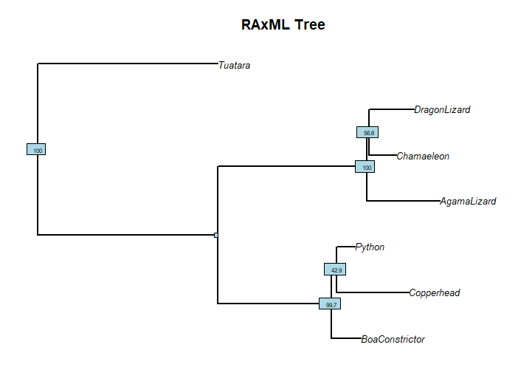

**SLC8A1**

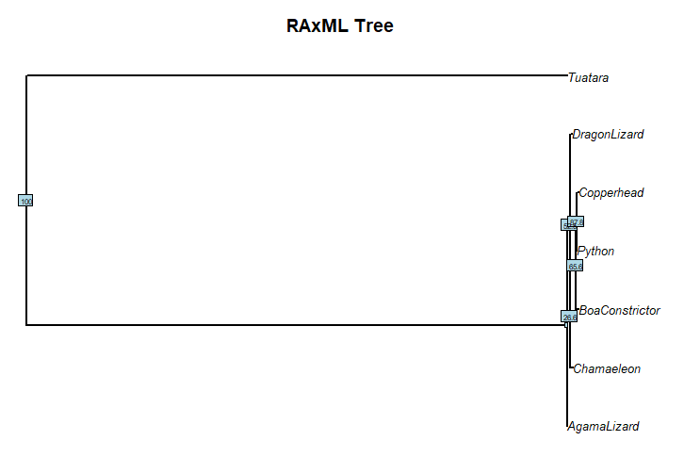

In the R35-reptiles RAxML tree, the lizard and snakes have distinct, separate clades. In the SLC8A1 RAxML tree, there is no clear separation between the lizard and snake clades. For example, the snakes all share a node with the Chaemeleon and there is no node separating the lizards from the snakes. There are no polytomies in either tree. The node with the lowest bootstrap support is between the python and the copperhead at 42.9 in the R35 tree and the Chamaeleon and snakes in the SLC tree at 26.6.

Note: Again, my laptop couldn’t show the distinctions in the SLC tree, so I redid this assignment as a cladogram on my personal computer and stretched it across my two screens. Then, I did it by doing the pdf and changing the width to 30. This was the best I could do. I would like to meet at the ending of this week or next week on this, since I will have 2 exams on Oct. 6 and 7:

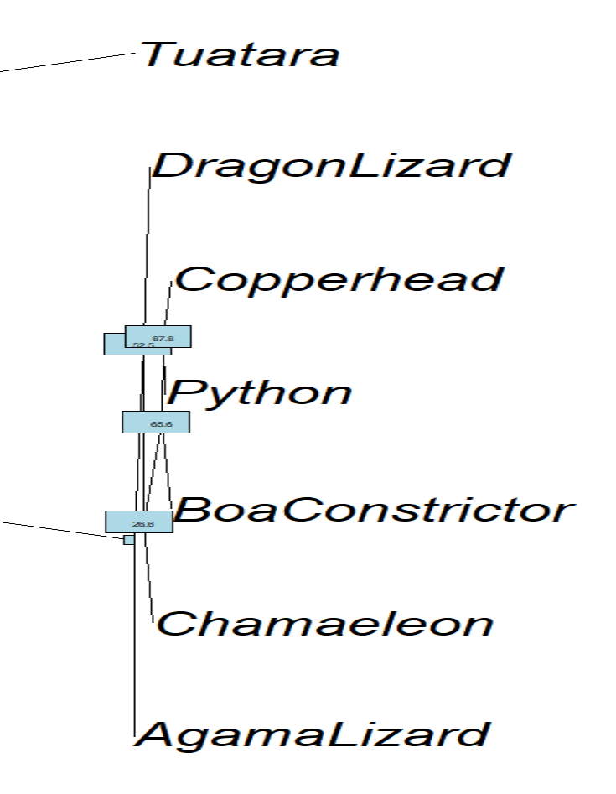



#### ****Question 2:****What is the symmetric difference, branch score difference, and path difference between your two trees?  Which number implies the biggest difference in the trees?  Based on what you know about the definition of these metrics, why would one score be much higher than the others?  Does your highest score make sense given what you see when you plot the two trees? (3 pts)

The symmetric difference is 4.0, the branch score difference is 20.725578, and the path difference is 5.830952. The biggest number implies the biggest difference in the trees, so the branch score implies the biggest difference. It was the highest since the species and branch lengths are very physically distant, contributing the most to the higher score/difference. The branch length difference and the construction of the trees based on nodes, edges, and clades between the trees contribute to the difference in metric scores. One tree having a different unique structure or length causes the difference to be higher than another score. Yes, the highest score makes sense since the SLC8A1 tree has very short branches, opposite to the R35 tree.

#### ****Question 3:****Provide a plot of you best tree with bootstrap support values.  Describe where the legless lizards appear on the tree in relation to the regular, 4-legged lizard species. (5 pts)

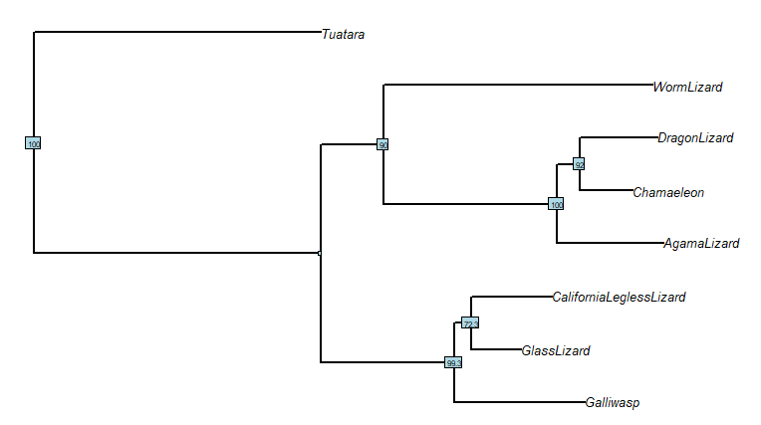

In the upper clade, the worm lizard is separate from the other 3 legged lizards and in the separate bottom clade, the California legless lizard and glass lizard share a clade and a node with the Galli wasp, a legged lizard. A single legless and a single legged lizard do not share an immediate node or clade, it is usually a group of one connected to one from the other group.

#### ****Question 4:****Provide the plot of your strict consensus tree.  Do you retain any phylogenetic information in this tree, or did all of the nodes turn into polytomies? (2 pts)

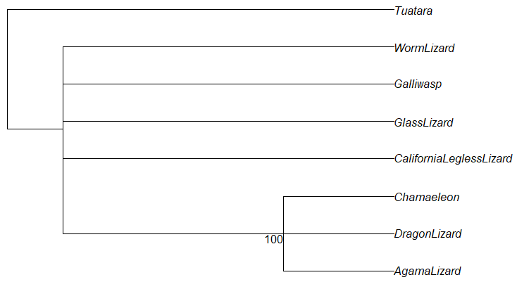

This tree turned into a bunch of polytomies from the last one.

#### ****Question 5:****Provide the plot of your majority rule consensus tree.  Do you get back all of the phylogenetic information you lost in the strict consensus tree, or are there still polytomies? (2 pts)

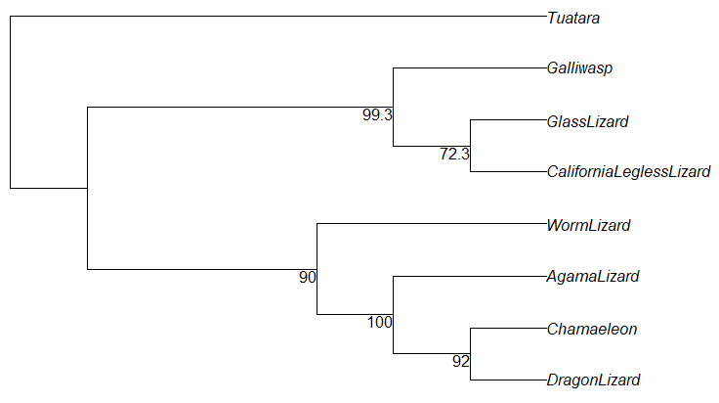

Yes, the information that was lost in the strict consensus tree was retrieved.

#### ****Question 6:****Provide the plot of your maximum clade credibility tree.  (1 pt)

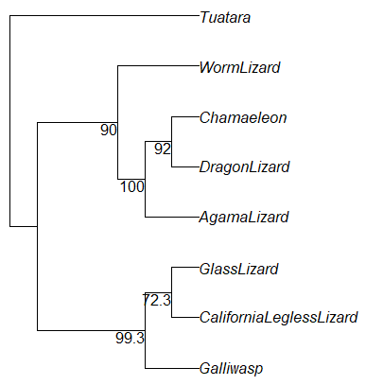

#### ****Question 7:****Provide the plot of your average tree. Do any of the clades or relationships change when compared to your maximum clade credibility tree?(2 pts)

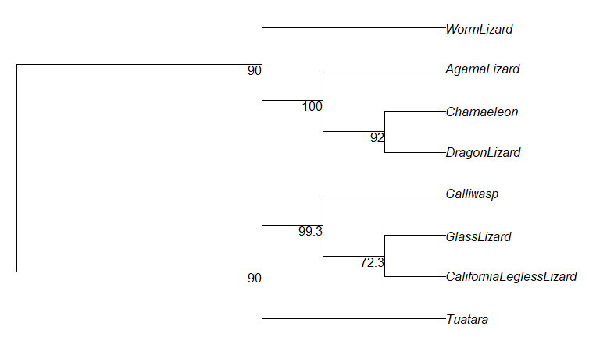

The worm lizard, agama lizard, chamaeleon, and dragon lizard clade stayed the same, but the other clade is slightly different. The tuatara is connected to the galliwasp, glass lizard, and California legless lizard clade in the average tree, where in the maximum clade credibility tree, it is the outgroup and is not part of a specific group/clade.

#### ****Question 8:****Provide the plot of your agreement subtree. Which taxa are included in this tree?(2 pts)

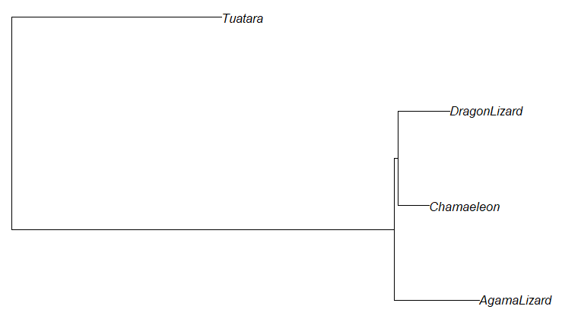

These are all legged lizards, not including the galliwasp.

#### ****Question 9:****Provide the plot of your combined super tree. Looking at where your legless lizards end up on this tree, how many times do you think "leglessness" evolved? (3 pts)

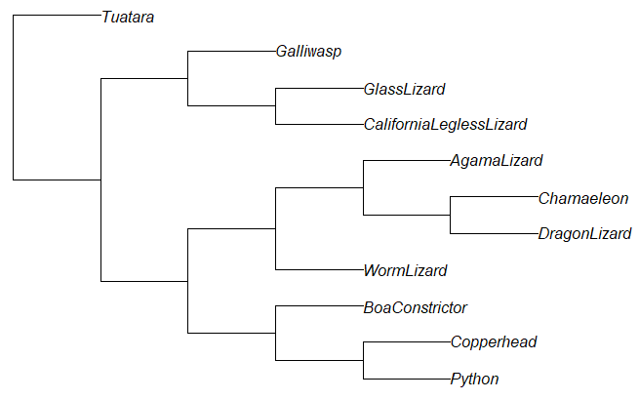

I think it started out as legged animals, then leglessness evolved or appeared at least 3 times before the glass lizard and California clade, the node that holds the bottom 3 snakes, and again at the worm lizard branch.

