CS5002 Prof. Higger
Homework2
Name: Shangjun Jiang
Homework group: Wei Han, Shangjun Jiang

Problem 1.
i. ((A^{C} ∩ B) ∪ (A^{C} ∩ B^{C}))^{C}
= (A^{C} ∩ B)^{C} ∩ (A^{C} ∩ B^{C})^{C}
= (A ∪ B^{C}) ∩ (A ∪ B)
= A U (B^{C} ∩ B)
= A ∪ ∅
= A

ii. (A^{C} ∩ B^{C})^{C} ∩ U
= (A^{C} ∩ B^{C})^{C}
= A ∪ B

iii. (A ∪ A) ∩ (B ∪ A^{C})
= A ∩ (B ∪ A^{C})
= (A ∩ B) ∪ (A ∩ A^{C})
= (A ∩ B) ∪ ∅
= (A ∩ B)

Problem 2.
i. e(n) = |n| where e : N → N (where we define N to exclude 0)
Bijective. For x∈N(exclude 0), each x is positive, which means e(n)=n, where we can say that each element of the codomain is mapped to by exactly one element of the domain, and they are just the same value. So according to definition of bijective, it is bijective.

ii. f(n) = n where f : Z → R
Injective. This is injective however not surjective, that is because, for any f(a)=f(b), we can figure that a=b, which proves it is injective, however, the codomain is all real numbers, which means not all elememts in codomain is mapped to a an element in domain, so it is not surjective.

iii. g(x) = max(x, 100) where g : R → R. The max function returns the maximum of its two input arguments so that g(1000) = 1000 and g(10) = 100
neither Injective nor Surjective. When x<100, we get g(x)=100, which means it is not an injection. For any x in R, g(x)≥100, so elements in codomain which are less than 100 are not mapped to, so it is not a surjection.

iv. Let A = {apple, banana, apricot, cake, orange} and B = {4, 5, 6, 7}. Define the function
h : A → B which counts the number of letters in the input. For example, h(apple) = 5 and
h(cake) = 4.
Surjective. We can list that h(apple)=5, h(banana)=6, h(apricot)=7, h(cake)=4, h(orange)=6, so for each elements in B, it is mapped to by at least one element in A, which shows it is surjective, besides, as h(banana)=h(orange)=6, and orange≠banana, it is not injective.

Problem 3.
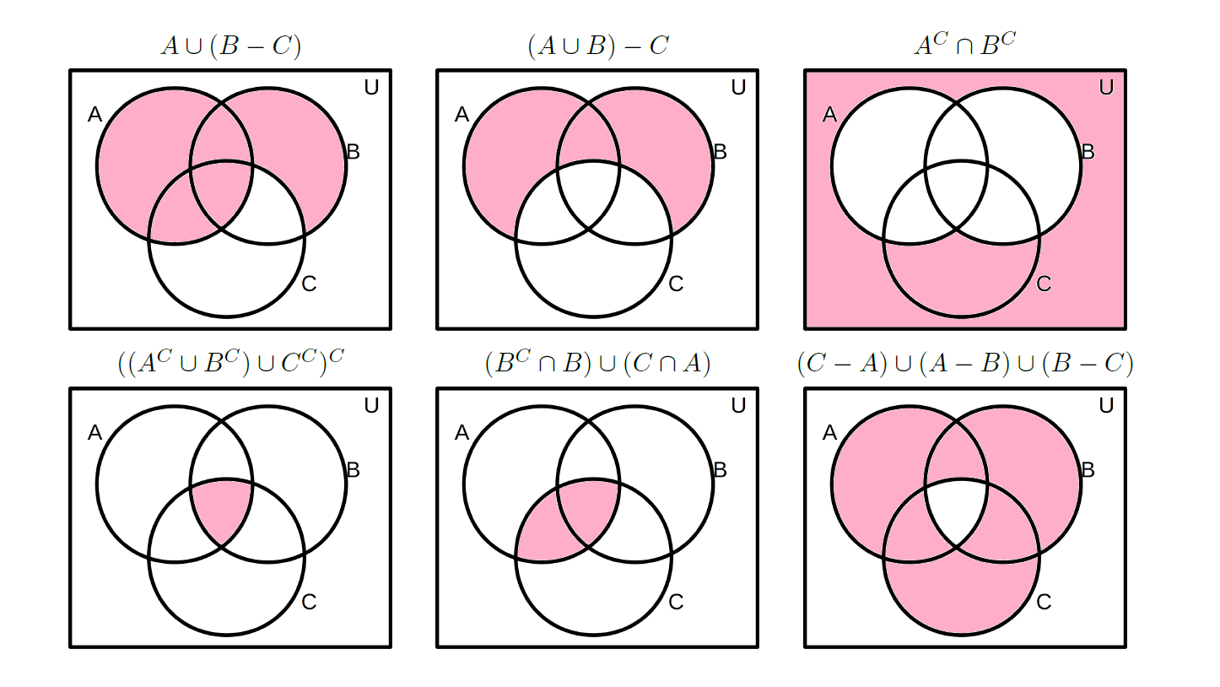
Problem 4.
i. A ∪ B 0111 OR
ii. A ∩ B 0001 AND
iii. A^{C} 1010 NOT

Problem 5.
i. {4}
ii. S = {x| -9≤x≤9 and x∈Z}

Problem 6.
i. {∅}
ii. {{1}, ∅}
iii. {∅, {1}, {2}, {1, 2}}
iv. {∅, {1}, {2}, {3}, {1, 2}, {1, 3}, {2, 3}, {1, 2, 3}}
v. 2^{n}

Problem 7.
 | Symmetric | Reflexive | Transitive | Equivilence Relation
less than | Flase | Flase | True | Flase
greater than or eaqual to | Flase | True | True | Flase
Absolute Value Function | True | True | True | True

