CS5002 Prof. Higger
Homework 8
Name: Shangjun Jiang
Homework group: Wei Han, Shangjun Jiang

Problem 1
i {C,E}
ii {G}
iii {A,D}
iv {H,I,G,F}
v {B,A,D,C,E}
vi {C,E,I,G}

Problem 2
i If every pair of nodes has an edge, there should be a path of AB-BC-CD-DE-EF-FA, which contradicts with the statement of ‘an acyclic graph’.

ii
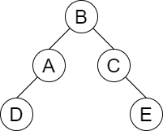

iii
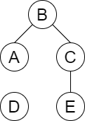

iv According to the definition of path, the length of a path can be infinite. e.g.(A-E-E-A-...-E)
cite from textbook:
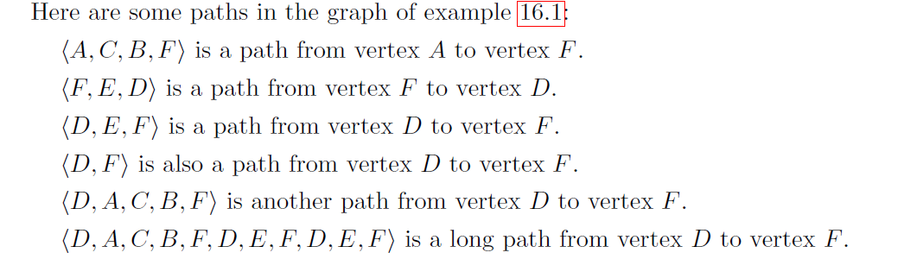

v


vi
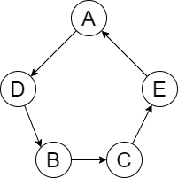

Problem 3
i ABFGCDEIHJK
ii ABCDFEHGIJK
iii EFHAIGBJKCD
iv EFABCDGHIJK

Problem 4
A→B→E→G weight:15
a | b | c | d | e | f | g
0 | 5(a) | 10(a) | ∞ | ∞ | ∞ | ∞
done | 5 | 9(b) | ∞ | 8(b) | ∞ | ∞
done | done | 9(b) | ∞ | 8(b) | 16(b) | 15(e)
done | done | 9(b) | 17(c) | done | 16(b) | 15(e)
done | done | done |  | done
At this step, the answer has come out. The path is A→B→E→G, and the list of nodes visited every step is shown as the table, which is abeg.

Problem 5
i A→B→C
B→A→C→D
C→A→B
D→B

ii
A B C D
A
B
C
D

iii
A→B→C
B→D
C→B
D

iv
A B C D
A
B
C
D

Problem 6
Because every pair of cities have exactly one airline flies the route,
routes operated by the two airlines in total are
C(n,2)=n×(n-1)/2
Now, assume that airline B can only connect (n-1) cities, which meet the requirement.
So, the most route it can operate will be
C(n-1,2)= (n-1)×(n-2)/2
the least route the other airline operates will be
C(n,2)-C(n-1,2)=n-1
And obviously the left city must connect all other (n-1) cities, which means the other airline can connect all the n cities. It shows there exist an airline connect all cities.
k represent the route airline A operates
k=n-1, when airline A fly the least airlines, airline A have to connect all cities.
k=n, obviously airline A fly a new route which was operated by the airline B
k=n+1, airline A fly two new routes which was operated by the airline B
...
k=C(n,2)-1, when airline B have to connect the (n-1) cities with n-2 airlines
we have travelled all possiblities, all the cases shown that either A must connect all cities to assure only (n-1) vertax are covered by B

