CS5002 Prof. Higger
Homework 9
Name: Shangjun Jiang
Homework group: Wei Han, Shangjun Jiang

Problem 1
i True
ii True
iii True
iv False
v True
vi True
vii True
viii False
ix True
x False
xi False

Probelm 2
i
10000 | log₂n, 3log₃n | 3n, 100n | nlog₂n, nlog₃n | n², 5n²+3 | 2^{n} | n!

ii
c=200, n₀=1
f(n) =100n+5, g(n)=n, there exists c=200, n₀=1, such that 100n+5≤200n, when n≥1.

iii
c=1, n_{o}=1
f(n) =n, g(n)=2^{n}, there exists c=1, n₀=1, such that n≤2^{n}, when n≥1.

iv
3n+4n²+3n!=O(f(n))
as n=O(n!), and n²=O(n!), we can figure out that
3n≤c₁n!
4n²≤c₂n!
and obviously, 3n!≤c₃n!
so 3n+4n²+3n!≤(c₁+c₂+c₃)n!=cn!,
so there exists, a non-negative real number c, when n≥n₀ to meet the big O
f(n)=n!

Problem 3
18, 45, 23, 2, -5, 10, 99, 0
i
18, □, 45, 23, 2, -5, 10, 99, 0
18<45, next
18, 45, □, 23, 2, -5, 10, 99, 0
23<45, then 23>18, next
18, 23, 45, □, 2, -5, 10, 99, 0
2<45, then 2<23, then 2< 18, next
2, 18, 23, 45, □, -5, 10, 99, 0
-5<45, then -5<23, then -5<18, then -5<2, next
-5, 2, 18, 23, 45, □, 10, 99, 0
10<45, then 10<23, then 10<18, then 10>2, next
-5, 2, 10, 18, 23, 45, □, 99, 0
99>45, coming to the end of array, next
-5, 2, 10, 18, 23, 45, 99, □, 0
0<99, then 0<45 , then 0<23, then 0<18, then 0<10, then 0<2, then 0>-5, next
-5, 2, 0, 10, 18, 23, 45, 99

ii
Original List |  |  |  |  | 18 | 45 | 23 | 2 | -5 | 10 | 99 | 0
Two Parts |  |  | 18 | 45 | 23 | 2 |  |  |  |  | -5 | 10 | 99 | 0
Four Parts |  | 18 | 45 |  | 23 | 2 |  |  |  |  | -5 | 10 |  | 99 | 0
Eight Parts | 18 |  | 45 |  | 23 |  | 2 |  |  | -5 |  | 10 |  | 99 |  | 0
Merge to Four Parts |  | 18 | 45 |  | 2 | 23 |  |  |  |  | -5 | 10 |  | 0 | 99
Merge to Two Parts |  |  | 2 | 18 | 23 | 45 |  |  |  |  | -5 | 0 | 10 | 99
Merge to Sorted Parts |  |  |  |  | -5 | 0 | 2 | 10 | 18 | 23 | 45 | 99

Problem 4
Time spent by each computer is:
Moe | $$\frac{n}{50}$$
Larry | $$\frac{2\sqrt{n}}{5}$$
Curly | $$\log_{2}{n}$$
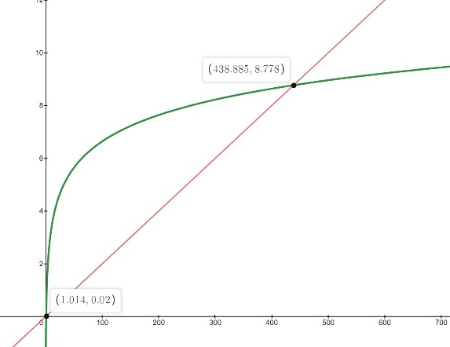
i From the graph of function we can see when n≥439,$\log_{2}{n}$ < $\frac{n}{50}$

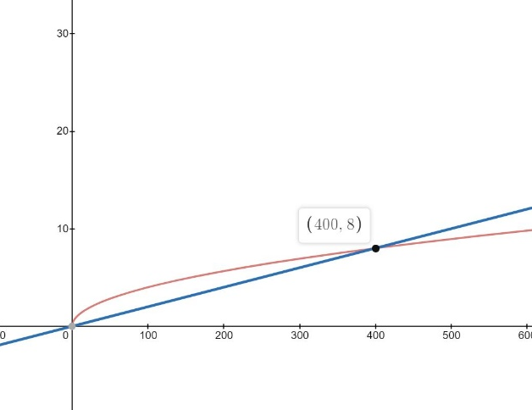
ii From the graph of function we can see when n≥401,
$\frac{2\sqrt{n}}{5}$ < $\frac{n}{50}$

iii From the graph of function we can see when n≥504,
$\log_{2}{n}<\frac{2\sqrt{n}}{5}$
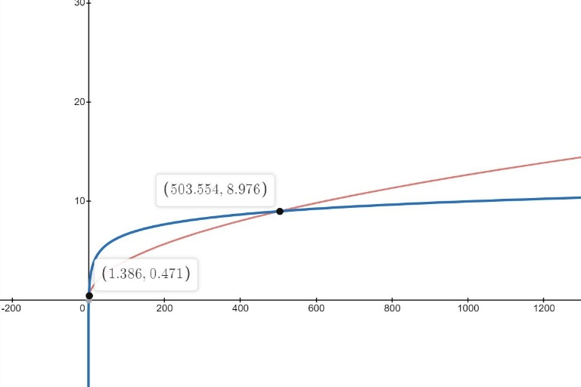

Problem 5
i Bubble Sort is more efficient when using it to detect a sorted list, when the list is already sorted, the complexity of the bubble sort is only O(n), compared to O(n²) which is the worse case.

ii According to the definition of nearly-d sorted list, any element in that list, if not sorted, should be no further than d spots from its sorted position, which means we need to make d swaps to make sure the not-sorted element at its sorted place.
Now assume that Bubble sort need to iterate d+1 times to sort a nearly-d sorted list, which means at least one element is swaped d+1 times. It is contradicted with the hypothesis it is a nearly-d sorted list. So It is the case that Bubble Sort need only pass through a nearly-d sorted list d times to ensure the list is sorted.

