CS5002 Prof. Higger
Midterm Exam
Due: Oct 14, 2020
Name: Shangjun Jiang
Start time 14:00
Finish Time 16:25

Problem 1
i
74 = 37 × 2 + 0
37 = 18 × 2 + 1
18 = 9 × 2 + 0
9 = 4 × 2 + 1
4 = 2 × 2 + 0
2 = 1 × 2 + 0
1 = 0 × 2 + 1
74 = (01001010)₂

12 = 6 × 2 + 0
6 = 3 × 2 + 0
3 = 1 × 2 + 1
1 = 0 × 2 + 1
12 = (00001100)₂
(01001010)₂ + (00001100)₂ = $\frac{\begin{matrix} 1 \\ 01001010 \\ + 00001100\end{matrix}}{ 01010110}$
= 01010100 in 8 digit unsigned binary
There is not an overflow.

ii
123 = 61 × 2 + 1
61 = 30 × 2 + 1
30= 15 × 2 + 0
15= 7 × 2 + 1
7= 3× 2 + 1
3= 1 × 2 + 1
1= 0 × 2 + 1
123 = (01111011)₂

23 = 11 × 2 + 1
11 = 5 × 2 + 1
5 = 2 × 2 + 1
2 = 1 × 2 + 0
1 = 0 × 2 + 1
23 = (00010111)₂
(01111011)₂ + (00010111)₂ = $\frac{\begin{matrix} 111111 \\ 01111011 \\ + 00010111\end{matrix}}{ 10010010}$
It is positive, thus the 8 digit two’s complement binary is 10010010.
146>127, An overflow occurred.

iii
30 = 15 × 2 + 0
15 = 7 × 2 + 1
7 = 3 × 2 + 1
3 = 1 × 2 + 1
1 = 0 × 2 + 1
30 = (00011110)₂
In two’s complement binary: -30 = 11100001+1=11100010

42 = 21 × 2 + 0
21 = 10 × 2 + 1
10 = 5 × 2 + 0
5 = 2 × 2 + 1
2 = 1 × 2 + 0
1 = 0 × 2 + 1
42 = (00101010)₂
(11100010)₂ + (00101010)₂ = $\frac{\begin{matrix} 11 1 \\ 11100010 \\ + 00101010\end{matrix}}{ 100001100}$
Discard the first ‘1’, the 7 digit two’s complement binary is 0001100.
As it mentioned, it is 7 digit binary, 12<63, There is not an overflow.
iv
240 = 15 × 16 + 0
15 = 0 × 16 + 15(F)
240 = (F0)₁₆

20 = 1 × 16 + 4
1 = 0 × 16 + 1
20 = (14)₁₆
(F0)₁₆ + (14)₁₆= $\frac{\begin{matrix} F0 \\ + 14\end{matrix}}{ 104}$ =(104)₁₆
As it mentioned, it is 2 digit hexadecimal,
However, a 2-digit hexadecimal can repreasent up to 15×16+15×1=255
255 < 260
Thus, an overflow occurred

Problem 2
i True
ii True
iii False
iv True
v True
vi False

Problem 3
i
E | S | P | V | R
T | T | T | F | T
T | T | F | F | F
T | F | T | F | T
T | F | F | F | F
F | T | T | T | F
F | T | F | F | F
F | F | T | F | F
F | F | F | F | F

ii V = ¬E ∧ S ∧ P
iii R = E ∧ P

Problem 4
i
((A ∩ A^{C}) ∪ (A ∩ (A ∪ B)))^{C}
= (∅ ∪ (A ∩ (A ∪ B)))^{C} ............Complement Laws
= (A ∩ (A ∪ B))^{C} ............Identity
= A^{C} ............Absorption Laws

ii
¬((¬P ∨ ¬Q) ∧ Q)
= ¬((¬P ∧ Q) ∨ (¬Q ∧ Q)) ............Distributive Laws
= ¬((¬P ∧ Q) ∨ F) ............Complement Laws
= ¬(¬P ∧ Q) ............Identity
= ¬(¬P) ∨ ¬Q ............DeMorgan’s Laws
= P ∨ ¬Q ............Double Negation

Problem 5
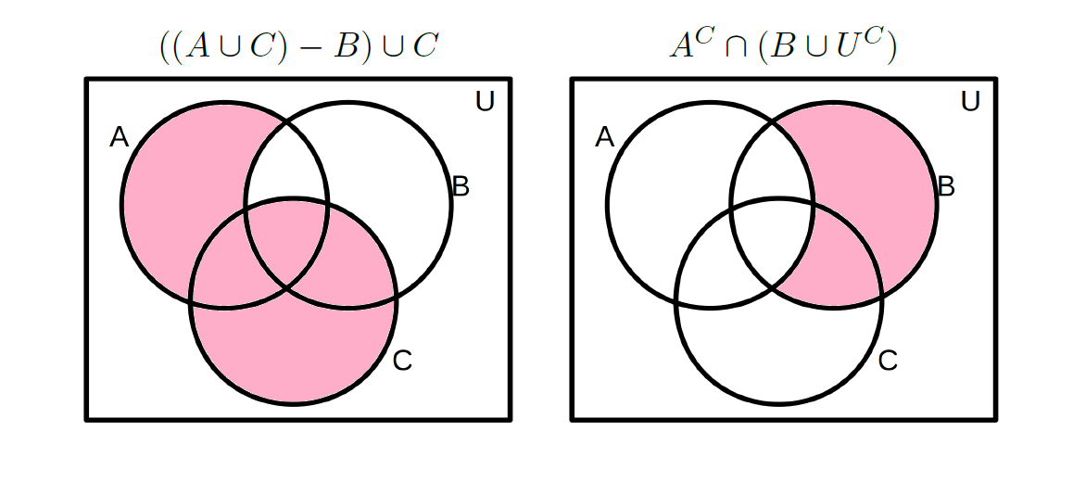
Problem 6
i [160/24] = 7 # In this document, [x] represents the cell of x.
The pigeonhole principle tells us that there are at least 7 students get the same grade.

ii This is not a pigeonhole problem.
0 other students must get the same grade as me, because I get a specific grade, I can get this grade alone, and others distributed in other grades.

Problem 7
i A ∪ B ∪ C
= |A| + |B| + |C| - |A ∩ B| - |A ∩ C| - |B ∩ C| + |A ∩ B ∩ C|
= 23 + 24 + 30 – 10 – 11 – 7 + 2
= 51

ii Shaded area
= |U| - |A ∪ B|
= |U| - (|A| + |B| - |A ∩ B|)
= 60 - (23 + 24 - 10)
= 60 – 37
= 23

iii Shaded area
= |A ∪ B ∪ C| - |C|
= 51 – 30
=21

Problem 8
i select 6 packages from 10 unique packages:
$C\left(10, 6\right)=\frac{10!}{\left(10-6\right)!×6!}=\frac{10!}{4!×6!}=210$
The delivery driver has 210 ways to deliver.

ii discard 4 packages from 10 packages
$C\left(10, 4\right)=\frac{10!}{\left(10-4\right)!×4!}=\frac{10!}{6!×4!}=210$
The dilivery driver has 210 ways to discard 4 of these packages.
Literally, dicard 4 and deliver the other 6 is just equivalent to selecting 6 to deliver.
Mathmatically, $C\left(10, 4\right)$is just equal to $C\left(10, 6\right)$.

iii P(10, 8) = $\frac{10!}{(10-8)!}=\frac{10!}{2!}$ = 10 × 9 × 8 × 7 × 6 × 5 × 4 × 3 = 1814400

iv It is an order-matter and repeatition-allow question.
10¹²⁰

v It is an order-not-matter and repetition-allow question.
n=10, k=120
$\left({k+n-1 \atop k}\right)=\frac{129!}{\left(129-120\right)!×120!}=\frac{129!}{9!×120!}$

vi Load each truck with 5 packages in advance.
Remain 120 – 5 × 10 = 70 packages
It is an order-not-matter and repetition-allow question.
n=10, k=70
$\left({k+n-1 \atop k}\right)=\frac{79!}{\left(79-70\right)!×70!}=\frac{79!}{9!×70!}$

vii Load 120 unique packages into 10 trucks evenly, which means each truck has 12 packages. So for the first truck, select 12 from 120 where order doesn’t matter and repetition not allowed. For the second truck, select 12 from 108, for the third truck, select 12 from 96...
Thus, the number of different ways equals:
C(120, 12) × C(108, 12) × C(96, 12) × C(84, 12) × C(72, 12) × C(60, 12) × C(48, 12) ×
C(36, 12) × C(24, 12) × C(12, 12)
=$\frac{120!}{108!×12!} × \frac{108!}{96!×12!} × \frac{96!}{84!×12!} ×… × \frac{24!}{12!×12!} × \frac{12!}{0!×12!}$
=$\frac{120!}{{(12!)}^{10}}$

