**Jwrap**

1. **发布时间：2006**

sourceforge项目注册时间

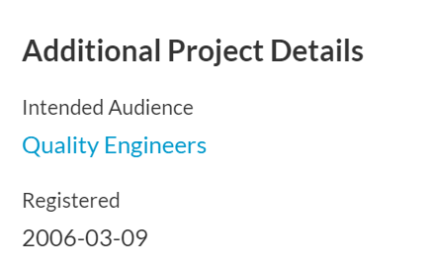

1. **工具使用形式和跨平台特性**

Desktop (GUI)

Windows平台 (VB编程，基于Excel)

1. **测试生成及其输入输出格式**
   1. **生成算法：**借助Jenny工具

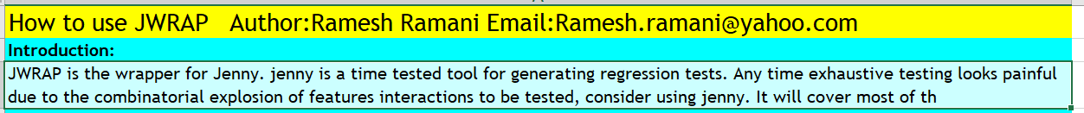

* 1. **支持维度：**1-5

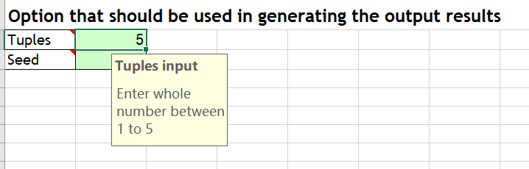

* 1. **可变力度：**No
  2. **种子：**No
  3. **约束：**Yes，禁止元组，通过颜色来标识禁止元组

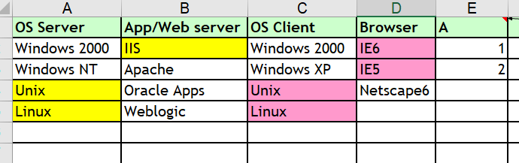

**约束检查：**加入矛盾约束，点击生成后提示

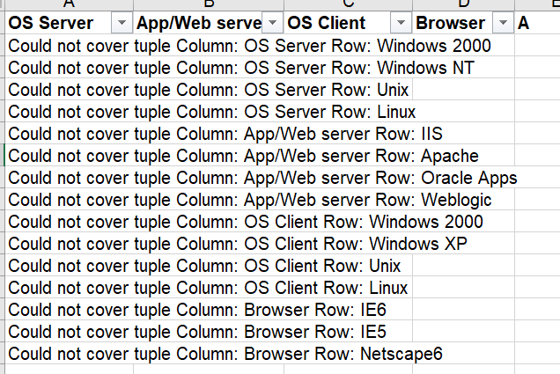

* 1. **建模语言：**Yes

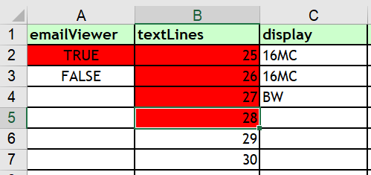

* 1. **输出格式（包括抽象测试用例、自然语言描述测试计划、代码片段等）：**

Excel

1. **其它测试活动**
   1. **测试用例优化：**No
   2. **测试执行：**No
   3. **覆盖率评估：**No
   4. **故障定位：**No
2. **额外功能** No
3. **和其它测试工具的兼容性：**No
4. **工具演化：**

7条更新记录，最早2006年，最近一次更新2009年

27-Mar-2006-Change the function copy and paste to template to avoid switching between the windows

28-Mar-2006- Changed the Tuple from 2-5 to 1-5 so that bare minimal combinations can be achived

04-May-2006-Changed the logic for creating the conditions and dimension (to fix the bug in creating the second condition for the same parameter in the next row

04-May-2006-Added the dynamic wait time mechanisam to help the slow process system to generate the output file

12-june-2006-Removed the color coding in the result screen as it is confusing the users

10-Jan-2007- Changed the array size of color array to 50 from 15 to accommodate more conditions, also changed the for loop to run for all the combinations to find duplicate values

06-jan-2009- fixed some of the minor bug fixes in selecting multiple colors