**Covering_Arrays**

1. **发布时间：2018**

github最早commit时间

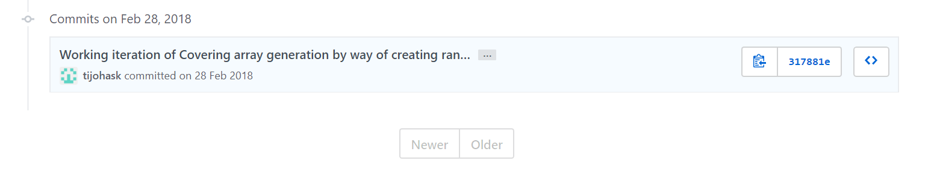

1. **工具使用形式和跨平台特性**

Desktop (CLI) 直接运行py文件

跨平台 (python)

1. **测试生成及其输入输出格式**
   1. **生成算法：**一次一条贪心，和爬山算法

代码片段 一次一条贪心

#Uses a greedy algorithm to make a covering array.

#Adds the first row that would give the most new interactions to the array, does this until the array is filled.

def greedy_generation(full, k_level, num_inter):

爬山算法

#Recursively improve the CA by finding the rows that can be removed

#and removing them.

def hill_climbing(pre_hill, k_level, num_inter, step):

* 1. **支持维度：**1-n

First argument is the number of interactions you want your covering array to have Expected to be a single positive integer that is **greater than 1 and less than the size of the argument array** (below)

* 1. **可变力度：**No
  2. **种子：**No
  3. **约束：**No
  4. **建模语言：**No

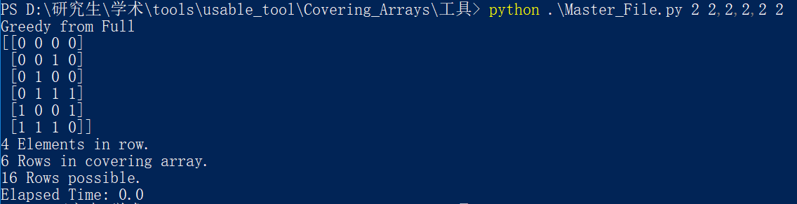

* 1. **输出格式（包括抽象测试用例、自然语言描述测试计划、代码片段等）：**

No

1. **其它测试活动**
   1. **测试用例优化：**No
   2. **测试执行：**No
   3. **覆盖率评估：**No
   4. **故障定位：**No
2. **额外功能**
3. **和其它测试工具的兼容性：**No
4. **工具演化：**

最早commit时间2018，最近commit时间2018，总计33条commit记录