**Jenny**

1. **发布时间：2003**

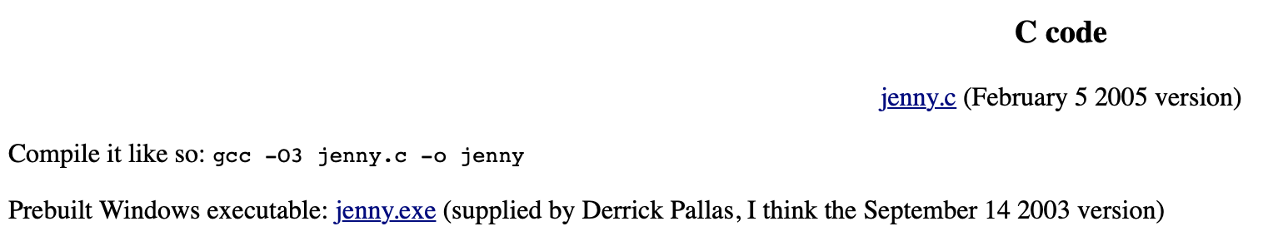

1. **工具使用形式和跨平台特性**

Desktop (GUI)

Cross (提供exe版本以及源代码)

1. **测试生成及其输入输出格式**
   1. **生成算法：Greedy (OTAT)**

jenny first covers single features, then pairs of features, then triples, and so forth up to the n-tuples requested by the user. Each pass checks whether the existing tests cover all tuples, and if not, make a list of uncovered tuples and add more tests until all tuples are covered

* 1. **支持维度：**1-32

-n gives the n in n-tuples. It must be a number between 1 and 32.

* 1. **可变力度：**No
  2. **种子：**Yes

-o is for old testcases. For example, -ofoo.txt will read old testcases from the file foo.txt. It will include those testcases first in the output, then append new testcases as required.

* 1. **约束：**Yes，禁止元组

-w gives a restriction, a "without". -w1a2bc5d means that the combination of the first dimension's first feature (1a), the second dimension's second or third feature (2bc), and the fifth dimension's fourth feature (5d) is disallowed. The position of withouts is irrelevant.

**约束检查：**Yes, 加入矛盾约束，点击生成后提示

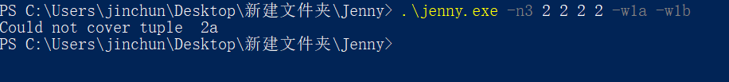

* 1. **建模语言：**No，仅通过命令行参数提供信息，参数个数最多52个 [a-z A-Z]

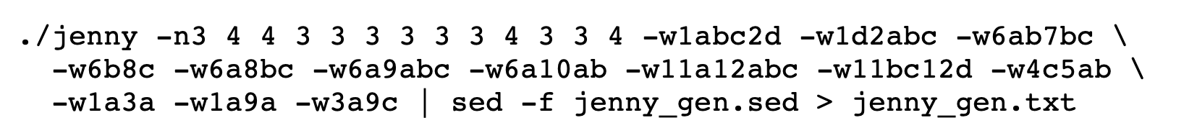

* 1. **输出格式（包括抽象测试用例、自然语言描述测试计划、代码片段等）：**

No (命令行标准输出)

1. **其它测试活动**
   1. **测试用例优化：**No
   2. **测试执行：**No
   3. **覆盖率评估：**No
   4. **故障定位：**No
2. **额外功能** No
3. **和其它测试工具的兼容性：**No
4. **工具演化：**

2003到2005年，4次更新历史

