Activation Functions in Neural Networks

Metadata
Created at: 2026-03-29 07:15:22
Video ID: 7LcUkgzx3AY

Notes

Activation Functions in Neural Networks

Overview of Activation Functions
- Activation functions (also called **transfer functions**) are core components of artificial neural networks.
- In an artificial neuron:
- Compute weighted sum + bias:
$$z = \sum_i w_i x_i + b$$
- Pass $z$ through an activation function $g(\cdot)$:
$$a = g(z)$$
- $g(\cdot)$ acts as a **mathematical gate** between:
- Net input $z$ (weighted sum + bias).
- Final output $a = g(z)$ passed to the next layer.
- The activation function decides:
- Whether a neuron will be “activated” or not.
- If activated, **how strongly** it responds.

Computation Inside a Neuron (Forward Pass)
- Scalar form for one neuron:
- Net input:
$$z = \sum_i w_i x_i + b$$
- Activation:
$$a = g(z)$$
- Layer-wise notation (clarification):
- $a^{(l)}$ denotes the **activations of layer $l$**.
- $z^{(l)}$ denotes the **pre-activations** (weighted sum + bias) of layer $l$.
- Vector/matrix form for a layer:
- Inputs: $\mathbf{x}$, weights: $W$, biases: $\mathbf{b}$.
- Net input and activation:
$$
\mathbf{z} = W\mathbf{x} + \mathbf{b}, \quad
\mathbf{a} = g(\mathbf{z})
$$

---

Need for Activation Functions

Linear vs Non-Linear Behavior (Conceptual)
- If **no activation function** is used, or $g$ is **linear** (e.g., identity $g(z) = z$):
- Each layer performs an affine transformation:
$$\mathbf{y} = W\mathbf{x} + \mathbf{b}$$
- Composition of affine transformations is still affine.
- The full network behaves like a **linear model**:
- With a linear output: like **linear regression**.
- With a sigmoid output: like **logistic regression**.
- It **cannot capture non-linear patterns** or non-linearly separable data.
- If a **non-linear activation function** is used in hidden layers (e.g., sigmoid, $\tanh$, ReLU):
- Overall input–output relationship becomes **non-linear**.
- The network can model **non-linearly separable** data and complex decision boundaries.
- This is what the instructor calls **“non-linear pattern / non-linear editing capture power”**.

Explicit Scalar Derivation (Mirroring Transcript Style)
- Consider a small feedforward network (one hidden layer, identity activations) with scalar inputs:
- Inputs: $x_1, x_2$.
- Hidden neuron:
- Weights: $w_{11}, w_{12}$, bias: $b_1$.
- Pre-activation:
$$z_1 = w_{11} x_1 + w_{12} x_2 + b_1$$
- Activation (identity $g(z) = z$):
$$a_1 = g(z_1) = z_1$$
- Output neuron:
- Weights: $w_{21}$, bias: $b_2$.
- Output (again identity for illustration):
$$y = w_{21} a_1 + b_2$$
- Substitute $a_1$:
$$
y = w_{21} (w_{11} x_1 + w_{12} x_2 + b_1) + b_2
$$
$$
y = (w_{21} w_{11}) x_1 + (w_{21} w_{12}) x_2 + (w_{21} b_1 + b_2)
$$
- This is a **first-degree polynomial** (degree 1) in $(x_1, x_2)$:
- A simple **linear relationship** between input and output.
- Matches the instructor’s statement: input–output relation is **linear (degree-1 polynomial)** when hidden layers are linear.

General Matrix Derivation: Linear Network Collapses to Linear Map
- Consider a feedforward network with:
- Input $\mathbf{x}$.
- Hidden layer with linear activation (identity).
- Output layer with linear activation (identity).
- Let:
- Hidden layer: weights $W_1$, biases $\mathbf{b}_1$.
- Output layer: weights $W_2$, biases $\mathbf{b}_2$.
- Forward propagation:
- Hidden activations (identity activation $g(z) = z$):
$$
\mathbf{a}^{(1)} = W_1 \mathbf{x} + \mathbf{b}_1
$$
- Output:
$$
\mathbf{a}^{(2)} = W_2 \mathbf{a}^{(1)} + \mathbf{b}_2
$$
- Substitute:
$$
\mathbf{a}^{(2)} = W_2 (W_1 \mathbf{x} + \mathbf{b}_1) + \mathbf{b}_2
$$
$$
\mathbf{a}^{(2)} = (W_2 W_1)\mathbf{x} + (W_2 \mathbf{b}_1 + \mathbf{b}_2)
$$
- Again a single affine transformation:
$$
\mathbf{a}^{(2)} = W' \mathbf{x} + \mathbf{b}', \quad
W' = W_2 W_1, \ \mathbf{b}' = W_2 \mathbf{b}_1 + \mathbf{b}_2
$$
- Conclusion:
- Stacking linear layers **without non-linear activations** is equivalent to **one linear layer**.
- With a linear output → behaves like **linear regression**.
- With a sigmoid output → behaves like **logistic regression**.

Concrete Experimental Illustration (2D Non-Linear Data)
- Dataset:
- 2D data that is **non-linearly separable** (no single straight line can separate the classes).
- Model 1 (all-linear hidden layers):
- Two hidden layers with 128 neurons each.
- Hidden activations: **linear** (identity; effectively no activation).
- Output layer: 1 neuron with **sigmoid** activation.
- Behavior after training (as described):
- Decision boundary is essentially a **single straight line**.
- Despite multiple layers, the model behaves like a **logistic regression** classifier:
- Because hidden layers collapse into one affine transformation.
- Model 2 (non-linear hidden activations):
- Same architecture, but hidden layers use **ReLU** activation.
- Output layer: 1 neuron with **sigmoid** activation.
- Behavior after training:
- Learns **complex, non-linear** decision boundaries.
- Correctly captures the **non-linearly separable** structure of the data.
- Takeaways:
- In this specific experiment: linear hidden layers + sigmoid output $\Rightarrow$ behavior like **logistic regression**.
- In general: without non-linear activations, any deep ANN collapses to a **single affine map** and cannot capture non-linear data.

---

Desirable Properties of an “Ideal” Activation Function

1. Non-Linearity
- Requirement:
- Activation function $g(x)$ should be **non-linear**.
- Relationship between input and output should **not** be globally of the form $ax + b$.
- Reason (as per instructor):
- Non-linear activation adds **non-linear data capture power** to the network.
- Enables capturing **non-linear patterns/relationships** in data.
- Related concept explicitly mentioned:
- **Universal Approximation** idea:
- With a **non-linear activation function** and **enough neurons/hidden units**, a network can capture **any non-linear relationship** (universal approximation theorem intuition).

2. Differentiability (Important but Not Strictly Mandatory)
- Preferred property:
- $g(x)$ should be **differentiable**:
- We can compute $\frac{dg(x)}{dx}$ (or $\frac{\partial g}{\partial x}$) at all relevant points.
- Reason (lecture context):
- Training uses **gradient descent** and **backpropagation**.
- These algorithms:
- Rely on **derivatives of activation functions** to update weights.
- If $g$ is not differentiable, standard gradient descent cannot be applied directly.
- Nuance emphasized:
- Differentiability is **important** but **not strictly mandatory**.
- Example given: **ReLU**:
- Not differentiable at $x = 0$.
- Still widely used in practice.
- Frameworks handle the non-differentiable point with a convention; training still works.

3. Computational Efficiency
- Desired property:
- Activation $g(x)$ and its derivative $g'(x)$ should be:
- **Simple to compute**.
- **Fast** to evaluate.
- Reason:
- Activations and derivatives are computed repeatedly during training.
- If computation is expensive:
- Overall training becomes **slow**.
- Hence:
- Prefer **computationally inexpensive** functions (e.g., simple algebraic / piecewise forms).

4. Zero-Centered / Mean-Near-Zero Outputs
- Desired property:
- Activations should be **zero-centered** or have **mean approximately 0**.
- That is, outputs of $g(x)$ over typical inputs are centered around $0$.
- Reason (as stated):
- If outputs/activations are around **zero mean**, then:
- Inputs to subsequent layers are more “balanced”.
- Training tends to **converge faster**.
- Example explicitly mentioned:
- **$\tanh$ activation**:
- Output range: $(-1, 1)$.
- Can produce **zero-centered activations**.
- Instructor’s emphasis:
- When data (and thus activations) are more **normal / centered**, convergence is usually **faster**.
- The key requirement is **mean near zero** (not necessarily strictly Gaussian-shaped).

5. Non-Saturating Behavior
- Definition (lecture framing):
- **Saturating activation functions**:
- “Squeeze” inputs into a **fixed, bounded interval**.
- Examples:
- Sigmoid: outputs in $(0,1)$.
- $\tanh$: outputs in $(-1,1)$.
- **Non-saturating activation functions**:
- Do **not** compress inputs into a narrow fixed range.
- Example: **ReLU**, which is unbounded on the positive side.
- Reason (as stated in the segment):
- Saturating functions (e.g., sigmoid, $\tanh$):
- Create issues like **vanishing gradient problems** during backpropagation.
- Especially when outputs are squeezed into small intervals (e.g., $(0,1)$, $(-1,1)$).
- Non-saturating functions:
- Operate over a **wider range**.
- Help avoid/mitigate **vanishing gradient** issues.
- Key point:
- When choosing an activation function, prefer one that is **non-saturating in nature** so that it does **not squash inputs into a tiny range**.

---

Saturating vs Non-Saturating Activation Functions

Saturating Activation Functions (As in Lecture)
- Concept:
- Functions that **squeeze** their input values into a **fixed, bounded range**.
- When input is very large (positive or negative), output:
- Becomes **almost constant** within that range.
- Examples (from transcript):
- **Sigmoid**:
- Any input is mapped to the interval $(0, 1)$.
- **$\tanh$**:
- Any input is mapped to the interval $(-1, 1)$.
- Consequence (as discussed):
- These functions are called **saturating functions**.
- In saturated regions:
- Backpropagation experiences **vanishing gradient problems**.
- Gradients get smaller as they propagate backwards, leading to:
- **Very small updates** to earlier-layer weights.
- Training may effectively **stall** (“weights will not update”).

Non-Saturating Activation Functions (As in Lecture)
- Concept:
- Functions that **do not squash** inputs into a narrow fixed interval.
- Maintain useful behavior over a **larger input range**.
- Example:
- **ReLU** (Rectified Linear Unit):
- Defined as:
$$\text{ReLU}(x) = \max(0, x)$$
- For $x > 0$, outputs can grow without being clamped to a small interval.
- Therefore, considered **non-saturating** (on the positive side).
- Practical implication (as per instructor):
- With ReLU and similar non-saturating functions:
- **Vanishing gradient** problem is much less severe.
- Training of deeper networks is more feasible.

Supplemental Mathematical Details (Standard, Not Fully Spelled Out in Transcript)
- Sigmoid:
- Function:
$$
\sigma(x) = \frac{1}{1 + e^{-x}}
$$
- Derivative:
$$
\sigma'(x) = \sigma(x) \bigl(1 - \sigma(x)\bigr)
$$
- Hyperbolic tangent:
- Function:
$$
\tanh(x) = \frac{e^{x} - e^{-x}}{e^{x} + e^{-x}}
$$
- Derivative:
$$
\tanh'(x) = 1 - \tanh^2(x)
$$
- ReLU:
- Function:
$$
\text{ReLU}(x) = \max(0, x)
$$
- Derivative (almost everywhere):
$$
\frac{d}{dx}\text{ReLU}(x) =
\begin{cases}
0, & x < 0 \\
1, & x > 0
\end{cases}
$$
(not defined at $x=0$; handled by convention in practice).
- These formulas are **standard** and help understand:
- Why sigmoid/$\tanh$ have **small derivatives** in tails (saturation).
- Why ReLU has a **constant derivative 1** on $x>0$ (non-saturating region).

---

Sigmoid Activation Function (As Introduced Here)

Definition and Basic Properties
- Sigmoid (logistic) activation function:
$$
\sigma(x) = \frac{1}{1 + e^{-x}}
$$
- Range and limits (as described with the graph):
- Output range: $(0, 1)$.
- For very large positive $x$:
- $\sigma(x) \approx 1$.
- For very large negative $x$:
- $\sigma(x) \approx 0$.
- At $x = 0$:
- $\sigma(0) = 0.5$.
- Graph (qualitative description):
- S-shaped, monotonically increasing curve.
- Steepest near $x = 0$.
- Flattens near 0 and 1 at extremes.

Derivative Behavior (Qualitative, Per Slides)
- The derivative curve (shown in lecture):
- Maximum derivative at $x = 0$:
- Approximately $0.25$ (peak of the derivative curve).
- For $\lvert x \rvert$ large:
- Derivative $\approx 0$.
- Non-negligible derivative mainly in a central band (roughly between some negative and positive value).
- Interpretation:
- Sigmoid is **most sensitive** near $x = 0$.
- In the far tails:
- Gradient becomes very small.
- Contributes to **vanishing gradient** when stacked across many layers.

Advantages Highlighted
- Output in $(0,1)$:
- Can be interpreted as a **probability** (e.g., probability of class “1”).
- Use in binary classification (as mentioned):
- **Output layer** activation for **binary classification problems**:
- Example scenario: predicting **Yes/No** decisions.
- Output close to 1 → likely “Yes”.
- Output close to 0 → likely “No”.
- Non-linear:
- Provides **non-linear decision boundaries** when used in hidden layers.
- Differentiable:
- Smooth and differentiable for all real $x$ (helpful for gradient-based training).

Disadvantages (Implied / Connected to Earlier Discussion)
- Saturating:
- Squashes inputs into the range $(0,1)$.
- In extreme regions:
- Output is almost constant.
- Derivative is very small.
- Leads to **vanishing gradient** issues in deep networks.
- Not zero-centered:
- Outputs are strictly positive $(0,1)$.
- Mean activation is **not around 0**.
- This can **slow convergence** compared to zero-centered activations (like $\tanh$).

---

Tanh and ReLU (As Mentioned in This Segment)

Hyperbolic Tangent ($\tanh$)
- Activation function (standard formula):
$$
\tanh(x) = \frac{e^{x} - e^{-x}}{e^{x} + e^{-x}}
$$
- Properties emphasized:
- Output range: $(-1, 1)$.
- **Zero-centered**:
- Can have activations with mean near 0.
- Role in this lecture:
- Example of an activation whose outputs can be **zero-centered**.
- Also an example of a **saturating** activation (since it maps to $(-1,1)$), so:
- Can contribute to **vanishing gradient** problems similar to sigmoid.

ReLU (Rectified Linear Unit)
- Activation function (standard formula):
$$
\text{ReLU}(x) = \max(0, x)
$$
- Key properties emphasized:
- **Non-linear**.
- **Non-saturating** for $x > 0$:
- Outputs can grow without being squashed into a small interval.
- Not differentiable at $x=0$, yet:
- Still widely used in practice (supports the point that strict differentiability is not mandatory).
- Role in this lecture:
- Used in the experimental example:
- ReLU in hidden layers enabled learning **non-linear decision boundaries**.
- Given as a primary example of a **non-saturating** activation function.

---

Ideal Activation Function Summary (From This Lecture)

Consolidated List of Five Properties
- An “ideal” activation function (as described here) should:
1. **Be non-linear**:
- So the network has **non-linear data capture power**.
- Supports the **universal approximation** idea: with enough neurons and non-linear activation, can approximate complex non-linear relationships.
2. **Be differentiable** (or almost everywhere differentiable):
- So gradients can be computed for backpropagation and gradient descent.
- Minor non-differentiable points (e.g., ReLU at 0) are acceptable.
3. **Be computationally inexpensive**:
- So forward $g(x)$ and backward $g'(x)$ computations are fast.
4. **Produce zero-centered / mean-near-zero outputs**:
- Activations should have mean approximately 0 (zero-centered), which:
- Helps make the input to each layer more “normal/centered”.
- Typically leads to **faster convergence**.
- Example: $\tanh$ with range $(-1,1)$.
5. **Be non-saturating**:
- Should not squeeze inputs into a narrow bounded range with flat extremes.
- Helps avoid **vanishing gradient** problems.
- Example: ReLU (non-saturating on $x>0$).

---

Scope Note (Adjusted to This Segment)

- These notes are based on the provided transcript segment and include:
- Definitions and roles of activation functions.
- The conceptual and algebraic demonstration that purely linear networks collapse to a single **linear/affine** model.
- The **five ideal properties** of activation functions as listed by the instructor.
- Discussion of:
- **Saturating vs non-saturating** functions.
- Examples: sigmoid, $\tanh$, ReLU.
- Mention of the **universal approximation** idea.
- Some explicit formulas and derivative expressions (for sigmoid, $\tanh$, ReLU) are:
- **Standard supplemental details**.
- Included for mathematical clarity, even when not fully written out in the transcript.
- More advanced topics (e.g., full formal backpropagation derivations beyond what was verbally hinted) are **not expanded here**, to keep alignment with the content and level of the given lecture segment.

Key images
Slide on activation functions with diagram and equation (at 51s)
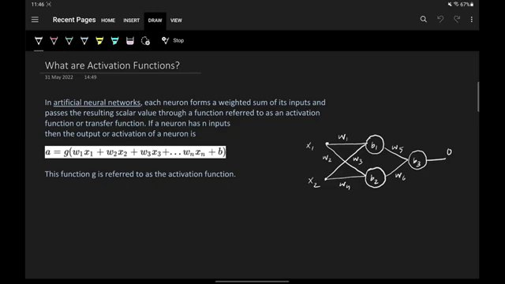

Partial equation and notes on activation functions (at 170s)
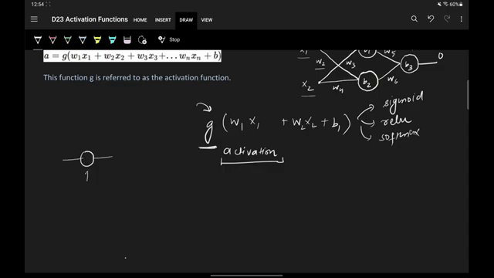

Wikipedia page on activation functions (at 212s)
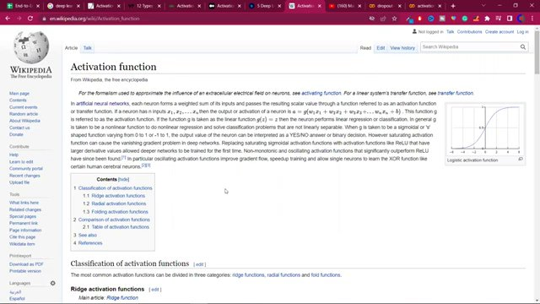

Scatter plot showing data points (at 310s)
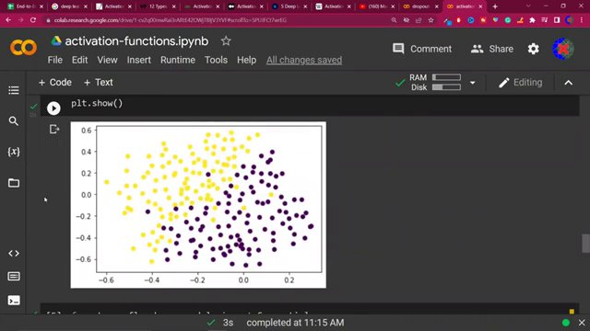

Code snippet for neural network model (at 323s)
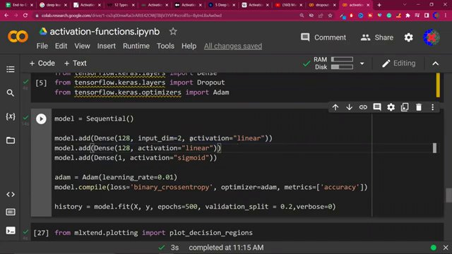

Decision boundary plot with data points (at 346s)
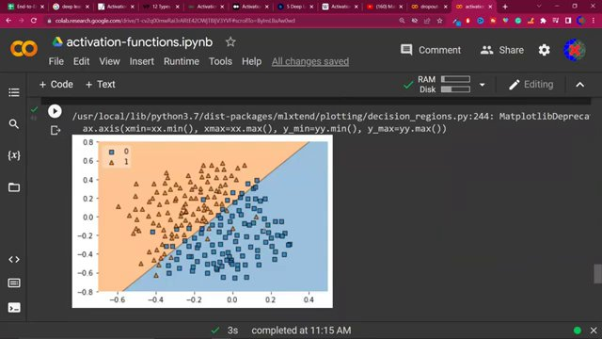

Sequential model code snippet with activation functions (at 364s)
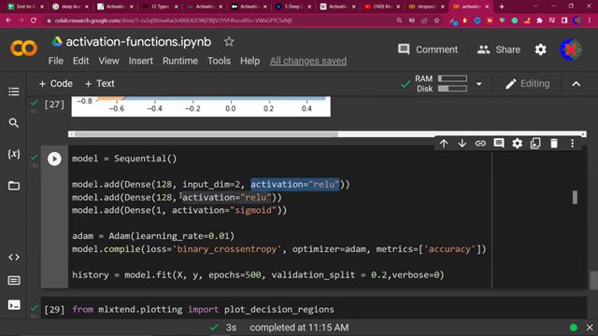

Code snippet for plotting decision regions (at 383s)
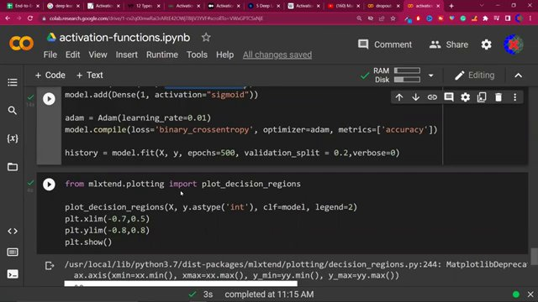

Diagram illustrating activation functions (at 403s)
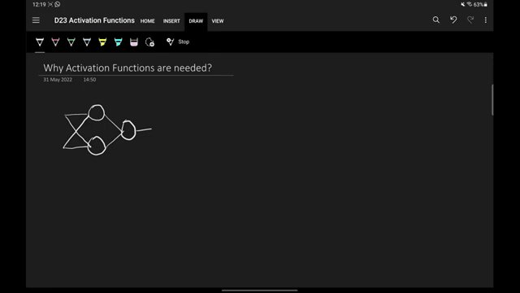

Partial equations and diagram on activation functions (at 505s)
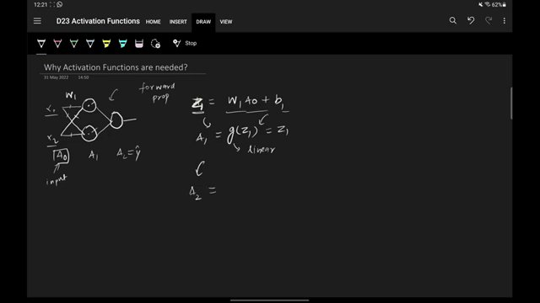

More complete equations on activation functions (at 554s)
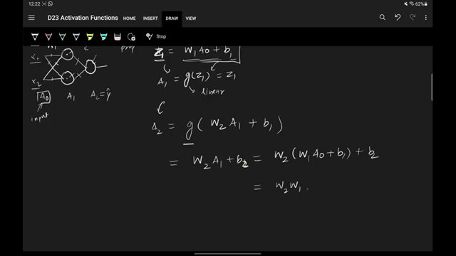

Equations with additional graph (at 605s)
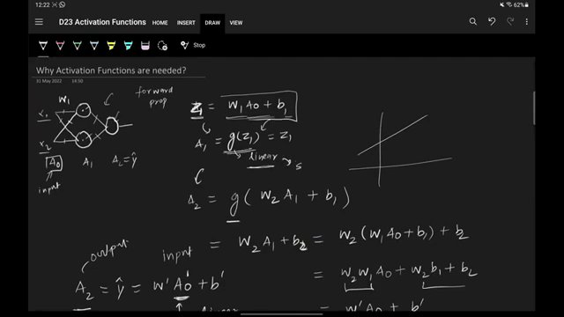

Detailed equations with graph and annotations (at 630s)
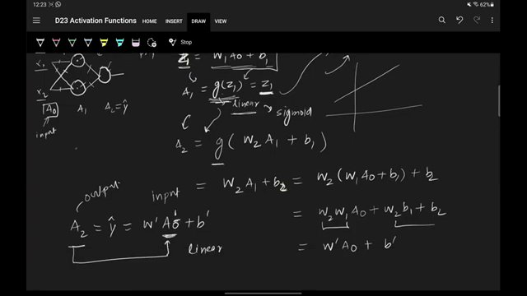

Complete equations with graph and sigmoid function (at 646s)
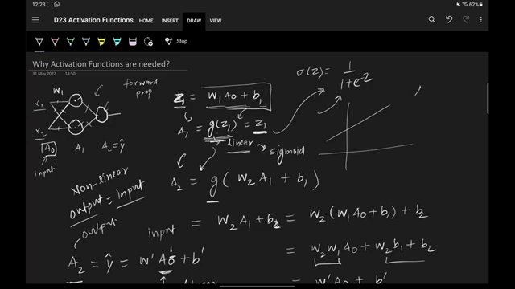

Detailed notes on activation functions with diagram (at 864s)
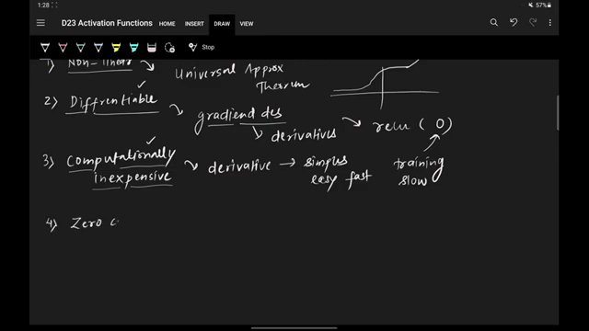

Continuation of notes on zero-centered activation functions (at 978s)
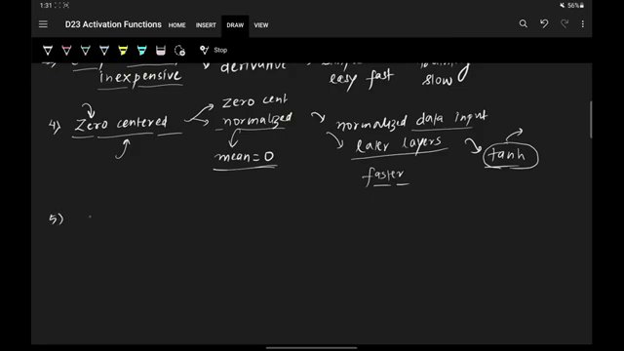

Complete notes on non-saturating activation functions (at 1036s)
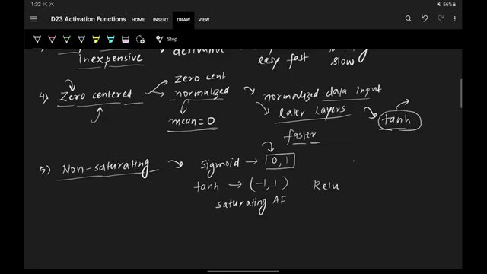

Graphs of sigmoid activation function (at 1126s)
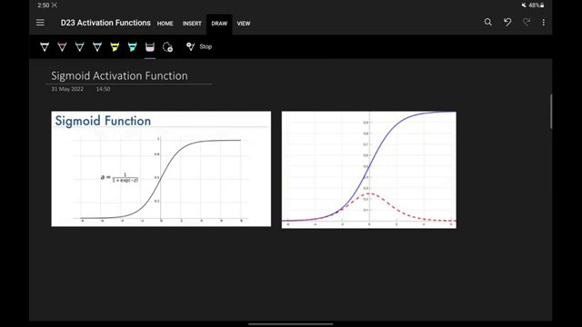

Equation for sigmoid function with partial notes (at 1239s)
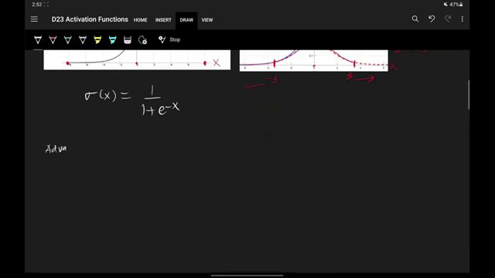

Sigmoid function graphs and equation (at 1314s)
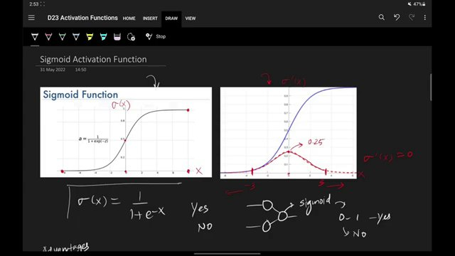

Advantages of sigmoid function (at 1321s)
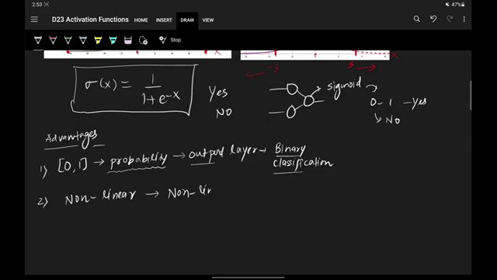

Complete advantages of sigmoid function (at 1365s)
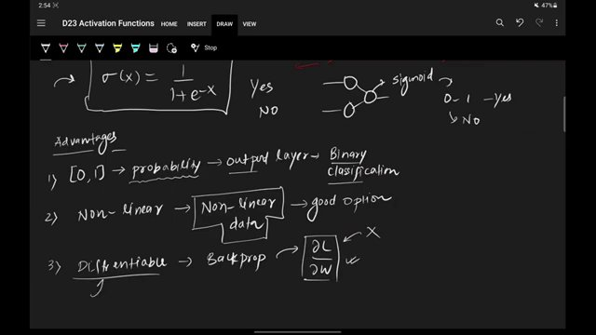

Disadvantages of sigmoid function (at 1405s)
