Dropout (“Drafts/Droplets”) for Overfitting in Neural Networks

Metadata
Created at: 2026-03-29 11:07:43
Video ID: gyTlcHVeBjM

Notes

Dropout (“Drafts/Droplets”) for Overfitting in Neural Networks

Intro and Context
- Focus: Dropout (called “drafts/droplets” in the transcript) as a method to reduce overfitting in deep neural networks.
- Objectives:
- Define overfitting and why it is severe in neural networks.
- List main strategies to reduce overfitting.
- Explain what dropout does at the level of neurons/layers.
- Use the specific 5–5–1 example network with dropout $p = 0.5$.
- Convey the idea that each training point sees a slightly different architecture.
- Context within a broader “toolbox”:
- Techniques already covered in the course:
- Early stopping.
- Input normalization.
- Classical regularization (L1/L2) in standard ML models.
- Dropout is introduced as a comparatively recent technique, widely used now for training neural networks.

Overfitting in Machine Learning and Neural Networks

What is Overfitting?
- A model is overfitting when:
- It “remembers” the training data too precisely.
- Training performance is very high (almost no mistakes).
- Performance on new/unseen data (test/validation) is poor.
- Intuition from the lecture:
- The model has “stored” the training data inside itself.
- It fits:
- True patterns in the data, plus
- Noise, outliers, and accidental patterns of the training set.

Geometric Illustration: Blue vs Red Classification
- Setup:
- Binary classification between blue and red points.
- Goal: Learn a decision boundary separating them.
- Overfitted decision boundary (green curve):
- Boundary has many twists and turns.
- Tries to avoid even a single mistake on the training set.
- Follows each individual point too closely.
- If some training points are removed and replaced with new ones:
- The complex boundary gives poor predictions.
- Indicates memorization instead of generalization.
- Better decision boundary (black curve/surface):
- Smoother, simpler surface between classes.
- Does not insist on zero training error.
- Captures the “real” separation pattern.
- Performs better on new data.

Why Neural Networks Are Prone to Overfitting
- Typical neural network properties:
- Multiple hidden layers (deep networks).
- Many neurons per layer.
- Fully connected layers → many weights and connections.
- Consequences:
- Very high capacity to represent complex functions and tiny patterns.
- Many possible internal “arrangements” (combinations of neuron activations and weights).
- The network can:
- Capture extremely fine-grained patterns.
- Start fitting small, insignificant details of the training set.
- Overfitting pattern described in the lecture:
- Network begins to focus on very specific, small patterns.
- Tries to capture every small irregularity.
- This leads to strong overfitting, especially when:
- The architecture is complex.
- Training is prolonged without control.

General Strategies to Reduce Overfitting

Strategy 1: Add More Data
- Increasing dataset size:
- Reduces the chance that the model simply memorizes examples.
- Encourages learning robust patterns that hold across many samples.
- More and more diverse data:
- Helps the model generalize.
- Reduces overfitting probability.

Strategy 2: Reduce Network Complexity
- Reduce model capacity directly:
- Fewer hidden layers (e.g., use 7 instead of 10).
- Fewer neurons per layer (e.g., 64 instead of 128).
- Effects:
- Fewer neurons → fewer connections/weights.
- Fewer connections → fewer ways to model tiny, noisy patterns.
- Overfitting chance decreases when the model is “smaller”.

Strategy 3: Early Stopping
- Idea:
- Detect when overfitting starts during training.
- Stop training at that point.
- Use:
- Track training vs validation behavior.
- Once validation performance starts degrading while training performance improves:
- Terminate training.
- Already covered in previous course videos.

Strategy 4: Classical Regularization (L1/L2) in ML Models
- Mentioned as “Technique 14” in the broader course context.
- Typical use:
- In traditional models (e.g., regression, logistic regression, classical ML classifiers).
- Effect:
- Adds a penalty to large weights.
- Makes the model less complex and less prone to overfitting.
- The instructor states:
- These regularization ideas carry over conceptually to neural networks.
- Detailed neural-network-specific treatment is deferred to a later video.

Strategy 5: Control Specialization of Neurons
- From the overfitting discussion:
- Overfitting arises when:
- The network has many nodes and connections.
- It can focus on very specific small patterns.
- Two ways to combat this:
1. Reduce the number of neurons and thus the number of connections.
2. Change training so that neurons do not focus excessively on a single pattern.
- Desired behavior:
- Neurons should not concentrate only on “one kind of pattern”.
- Neurons should distribute their attention more evenly across multiple input patterns.
- The model should:
- Avoid over-reacting to tiny details.
- Focus more on the overall structure of the data.

Dropout (“Drafts/Droplets”): Concept and Setup

Origin and Role
- Dropout (“draft”/“droplets” in transcript) is:
- A relatively recent technique in deep learning.
- Widely used for reducing overfitting in neural networks.
- According to the lecture:
- Introduced (or popularized) by Srivastava and collaborators.
- After its introduction, it became very famous and standard in deep learning training pipelines.
- Position in the “toolkit”:
- Another method alongside:
- Early stopping.
- Input normalization.
- Classical regularization.
- Especially targeted at overfitting in deep neural networks.

Example Network Architecture
- Example classification task:
- Binary classification (output is 0/1).
- Input has 5 columns (features).
- Neural network architecture:
- Input layer: 5 input nodes (one per feature).
- Hidden layer 1: 5 neurons.
- Hidden layer 2: 5 neurons.
- Output layer: 1 neuron (for binary output).
- All layers are fully connected.
- This is the running example used to explain dropout behavior.

Dropout Rate per Layer
- For dropout, the instructor chooses:
- A dropout probability $p = 0.5$ for:
- The input layer.
- The first hidden layer.
- The second hidden layer.
- Meaning of $p = 0.5$:
- For each training example and for each of these layers:
- Approximately $50\%$ of the neurons in that layer are randomly “dropped” (turned off).
- Each layer can have its own dropout probability $p$:
- In the lecture example, all three layers use $p = 0.5$ for simplicity.

Dropout Mechanism: Per-Example Network Thinning

What “Dropping” a Neuron Means
- For a given training example (or “point”) and a given layer:
- Some neurons are randomly selected to be dropped.
- When a neuron is dropped:
- It is “turned off” for that example.
- Its output is effectively $0$.
- It has no connections to the next layer for that pass.
- All incoming and outgoing connections for that neuron are ignored during that forward/backward pass.
- The neuron is temporarily removed from the network for that example.

Per-Example Random Masks
- Each data point uses a new random dropout pattern:
- Example “Point 1”:
- Input layer: some 5 inputs; e.g., 2 are dropped, 3 remain.
- Hidden layer 1: e.g., 3 neurons dropped, 2 remain.
- Hidden layer 2: e.g., 2 neurons dropped, 3 remain.
- The remaining active neurons form a smaller effective network used to train on Point 1.
- Example “Point 2”:
- A new random subset is dropped in each dropout-enabled layer.
- The pattern of which neurons are active is different from Point 1.
- Key lecture statement:
- “हर पॉइंट के पहले decide करो randomly कौन सा node रहेगा, कौन सा node नहीं रहेगा”
- For every data point, you decide randomly which neurons will stay and which will not.
- So for each training example, you are effectively:
- Training on a slightly different neural network architecture.

Multiple Implicit Networks During Training
- Because dropout changes the architecture per example:
- For the first training example:
- You can think of one particular sub-network being trained.
- For the second training example:
- A slightly different sub-network is trained (different dropped neurons).
- For the third example:
- Yet another slightly different sub-network, and so on.
- Instructor’s description:
- “You are training on 10 different neural networks” (as an informal way to say “many different networks”).
- The architecture is changing slightly per example because:
- Different neurons and connections are active or dropped.
- Important conceptual summary:
- Dropout makes the effective network architecture:
- Dynamic and random from example to example.
- You can view training as happening over many slightly different networks that share parameters.

How Dropout Reduces Overfitting

Effect 1: Reduced Number of Active Neurons per Pass
- With $p = 0.5$:
- On average, half of the neurons in each dropout-enabled layer are inactive on any given training example.
- Impact on capacity:
- For that example, the network is smaller:
- Fewer neurons.
- Fewer active connections.
- This is similar in spirit to reducing the number of nodes (as discussed earlier as a general strategy).
- Overfitting reduction:
- Fewer active neurons per example:
- Reduces the network’s ability to fit tiny, highly specific patterns in that example.
- Limits memorization strength per forward/backward pass.

Effect 2: Forcing Balanced Use of Inputs (Avoiding Single-Pattern Focus)
- Consider a single neuron in some hidden layer:
- It takes inputs from several neurons in the previous layer.
- Each connection has a weight.
- Without dropout:
- The neuron might start relying mainly on one particular input:
- Example:
- One weight becomes very large.
- Other weights remain small.
- The neuron focuses heavily on a single pattern or feature.
- With dropout:
- The previously dominant input neuron may be dropped in many forward passes:
- Sometimes that specific input is not available at all.
- The neuron cannot assume that “this important input” will always be present.
- It must:
- Learn to extract useful information from other inputs too.
- Spread its attention across multiple input neurons.
- As a result:
- Weights become more balanced across all inputs.
- The neuron no longer over-focuses on a single pattern.
- Dependence on any one neuron/feature is reduced.

Combined Effect: Less Sensitivity to Small Variations
- Dropout enforces:
- Reduction in the number of active nodes per training example.
- Reduction in extreme specialization to a single input or a tiny pattern.
- The network becomes:
- Less reactive to minor fluctuations or very small patterns.
- More focused on bigger, overall patterns in the data (the general “shape” of the relationship).
- Instructor’s interpretation:
- “छोटे-छोटे changes के लिए insensitive हो जाता है, बड़ी चीज़ों पर focus करता है”
- The architecture becomes more “brilliant”:
- Ignores small, noisy fluctuations.
- Captures robust, overall structures in the data.

Intuitive “Company” Analogy (From Lecture)
- Company analogy:
- A company has many employees with different roles (testing, marketing, etc.).
- New policy:
- Each morning, randomly select about $50\%$ of employees to come to the office.
- The other $50\%$ must stay home.
- Intuition:
- Initially seems harmful: with half the staff absent, productivity should drop.
- But:
- No process can rely solely on a single person always being present.
- Other employees must learn parts of each other’s roles.
- Teams become less dependent on any single employee.
- Mapping to dropout:
- Employees ↔ Neurons.
- Random daily attendance ↔ Random dropout per example.
- Cross-training and robustness ↔ Neurons learning to depend on multiple inputs and patterns.
- Lecture emphasis:
- In a real company, it is not proven that productivity necessarily increases.
- But in neural networks, this “random absence” behavior via dropout:
- Empirically improves performance.
- Makes the network more robust.

Empirical Improvement Mentioned
- Instructor states:
- Using dropout can improve accuracy by around $2\%$.
- Interpretation:
- A jump from $95\%$ to $97\%$ accuracy:
- Numerically only 2 percentage points.
- But at an already high baseline (e.g., $95\%$), this is a **large** improvement.
- The $2\%$ figure is specifically cited as an observed gain and highlighted as significant.

Dropout and “Many Networks” Intuition

Multiple Slightly Different Architectures
- Due to random per-example dropout:
- For one example, some specific neurons are absent.
- For the next example, a different set is absent.
- Thus:
- Each training example effectively trains a slightly different neural network.
- Architectures differ in which neurons and connections remain.
- Lecture phrasing:
- “You are training on 10 different neural networks”
- Used as an intuitive way to say:
- You are training many different variants of the network structure.
- All share the same underlying set of weights when active.

High-Level Ensemble-Like Behavior (As Presented)
- The instructor’s reasoning:
- Because dropout constantly changes which units are present:
- You can think of training as if you had many different networks.
- Over training, all these variants contribute to the learning of shared weights.
- Test-time behavior:
- In the lecture excerpt provided, explicit test-time scaling details are **not** discussed.
- The focus remains on the training-time intuition:
- Multiple architectures.
- Shared parameters.
- Reduced overfitting.
- Important restriction for these notes:
- No detailed formulas or combinatorial counts (e.g., $2^N$ sub-networks) are asserted here, since they were not mentioned in the transcript excerpt.

Placement of Dropout Among Overfitting Solutions

Summary of Comparison
- Methods against overfitting mentioned in the transcript:
- Add more data.
- Reduce network complexity (layers/neurons).
- Early stopping.
- Classical regularization (L1/L2) for traditional models.
- Dropout.
- Dropout’s special features:
- Acts by:
- Randomly dropping neurons in input and hidden layers during training.
- Changing the effective architecture per training example.
- Simultaneously:
- Reduces effective node count per pass (capacity reduction).
- Forces neurons not to depend on any single partner/input (balanced focus).
- Works particularly well in deep, fully connected networks.

Practical Outcomes Highlighted
- Overfitting reduction:
- The model becomes less likely to memorize particular data points.
- It focuses on more general patterns that repeat across many examples.
- Accuracy gain in practice (as per instructor’s statement):
- Around $2\%$ improvement in accuracy is commonly observed.
- Such improvement is emphasized as very valuable when baseline accuracy is already high.

---

*Note: These notes are strictly grounded in the given transcript excerpt and the reviewer’s constraints. Mathematical details such as explicit loss formulations for L1/L2, detailed dropout scaling rules, or combinatorial counts of sub-networks, though valid in general, are intentionally omitted or kept at a high level because they were not mentioned in the provided portion of the lecture.*

Key images
Slide on improving neural network performance (at 4s)


Diagram showing the problem of overfitting (at 89s)
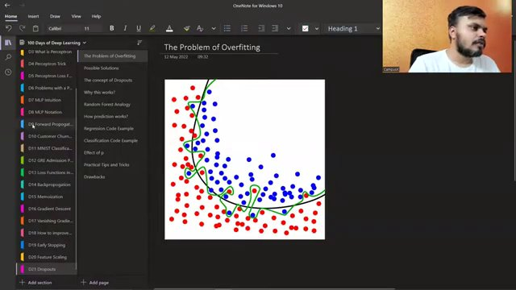

Diagram of neural networks with and without dropout (at 372s)
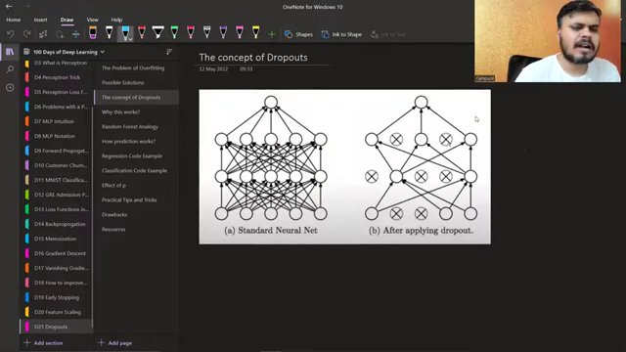

Combined diagram of neural network and overfitting (at 673s)
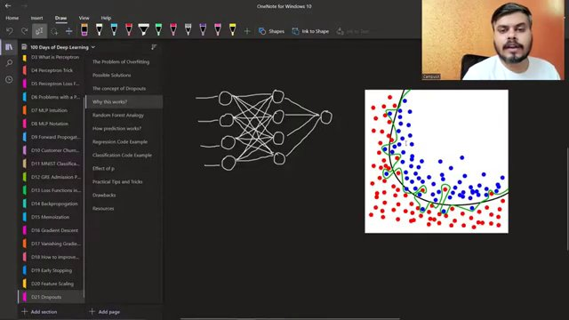

Neural network diagrams for different epochs (at 797s)
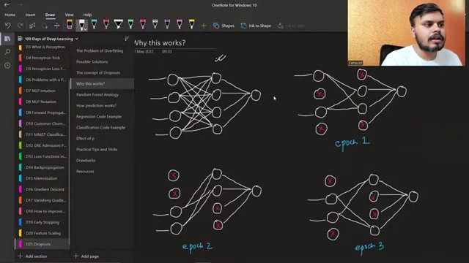

Neural network with decision boundary chart (at 914s)
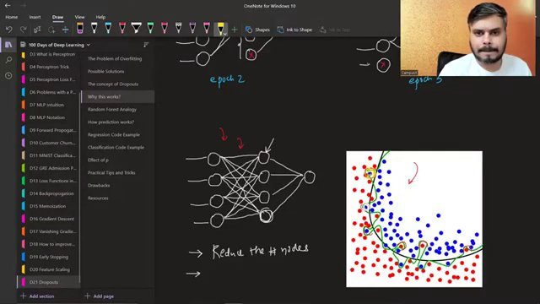

Annotated neural network diagrams for different epochs (at 919s)
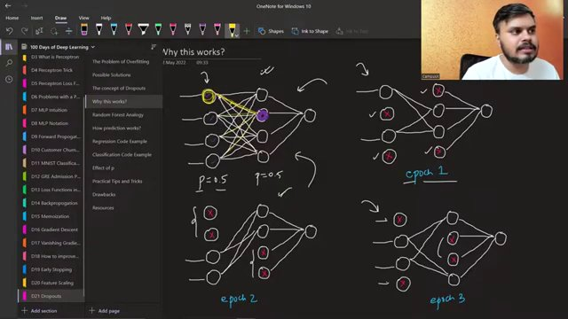

Complete annotated neural network diagrams for different epochs (at 1075s)
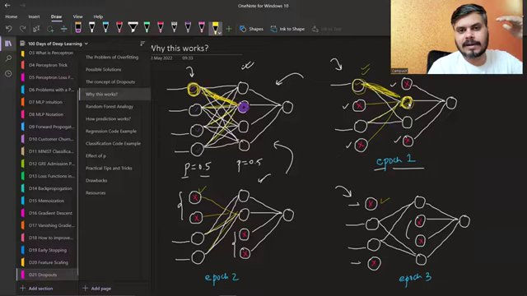

Neural network diagrams with epochs and annotations (at 1109s)
