Dropout Regularization in Neural Networks

Metadata
Created at: 2026-03-29 08:06:40
Video ID: gyTlcHVeBjM

Notes

Dropout Regularization in Neural Networks

Overfitting in Machine Learning and Neural Networks

- Overfitting:
- Model “memorizes” training data, including noise and outliers.
- Training performance is very high; performance on unseen (“नया / अंतिम”) data is poor.
- Decision boundary intuition (blue vs. red classification):
- Overfitted model:
- Very complex, twisted green decision surface.
- Tries to make zero mistakes on training points.
- Captures tiny, non-generalizable patterns.
- Well-generalizing model:
- Simpler black decision surface.
- Captures the core pattern between the two classes.
- Neural networks and overfitting:
- Deep, fully connected networks with many layers and many neurons are highly complex.
- Multiple layers with multiple nodes ⇒ huge number of possible connection patterns.
- Such architectures are “prone to overfitting” and often capture every small pattern.

Strategies to Reduce Overfitting (Recap)

Add More Data

- Increase dataset size and diversity.
- More and more different types of training data:
- Reduce chances of overfitting.
- Force the model to generalize rather than memorize specific examples.

Reduce Model Complexity

- Reduce number of layers and/or neurons:
- Example: instead of $10$ hidden layers, try $7$.
- Example: instead of $128$ neurons per layer, try $64$.
- Fewer neurons ⇒ fewer parameters and connections ⇒ fewer ways to fit tiny patterns.

Early Stopping

- Identify when overfitting starts during training.
- Stop training at that point (अर्ली स्टॉपिंग):
- Prevents the model from continuing to overfit after that stage.

Other Regularization Methods (Mentioned Only)

- L1 / L2 regularization (रेगुलराइजेशन):
- Mentioned as a known machine-learning technique.
- Applicable to neural networks as well.
- Detailed treatment deferred to a later video.

Core Two-Point Intuition for Reducing Overfitting

- Two key ideas to reduce overfitting in neural networks:
1. **Reduce number of neurons (nodes)**:
- Removing neurons reduces number of possible connections.
- Fewer connections ⇒ fewer possibilities to capture extremely small, spurious patterns.
2. **Change neuron behavior**:
- Ensure neurons do not focus on a single type of pattern or a single input.
- Force neurons to distribute attention more evenly across different patterns/inputs.
- If both are achieved:
- Network pays less attention to very fine details.
- Network focuses more on the overall structure in the data.
- Dropout is introduced as a technique that implements both ideas simultaneously.

Dropout: Introduction and Terminology

- Dropout:
- A relatively recent technique (discovered a few years before the lecture).
- Proposed by Srivastava, Hinton, and collaborators.
- Very widely used to reduce overfitting in deep learning.
- Conceptual effect:
- During training, randomly “drop” (switch off) some neurons in chosen layers.
- A dropped neuron:
- Does not send output to the next layer for that training example.
- Is disconnected from the network for that step (incoming and outgoing connections removed).
- **Dropout rate / dropout probability**:
- In the transcript this is called “ड्रॉपआउट रेट $p$” (e.g., “ड्रॉपआउट रेट $(p) = 0.5$”).
- $p$ is the probability that a given neuron is dropped (switched off) during training.
- A neuron remains active with probability $(1 - p)$.

Example Network Setup for Explaining Dropout

- Problem:
- Binary classification (वाइनरी क्लासिफिकेशन प्रॉब्लम).
- Input: $5$ feature columns.
- Output: $1$ target column (binary).
- Network architecture:
- Input layer: $5$ neurons (one per feature column).
- Hidden layer $1$: $5$ neurons.
- Hidden layer $2$: $5$ neurons.
- Output layer: $1$ neuron.
- Fully connected:
- Every neuron in one layer connects to every neuron in the next.
- This small $5$–$5$–$5$–$1$ fully connected network is used to illustrate dropout.

How Dropout Is Applied in the Example

Dropout Rate $p$ per Layer

- For each layer, choose a dropout rate $p$ (ड्रॉपआउट रेट $p$).
- Example from transcript:
- Input layer: $p = 0.5$.
- Hidden layer $1$: $p = 0.5$.
- Hidden layer $2$: $p = 0.5$.
- Interpretation of “ड्रॉपआउट रेट $(p) = 0.5$”:
- For each point / step (“हर पॉइंट”, “हर स्टेप”), in that layer, about $50\%$ of neurons are randomly dropped.
- Each layer can, in principle, have a different dropout rate $p$; here all are $0.5$ for simplicity.

Per-Point Random Masking on the $5$–$5$–$5$–$1$ Network

- For each training example (“हर पॉइंट”):
- Input layer:
- Randomly choose some neurons to **turn off**:
- E.g., for point $1$, two out of the $5$ input neurons are randomly switched off.
- Those neurons become disconnected from the rest of the network for that example.
- Hidden layer $1$:
- Randomly drop some of its $5$ neurons (e.g., drop $3$, keep $2$) for that example.
- Hidden layer $2$:
- Again randomly drop some neurons (e.g., drop $2$, keep $3$) for that example.
- For the **next** point:
- A new random mask is sampled:
- Neurons that were off may become active.
- Neurons that were active may be dropped.
- Effective behavior:
- For point $1$, the active subset of neurons forms one subnetwork.
- For point $2$, a different active subset forms another subnetwork.
- This repeats for all points.

“जैसे 10 अलग-अलग न्यूरल नेटवर्क्स ट्रेन कर रहे हो”

- The instructor’s key phrase:
- Because each point sees a different subset of neurons:
- It is **as if** you are training “$10$ अलग-अलग न्यूरल नेटवर्क्स” (many different networks).
- Formally:
- For each point / step, the architecture is slightly different due to dropout.
- Across training, you train many slightly different subnetworks, all sharing weights.
- Important exam-aligned idea:
- Dropout makes training behave like training an ensemble of different networks on the same data, using a shared underlying parameter set.

How Dropout Implements the Two Key Anti-Overfitting Ideas

1. Effective Reduction of Number of Neurons and Connections

- With dropout rate $p$ in a layer:
- On average, fraction $p$ of neurons are dropped; fraction $(1 - p)$ remain.
- Example: for $p = 0.5$, about half the neurons in that layer are inactive for each point.
- Consequences:
- For each forward–backward pass, the **effective** number of neurons and connections is reduced.
- The subnetwork used for that point has fewer parameters and fewer connection patterns.
- This directly matches the first anti-overfitting idea:
- “नंबर ऑफ नोड्स रिड्यूस कर दो” ⇒ automatically reduce number of connections.
- With reduced capacity, the network has less ability to pick extremely fine-grained patterns.

2. Preventing Single-Pattern / Single-Weight Over-Focus

- Consider one specific neuron in a hidden layer:
- It receives inputs from several previous-layer neurons:
- Inputs: $x_1, x_2, x_3, x_4$.
- Weights: $w_1, w_2, w_3, w_4$.
- Without dropout:
- Depending on the data, this neuron may start to **over-focus** on a single input:
- E.g., $w_1$ (“यह वाला वेट”) becomes very large in magnitude.
- $w_2, w_3, w_4$ remain relatively small.
- In transcript terms:
- “एक वेट का वॉल्यूम बहुत ज़्यादा हो जाए, बाकी बहुत कम रह जाए।”
- Then the neuron effectively relies on a single pattern from that one predecessor neuron.
- With dropout:
- The particular predecessor neuron corresponding to $w_1$:
- Is **sometimes present**, sometimes **dropped** due to dropout rate $p$.
- For many steps, that input is **not** available at all.
- Therefore the neuron:
- Cannot depend only on that single input; it does not know if that neuron will be active in the next step.
- Must learn to use other inputs ($x_2, x_3, x_4$) as well.
- Over time:
- The very large weight $w_1$ is forced to **come down**:
- Because it cannot always provide information (its neuron is sometimes absent).
- Other weights $w_2, w_3, w_4$ are forced to **increase** to share importance.
- The neuron’s incoming weights become more **balanced**.
- Outcome:
- The neuron’s “attention” spreads across several patterns instead of one.
- This realizes the second idea:
- Neurons do not over-focus on a single pattern or single feature.
- They become more robust and less sensitive to small local peculiarities.

Mechanism: How Dropout Reduces Overfitting (Consolidated)

- Reduction of effective capacity per step:
- Each training point sees a smaller subnetwork:
- Fewer neurons.
- Fewer connections.
- This restricts the model’s ability to memorize very tiny, point-specific patterns.
- Reduction of co-adaptation:
- Neurons cannot rely on fixed partners always being present.
- Each neuron must be useful in many different “contexts” (different subsets of other neurons).
- Balanced feature usage:
- No neuron can safely rely on any single predecessor neuron:
- That predecessor might be dropped in the next step.
- Weights are forced to distribute more evenly.
- The network learns broader, more general patterns.
- Resulting behavior:
- Network becomes less sensitive to small, noisy variations.
- It focuses on the overall pattern in the data.
- Empirical remark from transcript:
- Using dropout can improve accuracy by around $2\%$.
- Example: moving from $95\%$ to $97\%$ accuracy is a large improvement in practice.

Optional / Beyond-Transcript Clarifications

Ensemble-Like Interpretation (Optional)

- The instructor’s wording:
- “हर स्टेप पर आपका आर्किटेक्चर थोड़ा सा चेंज हो जाता है।”
- “ऐसा समझ लो कि तुम कई अलग-अलग न्यूरल नेटवर्क्स ट्रेन कर रहे हो।”
- Interpretation:
- You can view dropout training as similar to training an ensemble of many related networks:
- Each point uses a different subnetwork.
- All subnetworks share the same underlying weights.
- This is an **intuition** to understand why generalization improves:
- Not a detailed mathematical derivation in the transcript.
- Treat as optional high-level mental model, not as a formally proved result here.

Key images
Slide on improving neural network performance (at 4s)


Diagram showing the problem of overfitting (at 89s)
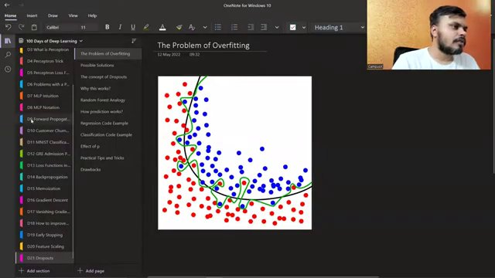

Diagram of neural networks with and without dropout (at 372s)
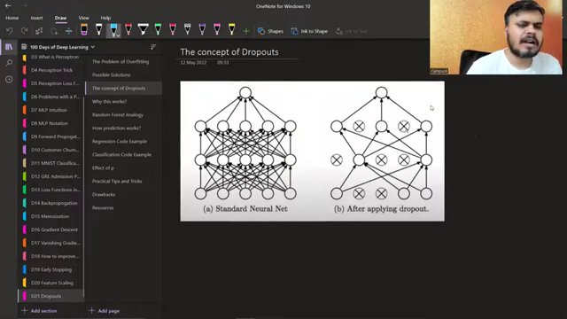

Combined diagram of neural network and overfitting (at 673s)
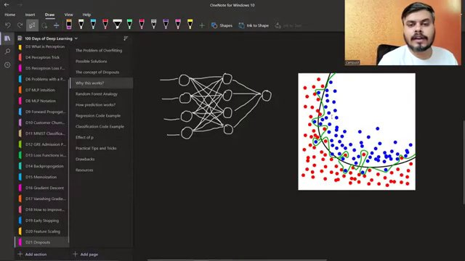

Neural network diagrams for epochs 1 to 3 (at 797s)
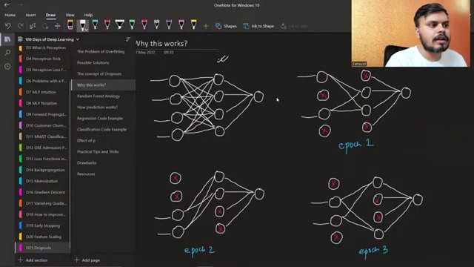

Neural network diagram with data points and decision boundary (at 914s)
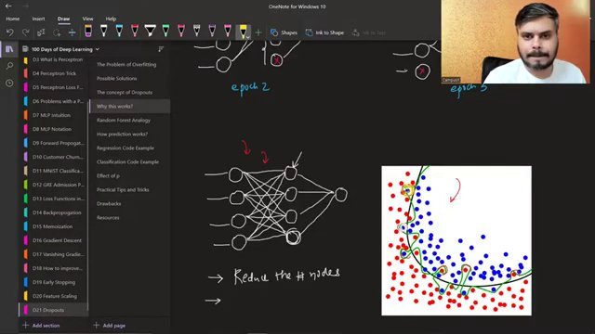

Neural network diagrams with dropout rates (at 919s)
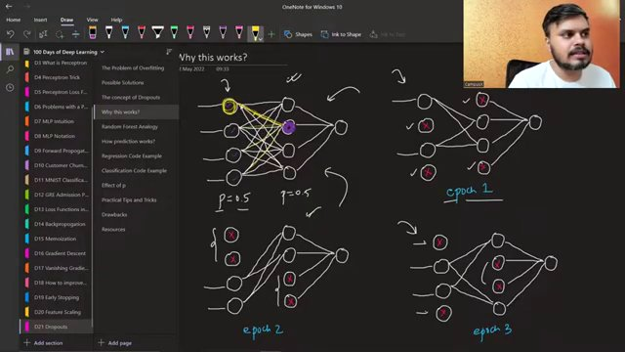

Complete neural network diagrams with dropout rates and epochs (at 1075s)
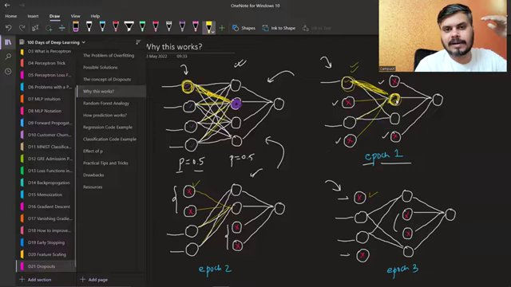

Neural network diagrams with epochs and annotations (at 1109s)
