Sigmoid Function and Its Derivative

Metadata
Created at: 2026-03-27 17:01:49
Video ID: awjXaFR1jOM

Notes

Sigmoid Function and Its Derivative

Sigmoid Function: Definition and Properties
- Sigmoid (logistic) function:
$$\sigma(x) = \frac{1}{1 + e^{-x}}$$
- Maps any real number $x \in (-\infty, \infty)$ to a value in $(0, 1)$.
- “Squashes” large positive and negative inputs into a bounded range.
- Widely used in:
- Logistic regression (as activation / link function)
- Neural networks (e.g., multilayer perceptron) as activation
- Loss functions and backpropagation require its derivative

Goal
- Compute the derivative of the sigmoid function $\sigma(x)$.
- Final result (to be derived):
$$\boxed{\frac{d}{dx}\sigma(x) = \sigma(x)\bigl(1 - \sigma(x)\bigr)}$$

Derivative Rules Used
- Reciprocal rule:
$$\frac{d}{dx}\left(\frac{1}{u(x)}\right) = -\frac{u'(x)}{[u(x)]^2}$$
- Chain rule:
$$\frac{d}{dx}f\bigl(g(x)\bigr) = f'\bigl(g(x)\bigr) \cdot g'(x)$$
- Exponential derivative:
$$\frac{d}{dx}e^{x} = e^{x}, \quad \frac{d}{dx}e^{-x} = -e^{-x}$$

Step-by-Step Derivation

1. Start from the definition
- Given:
$$\sigma(x) = \frac{1}{1 + e^{-x}}$$
- Let:
- $u(x) = 1 + e^{-x}$
- So $\sigma(x) = \frac{1}{u(x)}$

2. Apply reciprocal rule
- Using $\frac{d}{dx}\bigl(\frac{1}{u}\bigr) = -\frac{u'}{u^2}$:
$$\frac{d}{dx}\sigma(x) = -\frac{u'(x)}{[u(x)]^2}$$

3. Differentiate $u(x) = 1 + e^{-x}$
- Derivatives:
- $\frac{d}{dx}(1) = 0$
- $\frac{d}{dx}(e^{-x}) = -e^{-x}$ (by chain rule)
- So:
$$u'(x) = 0 + (-e^{-x}) = -e^{-x}$$

4. Substitute back into reciprocal rule
- Substitute $u'(x) = -e^{-x}$ and $u(x) = 1 + e^{-x}$:
$$
\frac{d}{dx}\sigma(x)
= -\frac{-e^{-x}}{(1 + e^{-x})^2}
= \frac{e^{-x}}{(1 + e^{-x})^2}
$$

5. Express derivative in terms of $\sigma(x)$
- Observe:
$$\sigma(x) = \frac{1}{1 + e^{-x}}$$
$$1 - \sigma(x) = 1 - \frac{1}{1 + e^{-x}}
= \frac{1 + e^{-x} - 1}{1 + e^{-x}}
= \frac{e^{-x}}{1 + e^{-x}}$$
- Multiply:
$$
\sigma(x)\bigl(1 - \sigma(x)\bigr)
= \left(\frac{1}{1 + e^{-x}}\right)\left(\frac{e^{-x}}{1 + e^{-x}}\right)
= \frac{e^{-x}}{(1 + e^{-x})^2}
$$

- Therefore:
$$
\frac{d}{dx}\sigma(x)
= \sigma(x)\bigl(1 - \sigma(x)\bigr)
$$

Final Result and Interpretation
- Derivative of sigmoid:
$$\boxed{\frac{d}{dx}\sigma(x) = \sigma(x)\bigl(1 - \sigma(x)\bigr)}$$
- Key characteristics:
- Always positive (since $0 < \sigma(x) < 1$).
- Maximum at $x = 0$ where $\sigma(0) = 0.5$:
$$\sigma'(0) = 0.5 \cdot (1 - 0.5) = 0.25$$
- Symmetric around $x = 0$.
- Very useful in machine learning:
- Appears directly in backpropagation when sigmoid is used as activation.
- Gradient computations simplify because the derivative is expressed in terms of $\sigma(x)$ itself.

Key images
Sigmoid function graph with menu (at 0s)
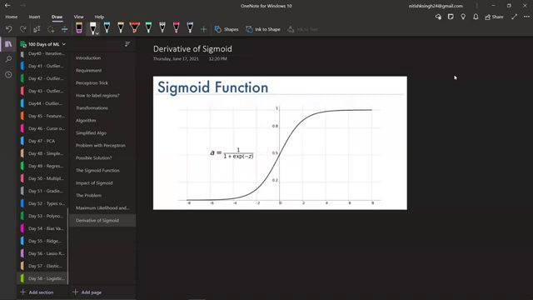

Partial derivative equation with graph (at 121s)
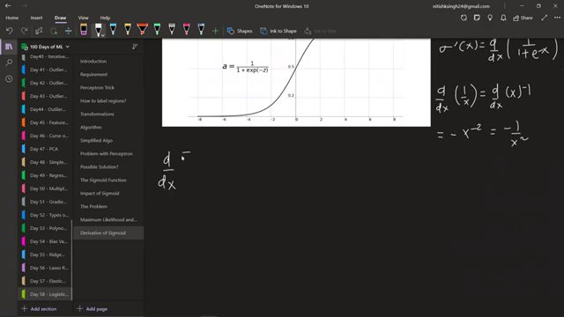

Complete derivative equation derivation (at 218s)
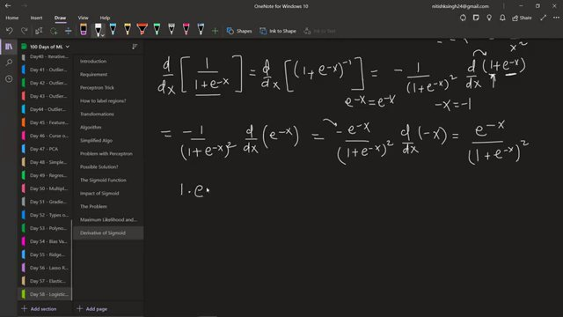

Continuation of derivative equation (at 291s)
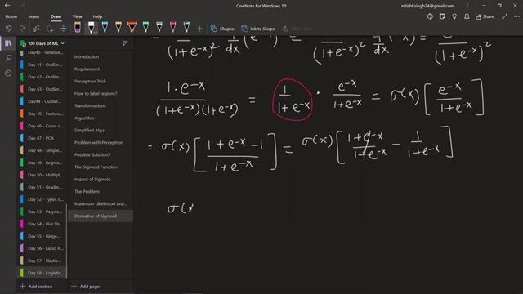

Graph comparing sigmoid and its derivative (at 342s)
