YouTube Notes 2_gCL5RAkHc

Metadata
Created at: 2026-03-24 08:01:51
Video ID: 2_gCL5RAkHc

Notes

Perceptron Loss Function and Its Flexibility

Recap: Perceptron Model & Geometry
- Perceptron is a mathematical model inspired by a neuron.
- Inputs: e.g. `x1 = CGPA`, `x2 = IQ`; output: placement yes/no.
- Parameters:
- Weights: `w1`, `w2`
- Bias: `b`
- Computation:
- Linear score: `z = w1·x1 + w2·x2 + b` (dot product + bias)
- Activation (step function):
- If `z ≥ 0 → output = 1`
- If `z < 0 → output = 0` (or sometimes `-1`)
- Geometric view:
- Perceptron corresponds to a line in 2D (or hyperplane in higher dimensions).
- Line divides space into two regions (positive and negative side).
- Used for binary classification.
- Two stages:
- Prediction: compute `z` and apply activation.
- Training: adjust `w` and `b`.

Perceptron Trick (Heuristic Training Rule)
- Earlier trick:
- Start with a random line (random `w1`, `w2`, `b`).
- Repeatedly pick a random data point.
- Ask: Is this point on correct side of the line?
- If misclassified: pull the line towards that point (update `w`, `b`).
- If correctly classified: do not change `w`, `b`.
- Repeat many times (e.g. 1000 iterations) until line roughly separates classes.
- Result:
- You eventually get some separating line with parameters `(w1, w2, b)`.

Problems with the Perceptron Trick
- No guarantee of best line:
- Different random orders of points can yield very different separating lines.
- You cannot be sure if the obtained `(w1, w2, b)` is “best” among all possible lines.
- Quality is not quantified:
- Rule only cares about correct vs incorrect classification.
- It does not tell “how good” the separation is.
- Convergence issues:
- There is a small possibility the algorithm fails to converge (due to random selection patterns).
- E.g., repeatedly picking only correctly classified points → no updates.
- Overall:
- A good “jugāḍ” (hack) that works most of the time.
- But:
- ~1–2% cases might not converge.
- 100% of the time you cannot quantify optimality of the final line.

Role of Loss Functions in ML
- In ML you usually don’t use ad-hoc tricks to find parameters.
- You define a loss function to:
- Quantify “how good or bad” a model is.
- Assign a numeric score to each parameter setting.
- For the perceptron line:
- Many different lines possible, each with different `w1, w2, b`.
- Loss function maps each line (i.e. each `(w1, w2, b)`) to a number.
- Lower loss = better line.
- Mathematically:
- Loss is a function `L(w1, w2, b)` (via dependence on `z = w·x + b`).
- If you change `w1`, `w2`, or `b`, the loss value changes.
- Goal:
- Adjust `w1, w2, b` so that `L(w1, w2, b)` is minimized.
- That minimizer gives the best line (w.r.t. chosen loss).

Simple Example Loss Functions for a Line

1) Loss = Number of Misclassified Points
- For each line:
- Count number of misclassified points.
- Loss = that count.
- Example:
- Blue line misclassifies 7 points → loss = 7.
- White line misclassifies 5 points → loss = 5.
- White line is better (lower loss).
- Issue:
- All mistakes treated equally.
- A point far from the line (big error) and one just slightly across line (small error) both counted as 1.

2) Loss = Sum of Distances of Misclassified Points
- Improvement:
- For each misclassified point, compute perpendicular distance to line.
- Loss = sum of these distances.
- Interpretation:
- Farther misclassified points imply larger mistakes.
- Near misclassified points imply smaller mistakes.
- Guides toward better line more effectively.
- Practical note:
- True distance formula is somewhat complex.
- In perceptron loss, a simpler surrogate proportional to distance is used instead.

Perceptron-Style Distance Surrogate
- Instead of exact distance, use:
- Plug point coordinates into line equation.
- For line: `2x + 3y + 4 = 0`
- For point `(4, 6)`:
- Value = `2·4 + 3·6 + 4 = 8 + 18 + 4 = 30`.
- For point `(-2, -2)`:
- Value = `2·(-2) + 3·(-2) + 4 = -4 - 6 + 4 = -6`.
- Take absolute value for magnitude:
- `|30|` and `|−6|`.
- Sum of such magnitudes is proportional to total distance of misclassified points.
- Advantage:
- Much simpler to compute (just dot product + bias).

Actual Perceptron Loss Used in scikit-learn (Hinge-like)
- According to scikit-learn’s SGD documentation:
- Perceptron uses a hinge-like loss without the margin shift.
- General SGD loss form:
- `Loss = (average loss term) + (regularization term)`
- For perceptron (ignoring regularization):
- Loss function is:
- `L(w, b) = (1/N) Σ_i max(0, -y_i · (w·x_i + b))`
- Here:
- `N` = number of samples.
- `y_i` ∈ {−1, +1}.
- `x_i` is feature vector for sample `i`.
- `w·x_i + b` is the score for that sample.
- Relation to the “surrogate distance”:
- `w·x_i + b` is the plugged-in line value for point `x_i`.
- `y_i·(w·x_i + b)`:
- Positive if correctly classified.
- Negative if misclassified.
- `max(0, −y_i·(w·x_i + b))`:
- 0 for correctly classified points.
- Positive quantity proportional to misclassification severity (for misclassified points).
- Final objective:
- Find `(w, b)` that minimize:
- `L(w, b) = (1/N) Σ_i max(0, −y_i·(w·x_i + b))`

Interpretation of Perceptron Loss per Point
- Four case types for a given line:
1. Data says `+1` and model also predicts positive side:
- `y_i = +1`, `w·x_i + b > 0` → product `y_i·(w·x_i + b) > 0`.
- `−y_i·(w·x_i + b) < 0`, so `max(0, …) = 0`.
- Contribution to loss = 0.
2. Data says `−1` and model predicts negative side:
- `y_i = −1`, `w·x_i + b < 0` → product `y_i·(w·x_i + b) > 0`.
- Again contribution = 0.
3. Data says `+1` but model predicts negative side:
- `y_i = +1`, `w·x_i + b < 0` → product < 0.
- `−y_i·(w·x_i + b) > 0` → positive contribution.
4. Data says `−1` but model predicts positive side:
- `y_i = −1`, `w·x_i + b > 0` → product < 0.
- Again positive contribution.
- Summary:
- Correctly classified points → 0 loss contribution.
- Misclassified points → positive value proportional to how “deep” they are on the wrong side.
- This behaves like the surrogate distance sum discussed earlier.

Full Dataset Loss Expression
- Data:
- `N` rows.
- Each row `i` has inputs `x_i` and label `y_i`.
- Features in 2D: `x_i = (x_i1, x_i2)`.
- Model:
- `z_i = w1·x_i1 + w2·x_i2 + b`.
- Loss:
- `L(w1, w2, b) = (1/N) Σ_i max(0, −y_i·(w1·x_i1 + w2·x_i2 + b))`.
- Only `w1`, `w2`, `b` are variables:
- `x_i`, `y_i` are constant given the dataset.
- Optimization goal:
- Find `w1, w2, b` that minimize `L(w1, w2, b)`.

Minimizing Loss with Gradient Descent
- Target optimization:
- `argmin_{w1, w2, b} L(w1, w2, b)`.
- Use Gradient Descent (or SGD):
- Initialize:
- Choose some initial `w1, w2, b` (e.g., random).
- Choose learning rate `η` (e.g., 0.1).
- Iterative update rules:
- `w1_new = w1_old − η · (∂L/∂w1)`
- `w2_new = w2_old − η · (∂L/∂w2)`
- `b_new = b_old − η · (∂L/∂b)`
- Need partial derivatives:
- Compute `∂L/∂w1`, `∂L/∂w2`, `∂L/∂b`.
- These come from differentiating the loss expression.

Differentiating the Perceptron Loss
- Loss:
- `L = (1/N) Σ_i max(0, −y_i·(w·x_i + b))`
- Difficult part is derivative of `max(0, u)`:
- Let `u_i = −y_i·(w·x_i + b)`.
- `max(0, u_i)` has piecewise derivative:
- If `u_i ≤ 0` → derivative = 0.
- If `u_i > 0` → derivative = derivative of `u_i`.
- Use chain rule:
- `∂L/∂(w·x_i + b) = (1/N) *`:
- `0` if `−y_i·(w·x_i + b) ≤ 0`
- `−y_i` if `−y_i·(w·x_i + b) > 0`
- For 2D case:
- `z_i = w1·x_i1 + w2·x_i2 + b`.
- `∂z_i/∂w1 = x_i1`
- `∂z_i/∂w2 = x_i2`
- `∂z_i/∂b = 1`
- Combining (piecewise):
- For each sample `i`:
- If `y_i·z_i ≥ 0` (correctly classified):
- Contribution to all gradients = 0.
- If `y_i·z_i < 0` (misclassified):
- `∂L/∂w1` gets added term `−(1/N)·y_i·x_i1`.
- `∂L/∂w2` gets added term `−(1/N)·y_i·x_i2`.
- `∂L/∂b` gets added term `−(1/N)·y_i`.

Practical SGD-Style Update for Perceptron
- Pseudo-code skeleton:
- Initialize `w1, w2, b` (e.g. all 0 or small random values).
- Set learning rate `η` (e.g. 0.1).
- Loop for some epochs (e.g. 1000 times):
- For each sample `i`:
- Compute `z_i = w1·x_i1 + w2·x_i2 + b`.
- Compute `margin = y_i · z_i`.
- If `margin ≤ 0` (misclassified):
- `w1 = w1 + η · y_i · x_i1`
- `w2 = w2 + η · y_i · x_i2`
- `b = b + η · y_i`
- Else:
- No update (since gradient is 0 for correctly classified points).
- This corresponds to gradient descent on the perceptron loss.

Implementation Example (Conceptual)
- Dataset:
- 2D points with labels `+1` or `−1`.
- Function `perceptron(X, y)`:
- Initialize `w1, w2, b = 0`.
- `learning_rate = 0.1`.
- For epoch in range(1000):
- For each row `i` in `X`:
- `z = w1*x_i1 + w2*x_i2 + b`.
- `if y_i * z <= 0:` (misclassified)
- `w1 += learning_rate * y_i * x_i1`
- `w2 += learning_rate * y_i * x_i2`
- `b += learning_rate * y_i`
- Return final `w1, w2, b`.
- Final weights define the separating line.

Perceptron as a Flexible Mathematical Model
- Core architecture:
- Inputs → weighted sum (`z = w·x + b`) → activation function → output.
- Training uses some loss function + an optimizer (e.g. SGD).
- Flexibility:
- By changing activation function and loss function, the same perceptron structure can implement:
- Classic perceptron classification.
- Logistic regression.
- Softmax (multiclass) regression.
- Linear regression.

Mapping Combinations to Known Algorithms

1) Classic Perceptron (Binary Hard Classification)
- Activation function:
- Step function:
- `output = 1` if `z ≥ 0`
- `output = −1` (or 0) if `z < 0`
- Loss function:
- Perceptron / hinge-like loss:
- `L = (1/N) Σ_i max(0, −y_i·(w·x_i + b))`
- Output:
- Discrete class label (e.g. `+1` or `−1`).

2) Logistic Regression (Binary Probabilistic Classification)
- Activation function:
- Sigmoid:
- `σ(z) = 1 / (1 + e^(−z))`
- Interpreted as `P(y = 1 | x)`.
- Loss function:
- Binary cross-entropy (log loss):
- `L = −[ y·log(p) + (1 − y)·log(1 − p) ]`
- Where `p = σ(z)`.
- Relationship:
- Perceptron + sigmoid + binary cross-entropy = logistic regression.
- Output:
- Probability between 0 and 1.

3) Softmax Regression (Multiclass Classification)
- Activation function:
- Softmax for `K` classes:
- For class `k`:
- `p_k = e^{z_k} / Σ_j e^{z_j}`
- `z_k = w_k·x + b_k` for each class.
- Loss function:
- Categorical cross-entropy:
- `L = − Σ_k y_k · log(p_k)`
- `y_k` is 1 for true class, 0 otherwise.
- Output:
- Probability distribution over multiple classes.

4) Linear Regression (Regression on Real Numbers)
- Activation function:
- Identity / linear:
- `output = z` (no nonlinearity).
- Loss function:
- Mean squared error (MSE):
- `L = (1/N) Σ_i (y_i − z_i)²`
- Output:
- Real-valued prediction (could be any real number).

Key Insight: One Model, Multiple Behaviors
- The underlying perceptron structure is the same:
- `z = w·x + b`
- Train with SGD (or another optimizer).
- Behavior is controlled by:
- Choice of activation function.
- Choice of loss function.
- Summary of combinations:

- `Activation: step` + `Loss: hinge-like (perceptron)` → perceptron (hard binary classifier).
- `Activation: sigmoid` + `Loss: binary cross-entropy` → logistic regression (binary probabilistic).
- `Activation: softmax` + `Loss: categorical cross-entropy` → softmax regression (multiclass classification).
- `Activation: identity` + `Loss: mean squared error` → linear regression.

- The perceptron is thus a general mathematical template; changing its components tailors it to different tasks.

Next Steps (Beyond Single-Layer Perceptron)
- Single-layer perceptron has limitations (to be discussed later).
- These limitations motivate Multi-Layer Perceptrons (MLPs).
- Future topics:
- Why single-layer perceptron fails on some problems.
- How MLPs extend this model with multiple layers and nonlinearities.

Key images
PERCEPTRON DIAGRAM AND DATA TABLE. (at 91s)
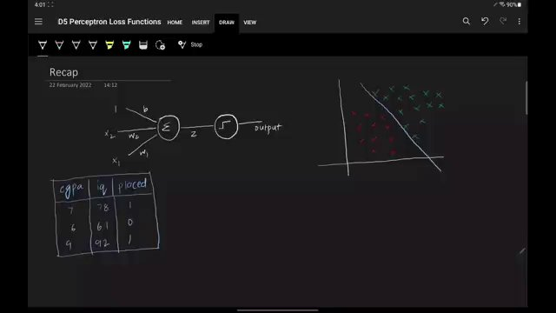

MATHEMATICAL FORMULATION OF OPTIMIZATION PROBLEM. (at 1383s)
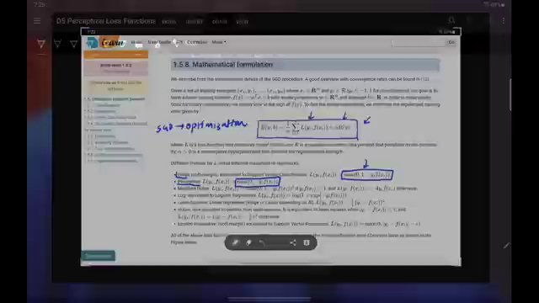

PERCEPTRON ALGORITHM CODE SNIPPET (at 2795s)
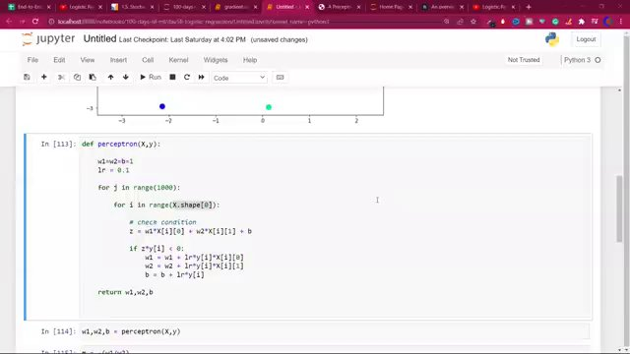

"PERCEPTRON ALGORITHM CODE SNIPPET" (at 2825s)
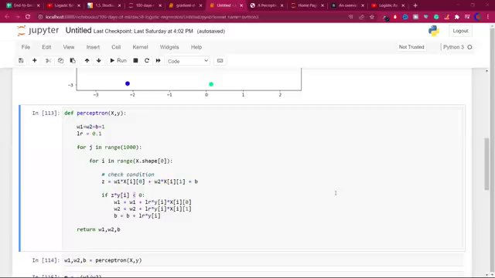

Interview question bank

*Target roles: ML Engineer / Data Scientist / AI Engineer. Questions are sourced from web pages only (not invented).*

Summary table

| Topic | # Companies | # Questions | Top sources |
|-------|-------------|-------------|-------------|
| Perceptron model and geometric interpretation | 1 | 4 | kavitagupta.substack.com, yashdave9706.medium.com, users.pja.edu.pl, danushka.ne |
| Perceptron trick training rule | 0 | 0 | users.pja.edu.pl, danushka.net, cs.umd.edu, kavitagupta.substack.com |
| Limitations of the basic perceptron learning rule | 1 | 1 | medium.com/@yashdave9706, articsledge.com, users.pja.edu.pl, danushka.net, cs.um |
| Loss functions in machine learning | 0 | 0 | devinterview.io, tryexponent.com, analyticsvidhya.com, geeksforgeeks.org, bugfre |
| Perceptron loss function (hinge-like loss) | 0 | 0 | None |
| Geometric interpretation of perceptron loss | 0 | 0 | medium.com/@yashdave9706, users.pja.edu.pl, danushka.net, cs.umd.edu |
| Simple loss function examples for linear classifiers | 0 | 0 | None |
| Gradient descent optimization for perceptron loss | 0 | 0 | devinterview.io, tryexponent.com, analyticsarora.com, medium.com, youtube.com |
| Derivatives of perceptron loss and update rules | 0 | 0 | users.pja.edu.pl, danushka.net, geeksforgeeks.org, bugfree.ai |
| Perceptron SGD-style implementation | 0 | 0 | danushka.net, cs.umd.edu |
| Perceptron as a flexible model via activation and loss choices | 0 | 0 | articsledge.com, medium.com/@yashdave9706 |
| Relationship between perceptron, logistic regression, softmax regression, and linear regression | 0 | 0 | articsledge.com, tryexponent.com, interviewnode.com |
| **Total (all in bank)** | 1 | 5 | See sections below |

Coverage report

- Extracted topics: 12
- Questions with attribution: 5
- Excluded (unattributed): 1

**Topic coverage notes:**
The material focuses on the perceptron: its model and geometry, heuristic training rule and its issues, formalization via loss functions (especially the perceptron/hinge-like loss), optimization with gradient descent/SGD, and how different activation–loss combinations turn the same perceptron template into perceptron, logistic, softmax, or linear regression.

Questions by topic → company

Limitations of the basic perceptron learning rule

**N/A**
- **Q:** Can perceptrons handle non-linearly separable data?
- *Role/level:* N/A
- *Source:* https://kavitagupta.substack.com/p/interview-questions-with-answers
- *Evidence:* ### **5. Can perceptrons handle non-linearly separable data?**

***Answer.*** No. Perceptrons are inherently designed to solve problems with linearly separable data only.

Perceptron model and geometric interpretation

**N/A**
- **Q:** What is a perceptron?
- *Role/level:* N/A
- *Source:* https://kavitagupta.substack.com/p/interview-questions-with-answers
- *Evidence:* ### **1. What is a perceptron?**

***Answer:*** A perceptron is the earliest and simplest form of a neural network.

- **Q:** What are the components of a perceptron?
- *Role/level:* N/A
- *Source:* https://kavitagupta.substack.com/p/interview-questions-with-answers
- *Evidence:* ### **2. What are the components of a perceptron?**

***Answer:*** The components of a perceptron are given below:

- **Q:** What is meant by the data is linearly separable?
- *Role/level:* N/A
- *Source:* https://kavitagupta.substack.com/p/interview-questions-with-answers
- *Evidence:* ### **3. What is meant by the data is linearly separable?**

***Answer:*** The dats is said to be linearly separable if we can divide its data points into mutually exclusive classes using a hyperplane.

- **Q:** Which activation function is generally used in a perceptron?
- *Role/level:* N/A
- *Source:* https://kavitagupta.substack.com/p/interview-questions-with-answers
- *Evidence:* ### **4. Which activation function is generally used in a perceptron?**

***Answer:*** The most commonly used activation function in a perceptron is ‘step function’.

Unattributed (excluded from main list)

- **Topic:** Perceptron trick training rule — Question 6 on the Substack page is truncated in the provided content ('### **6. What is the weights update rule in a') so the full question text is not visible; per instructions, I cannot invent or complete questions that are not fully present. — _What is the weights update rule in a_

