YouTube Notes 4xRonrhtkzc

Metadata
Created at: 2026-03-22 18:46:28
Video ID: 4xRonrhtkzc

Notes

Regularization in Neural Networks

Context and Motivation
- Topic: Regularization in machine learning / deep learning, especially neural networks.
- Goal: Fix an overfitting neural network using regularization.
- Previous techniques in the broader series:
- Normalizing inputs
- Early stopping
- Dropout
- Profiling layers (model inspection)
- Regularization is an important checklist item when model performance is poor due to overfitting.

Overfitting: What and Why

Definition of Overfitting
- Overfitting: Model performs very well on training data but poorly on new / test data.
- Cause:
- Model is too complex.
- It learns minor, very specific patterns in training data.
- It “memorizes” rather than “understands” general concepts.
- Analogy:
- Student who memorizes entire book without understanding; fails when questions are slightly different.

Overfitting in Complex Models
- Complex models: deep neural networks, very deep decision trees, etc.
- Such models try to minimize training error aggressively, capturing even tiny idiosyncrasies.
- Decision boundary example:
- Simple model → smooth, roughly linear or slightly curved boundary.
- Highly complex model → very wiggly, convoluted boundary that passes through almost all training points.

Neural Network Complexity and Overfitting
- Complexity driven by:
- Number of neurons.
- Number of layers.
- Dense connectivity (each neuron connected to many others).
- Example progression:
- Network with 1 neuron:
- Behaves like a perceptron.
- Can only draw a single straight line decision boundary.
- Increase to 10, 50, 250, 1000 neurons:
- Capacity to form many “line segments” and curves increases.
- Decision boundary becomes highly convoluted to reduce training error close to zero.
- Intuition:
- With `k` neurons, you can combine many linear pieces (effectively, many lines).
- With hundreds or thousands of neurons, model can draw extremely complex boundaries.
- Problem:
- Model captures noise / random fluctuations (spurious patterns) in the training data.
- Fails to generalize to unseen data → classic overfitting.

Strategies to Reduce Overfitting (High-Level)

1. Increase Data
- Add more training data:
- Helps model learn more general patterns.
- Reduces focus on small, random fluctuations.
- Limitation:
- Real data is expensive and often not readily available.

2. Data Augmentation
- Create synthetic data from existing samples.
- Common in computer vision:
- Example: For a dog image:
- Flip horizontally.
- Crop regions.
- Rotate or invert.
- Produces multiple “new” images from one original.
- Effect:
- Increases effective dataset size.
- Helps model generalize better.
- Will be studied in detail later (e.g., in CNNs).

3. Reduce Model Complexity
- Reduce capacity so model can’t fit all tiny details.
- Techniques:
- Dropout:
- Randomly turn off a percentage of neurons in each layer during training.
- Reduces effective complexity and prevents co-adaptation.
- Early stopping:
- Monitor validation loss.
- Stop training where validation loss starts to worsen, even if training loss keeps improving.
- 3rd key technique in this category: Regularization (focus of this video).

Regularization: Concept

Intuition via Network Simplification
- Idea:
- Overfitting arises partly because the model has too many effective neurons/weights.
- If we “weaken” many connections, network becomes simpler.
- Approach:
- Reduce some weights towards zero.
- Very small weight ≈ that connection/neuron is “almost non-existent”.
- Fewer effective neurons / connections → simpler model → less overfitting.

What Regularization Does
- Regularization adds a penalty on large weights to the loss function.
- Effect:
- Optimizer prefers solutions with smaller weights.
- Over time, many weights shrink towards zero.
- Model becomes less complex, reducing overfitting.

Loss Function and Regularization Term

Base Loss Function
- In ML/DL, we learn weights `w` by minimizing a loss (cost) function.
- Examples:
- Regression: Mean Squared Error (MSE).
- Classification: Binary cross-entropy / log loss.
- Base objective (without regularization):
- `Loss_original(w)` = some function of data and weights to be minimized.

Adding a Penalty Term
- With regularization:
- `Loss_regularized(w) = Loss_original(w) + Penalty_term(w)`
- For L2 regularization:
- Penalty term:
- `Penalty_L2 = (λ / (2n)) × Σ (w_i²)` over all weights `w_i`.
- Parameters / symbols:
- `λ` (lambda): regularization hyperparameter.
- Controls strength of regularization.
- Larger `λ` → stronger regularization (weights driven more strongly towards zero).
- `λ = 0` → no regularization (penalty term disappears).
- `n`: number of training samples (or sometimes number of rows; included for scaling).
- `1/2`: used for mathematical convenience; some formulations omit it.

Variants of Regularization Terms
- L2 (Ridge-type) regularization:
- Penalizes sum of squared weights.
- L1 (Lasso-type) regularization:
- Penalizes sum of absolute values of weights.
- Combined L1 + L2:
- Known as Elastic Net (in linear models).
- In this video:
- Focus on L2 and also mention of L1 and L1+L2 in neural networks.
- In notation, sometimes written as:
- `Loss_regularized = Loss_original + (λ / (2n)) ||W||₂²` for L2.
- Or with L1 norm `||W||₁` for L1.
- Important:
- Bias terms are typically not regularized:
- Biases are excluded from the penalty sum.
- Only weights (connections) are included.

Matrix/Layer-Wise Form
- For deep networks:
- Weights are matrices per layer: `W^(l)` (rows × columns).
- Equivalent matrix form:
- `Loss_regularized = Loss_original + (λ / (2n)) × Σ over layers (Σ over all elements of W^(l)²)`
- Notation differences in textbooks / code are equivalent if they:
- Sum squares of all non-bias weights.
- Multiply by appropriate scaling with `λ`, `n`, and optional `1/2`.

Why Regularization Shrinks Weights (L2 Intuition)

Gradient Descent Without Regularization
- Standard weight update (for one weight `w`):
- `w_new = w_old - η × (∂Loss_original / ∂w_old)`
- `η` = learning rate.

With L2 Regularization
- New loss:
- `Loss_total = Loss_original + (λ / (2n)) × Σ(w_i²)`
- Partial derivative w.r.t. a specific weight `w`:
- `∂Loss_total / ∂w = ∂Loss_original / ∂w + (λ / n) × w`
- (since derivative of `(w²)` is `2w`; `2` cancels with `1/2`, remaining `(λ / n) × w`).
- New update rule:
- `w_new = w_old - η × [ ∂Loss_original / ∂w_old + (λ / n) × w_old ]`
- Rearranging:
- `w_new = w_old - η × ∂Loss_original / ∂w_old - η × (λ / n) × w_old`
- `w_new = w_old × (1 - η × λ / n) - η × ∂Loss_original / ∂w_old`
- Interpretation:
- There is now an extra multiplicative factor `(1 - η × λ / n)` applied to `w_old`.
- Since `η × λ / n` is positive and usually < 1:
- `0 < (1 - η × λ / n) < 1`
- Result:
- Even if gradient from `Loss_original` were zero, weight would shrink:
- `w_new ≈ w_old × (1 - something_positive_less_than_1)`
- After repeated updates, weights keep decreasing in magnitude.
- They move closer and closer to 0 (but typically not exactly 0 in L2).

Relation to Weight Decay
- The multiplicative shrink term `(1 - η × λ / n)` is often referred to as weight decay.
- In practice:
- L2 regularization in neural networks is frequently called “weight decay”.
- Strictly speaking, “weight decay” can have slightly different implementations, but in many practical cases:
- L2 regularization ≈ weight decay (for intuition and many frameworks).

Effect Summary
- Repeated gradient updates with L2:
- Weights are continuously reduced.
- Model capacity is effectively reduced.
- Complex/wiggly decision boundaries are discouraged.
- Helps prevent overfitting.

L1 vs L2 Behavior (High-Level)
- L1 regularization:
- Encourages many weights to become exactly zero.
- Produces a sparse model (lots of zero weights).
- L2 regularization:
- Shrinks weights towards zero but usually not exactly zero.
- Weights become small, but not sparse.
- In neural networks:
- L2 is generally more commonly used and tends to perform more robustly in practice.
- L1 can be useful when explicit sparsity is desired.
- Combination L1+L2 also exists and is used in some settings.

Practical Keras Implementation (L2 and L1)

Baseline Model (No Regularization)
- Dataset:
- Synthetic 2D classification dataset (e.g., using `make_classification`-like function).
- Model architecture:
- Input dimension: 2 features.
- Hidden Layer 1: 128 units.
- Hidden Layer 2: 128 units.
- Output layer: 1 unit (binary classification).
- Total parameters:
- Example shown: 384 parameters in one model, and 13012 in another example (depending on architecture).
- Training:
- Optimizer: e.g., Adam with learning rate 0.003.
- Loss: binary cross-entropy.
- Metric: accuracy.
- Epochs: 200 (intentionally long to force overfitting).
- Validation split: 0.2.
- Observations:
- Training loss continues decreasing.
- Validation loss starts increasing strongly → clear overfitting.
- Decision boundary on training data extremely complex and wiggly.

Model with L2 Regularization
- Modification:
- Add `kernel_regularizer=regularizers.l2(λ)` to dense layers.
- Example:
- Hidden Layer 1: `Dense(128, activation='relu', kernel_regularizer=regularizers.l2(0.01))`
- Hidden Layer 2: `Dense(128, activation='relu', kernel_regularizer=regularizers.l2(0.01))`
- Output Layer: `Dense(1, activation='sigmoid')` (no regularizer or optional regularizer).
- Training procedure:
- Same optimizer, loss, epochs, and validation split as baseline.
- Observations:
- Decision boundary much smoother and less convoluted.
- Better generalization on test/unseen data.
- Training vs validation curves show significantly reduced overfitting.

Model with L1 Regularization
- Change L2 to L1:
- `kernel_regularizer=regularizers.l1(λ)`
- Example tuning:
- Using a relatively strong λ (e.g., 0.08) showed:
- Some overfitting still present but less than no-regularization case.
- Results typically not as stable/good as L2 in the demonstrated setting.
- Conclusion from experiment:
- In deep learning tasks, L2 often yields better practical performance than L1 (in this tutorial’s experience).
- Both should be tried and tuned; outcome can be task-dependent.

Empirical Evidence: Weight Distribution Analysis

Extracting Weights
- After training:
- `model.get_weights()` returns list of arrays:
- For each dense layer: weight matrix and bias vector.
- Example:
- First layer weights shape: `(2, 128)` → total 256 weights.
- Extraction:
- For first layer of model without regularization:
- Store `weights_model1 = model1.get_weights()[0].reshape(-1)` (256 values).
- For first layer of model with L2:
- Store `weights_model2 = model2.get_weights()[0].reshape(-1)`.

Boxplot Comparison
- Boxplot for weights without regularization:
- Wider spread.
- Many weights lie outside range `[-1, 1]`.
- Outliers with large positive or negative values.
- Boxplot for weights with L2 regularization:
- Most weights in narrow range, e.g., around `[-0.6, 0.4]`.
- Centered around zero.
- Clearly compressed distribution.
- Numeric summary:
- Without regularization:
- Max weight example: ~1.75.
- Min weight example: ~-2.78.
- With L2 regularization:
- Max weight example: ~0.38.
- Min weight example: ~-0.5.
- Conclusion:
- L2 significantly shrinks weight magnitudes and pulls them toward zero (but not exactly zero).

Density Plot Visualization
- Probability density function (PDF) / histogram comparison:
- Without regularization (blue):
- Weights spread over a wider range.
- With regularization (orange):
- Weights concentrated near zero; narrow, tall peak.
- Intuition:
- Regularization compresses the weight distribution towards zero, reflecting lower model complexity.

L1 Regularization Effects (Empirical Note)
- L1 experiment:
- After applying L1 and rerunning training and plots:
- Regularization effect visible (weights reduced).
- Still more overfitting compared to L2 case in this demonstration.
- Weight distribution:
- Also shrunk, but pattern slightly different (more tendency towards exact zero in general L1 behavior).
- General remark:
- In many deep learning setups, L2 (weight decay) is usually preferred.
- L1 may be used when sparsity (many exact zeros) is desired.

Key Hyperparameters and Practical Tips

Lambda (`λ`) Tuning
- `λ` is critical:
- Too small:
- Regularization weak → model may still overfit.
- Too large:
- Weights become too small.
- Model underfits (poor performance on both training and test).
- Trade-off:
- Need to tune on validation set:
- Search over values like `1e-4, 1e-3, 1e-2, 1e-1` etc.

Learning Rate (`η`)
- Interaction:
- `η` interacts with λ through factor `(1 - η × λ / n)`.
- If η is too large with strong λ, shrinkage can be very aggressive.
- Practical:
- Often keep η small to maintain stable training when using regularization.

When to Use Which Technique
- Overfitting detected (training loss ↓, validation loss ↑):
- Candidate actions:
- Add more data / data augmentation.
- Use dropout.
- Use early stopping.
- Add L2/L1 regularization to dense/convolutional layers.
- Combined strategies:
- In practice, multiple are used together (e.g., L2 + dropout + early stopping).

L1 vs L2 Summary in Neural Networks
- L1 regularization:
- Produces sparse weights (many exactly 0).
- Can simplify model by effectively removing many connections.
- L2 regularization:
- Produces small but non-zero weights.
- Generally more stable and commonly used as “weight decay”.
- In this lecture’s experiments:
- L2 regularization:
- Showed cleaner decision boundaries.
- Reduced overfitting more effectively.
- L1 regularization:
- Helpful but slightly less effective in example; still some noticeable overfitting.

Additional Learning Resources
- Instructor’s recommended playlist:
- “Basics of Regularization” for linear and logistic regression.
- Covers:
- L1, L2, Elastic Net.
- Full mathematical derivations.
- Interview-level depth.
- Suggested path:
- Study that playlist for deep understanding of regularization theory.
- Then apply concepts to neural networks as shown in this video.

Implementation Summary in Keras (Key Steps)
- Import regularizers:
- `from tensorflow.keras import regularizers`
- Define model with L2:
- Example:
- `model = Sequential([`
- `Dense(128, activation='relu', input_dim=2, kernel_regularizer=regularizers.l2(0.01)),`
- `Dense(128, activation='relu', kernel_regularizer=regularizers.l2(0.01)),`
- `Dense(1, activation='sigmoid')`
- `])`
- Compile:
- `model.compile(optimizer=Adam(learning_rate=0.003), loss='binary_crossentropy', metrics=['accuracy'])`
- Train:
- `model.fit(X_train, y_train, epochs=200, validation_split=0.2)`
- Evaluate and visualize:
- Training/validation curves.
- Decision boundaries.
- Weight distributions (via `get_weights()` and plots).

Key images
"NEURAL NETWORK OVERFITTING VISUALIZATION" (at 291s)
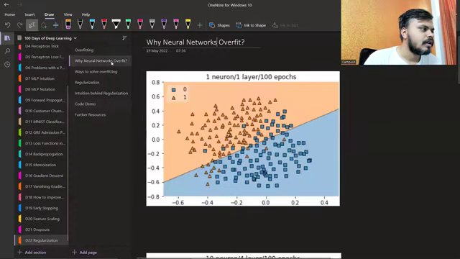

"NEURAL NETWORK DECISION BOUNDARY VISUALIZATION" (at 416s)
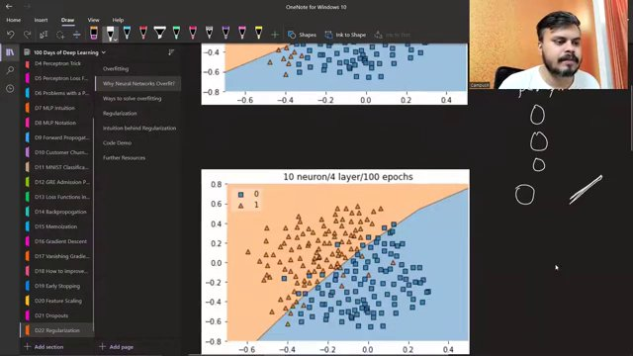

NEURAL NETWORK DECISION BOUNDARY DIAGRAMS. (at 475s)
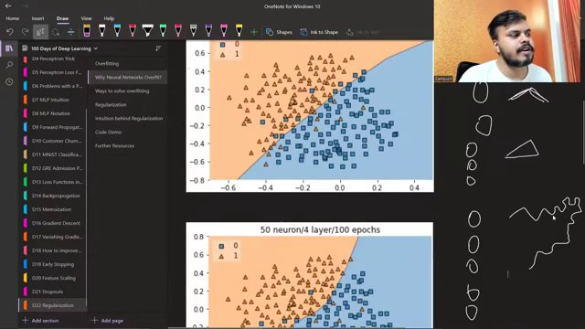

"DENSITY PLOT AND MODEL WEIGHTS OUTPUT" (at 1819s)
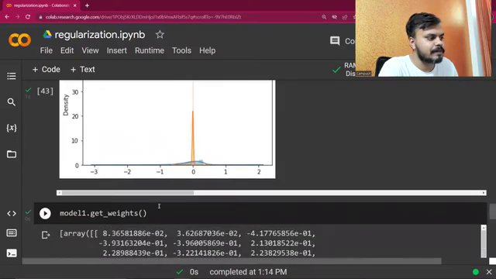

"WEIGHT DISTRIBUTION PLOT AND MODEL WEIGHTS OUTPUT" (at 1832s)
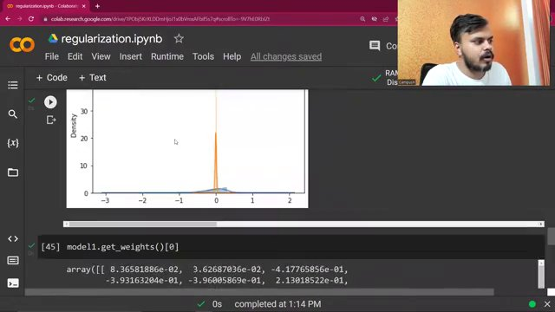

DECISION BOUNDARY PLOT IN REGULARIZATION EXAMPLE. (at 2027s)
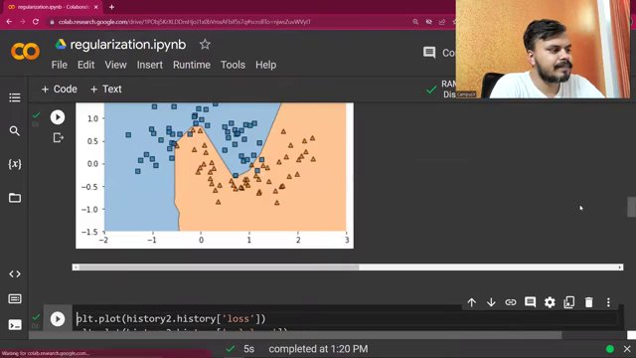

Interview question bank

*Questions sourced from real web pages — interview prep sites, Glassdoor, forums, and company blogs.*

> **No questions were extracted.** This can happen if web search returned insufficient content. Ensure `TAVILY_API_KEY` is set in `.env` for best results (full-page extract). DuckDuckGo fallback only returns short snippets.

Summary table

| Topic | # Companies | # Questions | Top sources |
|-------|-------------|-------------|-------------|
| Regularization techniques in neural networks | 0 | 0 | |
| Overfitting and generalization in machine learning | 0 | 0 | |
| Neural network capacity and complexity control | 0 | 0 | |
| L2 regularization and weight decay | 0 | 0 | |
| L1 regularization and sparsity | 0 | 0 | |
| Gradient descent with regularization | 0 | 0 | |
| Early stopping, dropout, and other overfitting countermeasures | 0 | 0 | |
| Implementing regularization in Keras | 0 | 0 | |
| Analyzing weight distributions and model behavior under regularization | 0 | 0 | |
| Hyperparameter tuning for regularization | 0 | 0 | |

Coverage report

- Extracted topics: 10
- Questions with attribution: 0
- Excluded (unattributed): 0

**Topic coverage notes:**
The material focuses on understanding and fixing overfitting in neural networks using regularization, especially L2 (weight decay) and also L1, including mathematical intuition, gradient-descent-based derivations, and concrete Keras implementations. It situates regularization among other overfitting countermeasures like dropout, early stopping, data augmentation, and increased data, and demonstrates empirically how regularization changes decision boundaries and weight distributions.

Questions by topic → company

