YouTube Notes 6xO-x8y0YSY

Metadata
Created at: 2026-03-24 07:36:40
Video ID: 6xO-x8y0YSY

Notes

Backpropagation Intuition, Gradient, Derivative & Learning Rate

Overall Goal
- Focus is on *why* the backpropagation (BP) algorithm works and why its update rule reduces loss.
- Previous videos focused on *how* to implement BP; here the emphasis is on intuition and math behind it.
- Aim: understand why parameter updates of form `w_new = w_old - η · (∂L/∂w_old)` lead to correct training.

---

Structure of Training Loop (Reminder)
- You choose a `num_epochs` (how many passes over the entire dataset).
- For each epoch:
- Inner loop runs once per data row (sample).
- For each sample:
- Randomly pick a data point (or iterate systematically).
- Compute prediction `ŷ` using current model parameters.
- Take true target `y` for that point.
- Compute loss `L(y, ŷ)`:
- Regression: typically MSE.
- Classification: typically cross-entropy.
- Update all weights and biases using the BP update rule.
- Total number of gradient steps ≈ `epochs × number_of_rows`.

---

Loss as a Function of Parameters
- Example setup:
- Dataset: CGPA, profile, etc. → target: salary/package.
- Simple neural network with total 3 nodes (small MLP).
- Loss function (example regression): `L = (y - ŷ)²`.
- `ŷ` is determined by the neural network’s weights and biases.
- Key point:
- Although we can write `L = (y - ŷ)²`, `ŷ` itself is a complex expression in terms of all model parameters.
- For a small 2-layer network, `ŷ` becomes a nested expression involving multiple weights, inputs, and biases.
- Example of structure for a node:
- `h = w21·x1 + w22·x2 + w23·x3 + b21`
- Similar expressions for other nodes.
- Important conclusion:
- Loss `L` is a mathematical function of *all* trainable parameters:
- All weights `w_ij` and all biases `b_i`.
- If there are 9 trainable parameters in the toy network, then:
- `L = f(w11, w12, …, w23, b11, …)` i.e. `L` is a function of 9 variables.
- Changing any of these 9 values changes the loss.
- Training = finding parameter values that *minimize* this multi-variable function `L`.

---

Gradient vs Derivative

Single-variable function
- Suppose `y = f(x) = x² + x`.
- Derivative:
- `dy/dx = d/dx (x² + x) = 2x + 1`.
- Used notation: `d/dx` for single-variable derivative.
- Meaning of derivative:
- It is the *rate of change* of `y` with respect to `x`.

Multi-variable function
- Suppose `z = f(x, y) = x² + y²`.
- Partial derivatives:
- `∂z/∂x = 2x` (treat `y` as constant).
- `∂z/∂y = 2y` (treat `x` as constant).
- These partial derivatives together form the *gradient*.
- Terminology:
- For single variable → usually say “derivative” and use `d`.
- For multiple variables → say “gradient” and use `∂` notation.
- Gradient is “just” a collection of derivatives of a function with respect to each of its arguments.

Gradient of Loss in Neural Network
- Loss `L` depends on many parameters: `w11, w12, …, b21, …`.
- Gradient of loss means:
- Compute `∂L/∂w11`, `∂L/∂w12`, …, `∂L/∂b21`, etc.
- Backpropagation algorithm is the procedure to efficiently compute all these partial derivatives (gradients).

---

Intuition of Derivative / Gradient

Rate of change interpretation
- If `y = f(x)`, derivative `dy/dx` is:
- “If `x` changes by 1 unit, how much does `y` change?”
- Example:
- Suppose at some region, `x` increases by 1 and `y` increases by 2.
- Then `dy/dx ≈ 2` there.
- If derivative is negative, e.g. `dy/dx = -3`:
- Increasing `x` by 1 decreases `y` by 3.
- Both magnitude and sign matter:
- Magnitude: how large the change is.
- Sign: whether `y` increases or decreases when `x` increases.

Derivative at a specific point
- Example:
- `y = x² + 2x`.
- First compute derivative: `dy/dx = 2x + 2`.
- At `x = 5`:
- `dy/dx |_{x=5} = 2·5 + 2 = 12`.
- Interpretation:
- At `x = 5`, if you increase `x` slightly, `y` increases roughly 12 times that small change.

Generalization to parameters in network
- When we compute `∂L/∂w`, we are asking:
- “If this weight `w` increases by 1 (or a small amount), how much will the loss `L` change?”
- Sign and magnitude again:
- Positive `∂L/∂w` → increasing `w` increases `L`.
- Negative `∂L/∂w` → increasing `w` decreases `L`.

---

Minima and Critical Points (Single Variable)

- Given `y = f(x)` with a U-shaped curve (e.g., quadratic):
- Minimum occurs at lowest point on the graph.
- Analytic method:
- Compute derivative: `dy/dx`.
- Set `dy/dx = 0`.
- Solve for `x`; that `x` is a candidate minimum (or maximum).
- Example:
- `y = x²`.
- `dy/dx = 2x`.
- Set `2x = 0` → `x = 0`.
- Minimum occurs at `x = 0`.

---

Minima in Multi-variable Case

- Example function: `z = 2x² + 2y²`.
- This is a 3D surface (bowl-shaped).
- Minimization:
- Compute partial derivatives:
- `∂z/∂x = 4x`.
- `∂z/∂y = 4y`.
- Set them to zero:
- `4x = 0` → `x = 0`.
- `4y = 0` → `y = 0`.
- Minimum at `(x, y) = (0, 0)`.
- For neural networks:
- Loss `L` is a function of many parameters.
- In principle, to find the minimum:
- Compute partial derivatives wrt all parameters.
- Set each derivative to 0.
- Solve for each parameter.
- In practice, explicitly solving this system is intractable, hence iterative gradient-based updates.

---

Special Simplification for Intuition

- To simplify reasoning:
- Assume for a while:
- All weights and biases except one parameter are constants.
- Focus on one bias, e.g. `b21`, as the only variable.
- Then:
- Loss `L` becomes a function of just `b21`: `L = g(b21)`.
- This helps to visualize:
- 2D curve: horizontal axis `b21`, vertical axis `L`.
- Our job: find the `b21` that minimizes `L`.

---

Update Rule for a Single Parameter (e.g., b21)

Basic update
- General update rule for a parameter `θ` (weight or bias):
- `θ_new = θ_old - η · (∂L/∂θ_old)`.
- For `b21`, ignoring learning rate momentarily:
- Simplified update: `b21_new = b21_old - (∂L/∂b21)`.

Why the negative sign?

1. Interpretation of `∂L/∂b21`:
- It measures how `L` changes when `b21` changes.
- If `∂L/∂b21 > 0`:
- Increasing `b21` increases `L`.
- To *decrease* `L`, you must decrease `b21`.
- If `∂L/∂b21 < 0`:
- Increasing `b21` decreases `L`.
- To *decrease* `L`, you must increase `b21`.

2. Role of the negative sign:
- Update rule: `b21_new = b21_old - η · (∂L/∂b21)`.
- If `∂L/∂b21 > 0`:
- Subtracting a positive number → `b21_new < b21_old`, so `b21` decreases.
- If `∂L/∂b21 < 0`:
- Subtracting a negative number → effectively adding → `b21_new > b21_old`, so `b21` increases.
- Thus:
- The `-` sign automatically chooses whether to increase or decrease `b21` to reduce loss.
- We are always moving in the *negative gradient direction*, which is the direction of steepest descent (locally).

Graphical viewpoint
- Plot: x-axis `b21`, y-axis `L(b21)`.
- Start from some initial `b21`:
- Compute slope (derivative) at that point: `∂L/∂b21`.
- If slope is positive (curve rising to the right):
- Move to the *left* (decrease `b21`).
- If slope is negative (curve falling to the right):
- Move to the *right* (increase `b21`).
- Algorithm:
- At current `b21`, compute gradient.
- Step in the opposite direction of this gradient.
- Repeat, and you gradually approach the minimum.

---

Learning Rate (η)

Purpose
- Learning rate `η` scales the size of the update step:
- Full update: `θ_new = θ_old - η · (∂L/∂θ)`.
- Without `η` (i.e., `η = 1` by default):
- Steps might be very large.
- Can overshoot the minimum, oscillate, or diverge.

Behavior with large η
- Example: start at `b21 = -5`, derivative around `-50`:
- With `η = 1`:
- `b21_new = -5 - (−50) = 45` (large jump).
- Next step may jump far again in the other direction.
- Trajectory: big zig-zag jumps, may never settle near minimum.

Behavior with small η
- Example: `η = 0.1`.
- Same derivative `-50` at `b21 = -5`:
- `b21_new = -5 - 0.1·(−50) = -5 + 5 = 0`.
- Steps are smaller and smoother:
- As you near the minimum, gradients get smaller.
- Step sizes automatically shrink.
- Trade-off:
- Too small `η`:
- Very slow convergence; many iterations needed.
- Too large `η`:
- Risk of divergence or oscillation.

Visualization with Tool
- A web tool (Google visualization) shows:
- Different values of learning rate and how the curve of loss changes as gradient descent proceeds.
- With very small `η`:
- Many small steps, slow but stable approach to minimum.
- With moderate `η` (e.g., 0.1):
- Faster convergence with stable path.
- With large `η` (e.g., 1 or more):
- Steps overshoot the minimum and may diverge.

---

Convergence and Stopping Criterion

Ideal convergence definition
- Update rule for weight `w`:
- `w_new = w_old - η · (∂L/∂w)`.
- Convergence intuition:
- When `w_new` is very close to `w_old`, update adds almost nothing:
- This happens when `(∂L/∂w) → 0`.
- `∂L/∂w ≈ 0` implies:
- We are near a minimum (or sometimes a flat region).
- Theoretical stopping condition:
- Stop when gradients become very close to 0 for all parameters.

Practical approach
- Exact gradient-zero stopping is not always used explicitly.
- Common approximations:
- Fix a number of epochs or iterations:
- e.g., repeat outer loop for `num_epochs = 100` or `1000`.
- Assumption: within that many passes, convergence will approximately occur.
- Or use convergence heuristics (not detailed here).

---

Number of Epochs vs Convergence
- Training loop structure usually:
- Outer loop: `for epoch in range(num_epochs):`
- Inner loop: over all samples.
- Ideal:
- Run until convergence (gradient nearly zero, parameters not changing much).
- Practice:
- Choose `num_epochs` large enough so that model is *likely* to converge.
- Often use a fixed number like 100, 200, etc., as a practical shortcut.

---

Visualization & Project Idea
- There is a web-based visualization tool (single webpage) that:
- Shows neural network architectures.
- Animates forward pass and backpropagation.
- Displays gradient computation and parameter updates.
- Educational value:
- Helps build intuition for how gradients flow and how updates change loss.
- Project suggestion:
- For learners with basic web development skills:
- Implement a simple visualizer for backpropagation and gradient descent.
- Animate:
- Forward calculation.
- Loss computation.
- Gradient computation.
- Parameter updates over time.

---

Summary of Key Intuitions
- Loss is a function of all trainable parameters; training = minimizing this function.
- Derivative / gradient = rate of change of loss with respect to each parameter.
- Gradient descent update:
- Move parameters in direction opposite to gradient (negative gradient) to reduce loss.
- Negative sign in update rule ensures:
- If increasing a parameter increases loss → we decrease the parameter.
- If increasing a parameter decreases loss → we increase the parameter.
- Learning rate controls step size:
- Too large → instability and divergence.
- Too small → slow convergence.
- Convergence is reached when gradients become very small and consecutive parameter values hardly change.

Key images
BACKPROPAGATION NOTES WITH LOSS FUNCTION EQUATION. (at 180s)
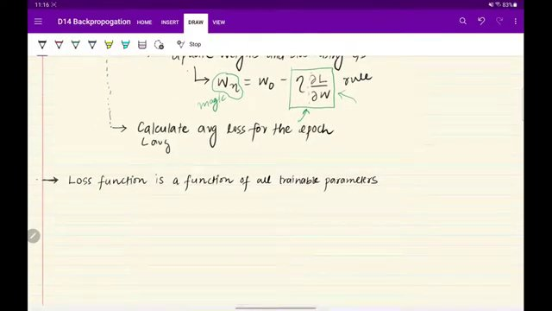

LOSS FUNCTION AND BACKPROPAGATION DIAGRAM. (at 270s)
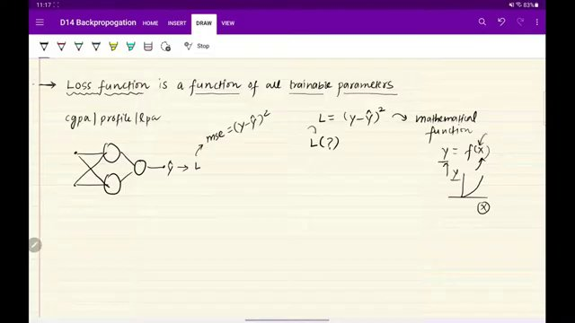

BACKPROPAGATION DIAGRAM AND EQUATIONS. (at 360s)
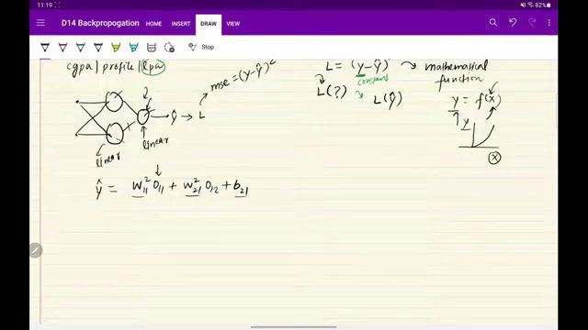

LOSS FUNCTION AND NEURAL NETWORK EQUATIONS. (at 450s)
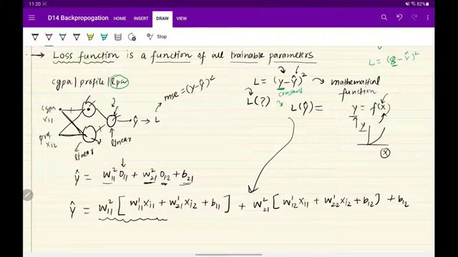

BACKPROPAGATION AND LOSS FUNCTION EQUATIONS. (at 540s)
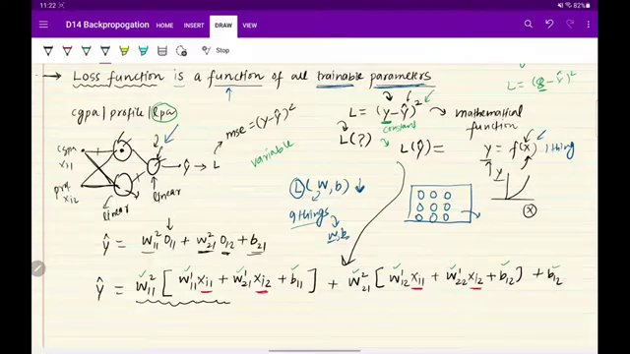

BACKPROPAGATION AND GRADIENT CONCEPTS WITH GRAPHS. (at 855s)
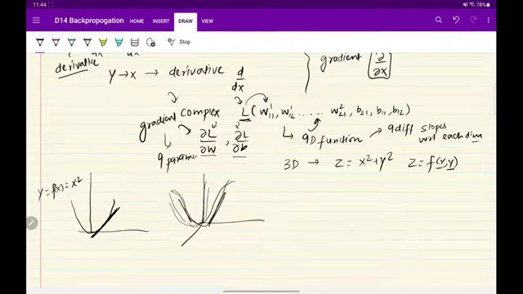

Interview question bank

*Target roles: ML Engineer / Data Scientist / AI Engineer. Questions are sourced from web pages only (not invented).*

Summary table

| Topic | # Companies | # Questions | Top sources |
|-------|-------------|-------------|-------------|
| Backpropagation intuition | 2 | 4 | medium.com, linkedin.com, geeksforgeeks.org, analyticsarora.com, analytixlabs.co |
| Training loop and epochs in neural networks | 1 | 7 | linkedin.com, tryexponent.com, interviewcoder.co, medium.com/@juanc.olamendy, st |
| Loss function as a function of parameters | 1 | 1 | linkedin.com, bugfree.ai, geeksforgeeks.org, towardsdatascience.com |
| Gradient vs derivative | 1 | 1 | linkedin.com, towardsdatascience.com, geeksforgeeks.org |
| Rate of change interpretation of derivative | 0 | 0 | linkedin.com, towardsdatascience.com, linkedin.com/posts/hemansnation |
| Finding minima using derivatives | 0 | 0 | towardsdatascience.com |
| Multivariable minima and gradient | 0 | 0 | towardsdatascience.com |
| Gradient descent update rule | 1 | 2 | linkedin.com, tryexponent.com, devinterview.io, analyticsarora.com, medium.com |
| Negative gradient direction in optimization | 0 | 0 | towardsdatascience.com |
| Learning rate in gradient descent | 0 | 0 | towardsdatascience.com, medium.com/@juanc.olamendy, stackoverflow.com |
| Convergence criteria in gradient descent | 1 | 1 | towardsdatascience.com, medium.com/@juanc.olamendy |
| Visualization tools for neural network training | 0 | 0 | |
| **Total (all in bank)** | 2 | 16 | See sections below |

Coverage report

- Extracted topics: 12
- Questions with attribution: 16
- Excluded (unattributed): 4

**Topic coverage notes:**
Content focuses on mathematical intuition for backpropagation and gradient descent: loss as a function of parameters, derivatives/gradients, minima in one and multiple dimensions, the negative-gradient update rule, learning rate effects, convergence, and brief mention of visualization tools and training loop structure.

Questions by topic → company

Backpropagation intuition

**Nielsen**
- **Q:** Explain backpropagation in simple terms.
- *Role/level:* General ML/DL engineer
- *Source:* https://www.linkedin.com/posts/nihar-penchala_datascience-deeplearning-interviewquestions-activity-7371013068417458176-r2K_
- *Evidence:* Here are today’s 10 interview questions:
...
6. Explain backpropagation in simple terms.

- **Q:** What is the role of hidden states in RNNs?
- *Role/level:* General ML/DL engineer
- *Source:* https://www.linkedin.com/posts/nihar-penchala_datascience-deeplearning-interviewquestions-activity-7372468831006597120-UYX_
- *Evidence:* Here are today’s 10 interview questions:
3. What is the role of hidden states in RNNs?

- **Q:** What is truncated backpropagation through time (BPTT)?
- *Role/level:* General ML/DL engineer
- *Source:* https://www.linkedin.com/posts/nihar-penchala_datascience-deeplearning-interviewquestions-activity-7372468831006597120-UYX_
- *Evidence:* Here are today’s 10 interview questions:
5. What is truncated backpropagation through time (BPTT)?

**Paypay Japan**
- **Q:** How do you understand Backpropagation? Explain the mechanism of action?
- *Role/level:* General ML/DL engineer
- *Source:* https://medium.com/jp-tech/12-deep-learning-interview-questions-you-should-not-be-missed-part-2-8f42deeb4483
- *Evidence:* ## 5. How do you understand Backpropagation? Explain the mechanism of action?

This question aims to test knowledge of how a neural network works.

Convergence criteria in gradient descent

**Nielsen**
- **Q:** Why do RNNs struggle with long-term dependencies?
- *Role/level:* General ML/DL engineer
- *Source:* https://www.linkedin.com/posts/nihar-penchala_datascience-deeplearning-interviewquestions-activity-7372468831006597120-UYX_
- *Evidence:* Here are today’s 10 interview questions:
8. Why do RNNs struggle with long-term dependencies?

Gradient descent update rule

**Nielsen**
- **Q:** Difference between batch gradient descent and stochastic gradient descent (SGD)?
- *Role/level:* General ML/DL engineer
- *Source:* https://www.linkedin.com/posts/nihar-penchala_datascience-deeplearning-interviewquestions-activity-7371013068417458176-r2K_
- *Evidence:* Here are today’s 10 interview questions:
...
8. Difference between batch gradient descent and stochastic gradient descent (SGD)?

- **Q:** Compare RNN vs CNN in handling text or sequences.
- *Role/level:* General ML/DL engineer
- *Source:* https://www.linkedin.com/posts/nihar-penchala_datascience-deeplearning-interviewquestions-activity-7372468831006597120-UYX_
- *Evidence:* Here are today’s 10 interview questions:
6. Compare RNN vs CNN in handling text or sequences.

Gradient vs derivative

**Nielsen**
- **Q:** Explain the vanishing gradient problem in RNNs.
- *Role/level:* General ML/DL engineer
- *Source:* https://www.linkedin.com/posts/nihar-penchala_datascience-deeplearning-interviewquestions-activity-7372468831006597120-UYX_
- *Evidence:* Here are today’s 10 interview questions:
4. Explain the vanishing gradient problem in RNNs.

Loss function as a function of parameters

**Nielsen**
- **Q:** What is the role of loss functions in training a neural network?
- *Role/level:* General ML/DL engineer
- *Source:* https://www.linkedin.com/posts/nihar-penchala_datascience-deeplearning-interviewquestions-activity-7371013068417458176-r2K_
- *Evidence:* Here are today’s 10 interview questions:
...
7. What is the role of loss functions in training a neural network?

Training loop and epochs in neural networks

**Nielsen**
- **Q:** What are epochs, batches, and iterations in DL training?
- *Role/level:* General ML/DL engineer
- *Source:* https://www.linkedin.com/posts/nihar-penchala_datascience-deeplearning-interviewquestions-activity-7371013068417458176-r2K_
- *Evidence:* Here are today’s 10 interview questions:
...
9. What are epochs, batches, and iterations in DL training?

- **Q:** What is the difference between machine learning and deep learning?
- *Role/level:* General ML/DL engineer
- *Source:* https://www.linkedin.com/posts/nihar-penchala_datascience-deeplearning-interviewquestions-activity-7371013068417458176-r2K_
- *Evidence:* Here are today’s 10 interview questions:
1. What is the difference between machine learning and deep learning?

- **Q:** What is a Recurrent Neural Network (RNN), and how is it different from a feedforward NN?
- *Role/level:* General ML/DL engineer
- *Source:* https://www.linkedin.com/posts/nihar-penchala_datascience-deeplearning-interviewquestions-activity-7372468831006597120-UYX_
- *Evidence:* Here are today’s 10 interview questions:
1. What is a Recurrent Neural Network (RNN), and how is it different from a feedforward NN?

- **Q:** How do RNNs handle sequential data like text or time-series?
- *Role/level:* General ML/DL engineer
- *Source:* https://www.linkedin.com/posts/nihar-penchala_datascience-deeplearning-interviewquestions-activity-7372468831006597120-UYX_
- *Evidence:* Here are today’s 10 interview questions:
2. How do RNNs handle sequential data like text or time-series?

- **Q:** What is the difference between one-to-one, one-to-many, many-to-one, many-to-many RNN structures?
- *Role/level:* General ML/DL engineer
- *Source:* https://www.linkedin.com/posts/nihar-penchala_datascience-deeplearning-interviewquestions-activity-7372468831006597120-UYX_
- *Evidence:* Here are today’s 10 interview questions:
7. What is the difference between one-to-one, one-to-many, many-to-one, many-to-many RNN structures?

- **Q:** What are some real-world applications of RNNs?
- *Role/level:* General ML/DL engineer
- *Source:* https://www.linkedin.com/posts/nihar-penchala_datascience-deeplearning-interviewquestions-activity-7372468831006597120-UYX_
- *Evidence:* Here are today’s 10 interview questions:
9. What are some real-world applications of RNNs?

- **Q:** How do bidirectional RNNs improve performance over standard RNNs?
- *Role/level:* General ML/DL engineer
- *Source:* https://www.linkedin.com/posts/nihar-penchala_datascience-deeplearning-interviewquestions-activity-7372468831006597120-UYX_
- *Evidence:* Here are today’s 10 interview questions:
10. How do bidirectional RNNs improve performance over standard RNNs?

Unattributed (excluded from main list)

- **Topic:** Gradient descent update rule — Appears on Exponent as 'Explain gradient descent' with an '(OpenAI)' tag, but the question is hosted on a prep platform rather than quoted as asked at OpenAI in the visible snippet; to avoid over-attribution, it was not tied to a real employer. — _Explain gradient descent._
- **Topic:** Gradient descent update rule — Mentioned as 'Watch an MLE from Snapchat answer this interview question' on Exponent, but the visible text is course marketing rather than the original company-authored question, so attribution to Snap was considered too indirect. — _Explain mini-batch and stochastic gradient descent._
- **Topic:** Backpropagation intuition — Quoted in a narrative on Interview Coder as an example of what interviewers might ask but not tied to a specific company or presented as an actual sourced question. — _Can you walk me through how backpropagation works?_
- **Topic:** Gradient descent update rule — Appears as a rhetorical section heading in a Towards Data Science article rather than as a documented interview question from a real employer. — _So, we’ve set up the loss function to measure how different our predictions are from actual results. To close this gap, we adjust the model’s parameters. Why do most algorithms use gradient descent fo_

