YouTube Notes 7z6yXpYk7sw

Metadata
Created at: 2026-03-18 16:25:42
Video ID: 7z6yXpYk7sw

Notes

Gradient Descent: Batch, Stochastic, and Mini‑Batch

Gradient Descent Basics
- Gradient descent is an optimization algorithm used to minimize an objective (loss) function and is commonly used to optimize neural networks.
- Goal: minimize loss `L` with respect to model parameters (weights, biases).
- Update rule: `w_new = w_old - η * (∂L/∂w_old)` and similarly for biases; `η` is the learning rate.
- Conceptual view: follow the negative gradient (downhill direction of the loss surface) to reach a minimum.
- In neural networks (via backpropagation):
- For each data point (or set of points), compute predictions.
- Compute loss.
- Compute gradients via derivatives (backprop).
- Update weights and biases via gradient descent.
- The whole weight-update procedure in backprop is an application of gradient descent.

Three Variants of Gradient Descent
- Variants differ only in how much data they use to compute the gradient at each update step.
- Three types:
- Batch gradient descent (also called vanilla gradient descent).
- Stochastic gradient descent (SGD).
- Mini‑batch gradient descent.
- Key differentiator: based on the amount of data used to compute the gradient between two successive parameter updates.

---

Batch Gradient Descent (Vanilla Gradient Descent)

Core Idea
- Use the entire dataset to compute the gradient, then update parameters once per epoch.
- For dataset with `N` rows (data points):
- Per epoch, compute predictions for all `N` points at once.
- Compute a *single* overall loss (e.g., sum or mean over all `N` points).
- Perform *one* weight & bias update per epoch.

Vectorization
- Implementation uses vectorized operations (dot products) to avoid explicit inner loops over data points.
- For inputs `X` (shape `N × d`) and weights `W`:
- Compute predictions: `y_hat = X · W + b` in one shot.
- You get a vector of `N` predictions.
- Loss is computed over all these predictions (e.g., `Σ loss_i` from `i = 1` to `N`).
- Based on this single aggregated loss, update `W` and `b` once.

Update Count
- If you run for `E` epochs and dataset has `N` points:
- Number of weight updates = `E` (independent of `N`).
- Compared to point‑wise methods:
- In per‑sample updating, one epoch causes `N` updates.
- In batch gradient descent, one epoch causes 1 update.
- In terms of notation from the transcript:
- `number_of_updates = number_of_epochs` (for batch gradient descent).
- `number_of_updates = number_of_epochs × number_of_rows` (for sample‑wise/SGD).

Example (with code logic)
- Pseudocode for batch gradient descent:
- Decide `epochs = T`.
- For `epoch` in `range(T)`:
- Use *entire* dataset `X` and `y`:
- `y_hat = X · W + b` (dot product).
- Compute `loss` over all samples.
- Compute gradients using this loss.
- Update `W` and `b` once.

Performance Comparison (Time)
- With same number of epochs and same dataset size:
- Batch gradient descent performs fewer updates than SGD:
- Batch: `E` updates.
- SGD: `E × N` updates.
- Therefore, in terms of *wall‑clock training time* for a fixed number of epochs, batch gradient descent is typically faster than SGD.
- Demonstrated with Keras example:
- Using `batch_size = N` ⇒ batch gradient descent.
- Using `batch_size = 1` ⇒ stochastic gradient descent.
- Batch (`batch_size = N`) ran much faster (e.g., ~0.5 seconds) compared to SGD (`batch_size = 1`, ~10 seconds) for the same number of epochs.

Convergence Behavior
- If you compare both algorithms for the *same number of epochs*:
- Batch is faster in **time** to complete those epochs.
- If you consider **number of parameter updates** instead:
- SGD does many more updates per epoch.
- For the *same number of epochs*, SGD may reach a good solution in fewer epochs than batch.
- But each epoch of SGD is more expensive (more updates) than batch’s single update.

Loss Curve Stability
- Batch gradient descent:
- Loss typically decreases smoothly over epochs.
- Few or no random spikes; trajectory is stable.
- Behavior reason:
- Each step uses the full dataset, so gradient represents all points and is stable.

Vectorization Trade‑off
- Vectorization (dot products instead of explicit loops) is much faster computationally than looping in Python.
- But:
- Full batch gradient descent must load the entire dataset into memory at once.
- For very large datasets (e.g., millions of rows), this may not fit in RAM.
- In such cases, pure batch gradient descent is not feasible.

---

Stochastic Gradient Descent (SGD)

Core Idea
- Use *one* randomly selected data point at a time to compute the gradient and update parameters.
- Per update:
- Shuffle data (or otherwise randomize order).
- Pick 1 sample.
- Compute its prediction.
- Compute its loss.
- Compute gradients based on that single sample.
- Immediately update weights and biases.

Update Count
- For dataset with `N` rows and `E` epochs:
- Each epoch: loop over all `N` rows sample‑by‑sample.
- Number of updates per epoch = `N`.
- Total updates = `E × N`.
- In transcript terms:
- If there are 10 epochs and 50 rows:
- Updates = `10 × 50 = 500` times.

Pseudocode Logic
- Decide epochs `T`.
- Outer loop: `for epoch in range(T)`:
- Optionally shuffle dataset once per epoch.
- Inner loop: over each row `i` (or pick random indices one by one):
- Take a single point:
- `x_i`, `y_i`.
- Compute `y_hat_i` for that point.
- Compute `loss_i`.
- Compute gradient based on `loss_i`.
- Update `W` and `b` using `loss_i`’s gradient.

Properties of the Updates
- Update frequency:
- Much higher than batch gradient descent.
- Hence often faster convergence (in terms of *number of epochs* needed to get near a good solution).
- Shuffling (randomization):
- Done to avoid bias from always seeing data in the same order.
- Random point selection or shuffled order helps reduce systematic biases.

Convergence Speed vs Time
- **Convergence in terms of epochs / updates:**
- For the same number of epochs, SGD tends to move towards the solution faster than batch, because:
- It updates far more often (per epoch).
- **Wall‑clock time per epoch:**
- SGD takes more time than batch:
- More individual updates.
- Demonstrated in Keras example: `batch_size = 1` used ~10 seconds where batch used ~0.5 seconds for the same epochs.

Loss Curve Shape
- SGD’s loss curve is typically noisy:
- Shows spikes and oscillations.
- Loss may go up and down while overall trending downward.
- Explanation:
- Each update’s direction is determined by a single random sample.
- That sample’s gradient may not represent the full dataset direction, causing zig‑zagging.

2D/3D Intuition (Local vs Global Minimum)
- Imagine a 3D loss surface with multiple minima:
- Global minimum: best possible.
- Local minima: suboptimal basins.
- Batch gradient descent:
- Moves smoothly downhill.
- If it falls into a local minimum, it may stay there (no inherent randomness to escape).
- SGD:
- Due to noise and randomness in updates, its path looks jittery, like a drunk walk.
- This randomness can:
- Help jump out of local minima.
- Allow reaching closer to the global minimum.
- Trade‑off:
- Benefit: ability to escape local minima and explore more of the loss landscape.
- Drawback: may not converge exactly/stably to the best point; may keep oscillating around it and give an approximate solution rather than a perfectly stable one.

---

Comparing Batch vs Stochastic Gradient Descent

Update Frequency
- Batch:
- Updates per epoch = 1.
- SGD:
- Updates per epoch = number of rows `N`.
- Consequence:
- SGD has higher frequency of weight updates; moves parameters more often.

Time per Epoch vs Convergence per Epoch
- Time to run 1 epoch:
- Batch is faster; fewer updates.
- SGD is slower; many more updates.
- Convergence toward good weights (if measured per epoch):
- SGD usually converges in fewer epochs than batch because of more updates.
- Overall judgment:
- If you fix *number of epochs*, batch finishes faster in wall‑clock time.
- If you fix *number of updates* or look at how quickly loss decreases *per update*, SGD can reach good regions faster.

Stability of Loss
- Batch:
- Stable, smooth decrease.
- SGD:
- Noisy, with spikes and oscillations.

Local Minima and Randomness
- Batch:
- May get stuck in local minima; low randomness.
- SGD:
- Randomness can:
- Help escape local minima.
- But also hinder precise convergence.

Memory and Vectorization
- Batch:
- Uses full vectorization (dot products) over the whole dataset.
- Requires loading the entire dataset into memory.
- Not suitable for very large datasets that don’t fit into RAM.
- SGD:
- Processes one sample at a time; doesn’t need the full dataset in memory simultaneously.
- But doesn’t fully exploit vectorization on the entire dataset in a single operation.

---

Mini‑Batch Gradient Descent

Motivation
- Need a method that:
- Is faster (like batch, leveraging vectorization).
- Has better convergence qualities (like SGD, more frequent updates).
- Avoids huge memory requirements of full batch.
- Mini‑batch gradient descent is the middle ground between batch and SGD.

Core Idea
- Split the dataset into small batches (mini‑batches) of size `B`.
- For each mini‑batch:
- Use vectorized operations across that mini‑batch.
- Compute predictions and loss for those `B` samples.
- Compute gradient from only those `B` samples.
- Update weights and biases once per mini‑batch.
- Repeat this across all mini‑batches in an epoch.

Example of Batch Partitioning
- Dataset has 320 rows; choose `batch_size = 32`:
- Total number of mini‑batches per epoch: `320 / 32 = 10`.
- For each inner step:
- Work on 32 rows.
- Perform vectorized forward, loss, gradient, and 1 update.
- Per epoch:
- Number of updates = 10.

- If dataset has 400 rows and `batch_size = 150`:
- Theoretical division: `400 / 150 ≈ 2.66`.
- Actual batches:
- Batch 1: 150 rows.
- Batch 2: 150 rows.
- Batch 3: remaining 100 rows.
- So 3 batches, 3 updates per epoch.

General Formulas
- Given:
- `N` = number of rows in dataset.
- `B` = batch size.
- Number of mini‑batches per epoch:
- `num_batches = ceil(N / B)`.
- Number of updates per epoch:
- Equals `num_batches`.
- Total updates over `E` epochs:
- `E × num_batches`.

Relationship to Batch and SGD
- When `batch_size = N`:
- Mini‑batch becomes batch gradient descent.
- When `batch_size = 1`:
- Mini‑batch becomes stochastic gradient descent.
- In typical practice:
- Choose `1 < batch_size < N`, giving behavior between the two extremes.

Speed and Convergence Ordering
- Speed (per epoch, wall‑clock time), for same epochs:
- Fastest: batch gradient descent (fewest updates).
- Middle: mini‑batch gradient descent.
- Slowest: SGD (most updates).
- Convergence speed (towards solution), for same epochs:
- Slowest: batch gradient descent (fewest updates per epoch).
- Middle: mini‑batch gradient descent.
- Fastest: SGD (most updates per epoch).
- Loss curve smoothness:
- Batch: smooth.
- Mini‑batch: moderately noisy.
- SGD: highly noisy.

Memory & Vectorization Advantages
- Mini‑batch uses vectorization on batch chunks (dot product on `B` rows at a time).
- Only a subset of data needs to be in memory at a time, so:
- It scales better to large datasets than full batch.
- Still gets benefits of:
- Faster computation from vectorization.
- Some noise from smaller samples, helping with generalization and escaping local minima.

Practical Default
- In practice, “gradient descent” in deep learning almost always means mini‑batch gradient descent.
- Frameworks (like Keras) use the `batch_size` parameter:
- `batch_size = N` ⇒ batch gradient descent.
- `batch_size = 1` ⇒ SGD.
- Intermediate values ⇒ mini‑batch.

---

`batch_size` in Keras / Training APIs

Interpretation of `batch_size`
- `batch_size` controls gradient descent variant:
- `batch_size = total_number_of_rows`:
- All rows in one batch ⇒ batch gradient descent.
- `batch_size = 1`:
- Each row individually ⇒ stochastic gradient descent.
- `1 < batch_size < N`:
- Mini‑batch gradient descent.
- For dataset with 320 rows:
- `batch_size = 320` ⇒ 1 update/epoch (batch).
- `batch_size = 1` ⇒ 320 updates/epoch (SGD).
- `batch_size = 32` ⇒ 10 updates/epoch (mini‑batch).

Choosing `batch_size` as a Power of Two
- Common practice: choose batch sizes as powers of two (e.g., 8, 16, 32, 64, 128, 256).
- Reason (as described):
- System memory and hardware architectures are optimized for binary sizes.
- Powers of 2 often utilize RAM more effectively and can give performance improvements.
- Not strictly required:
- You *can* set `batch_size` to any integer (e.g., 10, 15).
- Powers of 2 are a performance optimization, not a hard rule.

Non‑Divisible `batch_size`
- If `N` is not perfectly divisible by `batch_size`:
- Final batch may contain fewer rows.
- Example (`N = 40`, `batch_size = 10`):
- 4 batches of size 10 (perfect division) ⇒ 4 updates.
- Example (`N = 40`, `batch_size = 18`):
- Batches:
- Batch 1: 18 rows.
- Batch 2: 18 rows.
- Batch 3: 4 rows.
- Total: 3 updates per epoch.
- General behavior:
- Last batch is simply smaller; training still uses all remaining rows.

---

Summary of Trade‑offs

Batch Gradient Descent
- Pros:
- Fast per epoch (few updates).
- Smooth, stable convergence.
- Clean gradient estimates.
- Cons:
- Requires full dataset in memory.
- Can get stuck in local minima.
- Fewer updates per epoch; slower progress in terms of updates.

Stochastic Gradient Descent (SGD)
- Pros:
- Many updates per epoch; can approach solutions with fewer epochs.
- Randomness helps escape local minima.
- Cons:
- Noisy loss curve; convergence less stable.
- More time per epoch due to many updates.
- May only converge to approximate neighborhood, not a perfectly stable point.

Mini‑Batch Gradient Descent
- Pros:
- Middle ground: gets stability + randomness.
- Leverages vectorization on small chunks.
- Works on larger datasets without requiring full dataset in memory.
- Typically used in practice: “best of both worlds.”
- Cons:
- Not as smooth as full batch, and not as exploratory (random) as pure SGD.
- Choice of `batch_size` is an extra hyperparameter to tune.

Key images
GRADIENT DESCENT EXPLANATION TEXT. (at 43s)
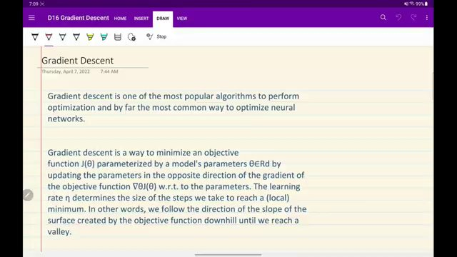

GRADIENT DESCENT UPDATE EQUATION AND COMPARISON NOTE. (at 1090s)
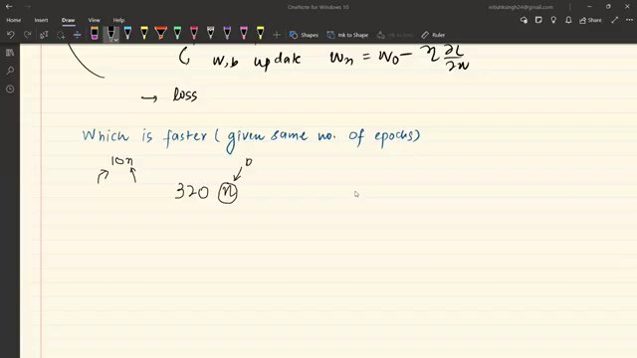

COMPARISON OF TRAINING SPEEDS GIVEN SAME NUMBER OF EPOCHS. (at 1165s)
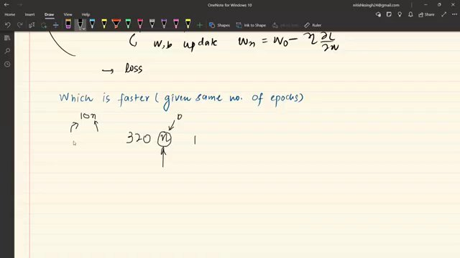

"TRAINING LOSS PLOT AND ACCURACY METRICS OUTPUT" (at 1423s)
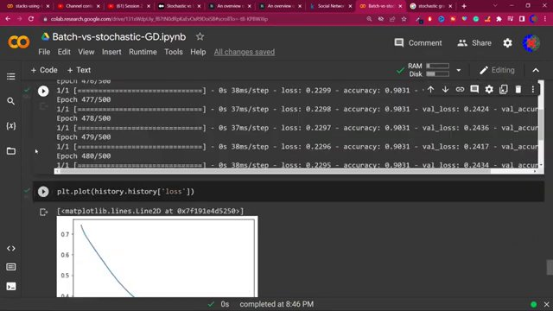

BATCH SIZE CALCULATION EXAMPLE. (at 2259s)
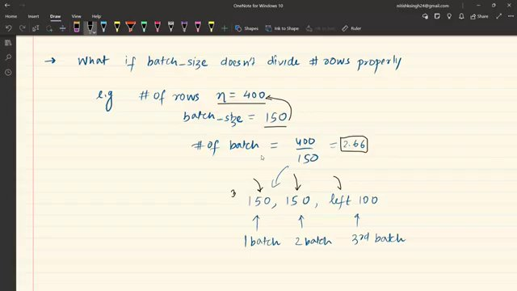

Interview question bank

*Target roles: ML Engineer / Data Scientist / AI Engineer. Questions are sourced from web pages only (not invented).*

> **No attributed questions were extracted.** For reliable results, set **`TAVILY_API_KEY`** in `.env` (Tavily search + full-page extract). DuckDuckGo-only mode often returns snippets too short to tie questions to a company.

Summary table

| Topic | # Companies | # Questions | Top sources |
|-------|-------------|-------------|-------------|
| Gradient descent basics | 0 | 0 | |
| Loss function and objective minimization | 0 | 0 | |
| Gradient descent update rule and learning rate | 0 | 0 | |
| Backpropagation as gradient descent | 0 | 0 | |
| Gradient descent variants | 0 | 0 | |
| Batch gradient descent | 0 | 0 | |
| Stochastic gradient descent | 0 | 0 | |
| Mini-batch gradient descent | 0 | 0 | |
| Vectorization in gradient computations | 0 | 0 | |
| Update frequency and convergence behavior | 0 | 0 | |
| Loss curve stability and local minima | 0 | 0 | |
| Batch size hyperparameter and its effects | 0 | 0 | |
| Choosing batch size as power of two | 0 | 0 | |

Coverage report

- Extracted topics: 13
- Questions with attribution: 0
- Excluded (unattributed): 0

**Topic coverage notes:**
Content centers on gradient descent and its three variants (batch, stochastic, mini‑batch), with emphasis on update rules, batch_size behavior in frameworks, vectorization, convergence properties, and practical engineering trade‑offs such as memory and power‑of‑two batch sizes.

Questions by topic → company

