YouTube Notes Lu2bruOHN6g

Metadata
Created at: 2026-03-24 18:01:17
Video ID: Lu2bruOHN6g

Notes

Perceptron Training: Intuition, Geometry, and Algorithm

Goal of the Lecture
- Focus: How to train perceptron weights and biases (how to find their values).
- Plan:
- Build mathematical intuition from geometry.
- Translate intuition into code.
- Visualize the process with an animation.

Linear Separability and Decision Boundary
- Data is assumed linearly separable:
- You can draw a line that correctly separates data into two classes.
- Objective:
- Find a line that properly classifies points into two classes (e.g., blue vs green).
- Start from a bad/random line and iteratively move it to a good one.

Misclassified Points and Line Adjustment (Intuition)
- Consider:
- The line says a point is green region, but in truth the point is blue (misclassified).
- Strategy:
- Each misclassified point “complains” and asks the line to move/rotate so it comes to the correct side.
- Repeatedly:
- Randomly select a point (student).
- If misclassified, adjust the line towards/away from that point.
- After enough iterations, the line converges and loop stops.

Positive vs Negative Region for a Line
- Line equation (generic): `a x + b y + c = 0`.
- Positive region:
- Defined as set of `(x, y)` where `a x + b y + c > 0`.
- Negative region:
- Defined as set of `(x, y)` where `a x + b y + c < 0`.
- Example 1:
- Line: `2x + 3y + 5 = 0`.
- Positive region: `2x + 3y + 5 > 0` (blue shaded region).
- Example 2:
- Line: `-2x + 3y - 5 = 0`.
- Positive region: `-2x + 3y - 5 > 0`.

How to Check Which Side a Point Lies On
- Given:
- Line: `a x + b y + c = 0`.
- A point `(x₀, y₀)`.
- Procedure:
- Compute `value = a x₀ + b y₀ + c`.
- If `value > 0` → point in positive region.
- If `value < 0` → point in negative region.

Types of Transformations of a Line
- General linear form: `a x + b y + c = 0`.

1. Change in `c` (translation)
- When you vary `c`:
- Line moves parallel up/down.
- Example:
- `2x + 3y + 5 = 0` vs `2x + 3y + 0 = 0`.
- Decreasing `c` (e.g., from 5 to 0) moves line up.
- Increasing `c` moves line down.

2. Change in `a` or `b` (rotation)
- Example:
- Original red line: `2x + y + 5 = 0`.
- Changing coefficient of `x` or `y` rotates the line.
- Combined effect:
- Adjusting `a`, `b`, `c` together gives a generic transformation (rotation + translation).

Moving the Line Towards/From a Point
- Idea:
- If a point is on the wrong side, move the line towards that point to correct classification.
- Given a misclassified point `(x₁, y₁)`:
- Think in terms of adding the coordinates of the point to the coefficients.
- In raw intuition (before scaling):
- Add/subtract `x₁, y₁, 1` to coefficients to shift line.

Direction of Movement: Positive vs Negative Region
- If a negative point lies in the positive region:
- Want to move boundary towards negative region (so point becomes negative-side).
- Transformation sign (add or subtract) is chosen so the line moves towards negative side.
- If a positive point lies in the negative region:
- Want to move boundary towards positive region.

- Rule (high level):
- Move line towards the correct region:
- Moving towards negative region: use `+` sign in update.
- Moving towards positive region: use `−` sign in update.
- This is tied to whether the point is positive/negative and where it is currently classified.

Perceptron Model Formulation
- Model line: `w₀ + w₁ x₁ + w₂ x₂ = 0`.
- `w₀` is bias (intercept).
- `w₁, w₂` are weights.
- Input vector:
- Define `x₀ = 1` always.
- So model is: `w₀ x₀ + w₁ x₁ + w₂ x₂ = 0`.
- Prediction rule:
- Compute `z = w₀ x₀ + w₁ x₁ + w₂ x₂`.
- If `z ≥ 0` → prediction = 1 (e.g., placement will happen).
- If `z < 0` → prediction = 0 (e.g., placement will not happen).

Dataset Interpretation Example
- Suppose:
- Each point is a student.
- Input features: `x₁`, `x₂` (e.g., marks, skills).
- Label `y`:
- `1` → student placed (positive).
- `0` → not placed (negative).
- Geometry:
- One side of the line (positive region) = predicted “placed”.
- Other side (negative region) = predicted “not placed”.

Misclassification Cases (Geometric View)
- Case 1: True negative, predicted positive
- Student actually not placed (`y = 0`), but `z ≥ 0` (model says placed).
- Interpretation:
- Negative point in positive region.
- Need to update `w` to move line towards negative region (bring that point to correct side).

- Case 2: True positive, predicted negative
- Student actually placed (`y = 1`), but `z < 0` (model says not placed).
- Interpretation:
- Positive point in negative region.
- Need to update `w` to move line towards positive region.

- Case 3: Correctly classified
- True positive in positive region or true negative in negative region.
- No weight update ideally needed (line already correct wrt that point).

Learning Rate and Small-Step Updates
- Do not apply huge transformations in one step.
- Introduce learning rate `η`:
- `η` is a small number (e.g., 0.01, 0.1, etc.).
- Scheme:
- Scale point coordinates by `η` before updating weights.
- General pattern:
- `w_new = w_old − η × (something based on point and label)`.

Weight Update Rule (Matrix Form Intuition)
- Pack parameters and input:
- `w = [w₀, w₁, w₂]`.
- `x = [x₀, x₁, x₂]` with `x₀ = 1`.
- Intuitive rule for misclassified point:
- Form appears as:
- `w_new = w_old ± η × x`.
- Sign (`+` or `−`) chosen based on:
- Whether we need to move towards positive or negative region.

Simplifying the Algorithm (Avoiding Explicit Conditions)
- Theoretical full logic:
- Would check:
- (1) Negative point in positive region.
- (2) Positive point in negative region.
- And then choose update sign accordingly (two conditions).
- Simplified strategy:
- Use a single unified rule involving the label:
- Use label `y` and prediction `ŷ` implicitly in formula.
- In practice, loop:
- For each iteration:
- Randomly select a student.
- Compute prediction.
- Update weights using a single generic rule, without writing explicit `if` for both misclassification types in code (though conceptually they exist).

Canonical Perceptron Update (Implied)
- Conceptual rule (described verbally):
- Update weights depending on whether point is misclassified:
- If positive in negative region → adjust in positive direction.
- If negative in positive region → adjust in negative direction.
- This is compactly expressed as:
- `w_new = w_old + η × (y − ŷ) × x`.
- In the explanation:
- For positive misclassified as negative → effectively `w_new = w_old + η x`.
- For negative misclassified as positive → effectively `w_new = w_old − η x`.

High-Level Algorithm (Training Loop)
- Inputs:
- `X`: matrix of inputs (`N` rows, 2 feature columns `x₁`, `x₂`).
- `y`: output labels (0 or 1).
- Initialize:
- `w = [w₀, w₁, w₂]` with small random or zero values.
- Choose learning rate `η`.
- Loop:
- For `epoch` in range of epochs (e.g., 1000):
- Randomly select a training index `i` between `0` and `N−1`.
- Form `x = [1, X[i,0], X[i,1]]`.
- Compute `z = w ⋅ x`.
- Compute prediction: `ŷ = 1` if `z ≥ 0` else `0`.
- Update `w` with unified rule based on `x`, `y[i]`, and `ŷ`.
- Output:
- Final `w` (weights and bias/intercept).

Implementation Details Mentioned
- A function `perceptron(X, y)` is defined:
- Takes:
- `X`: 2-column input features.
- `y`: 0/1 output labels.
- Returns:
- Learned weights `w₁, w₂`.
- Intercept `w₀`.
- Setup:
- Initial `weights = [w₀, w₁, w₂]` as an array.
- `learning_rate = η`.
- Number of data points, e.g. 100 (`N = 100`).
- Inside training:
- `idx = random integer between 0 and N−1`.
- `x` is constructed with `x₀ = 1` and `x₁, x₂` from `X[idx]`.
- Use dot product: `z = weights ⋅ x`.
- Apply step function for prediction.
- Apply update rule to `weights`.

Extracting Line Parameters for Plotting
- Given learned coefficients:
- Line equation: `a x + b y + c = 0`.
- Slope `m = −a / b`.
- Intercept `intercept_on_y_axis = −c / b`.
- In context:
- `a = w₁`, `b = w₂`, `c = w₀`.
- These are used to draw line on a 2D plot to visualize classification boundary.

Visual Behavior of Training
- Visual dynamics:
- Initially line may not move if early sampled points are correctly classified.
- Once a misclassified point is encountered:
- That point “pulls” the line towards itself (depending on sign rule).
- Line rotates/translates accordingly.
- Over many random selections and updates:
- Line adjusts until it separates positive and negative points correctly.

Key images
"HOW TO LABEL REGIONS? DIAGRAM" (at 634s)
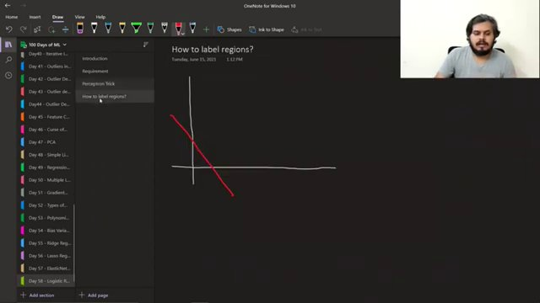

GRAPH OF LINEAR INEQUALITIES IN DESMOS. (at 788s)
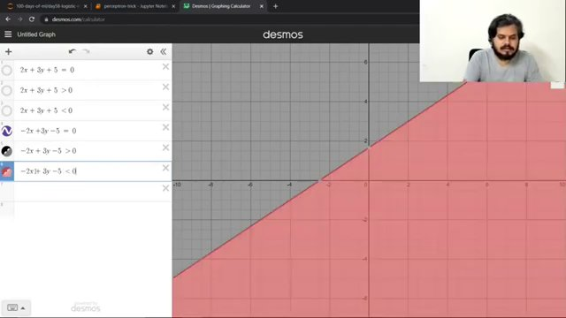

"TRANSFORMATIONS DIAGRAM WITH POINTS AND LINES" (at 1033s)
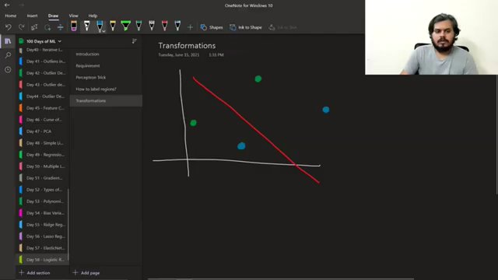

GRAPH OF LINEAR EQUATIONS WITH PLOTTED POINTS. (at 1241s)
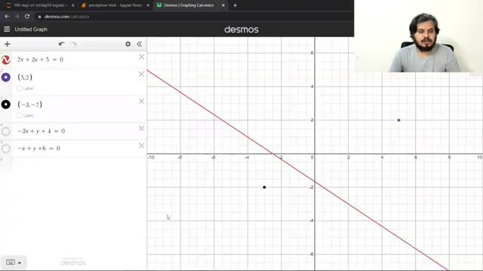

GRAPHING INEQUALITIES ON DESMOS. (at 1407s)
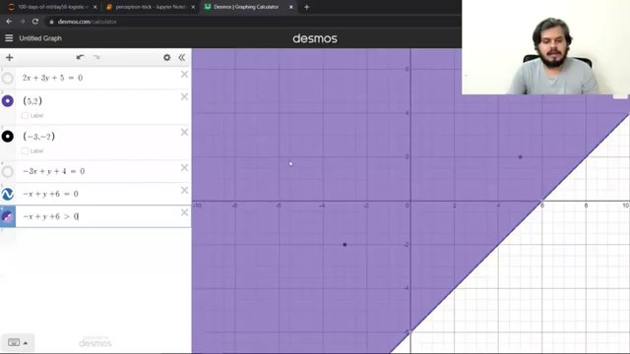

EQUATION AND DIAGRAM ON PERCEPTION TRICK. (at 2969s)
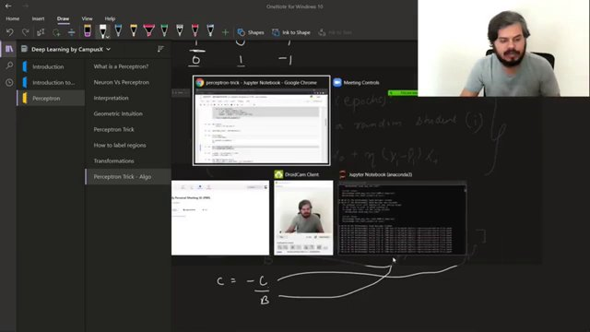

Interview question bank

*Target roles: ML Engineer / Data Scientist / AI Engineer. Questions are sourced from web pages only (not invented).*

Summary table

| Topic | # Companies | # Questions | Top sources |
|-------|-------------|-------------|-------------|
| Perceptron training and learning algorithm | 0 | 0 | appliedaicourse.com |
| Linear separability and decision boundary | 1 | 2 | kavitagupta.substack.com, thomascountz.com |
| Positive and negative regions of a linear classifier | 0 | 0 | |
| Geometric transformations of a line | 0 | 0 | |
| Misclassification handling in perceptron | 0 | 0 | |
| Perceptron weight update rule | 1 | 1 | kavitagupta.substack.com |
| Learning rate in perceptron training | 0 | 0 | |
| Perceptron model and prediction rule | 1 | 3 | kavitagupta.substack.com, appliedaicourse.com, thomascountz.com |
| Stochastic training loop for perceptron | 0 | 0 | |
| Perceptron implementation in code | 0 | 0 | |
| Interpreting perceptron as line parameters for plotting | 0 | 0 | |
| Geometric intuition of perceptron training | 0 | 0 | |
| **Total (all in bank)** | 1 | 6 | See sections below |

Coverage report

- Extracted topics: 12
- Questions with attribution: 6
- Excluded (unattributed): 4

**Topic coverage notes:**
The material centers on geometric intuition and implementation of the perceptron learning algorithm: linear separability, positive/negative regions, line transformations, misclassification-driven updates, learning rate, and a stochastic training loop with code. All topics are tightly related to perceptron training rather than broader deep learning architectures.

Questions by topic → company

Linear separability and decision boundary

**N/A**
- **Q:** What is meant by the data is linearly separable?
- *Role/level:* N/A
- *Source:* https://kavitagupta.substack.com/p/interview-questions-with-answers
- *Evidence:* ### **3. What is meant by the data is linearly separable?**

***Answer:*** The dats is said to be linearly separable if we can divide its data points into mutually exclusive classes using a hyperplane.

- **Q:** Can perceptrons handle non-linearly separable data?
- *Role/level:* N/A
- *Source:* https://kavitagupta.substack.com/p/interview-questions-with-answers
- *Evidence:* ### **5. Can perceptrons handle non-linearly separable data?**

***Answer.*** No. Perceptrons are inherently designed to solve problems with linearly separable data only.

Perceptron model and prediction rule

**N/A**
- **Q:** What is a perceptron?
- *Role/level:* N/A
- *Source:* https://kavitagupta.substack.com/p/interview-questions-with-answers
- *Evidence:* ### **1. What is a perceptron?**

***Answer:*** A perceptron is the earliest and simplest form of a neural network.

- **Q:** What are the components of a perceptron?
- *Role/level:* N/A
- *Source:* https://kavitagupta.substack.com/p/interview-questions-with-answers
- *Evidence:* ### **2. What are the components of a perceptron?**

***Answer:*** The components of a perceptron are given below:

- **Q:** Which activation function is generally used in a perceptron?
- *Role/level:* N/A
- *Source:* https://kavitagupta.substack.com/p/interview-questions-with-answers
- *Evidence:* ### **4. Which activation function is generally used in a perceptron?**

***Answer:*** The most commonly used activation function in a perceptron is ‘step function’.

Perceptron weight update rule

**N/A**
- **Q:** What is the weights update rule in a perceptron?
- *Role/level:* N/A
- *Source:* https://kavitagupta.substack.com/p/interview-questions-with-answers
- *Evidence:* ### **6. What is the weights update rule in a perceptron?**

***Answer.*** weight = weight + learning_rate*(actual_value - predicted_value)*input

Unattributed (excluded from main list)

- **Topic:** Perceptron training and learning algorithm — Explained in narrative form at appliedaicourse.com but never posed as an interview question; inventing this wording would violate the requirement that question_text must appear verbatim. — _How does the Perceptron work?_
- **Topic:** Perceptron implementation in code — Mentioned as future content in the Substack newsletter but not actually present as a question in the provided text. — _Implement a perceptron from scratch in Python._
- **Topic:** Interpreting perceptron as line parameters for plotting — Thomas Countz article explains the calculation but does not phrase it as a question; adding a question would be fabricated. — _How do you calculate the decision boundary of a perceptron?_
- **Topic:** Learning rate in perceptron training — Learning rate is implied in perceptron update discussions but no explicit interview-style question is present in the sources. — _What is the role of learning rate in perceptron training?_

