YouTube Notes Ue_6n1yT_R8

Metadata
Created at: 2026-03-22 14:52:16
Video ID: Ue_6n1yT_R8

Notes

Improving Neural Network Performance – Roadmap & Key Concepts

Recap of Previous Content
- Covered basics of deep learning and artificial neural networks.
- Studied:
- What is deep learning.
- Perceptron.
- Multilayer Perceptron (MLP) construction using perceptrons.
- Forward propagation (prediction process).
- Training MLP via backpropagation.
- Two critical mathematical tools: chain rule and gradient descent.
- Implemented basic projects in Keras and saw that reaching “some” accuracy is easy; real challenge is improving performance further (e.g., from 90% to 92%).

Overall Goal & Roadmap
- Objective: Given an already trained neural network, learn techniques to improve its performance.
- Next 10–15 videos (conceptually) focus on:
- How to tune and improve an artificial neural network’s performance.
- High-level overview now, detailed video per technique later.
- Two major levers for performance improvement:
1. Hyperparameter tuning.
2. Handling core training problems (vanishing/exploding gradients, data scarcity, slow training, overfitting).

---

Key Hyperparameters to Tune
- Hyperparameters: Values chosen by the deep learning engineer, not learned by the model.
- Important hyperparameters listed:
- Number of hidden layers.
- Number of neurons per hidden layer.
- Learning rate.
- Optimizer.
- Batch size.
- Activation functions.
- Number of epochs.

Impact of Good Hyperparameter Choices
- Correctly setting these hyperparameters substantially improves performance even with the same architecture.
- If you can:
- Choose good values for:
- Number of hidden layers.
- Neurons per layer.
- Learning rate.
- Optimizer.
- Batch size.
- Activation functions.
- Epochs.
- Then performance will “by default” improve relative to naive choices.

---

Core Training Problems to Address
- Even with well-chosen hyperparameters, neural networks can suffer from inherent issues:
1. **Vanishing gradients**:
- Gradients become very small as backprop moves towards earlier layers (especially with sigmoid).
- Weight updates become negligible → training effectively stops.
2. **Data scarcity (not enough data)**:
- Deep learning is “data-hungry”.
- Performance degrades when training data is limited.
3. **Slow training**:
- Training takes a long time; need techniques to speed up convergence without hurting performance.
4. **Overfitting**:
- Too many parameters (e.g., millions of weights in deep networks) relative to data.
- Model fits training data too well and fails to generalize.

- Plan:
- Discuss each problem at a high level.
- Later, cover detailed solutions in separate sessions.

---

Hyperparameter 1: Number of Hidden Layers
- Neural network layers:
- Input layer: where data enters.
- Output layer: where predictions are produced.
- Hidden layers: intermediate computation layers (core of feature learning).
- Question: How many hidden layers should be used?

Strategy: Deeper vs. Wider
- You could use:
- Single hidden layer with many neurons, or
- Multiple hidden layers with fewer neurons each.
- Empirical insight:
- Using multiple hidden layers with moderate neurons (deeper networks) tends to work better than a single very wide layer.

Representation Learning
- Deep learning leverages **representation learning**:
- Early (lower) layers learn **primitive features**:
- Edges, simple lines, very basic shapes.
- Middle layers combine primitive features into **patterns**:
- Shapes, parts of objects, facial regions.
- Deeper layers combine patterns into **complex concepts**:
- Whole faces, objects, and high-level abstractions.
- Deeper architectures (more hidden layers) capture:
- Hierarchical structure of data.
- Increasingly complex patterns.

Practical Guideline for Number of Hidden Layers
- Prefer **more hidden layers** with **fewer neurons each**, rather than one huge layer.
- How many layers is “enough”?
- Keep adding layers and experimenting until you start seeing **overfitting**.
- Once overfitting appears:
- Stop increasing the depth.
- Overfitting acts as a practical stopping criterion for depth.

---

Transfer Learning (Linked to Depth)
- Transfer learning: reuse knowledge from one trained model on a similar new task.
- Scenario:
- Model A trained for human face detection.
- New task: detect monkey faces.
- Approach:
- Keep **early layers** (which already capture generic primitives: lines, edges, simple shapes).
- Replace or retrain **later layers** for the new specific task (monkey faces).
- Benefit:
- Saves training time.
- Leverages previously learned generic features.
- Connection:
- Reinforces why we want deeper networks: different layers capture different levels of abstractions, enabling transfer learning.
- Guideline:
- Maintain **more hidden layers** with moderate neurons, instead of fewer extremely wide layers.

---

Hyperparameter 2: Number of Neurons per Layer

Input and Output Layers
- Input layer:
- Number of neurons fixed by input features.
- Example: If input has 2 features (e.g., CGPA and IQ), input layer has 2 neurons.
- Output layer:
- Determined by problem type:
- Regression: usually 1 neuron.
- Binary classification: 1 neuron (with appropriate activation).
- Multiclass classification: `#classes` neurons.

Hidden Layers – Neurons per Layer
- No strict formula/closed rule.
- Historical heuristic: **pyramid rule**:
- If you have 3 hidden layers:
- Layer 1: more neurons (e.g., 64).
- Layer 2: fewer (e.g., 32).
- Layer 3: even fewer (e.g., 16).
- Rationale:
- Early layers capture many primitive features.
- Later layers combine them into fewer, more complex features.
- Experimental finding:
- Pyramid vs. equal neurones-per-layer often gives similar performance.
- Pyramid pattern is not a strict requirement.

Key Guideline: Sufficiency
- The most important principle:
- Number of neurons must be **sufficient**.
- Explanation:
- If too few neurons are used, some important features may be lost early.
- Example:
- 2 inputs, then a hidden layer with 1 neuron:
- Effectively compresses all features into 1 dimension.
- Some useful information may be irreversibly discarded.
- Strategy:
- Start with **more neurons** than you think you need.
- If you face issues like overfitting or other constraints:
- Gradually reduce neuron counts.
- Answer to “How many neurons per layer?”:
- “Sufficient and slightly more than necessary; start large, then prune if needed.”

---

Hyperparameters to Be Covered Later (Brief Mentions)
- Learning rate:
- Controls step size in gradient descent.
- Too small → slow training.
- Too large → unstable or diverging training.
- Will be studied in context of **speeding up training**.
- Optimizer:
- We do not usually use plain vanilla gradient descent.
- Use advanced optimizers (e.g., Adam) to converge faster and better.
- Different optimizers will be discussed later.
- Activation functions:
- Choice affects:
- Vanishing gradients.
- Expressiveness and convergence.
- Will be revisited when discussing vanishing/exploding gradients.

---

Hyperparameter 3: Batch Size

Gradient Descent Variants (Context)
- Three types (previously discussed):
- Batch gradient descent:
- Use entire dataset to compute one gradient update.
- Slow but stable.
- Stochastic gradient descent (SGD):
- Update after each individual example.
- Fast but noisy.
- Mini-batch gradient descent:
- Compromise: process in chunks of size `batch_size` (e.g., 32, 64, 128).
- Commonly used in practice.

Batch Size as a Hyperparameter
- Batch size (`batch_size`) = number of samples used per parameter update.
- Typical choices:
- “Small” batch sizes, e.g., 32.
- “Large” batch sizes, e.g., 128 or 192 (often bounded by GPU RAM).

Trade-offs
- Large batch size:
- Pros:
- Faster training (fewer updates per epoch; efficient GPU usage).
- Cons:
- Often worse generalization (test performance may degrade).
- Small batch size:
- Pros:
- Better generalization (model performs better on unseen data).
- Cons:
- Training is slower.

Two Schools of Thought
1. **Small batch size**:
- Prefer small `batch_size` (e.g., 32) for better generalization, accept slower training.
2. **Large batch size + Learning Rate Schedule**:
- Use maximum feasible `batch_size` given GPU memory.
- Apply **learning rate scheduling** to recover good performance.

Learning Rate Scheduling: Warmup / Warming-Up
- Idea: Do not keep learning rate constant across epochs.
- Strategy (for large batch sizes):
- Initially set learning rate **small**.
- As epochs increase, **increase** learning rate.
- Term: referred to as **warmup / warming with learning rate**.
- Benefit:
- Achieves both:
- Fast training (large batch).
- Good results (due to adaptive learning rate).

Practical Recommendation
- Prefer:
- Large batch size + learning rate warmup (fast + accurate) where possible.
- If this fails or does not work well:
- Fall back to smaller batch sizes for more stable generalization.

---

Hyperparameter 4: Number of Epochs
- Epoch: one full pass over the training data.
- Simple view:
- More epochs → better training (to a point).
- Problem:
- Too many epochs can cause overfitting.

Early Stopping
- Technique: **early stopping**.
- Concept:
- Monitor model performance (often via validation loss/accuracy) after each epoch.
- If performance stops improving (or worsens) over a certain window:
- Automatically stop training.
- Implementation:
- Keras feature via **callbacks** (automatic monitoring and stopping).
- Guideline:
- Set epochs to a large number.
- Use early stopping so model itself “decides” when to stop training.
- You do not need to hand-tune the exact epoch count.

---

Solutions Overview for Key Problems

1. Vanishing / Exploding Gradient Problems
- Vanishing gradient (especially with sigmoid):
- Gradients near earlier layers become very small.
- Training stalls.
- Exploding gradient:
- Gradients become excessively large; weights blow up; instability.

Mitigation Techniques
- Better weight initialization:
- Instead of simple small random values (e.g., uniform around 0.1), use smart initialization strategies.
- Change activation functions:
- Move away from sigmoid for deeper networks.
- Use activations like ReLU (to be studied later).
- Batch Normalization:
- Normalizes activations layer-wise during training.
- Helps stabilize and speed up training; mitigates gradient issues.
- Gradient clipping:
- Specific for exploding gradients.
- Caps gradient values to a certain threshold.

2. Not Enough Data
- Deep learning needs large amounts of data.
- Solutions (high-level named):
- Transfer learning:
- Reuse models or parts of models trained on other related tasks.
- Data augmentation / semi-supervised / unsupervised elements (mentioned at high level).
- Full strategies will be covered further in “transfer learning” and related topics.

3. Slow Training
- Training too slow can be mitigated by:
- Using more advanced optimizers (e.g., Adam instead of vanilla gradient descent).
- Using learning rate schedulers:
- Change learning rate as training progresses (e.g., warmup, decay).
- These improve convergence speed while maintaining or improving accuracy.

4. Overfitting
- Overfitting arises due to too many parameters or training too long.
- Mitigation strategies:
- Regularization:
- Techniques like L1/L2 regularization (already encountered in previous regression-level context).
- Dropout:
- Randomly disable a subset of neurons during training to prevent co-adaptation.
- These methods help models generalize better to unseen data.

---

Summary of Upcoming Focus Areas
- Each of the following will be studied in detail (with practical demos and Keras code):
- Choosing number of hidden layers.
- Choosing number of neurons per layer.
- Activation functions.
- Learning rate and optimizers.
- Batch size selection and learning rate schedules (including warmup).
- Early stopping and callbacks.
- Weight initialization techniques.
- Batch normalization.
- Gradient clipping.
- Transfer learning (supervised/unsupervised angles).
- Regularization (L1/L2).
- Dropout.
- End goal:
- Be able to:
- Construct neural networks for varied data types.
- Systematically tune them.
- Solve common training issues.
- Improve performance beyond baseline implementations.

Key images
"HOW TO IMPROVE A NEURAL NETWORK: KEY POINTS AND DIAGRAM" (at 225s)
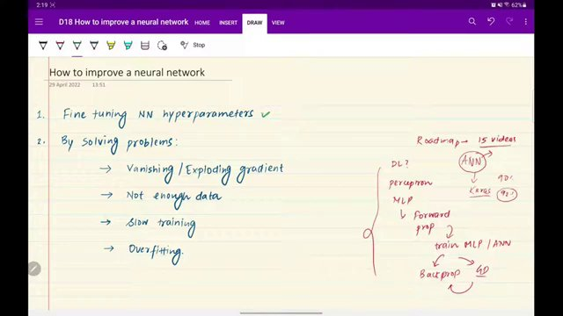

"IMPROVING NEURAL NETWORKS: HYPERPARAMETERS AND PROBLEM-SOLVING STRATEGIES" (at 315s)
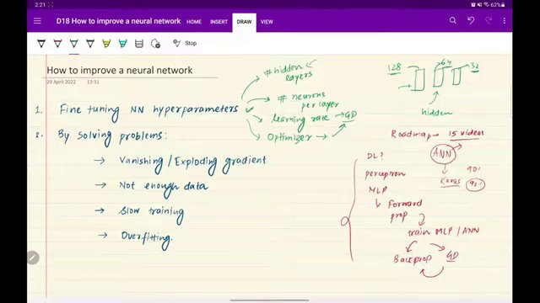

"FINE-TUNING HYPERPARAMETERS DIAGRAM" (at 585s)
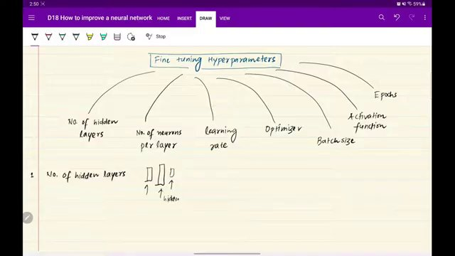

"NEURAL NETWORK HIDDEN LAYERS DIAGRAM" (at 675s)


TRANSFER LEARNING AND NEURAL NETWORK DIAGRAM. (at 855s)
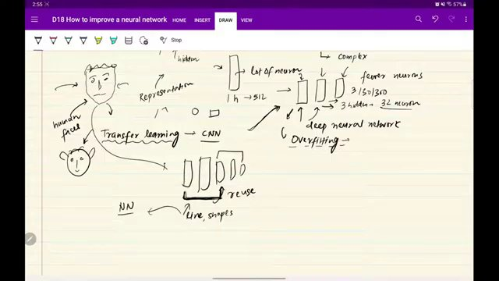

NEURAL NETWORK LAYER STRUCTURE DIAGRAM. (at 990s)
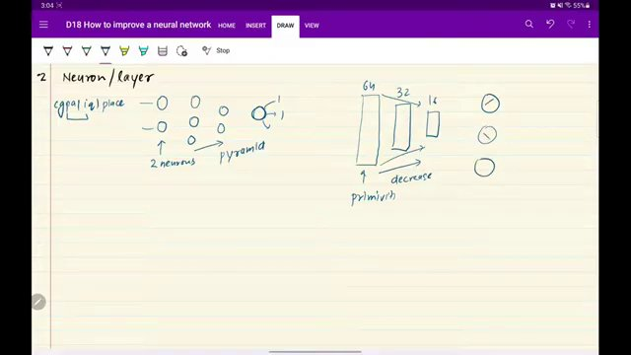

Interview question bank

*Target roles: ML Engineer / Data Scientist / AI Engineer. Questions are sourced from web pages only (not invented).*

> **No attributed questions were extracted.** For reliable results, set **`TAVILY_API_KEY`** in `.env` (Tavily search + full-page extract). DuckDuckGo-only mode often returns snippets too short to tie questions to a company.

Summary table

| Topic | # Companies | # Questions | Top sources |
|-------|-------------|-------------|-------------|
| Neural network hyperparameter tuning | 0 | 0 | |
| Multilayer Perceptron and backpropagation | 0 | 0 | |
| Gradient descent variants and learning rate | 0 | 0 | |
| Number of hidden layers and representation learning | 0 | 0 | |
| Number of neurons per layer | 0 | 0 | |
| Batch size selection and mini-batch training | 0 | 0 | |
| Learning rate scheduling and warmup | 0 | 0 | |
| Early stopping and callbacks | 0 | 0 | |
| Vanishing and exploding gradient problems | 0 | 0 | |
| Weight initialization strategies | 0 | 0 | |
| Activation functions and ReLU | 0 | 0 | |
| Batch normalization and gradient clipping | 0 | 0 | |
| Transfer learning | 0 | 0 | |
| Overfitting and regularization including dropout | 0 | 0 | |
| Data requirements and not-enough-data problem | 0 | 0 | |
| Advanced optimizers (e.g., Adam) | 0 | 0 | |

Coverage report

- Extracted topics: 16
- Questions with attribution: 0
- Excluded (unattributed): 0

**Topic coverage notes:**
Video is a roadmap-style overview for improving neural network performance, emphasizing hyperparameter tuning, core training pathologies (vanishing/exploding gradients, data scarcity, slow training, overfitting), and solution techniques (architecture choices, optimization tricks, regularization, transfer learning). Topics here are broad and will each be expanded in future, more detailed sessions.

Questions by topic → company

