YouTube Notes awjXaFR1jOM

Metadata
Created at: 2026-03-26 15:10:10
Video ID: awjXaFR1jOM

Notes

Sigmoid (Logistic) Function and Its Derivative

Sigmoid Function Basics
- Sigmoid (logistic) function is widely used in:
- Logistic regression
- Artificial neural networks (e.g., multilayer perceptron)
- As part of loss functions and activation functions
- Key property:
- Maps any real number (very large positive, very large negative, or any real) into the range (0, 1)
- “Squashes” input values into a bounded interval

- Standard form (as used in the explanation):
- `σ(x) = 1 / (1 + e^(−x))`
- In the transcript it is roughly written like: `1 / (1 + something^(-x))` (intended as exponential)

Derivative Rules Used

Reciprocal Rule
- For `f(x) = 1 / g(x)`:
- `f'(x) = −g'(x) / (g(x))^2`

Chain Rule (for exponent)
- For `h(x) = e^(−x)`:
- `h'(x) = e^(−x) * (−1) = −e^(−x)`

Step-by-Step Derivation of Sigmoid Derivative

1. Start with definition
- `σ(x) = 1 / (1 + e^(−x))`

2. Apply reciprocal rule
- Let `g(x) = 1 + e^(−x)`
- Then:
- `σ'(x) = −g'(x) / (g(x))^2`

3. Differentiate the denominator `g(x)`
- `g(x) = 1 + e^(−x)`
- Derivative of constant 1 is 0
- Derivative of `e^(−x)` is `−e^(−x)`
- So:
- `g'(x) = −e^(−x)`

4. Substitute into reciprocal rule
- `σ'(x) = −(−e^(−x)) / (1 + e^(−x))^2`
- Therefore:
- `σ'(x) = e^(−x) / (1 + e^(−x))^2`

Expressing Derivative in Terms of σ(x)

1. Recognize σ(x) and 1 − σ(x)
- `σ(x) = 1 / (1 + e^(−x))`
- Then:
- `1 − σ(x) = 1 − 1 / (1 + e^(−x))`
- Put over common denominator:
- `1 − σ(x) = (1 + e^(−x) − 1) / (1 + e^(−x))`
- `1 − σ(x) = e^(−x) / (1 + e^(−x))`

2. Multiply σ(x) and (1 − σ(x))
- `σ(x) * (1 − σ(x))`
- `= [1 / (1 + e^(−x))] * [e^(−x) / (1 + e^(−x))]`
- `= e^(−x) / (1 + e^(−x))^2`

3. Identify equality with previous derivative form
- Previously found:
- `σ'(x) = e^(−x) / (1 + e^(−x))^2`
- Thus:
- `σ'(x) = σ(x) * (1 − σ(x))`

Final Derivative Formula (Key Result)
- Derivative of sigmoid:
- `dσ(x)/dx = σ(x) * (1 − σ(x))`
- This form is very convenient in:
- Machine learning backpropagation
- Logistic regression gradient computation
- General analytical work with neural networks

Graphical Intuition (Qualitative)
- Sigmoid `σ(x)`:
- S-shaped curve
- Approaches 0 as `x → −∞`
- Approaches 1 as `x → +∞`
- Derivative `σ'(x)`:
- Bell-shaped curve centered at 0
- Maximum at `x = 0` (where `σ(0) = 0.5`, so derivative = `0.5 * 0.5 = 0.25`)
- Goes to 0 as `x → ±∞`

Practical Memory Tip
- To remember:
- “Derivative of the sigmoid is the sigmoid times one minus the sigmoid”
- `σ'(x) = σ(x) (1 − σ(x))`
- This self-referential property makes calculations in neural networks efficient.

Key images
"SIGMOID FUNCTION GRAPH" (at 45s)
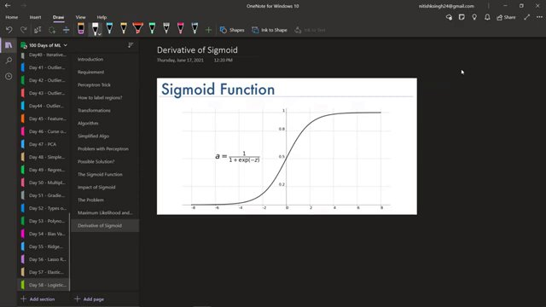

DERIVATIVE OF SIGMOID FUNCTION EQUATION AND GRAPH. (at 135s)
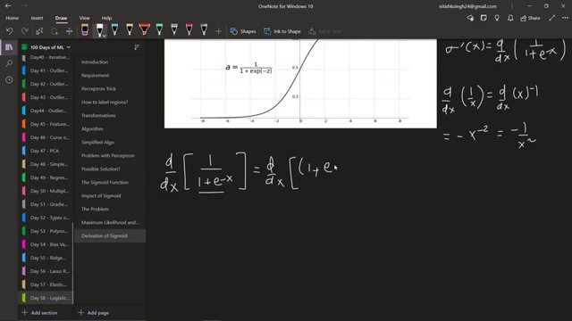

DERIVATIVE OF SIGMOID FUNCTION EQUATION (at 225s)
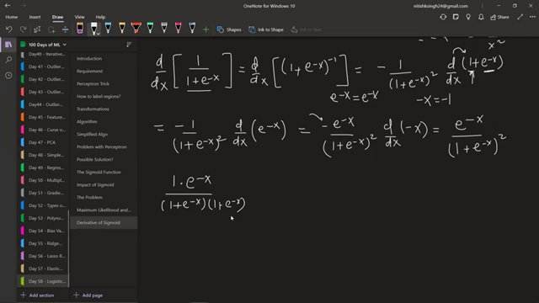

DERIVATIVE OF SIGMOID FUNCTION (at 315s)
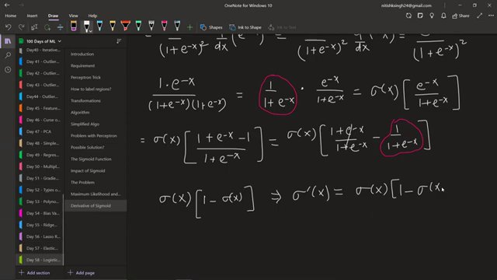

Interview question bank

*Target roles: ML Engineer / Data Scientist / AI Engineer. Questions are sourced from web pages only (not invented).*

> **No attributed questions were extracted.** For reliable results, set **`TAVILY_API_KEY`** in `.env` (Tavily search + full-page extract). DuckDuckGo-only mode often returns snippets too short to tie questions to a company.

Summary table

| Topic | # Companies | # Questions | Top sources |
|-------|-------------|-------------|-------------|
| Sigmoid function | 0 | 0 | |
| Derivative of sigmoid | 0 | 0 | |
| Logistic regression | 0 | 0 | |
| Multilayer perceptron | 0 | 0 | |
| Sigmoid as activation function | 0 | 0 | |
| Reciprocal rule for derivatives | 0 | 0 | |
| Chain rule for exponentials | 0 | 0 | |
| Sigmoid function properties | 0 | 0 | |
| Graphical intuition of sigmoid and its derivative | 0 | 0 | |
| Backpropagation with sigmoid | 0 | 0 | |

Coverage report

- Extracted topics: 10
- Questions with attribution: 0
- Excluded (unattributed): 0

**Topic coverage notes:**
Content focuses on the sigmoid (logistic) function, its calculus-based derivative derivation, and its role as an activation in logistic regression and multilayer perceptrons, emphasizing the compact form σ'(x) = σ(x)(1 − σ(x)).

Questions by topic → company

