YouTube Notes fne_UE7hDn0

Metadata
Created at: 2026-03-24 07:19:19
Video ID: fne_UE7hDn0

Notes

Deep Learning Course – Overview, History & Applications

Course / Video Structure
- Theoretical foundation is emphasized before technical implementation to build perspective.
- Three main topics covered:
- Types of neural networks.
- History of deep learning.
- Applications of deep learning across different domains.
- Practical part (coding) will start with the Perceptron after these introductory theory videos.
- Some content is reused from older recordings because initial explanations were already clear; current video is an edited/combined version.

Types of Neural Networks (High-Level Mention)
- Multiple types of artificial neural networks exist for different problem settings.
- Specifically named types:
- MLP (Multilayer Perceptron).
- CNN / ConvNet (Convolutional Neural Network).
- RNNs and their variants:
- LSTM (Long Short-Term Memory).
- GRU (Gated Recurrent Unit).
- GAN (Generative Adversarial Network).
- Different architectures are used for:
- Image processing and video-related applications (CNNs strongly highlighted).
- Sequence data and time-dependent tasks (RNN, LSTM, GRU).
- Data compression, dimensionality reduction, and reconstruction.
- Data generation (GANs).

Definition & Idea of Artificial Neural Networks (ANNs)
- ANN: Network of interconnected “neurons” (computational units) that learn mappings from input to output.
- Used as a powerful function approximator in supervised learning tasks:
- Regression.
- Classification.
- Capability:
- Capture very complex patterns in data.
- Reduce the need for manual feature engineering compared to traditional ML.
- Handle large, high-dimensional input spaces (e.g., images).

Historical Timeline of Deep Learning

Early Perceptron Era
- Perceptron introduced as a model that can learn from data (viewed as highly promising).
- Early hype: It was heavily promoted as a strong scientific breakthrough.
- However, a major limitation was highlighted:
- Single-layer perceptron cannot learn non-linearly separable functions.
- Specifically cannot learn XOR-type functions.
- A critical book/paper analyzed the limitations of perceptrons and concluded:
- There are important problems (e.g., XOR) that cannot be solved by a single-layer perceptron regardless of training.
- Consequences:
- Funding and enthusiasm for neural network research dropped significantly around late 1960s–1970s.
- Many projects were stopped; this period is often considered an “AI winter” for neural networks.

Revival via Multilayer Networks & Backpropagation
- Later research showed:
- If multiple layers of neurons (multilayer networks) are used, the model can represent much more complex, non-linear functions.
- Key development:
- Backpropagation algorithm proposed and popularized:
- Allows training of multilayer neural networks by propagating error from output back through the network.
- With multilayer networks plus backpropagation:
- Neural networks can approximate virtually any continuous function (universal approximation perspective).
- Limitations of the single-layer perceptron for non-linear problems were overcome.
- This led to renewed research and practical success of neural networks.

Modern Deep Learning Boom
- Competitions and Benchmarks:
- Around 2010–2012: deep neural networks started outperforming traditional methods on major competitions (e.g., image recognition challenges).
- A key competition in vision (ImageNet-style challenge implied) used deep CNNs to drastically reduce error rates.
- After such breakthrough results:
- Big companies (Google, Facebook, etc.) started investing heavily in deep learning research.
- Many research labs and industrial teams adopted deep architectures.
- Productization:
- Deep learning moved from research to real products:
- Search, recommendation systems, translation, speech, and more.
- Current stage:
- Deep learning is embedded in large-scale commercial products and critical applications.
- It is considered a central part of modern AI technology.

Applications of Deep Learning

Vision: Images & Video
- Image classification and recognition:
- Identifying objects, scenes, or content in images.
- Medical imaging:
- Detecting diseases like cancer from X-rays, CT scans, MRI, chest images, etc.
- Image enhancement / restoration:
- Converting low-quality images to high-quality.
- Restoring old or damaged photos:
- Removing noise, increasing resolution, reconstructing missing details.
- Automatic photo organization:
- Grouping photos by person, place, or event (e.g., clustering by faces, scenes).
- Video applications:
- Video processing and understanding tasks (implied use of CNNs and related architectures).

Text & Language (NLP)
- Machine translation:
- Real-time translation between languages (e.g., English ↔ Hindi) using deep models.
- Used in tools like Google Translate and in “instant translation” devices/apps.
- Text recognition and conversion:
- Extracting text from images or documents and converting it into another language.
- Helping users understand content they cannot read in the original language.
- General language tasks:
- Question answering, summarization, and conversational interfaces (implicitly referenced through examples of intelligent systems).

Speech & Audio
- Speech recognition:
- Converting spoken language into text.
- Audio generation:
- Music or sound pattern generation with neural networks.
- Voice-based assistants:
- Systems that understand speech and respond intelligently.

Generative Models
- GANs (Generative Adversarial Networks):
- Used to generate images that look realistic.
- Capable of:
- Generating faces, scenes, or other complex patterns.
- Potentially generating other media (music, handwriting, etc.).
- Use-cases mentioned:
- Creating new, lifelike images.
- Generating artistic compositions.
- Producing synthetic handwriting or text-like patterns.

Recommender Systems & Personalization
- Recommendation engines:
- Used by platforms like YouTube, social media, e-commerce:
- Recommend content based on user behavior and preferences.
- Matrix completion / recommendation:
- Predicting what items a user may like based on partial interaction data.

Healthcare & Drug Discovery
- Drug research:
- Assisting in exploring chemical spaces and evaluating potential drug compounds.
- Diagnosis support:
- Automatic detection of health conditions from medical data (images, signals).

Other Domains (High-Level Mentions)
- Education:
- Personalized learning and intelligent tutoring.
- Finance / business:
- Various analytics, forecasting, customer behavior modeling.
- Robotics and intelligent systems:
- Deep learning as a core component of smart behavior in autonomous systems.

Factors Behind Recent Deep Learning Success

Data Availability
- Explosion of labeled data:
- Social media, online platforms, and user interactions generate huge labeled datasets:
- Likes, clicks, views, comments, and other engagement signals act as labels.
- Over the last decade, especially post-2012:
- Volume and variety of data have grown enormously.

Hardware & Compute
- Advances in hardware:
- GPUs and other accelerators enabled training of large deep networks.
- Smartphones and consumer devices now have significant processing power:
- Deep learning models can run on-device in many cases.
- As compute power increased:
- Larger, deeper models became feasible.
- Training times reduced, enabling experimentation and deployment.

Algorithms & Research Focus
- Improved architectures:
- CNNs, LSTMs, GRUs, GANs, and other specialized networks are now standard.
- Better training techniques:
- Backpropagation combined with optimization and regularization advancements.
- Corporate & academic investment:
- Major companies funding research and engineering for scalable deep learning.

Course Positioning & Next Steps
- Theoretical coverage so far:
- Differences between traditional machine learning and deep learning.
- Why deep learning has become popular.
- Types of neural networks and their roles.
- Historical development and current applications to build a “big picture”.
- Upcoming content:
- Move into practical, implementation-focused topics.
- Start with the Perceptron:
- Introduced as the “building block” of MLP (Multilayer Perceptron).
- Expectation:
- Having this historical and conceptual perspective will make upcoming technical details easier to understand and connect.

Key images
RECURRENT NEURAL NETWORK DIAGRAM (at 308s)
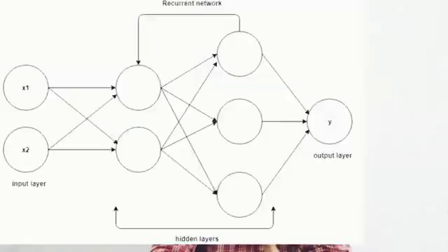

AUTONOMOUS VEHICLE SENSOR LAYOUT DIAGRAM. (at 1312s)
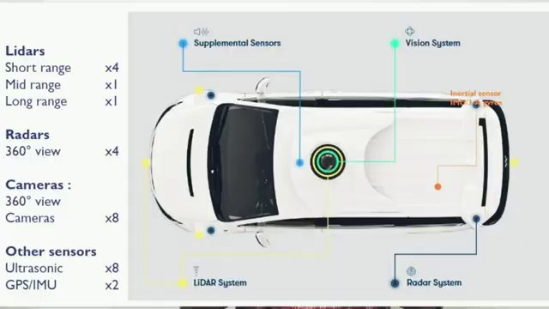

"IMAGE CAPTIONS FOR VARIOUS ACTIVITIES." (at 1602s)
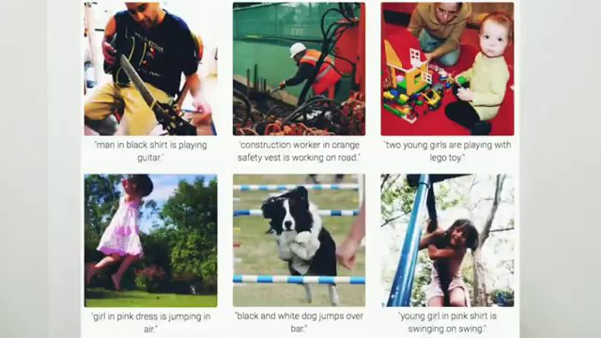

TEXT TRANSLATION EXAMPLE: "MÖRK" TO "DARK" (at 1636s)


Interview question bank

*Target roles: ML Engineer / Data Scientist / AI Engineer. Questions are sourced from web pages only (not invented).*

Summary table

| Topic | # Companies | # Questions | Top sources |
|-------|-------------|-------------|-------------|
| Types of neural networks | 1 | 1 | coursera.org, wikipedia.org, tryexponent.com, geeksforgeeks.org, interviewbit.co |
| Artificial Neural Networks (ANN) basics | 1 | 2 | coursera.org, ibm.com, youtube.com, geeksforgeeks.org |
| History of deep learning and perceptron | 1 | 1 | coursera.org, tryexponent.com, geeksforgeeks.org |
| Backpropagation and multilayer networks | 0 | 0 | |
| Modern deep learning boom | 0 | 0 | |
| Deep learning applications in computer vision | 0 | 0 | |
| Deep learning for NLP and translation | 0 | 0 | |
| Deep learning for speech and audio | 0 | 0 | |
| Generative models and GANs | 0 | 0 | |
| Recommender systems with deep learning | 0 | 0 | |
| Deep learning in healthcare and drug discovery | 0 | 0 | |
| Factors behind deep learning success | 0 | 0 | |
| Perceptron as building block of MLP | 0 | 0 | |
| **Total (all in bank)** | 1 | 4 | See sections below |

Coverage report

- Extracted topics: 13
- Questions with attribution: 4
- Excluded (unattributed): 6

**Topic coverage notes:**
Topics center on introductory deep learning: core ANN concepts, historical evolution (perceptron to backprop to modern boom), main architectures (MLP, CNN, RNN/LSTM/GRU, GAN), major application areas (vision, NLP, speech, recommendation, healthcare), and enabling factors like data and hardware. These form the conceptual foundation before moving to Perceptron implementation.

Questions by topic → company

Artificial Neural Networks (ANN) basics

**Coursera**
- **Q:** Explain artificial neurons’ basic structure.
- *Role/level:* All levels
- *Source:* https://www.coursera.org/articles/neural-network-interview-questions
- *Evidence:* ### 1. Explain artificial neurons’ basic structure.

**What they’re really asking:** Do you understand the inspiration for neural networking?

Neural networks are built to deliver machine-based processing inspired by how the human brain works, with neurons that interact to accomplish various tasks.

- **Q:** How do neural networks learn?
- *Role/level:* All levels
- *Source:* https://www.coursera.org/articles/neural-network-interview-questions
- *Evidence:* ### 2. How do neural networks learn?

**What they’re really asking:** Do you understand how neural networks process information?

Neural networks learn by creating connections and adjusting the weights of those connections between neurons through training processes.

History of deep learning and perceptron

**Coursera**
- **Q:** What is the vanishing gradient problem?
- *Role/level:* All levels
- *Source:* https://www.coursera.org/articles/neural-network-interview-questions
- *Evidence:* ### 4. What is the vanishing gradient problem?

**What they’re really asking:** Can you explain issues with neural network training?

The vanishing gradient problem can arise in neural network training when the gradients used to train the network become small or vanish during the backpropagation process.

Types of neural networks

**Coursera**
- **Q:** What are the different types of neural networks?
- *Role/level:* All levels
- *Source:* https://www.coursera.org/articles/neural-network-interview-questions
- *Evidence:* ### 3. What are the different types of neural networks?

**What they’re really asking:** Do you have the skills to work with various neural network types?

The different neural network types to remember for an interview include:

- **Feedforward:** A feedforward neural network processes data from input to output in one direction.
- **Backpropagation algorithm:** Backpropagation uses corrective feedback loops to improve predictive analytics.
- **Convolutional neural networks:** ...
- **Generative…

Unattributed (excluded from main list)

- **Topic:** Backpropagation and multilayer networks — Appears in a Medium article with no company attribution in title or content block; per rules, cannot assign to a specific real tech employer. — _How do you understand Backpropagation? Explain the mechanism of action?_
- **Topic:** Backpropagation and multilayer networks — Mentioned in Interview Coder blog narrative as a quoted question but not tied to a named hiring company within the provided snippet, so cannot be attributed. — _How backpropagation works?_
- **Topic:** Types of neural networks — GeeksforGeeks deep learning interview questions page is generic with no specific company context in the visible block, so cannot be attached to a named employer. — _What are the different types of Neural Networks?_
- **Topic:** Artificial Neural Networks (ANN) basics — From GeeksforGeeks deep learning interview questions section but not associated with a specific company in the snippet; attribution would violate the requirement to tie to a real employer. — _What is a Neural Network and Artificial Neural Network (ANN)?_
- **Topic:** Types of neural networks — InterviewBit deep learning interview questions page is generic prep content without explicit employer attribution in the provided portion. — _What are the different types of Neural Networks?_
- **Topic:** Types of neural networks — Interview Coder blog references various architectures but does not phrase them as specific interview questions from a named company in the visible excerpt. — _What are the different types of Neural Networks used in Deep Learning?_

