YouTube Notes jAqVuYJ8TP8

Metadata
Created at: 2026-03-23 20:24:14
Video ID: jAqVuYJ8TP8

Notes

Exponential Weighted Moving Average (EWMA)

Time Series Context
- Time series data: values recorded over time (e.g., daily stock prices, daily city temperatures).
- Axes example:
- X-axis: `date`
- Y-axis: `temperature`
- Raw data plotted as a jagged line; a smooth line overlaid can represent an average/trend.

What is Exponential Weighted Moving Average
- EWMA is a technique to find trends/patterns in time series–based data.
- Used to:
- Extract trend from noisy time series.
- Capture how the series is moving over time.
- Intuition:
- Produces a smoothed curve (trend line) that follows the data but is less noisy.
- Newer points influence the average more than older points.

Where EWMA is Used
- Time series forecasting.
- Business forecasting (e.g., companies forecasting metrics).
- Signal processing.
- Deep learning:
- Used while building optimizer algorithms.
- Specifically relevant to momentum-based optimization methods.

Two Key Properties of EWMA
- Property 1 (more weight to recent points):
- For time series `x₁, x₂, x₃, …`, later points have higher weight than earlier ones.
- Example: `x₃` has higher weight than `x₁`, `x₄` higher than `x₃`, etc.
- Property 2 (weights decay over time):
- As time passes, the weight of any fixed point decreases.
- A specific past data point is given less and less influence as we move further forward in time.

EWMA Formula
- EWMA at time `t`: `v_t`
- Data value at time `t`: `x_t`
- Decay/weight parameter: `β` with `0 ≤ β < 1`
- Recursive formula:
- `v_t = β * v_(t-1) + (1 - β) * x_t`
- Interpretation:
- `β * v_(t-1)`: contribution from past (previous EWMA).
- `(1 - β) * x_t`: contribution from current data point.

Initialization of EWMA
- `v_0` (initial EWMA) is treated inconsistently in different resources:
- Some take `v_0 = 0`.
- Others take `v_0 = x_0` (first data point).
- Both are seen in practice; there is no single strict standard.

Step-by-Step EWMA Computation (Example Pattern)
- Given time series values `x_0, x_1, x_2, …` and chosen `β`:
- Choose `v_0` (e.g., `0` or `x_0`).
- `v_1 = β * v_0 + (1 - β) * x_1`
- `v_2 = β * v_1 + (1 - β) * x_2`
- Continue similarly for `v_3, v_4, …`.
- Each `v_t` is then plotted to obtain the EWMA curve.

Effect of β: Intuition via Window Length
- Approximate effective window length of EWMA:
- EWMA acts roughly like an average over the last `1 / (1 - β)` points.
- Examples:
- If `β = 0.9`:
- `1 / (1 - 0.9) = 10`
- EWMA behaves like an average of roughly last 10 points.
- If `β = 0.5`:
- `1 / (1 - 0.5) = 2`
- EWMA behaves like an average of roughly last 2 points.

Graphical Behavior for Different β
- Same data, EWMA computed with different β values:
- Large `β` (e.g., `β = 0.98`):
- Very smooth, slow to react.
- Strong influence from long history; curve far from rapid fluctuations of raw data.
- Medium `β` (e.g., `β = 0.8`, `β = 0.5`):
- Intermediate smoothing; balances current vs. past.
- Small `β` (e.g., `β = 0.1`):
- EWMA follows data very closely.
- Very “reactive” to recent changes; less smoothing.

Interpretation of β in the Formula
- Formula: `v_t = β * v_(t-1) + (1 - β) * x_t`
- `β` controls how much weight is given to past vs current:
- `β * v_(t-1)`: past component (older points).
- `(1 - β) * x_t`: present component (current point).
- High `β`:
- Past component is large; older points get more cumulative weight.
- System is less sensitive to sudden recent changes.
- Low `β`:
- Present component dominates; current point heavily influences `v_t`.
- System is more “moody,” quickly updating based on recent events.

β and Weight Decay (Mathematical Expansion)
- Start with:
- `v_t = β * v_(t-1) + (1 - β) * x_t`
- Expand recursively:
- `v_1 = β * v_0 + (1 - β) * x_1`
- `v_2 = β * v_1 + (1 - β) * x_2`
- Substitute `v_1`:
- `v_2 = β * (β * v_0 + (1 - β) * x_1) + (1 - β) * x_2`
- `v_2 = β² * v_0 + β * (1 - β) * x_1 + (1 - β) * x_2`
- `v_3 = β * v_2 + (1 - β) * x_3`
- Substitute `v_2`:
- `v_3 = β³ * v_0 + β² * (1 - β) * x_1 + β * (1 - β) * x_2 + (1 - β) * x_3`
- Similarly for `v_4`, etc.
- General pattern:
- Coefficients on older `x` values are powers of `β` multiplied by `(1 - β)`.
- Example up to `v_4`:
- `v_4` includes terms like:
- `(1 - β) * x_4`
- `β * (1 - β) * x_3`
- `β² * (1 - β) * x_2`
- `β³ * (1 - β) * x_1`
- Since `0 ≤ β < 1`:
- Higher powers `β², β³, …` get smaller.
- Thus older points are multiplied by smaller factors.
- This proves mathematically: older data points have exponentially decaying weight.

Intuitive Analogy for β
- Very small β (high focus on present):
- Like a person whose mood changes instantly with today’s events.
- Very large β (high focus on past):
- Like a person whose current state is determined mainly by long-term history, not by today’s event.
- Choice of β:
- Need a “sweet spot” between being too reactive and too sluggish.
- In many deep learning optimizers, values like `β ≈ 0.9` are common.

EWMA in Python (Pandas)
- Example dataset:
- Daily climate data (Delhi).
- Columns:
- `date`
- `mean_temperature`
- Pandas function:
- `Series.ewm()` is used to compute EWMA.
- Key parameter: `alpha`
- Relation to β: `alpha = 1 - β`
- If `alpha = 0.9` then `β = 0.1`, etc.
- Basic usage pattern:
- Compute EWMA for each day using:
- `ewm(alpha=alpha_value).mean()` (implicitly applying EWMA).
- Result:
- A new column with EWMA values for each date.
- Plotting:
- Plot raw temperature and EWMA together to see smoothing.
- Suggested practice:
- Try different `alpha` (or equivalently `β`) values.
- Observe how the EWMA curve changes.
- As an exercise, implement EWMA manually from the formula instead of relying solely on `ewm()`.

Key images
"EFFECT OF BETA IN EWMA WITH EQUATIONS AND GRAPHS" (at 695s)
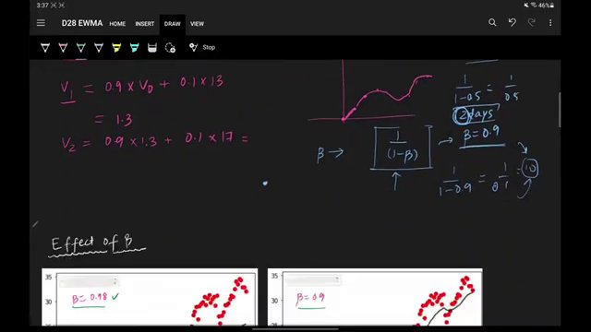

EXPONENTIAL WEIGHTED MOVING AVERAGE (EWMA) GRAPHS WITH DIFFERENT BETA VALUES. (at 756s)
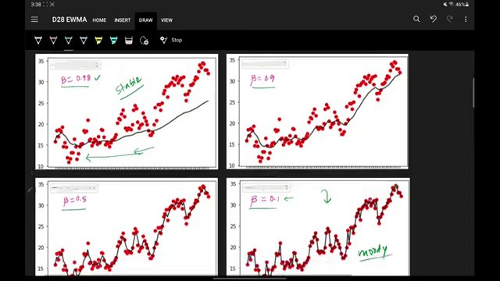

"MATHEMATICAL INTUITION AND EWMA EQUATIONS WITH GRAPHS" (at 1002s)
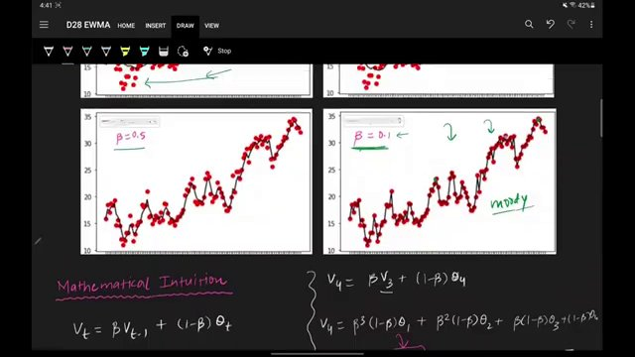

Interview question bank

*Target roles: ML Engineer / Data Scientist / AI Engineer. Questions are sourced from web pages only (not invented).*

Summary table

| Topic | # Companies | # Questions | Top sources |
|-------|-------------|-------------|-------------|
| Exponential Weighted Moving Average | 2 | 2 | aryanupadhyay.com, corporatefinanceinstitute.com, towardsdatascience.com, medium |
| Time series forecasting with EWMA | 1 | 1 | corporatefinanceinstitute.com, aryanupadhyay.com |
| EWMA mathematical formulation | 3 | 3 | aryanupadhyay.com, corporatefinanceinstitute.com, towardsdatascience.com, medium |
| Effect of beta parameter in EWMA | 3 | 3 | aryanupadhyay.com, corporatefinanceinstitute.com, towardsdatascience.com |
| Exponential weight decay interpretation | 1 | 1 | |
| Initialization choices for EWMA | 0 | 0 | |
| EWMA in deep learning optimizers | 1 | 1 | medium.com |
| EWMA implementation in Python (Pandas) | 0 | 0 | |
| Time series smoothing and trend extraction | 1 | 1 | |
| **Total (all in bank)** | 4 | 12 | See sections below |

Coverage report

- Extracted topics: 9
- Questions with attribution: 12
- Excluded (unattributed): 3

**Topic coverage notes:**
Content focuses on Exponential Weighted Moving Average: definition, properties, β parameter behavior, mathematical expansion, and practical implementation (Pandas) with mentions of its role in time series forecasting and deep learning optimizers. No unrelated ML topics appear in this excerpt.

Questions by topic → company

EWMA in deep learning optimizers

**Medium (Piyush Kashyap)**
- **Q:** In deep learning, EWMA is used extensively in optimizers like **Adam**.
- *Role/level:* General ML / DL
- *Source:* https://medium.com/@piyushkashyap045/exponential-weighted-moving-average-ewma-in-deep-learning-a-simple-guide-with-examples-ef247b3f964b
- *Evidence:* ## EWMA in Deep Learning Optimizers

In deep learning, EWMA is used extensively in optimizers like **Adam**. During training, Adam uses an exponential moving average to adjust the learning rate, making it more stable and allowing the model to converge faster.

EWMA mathematical formulation

**Aryan Upadhyay (blog)**
- **Q:** To understand how the curve is generated, we look at the recursive formula:
- *Role/level:* General ML / DS
- *Source:* https://www.aryanupadhyay.com/post/exponential-weighted-moving-average-ewma-theory-formula-example-intuition
- *Evidence:* **Mathematical Formulation**

To understand how the curve is generated, we look at the recursive formula:

Vₜ = β Vₜ₋₁ + (1 − β)θₜ

**Corporate Finance Institute**
- **Q:** The EWMA’s simple mathematical formulation described below:
- *Role/level:* Quant / Finance
- *Source:* https://corporatefinanceinstitute.com/resources/career-map/sell-side/capital-markets/exponentially-weighted-moving-average-ewma/
- *Evidence:* ### EWMA Formula

The EWMA’s simple mathematical formulation described below:

Where:

- **Alpha** = The weight decided by the user
- **r** = Value of the series in the current period

**Towards Data Science**
- **Q:** To understand how the exponential moving average works, let us look at its recursive equation:
- *Role/level:* General ML / DS
- *Source:* https://towardsdatascience.com/intuitive-explanation-of-exponential-moving-average-2eb9693ea4dc/
- *Evidence:* ## Formula

To understand how the exponential moving average works, let us look at its recursive equation:

![Exponential moving average formula](...)

Effect of beta parameter in EWMA

**Aryan Upadhyay (blog)**
- **Q:** The value of β dictates how far back into the past the model looks.
- *Role/level:* General ML / DS
- *Source:* https://www.aryanupadhyay.com/post/exponential-weighted-moving-average-ewma-theory-formula-example-intuition
- *Evidence:* **The Impact of Beta (**β**)**

The value of β dictates how far back into the past the model looks. A simple way to visualize this is :

- If β = 0.9 : We are averaging over roughly the last 10 days (1 / 0.1).

**Corporate Finance Institute**
- **Q:** For example, a 15-day moving average’s alpha is given by 2/(15+1), which means alpha is 0.125.
- *Role/level:* Quant / Finance
- *Source:* https://corporatefinanceinstitute.com/resources/career-map/sell-side/capital-markets/exponentially-weighted-moving-average-ewma/
- *Evidence:* #### N-Day EWMA

To compute the moving average, we first need to find the corresponding alpha, which is given by the formula below:

...

For example, a 15-day moving average’s alpha is given by 2/(15+1), which means alpha is 0.125.

**Towards Data Science**
- **Q:** In reality, weights lower than 1 / e make a tiny impact on the exponentially weighted average. That is why it is said that **for a given value of β, the exponential weighted average takes into consideration the last t = 1 / (1 – β) observations**.
- *Role/level:* General ML / DS
- *Source:* https://towardsdatascience.com/intuitive-explanation-of-exponential-moving-average-2eb9693ea4dc/
- *Evidence:* In reality, weights lower than 1 / e make a tiny impact on the exponentially weighted average. That is why it is said that **for a given value of β, the exponential weighted average takes into consideration the last t = 1 / (1 – β) observations**.

Exponential Weighted Moving Average

**Medium (Piyush Kashyap)**
- **Q:** What is EWMA?
- *Role/level:* General ML / DL
- *Source:* https://medium.com/@piyushkashyap045/exponential-weighted-moving-average-ewma-in-deep-learning-a-simple-guide-with-examples-ef247b3f964b
- *Evidence:* ## What is EWMA?

The Exponential Weighted Moving Average (EWMA) is a statistical technique used to find trends in time-series data.

**Towards Data Science**
- **Q:** What is Exponential Moving Average (EMA)?
- *Role/level:* General ML / DS
- *Source:* https://towardsdatascience.com/intuitive-explanation-of-exponential-moving-average-2eb9693ea4dc/
- *Evidence:* An **exponential (weighted) moving average** is a robust trade-off between these two methods.

This article covers the motivation behind the method, a description of its workflow and bias correction – an effective technique to overcome a bias obstacle in approximation.

Exponential weight decay interpretation

**Aryan Upadhyay (blog)**
- **Q:** We previously stated that EWMA gives more importance to new data and less to old data. But can we prove this mathematically ?
- *Role/level:* General ML / DS
- *Source:* https://www.aryanupadhyay.com/post/exponential-weighted-moving-average-ewma-theory-formula-example-intuition
- *Evidence:* **Mathematical Intuition: The Proof**

We previously stated that EWMA gives more importance to new data and less to old data. But can we prove this mathematically ?

Let's expand the recursive formula step-by-step to see exactly how the weights are assigned.

Time series forecasting with EWMA

**Corporate Finance Institute**
- **Q:** What is the Exponentially Weighted Moving Average (EWMA)?
- *Role/level:* Quant / Finance
- *Source:* https://corporatefinanceinstitute.com/resources/career-map/sell-side/capital-markets/exponentially-weighted-moving-average-ewma/
- *Evidence:* ## What is the Exponentially Weighted Moving Average (EWMA)?

The Exponentially Weighted Moving Average (EWMA) is a quantitative or statistical measure used to model or describe a time series.

Time series smoothing and trend extraction

**Aryan Upadhyay (blog)**
- **Q:** What is Exponential Weighted Moving Average (EWMA) ?
- *Role/level:* General ML / DS
- *Source:* https://www.aryanupadhyay.com/post/exponential-weighted-moving-average-ewma-theory-formula-example-intuition
- *Evidence:* Exponential Weighted Moving Average (EWMA): Theory, Formula, Example & Intuition

**What is Exponential Weighted Moving Average (EWMA) ?**

Let's look at the time-series data in the graph above.

Unattributed (excluded from main list)

- **Topic:** Any — This exact question string does not appear verbatim or as a substring in any provided source; only descriptive prose exists. — _Explain EWMA in the context of Adam optimizer._
- **Topic:** EWMA implementation in Python (Pandas) — No provided block mentions pandas or Series.ewm(), so cannot attribute this as a real interview question. — _How do you implement EWMA using pandas.Series.ewm().mean()?_
- **Topic:** Initialization choices for EWMA — Initialization trade-offs are discussed conceptually but not posed as an explicit question in the text. — _How should you initialize V0 for EWMA (e.g., 0 vs first observation) and what are the trade-offs?_

