YouTube Notes nqL9xYmhEpg

Metadata
Created at: 2026-03-24 06:48:48
Video ID: nqL9xYmhEpg

Notes

AdaGrad Optimizer (Transcript Notes)

AdaGrad: Name, Idea, and Use Cases
- Full form: AdaGrad = "Adaptive Gradient"
- Core idea: do not keep learning rate fixed; adapt/update learning rate based on the situation (per-parameter).
- Performs better than basic optimizers (e.g., plain Gradient Descent, Momentum) when:
- Input features have very different scales (e.g., `CGPA` in 0–10 vs `Salary` in 0–2,00,000).
- Data has sparse features (many zeros) that are still important, e.g.:
- Columns: IQ, CGPA, `IIT` (0/1), output: package.
- `IIT` column mostly zeros but highly informative for salary.
- For sparse but important columns, AdaGrad can give better results than standard Gradient Descent / Momentum.

Elongated Valley Problem in Loss Landscape
- When feature scales differ or some features are sparse:
- Loss surface `L(w, b)` vs parameters can become "elongated" (long narrow valley).
- If both axes (corresponding to parameters of well-scaled features) behave similarly → contours almost circular.
- If one feature is sparse/scale-mismatched → contours become long and narrow (elongated).
- Visual intuition:
- Normal data → contour plot roughly circular; movement toward minimum is smoother.
- With sparse / differently scaled features → one direction changes a lot, the other very little → elongated valley.

Why Standard GD/Momentum Struggle in Elongated Valleys
- In elongated valleys:
- One parameter direction shows strong changes in loss.
- Other direction shows little change initially.
- Behavior of plain Gradient Descent:
- Moves rapidly along one side of the valley (e.g., `b`-direction) going downwards.
- Very little movement along the other parameter (e.g., `w`-direction).
- Path: first goes deep down along one axis, then slowly shifts along the other axis → inefficient, time-wasting path.
- Behavior of Momentum:
- Similar to GD but with overshooting:
- High speed along one direction, overshoots, then comes back, then gradually moves toward minimum.
- Still not taking the “shortest path” along the valley to the minimum.
- Net issue:
- Both GD and Momentum are not efficient in presence of elongated valleys, especially when caused by sparse features.

Sparse Features and Unequal Parameter Updates (Mechanism)
- Consider a simple neural network:
- Single neuron with inputs:
- One sparse input `x` (many zeros).
- A constant `1` input (for bias).
- Parameters: weight `w` for `x`, bias `b` for constant input.
- Output: `ŷ = w·x + b` (assuming linear activation).
- Loss (example): mean squared error `L = (y - ŷ)²`.
- Gradients per sample:
- `∂L/∂w = 2 · (ŷ - y) · x`
- `∂L/∂b = 2 · (ŷ - y) · 1`
- In batch Gradient Descent over many rows:
- For sparse feature `x`:
- Many `x = 0` → many `∂L/∂w = 0`.
- Summation/average of gradients over batch gives small overall gradient for `w`.
- For bias `b`:
- Multiplied by `1` each time → gradient never zero just because of exact zero input.
- Batch gradient for `b` is normal-size.
- Consequence:
- Update for `w` is very small (because gradient mostly zero).
- Update for `b` is relatively large.
- Parameter movement:
- Large movement in `b`-direction.
- Very small movement in `w`-direction.
- Path of optimization:
- Initially goes mostly along `b`-axis (or the dense-feature axis).
- Hardly moves along sparse-feature axis.
- This explains observed behavior: first descending in one parameter direction, then only later starting to change the other parameter.

Root Cause and Desired Fix
- Root cause:
- Different effective gradient magnitudes for different parameters.
- Sparse features → small gradients (often zero) → very small updates.
- Dense/normal features → larger gradients → larger updates.
- Ideal goal:
- Make updates for different parameters somewhat comparable in scale.
- Avoid domination of one direction.
- We want both directions (e.g., `w` and `b`) to get reasonable movement.

AdaGrad’s Core Idea: Per-Parameter Learning Rates
- Traditional GD/Momentum:
- Single global learning rate `η` for all parameters.
- AdaGrad:
- Different learning rate for each parameter:
- Parameters with consistently large gradients → smaller effective learning rate.
- Parameters with consistently small gradients → larger effective learning rate.
- Intuition:
- If `|gradient|` is small → we want a big learning rate to ensure decent movement.
- If `|gradient|` is large → we want a small learning rate to avoid overshooting and over-dominance.

AdaGrad Mathematical Formulation
- Standard Gradient Descent update:
- `w_(t+1) = w_t - η · g_t` where `g_t = ∂L/∂w_t`.
- AdaGrad modifies it:
- `w_(t+1) = w_t - (η / (√v_t + ε)) · g_t`
- Accumulator:
- `v_t = v_(t-1) + g_t²`
- Terms:
- `g_t`: current gradient for parameter (could be `∂L/∂w`, `∂L/∂b`, etc.).
- `v_t`: running sum of squared gradients for that parameter (always non-negative).
- Each step squares gradient (ignores sign) and adds to previous value.
- `ε`: small constant to avoid division by zero (stability; not conceptually central).
- `η`: base learning rate (global multiplier before per-parameter scaling).
- Effect:
- If a parameter’s gradients have been large in the past:
- `v_t` is large → denominator `√v_t` is large → effective learning rate `η / √v_t` becomes small.
- If a parameter’s gradients are often small/zero (e.g., sparse feature):
- `v_t` grows slowly → denominator smaller → effective learning rate stays relatively large.
- Interpretation:
- You are scaling learning rate inversely proportional to the magnitude of historical gradients.
- This automatically balances update sizes across parameters:
- Keeps big-gradient parameters in check.
- Boosts updates for small-gradient (sparse) parameters.

AdaGrad Applied to Sparse Data / Elongated Valleys
- With sparse features:
- Gradients for corresponding weights are often near zero.
- `v_t` for those parameters remains relatively small.
- Their effective learning rate remains larger → weight moves more than it would under plain GD.
- For dense features (or bias) with frequent non-zero gradients:
- `v_t` accumulates quickly → denominator bigger → effective learning rate shrinks.
- Prevents overly large movement in that direction.
- Resulting optimization path:
- Movement becomes more balanced between directions.
- Path in contour plots:
- In AdaGrad: more diagonal, heading faster toward the valley’s bottom and the minimum.
- Convergence to near-minimum is quicker than with plain GD or Momentum.

Major Disadvantage of AdaGrad
- `v_t` is a cumulative sum of squared gradients:
- It keeps increasing (or stays at least non-decreasing) as training continues.
- As training progresses:
- `v_t` grows larger and larger for each parameter.
- Denominator `√v_t` grows.
- Effective learning rate `η / (√v_t + ε)` shrinks over time.
- Consequence:
- After many updates, learning rate becomes extremely small.
- Parameter updates become nearly zero.
- Training effectively “stalls” before truly reaching the global minimum.
- AdaGrad often gets close to solution but does not converge fully to optimum in complex neural networks.
- Practical takeaway:
- AdaGrad is not typically used for deep/complex neural networks.
- It may be used for simpler problems like linear regression, but not ideal for modern deep learning tasks.

Connection to Future Optimizers
- Limitations of AdaGrad motivate improved algorithms:
- RMSProp.
- Adam.
- These future optimizers:
- Retain beneficial ideas from AdaGrad (adaptive learning rates per parameter).
- Modify the way past gradients are accumulated/used (e.g., decaying instead of pure cumulative sum).
- Aim to prevent the AdaGrad “vanishing learning rate” problem while keeping adaptive behavior.

Key images
"ELONGATED BOWL PROBLEM DIAGRAMS" (at 269s)
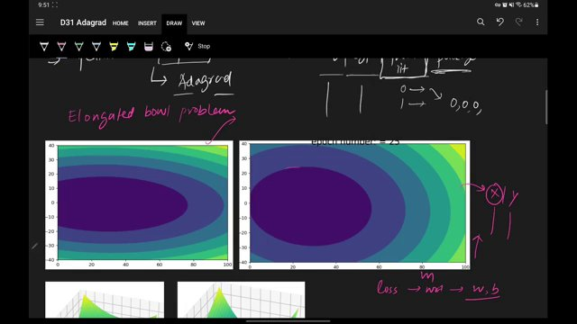

"BATCH GRADIENT DESCENT VISUALIZATION WITH GROUND TRUTH AND LOSS PLOTS" (at 449s)
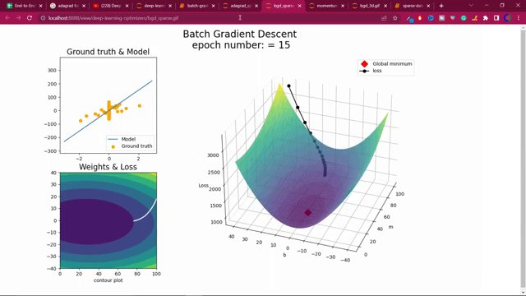

GRADIENT DESCENT EQUATIONS AND DIAGRAM. (at 809s)
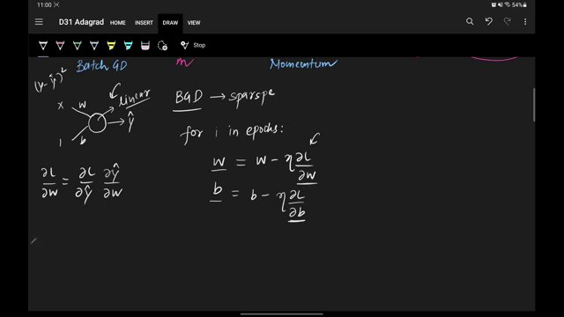

BATCH GRADIENT DESCENT AND MOMENTUM EQUATIONS. (at 899s)
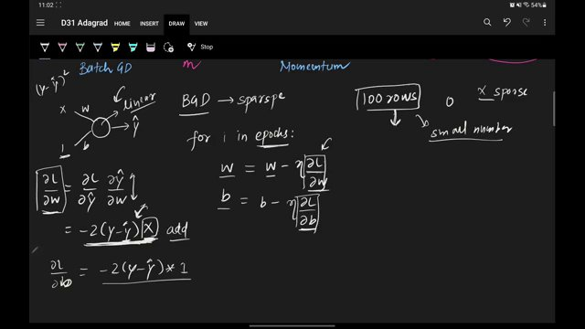

GRADIENT DESCENT UPDATE EQUATIONS AND NOTES ON SPARSE VS. NON-SPARSE DATA. (at 989s)
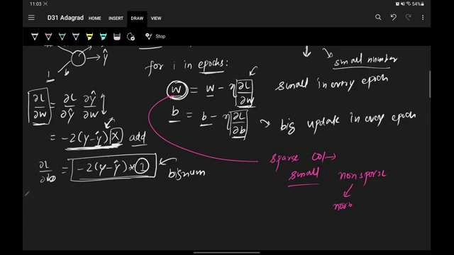

ADAGRAD UPDATE EQUATIONS AND INTUITION DIAGRAM. (at 1079s)
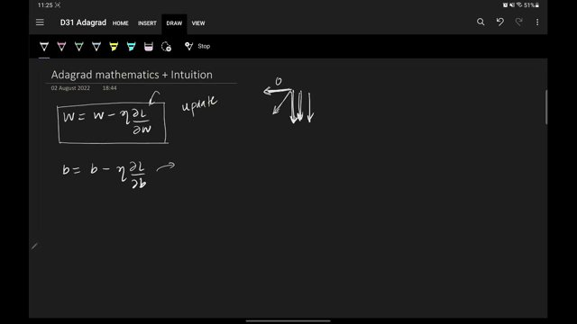

Interview question bank

*Target roles: ML Engineer / Data Scientist / AI Engineer. Questions are sourced from web pages only (not invented).*

Summary table

| Topic | # Companies | # Questions | Top sources |
|-------|-------------|-------------|-------------|
| AdaGrad optimizer | 0 | 0 | |
| Gradient descent and batch gradient descent | 10 | 24 | medium.com, tryexponent.com, github.com, mentorcruise.com, analyticsarora.com |
| Momentum optimizer | 1 | 1 | |
| Elongated valley problem in loss landscape | 0 | 0 | |
| Sparse features and feature scaling | 0 | 0 | |
| Per-parameter learning rates | 0 | 0 | |
| AdaGrad update rule | 0 | 0 | |
| Bias and weight gradients in a single-neuron linear model | 0 | 0 | |
| Effect of sparse inputs on gradient magnitudes | 0 | 0 | |
| AdaGrad’s learning rate decay problem | 0 | 0 | |
| Use of AdaGrad vs RMSProp and Adam | 1 | 1 | |
| **Total (all in bank)** | 10 | 27 | See sections below |

Coverage report

- Extracted topics: 11
- Questions with attribution: 27
- Excluded (unattributed): 10

**Topic coverage notes:**
Content focuses on AdaGrad: motivation via sparse features and elongated valleys, mathematical update rule, per-parameter learning rates, and its main drawback. It contrasts AdaGrad with plain Gradient Descent and Momentum, and briefly connects to RMSProp and Adam.

Questions by topic → company

Backpropagation in neural networks

**General**
- **Q:** How do you understand Backpropagation? Explain the mechanism of action?
- *Role/level:* Deep Learning Engineer
- *Source:* https://medium.com/jp-tech/12-deep-learning-interview-questions-you-should-not-be-missed-part-2-8f42deeb4483
- *Evidence:* ## 5. How do you understand Backpropagation? Explain the mechanism of action?

Gradient descent and batch gradient descent

**Airbnb**
- **Q:** What is cross-validation and why is it important?
- *Role/level:* Unknown
- *Source:* https://mentorcruise.com/questions/machinelearning/
- *Evidence:* ### What is cross-validation and why is it important?

What is cross-validation and why is it important?

**Amazon**
- **Q:** Explain linear and logistic regression regression
- *Role/level:* ML Engineer
- *Source:* https://www.tryexponent.com/blog/top-machine-learning-interview-questions
- *Evidence:* 2. Explain linear and logistic regression regression. (Amazon)

- **Q:** Explain linear and logistic regression regression.
- *Role/level:* Unknown
- *Source:* https://www.tryexponent.com/blog/top-machine-learning-interview-questions
- *Evidence:* 2. Explain linear and logistic regression regression. (Amazon)

- **Q:** Explain briefly batch gradient descent, stochastic gradient descent, and mini-batch gradient descent. and what are the pros and cons for each of them?
- *Role/level:* Unknown
- *Source:* https://github.com/youssefHosni/Data-Science-Interview-Questions-Answers/blob/main/Machine%20Learning%20Interview%20Questions%20%26%20Answers%20for%20Data%20Scientists.md
- *Evidence:* * [Q8: Explain briefly batch gradient descent, stochastic gradient descent, and mini-batch gradient descent. and what are the pros and cons for each of them?]

- **Q:** Given two related datasets, how would you determine which features are most important?
- *Role/level:* Unknown
- *Source:* https://mentorcruise.com/questions/machinelearning/
- *Evidence:* ### Given two related datasets, how would you determine which features are most important?

Given two related datasets, how would you determine which features are most important?

**Analytics Arora**
- **Q:** What are the different types of Gradient Descent methods?
- *Role/level:* Unknown
- *Source:* https://analyticsarora.com/8-unique-machine-learning-interview-questions-about-gradient-descent/
- *Evidence:* #### **What are the different types of Gradient Descent methods?**

The methods are:

- Batch Gradient Descent
- Stochastic Gradient Descent
- Mini-batch Gradient Descent

**General**
- **Q:** What is gradient descent?
- *Role/level:* Data Scientist
- *Source:* https://medium.com/grabngoinfo/gradient-descent-vs-616ba269de8d
- *Evidence:* Gradient descent is a commonly asked concept in data science and machine learning interviews. Some example interview questions are

- What is gradient descent?
- What are the pros and cons of stochastic gradient descent?
- What are the differences between batch gradient descent and mini-batch gradient descent?

- **Q:** What are the pros and cons of stochastic gradient descent?
- *Role/level:* Data Scientist
- *Source:* https://medium.com/grabngoinfo/gradient-descent-vs-616ba269de8d
- *Evidence:* Some example interview questions are

- What is gradient descent?
- What are the pros and cons of stochastic gradient descent?
- What are the differences between batch gradient descent and mini-batch gradient descent?

- **Q:** What are the differences between batch gradient descent and mini-batch gradient descent?
- *Role/level:* Data Scientist
- *Source:* https://medium.com/grabngoinfo/gradient-descent-vs-616ba269de8d
- *Evidence:* Some example interview questions are

- What is gradient descent?
- What are the pros and cons of stochastic gradient descent?
- What are the differences between batch gradient descent and mini-batch gradient descent?

- **Q:** Explain briefly batch gradient descent, stochastic gradient descent, and mini-batch gradient descent. and what are the pros and cons for each of them?
- *Role/level:* Data Scientist
- *Source:* https://github.com/youssefHosni/Data-Science-Interview-Questions-Answers/blob/main/Machine%20Learning%20Interview%20Questions%20%26%20Answers%20for%20Data%20Scientists.md
- *Evidence:* * Q8: Explain briefly batch gradient descent, stochastic gradient descent, and mini-batch gradient descent. and what are the pros and cons for each of them?

- **Q:** What are the main variants of gradient descent algorithms?
- *Role/level:* ML Engineer
- *Source:* https://devinterview.io/blog/gradient-descent-interview-questions/
- *Evidence:* * 2.

What are the main *variants of gradient descent algorithms*?

Answer:

- **Q:** How does gradient descent help in finding the local minimum of a function?
- *Role/level:* ML Engineer
- *Source:* https://devinterview.io/blog/gradient-descent-interview-questions/
- *Evidence:* * 4.

How does gradient descent help in finding the *local minimum* of a function?

Answer:

- **Q:** What challenges arise when using gradient descent on non-convex functions?
- *Role/level:* ML Engineer
- *Source:* https://devinterview.io/blog/gradient-descent-interview-questions/
- *Evidence:* * 5.

What challenges arise when using gradient descent on *non-convex functions*?

Answer:

- **Q:** Explain the purpose of using gradient descent in machine learning models.
- *Role/level:* ML Engineer
- *Source:* https://devinterview.io/blog/gradient-descent-interview-questions/
- *Evidence:* * 6.

Explain the purpose of using gradient descent in *machine learning models*.

Answer:

- **Q:** What is Vanishing Gradient? And how is this harmful?
- *Role/level:* Data Scientist
- *Source:* https://www.kaggle.com/getting-started/232154
- *Evidence:* ##### Question 21) What is Vanishing Gradient? And how is this harmful?

##### Question 22) What is Exploding Gradient Descent?

**GrabNGoInfo**
- **Q:** What is gradient descent?
- *Role/level:* Unknown
- *Source:* https://medium.com/grabngoinfo/gradient-descent-vs-616ba269de8d
- *Evidence:* Some example interview questions are

- What is gradient descent?
- What are the pros and cons of stochastic gradient descent?

- **Q:** What are the pros and cons of stochastic gradient descent?
- *Role/level:* Unknown
- *Source:* https://medium.com/grabngoinfo/gradient-descent-vs-616ba269de8d
- *Evidence:* Some example interview questions are

- What is gradient descent?
- What are the pros and cons of stochastic gradient descent?

- **Q:** What are the differences between batch gradient descent and mini-batch gradient descent?
- *Role/level:* Unknown
- *Source:* https://medium.com/grabngoinfo/gradient-descent-vs-616ba269de8d
- *Evidence:* * What are the differences between batch gradient descent and mini-batch gradient descent?

**Meta**
- **Q:** Can you explain the difference between supervised and unsupervised machine learning?
- *Role/level:* Unknown
- *Source:* https://mentorcruise.com/questions/machinelearning/
- *Evidence:* ### Can you explain the difference between supervised and unsupervised machine learning?

Can you explain the difference between supervised and unsupervised machine learning?

**Microsoft**
- **Q:** How would you evaluate a machine learning model?
- *Role/level:* Unknown
- *Source:* https://mentorcruise.com/questions/machinelearning/
- *Evidence:* ### How would you evaluate a machine learning model?

How would you evaluate a machine learning model?

**Nielsen**
- **Q:** Difference between batch gradient descent and stochastic gradient descent (SGD)?
- *Role/level:* Unknown
- *Source:* https://www.linkedin.com/posts/nihar-penchala_datascience-deeplearning-interviewquestions-activity-7371013068417458176-r2K_
- *Evidence:* Here are today’s 10 interview questions:
...
8. Difference between batch gradient descent and stochastic gradient descent (SGD)?

**OpenAI**
- **Q:** Explain gradient descent
- *Role/level:* ML Engineer
- *Source:* https://www.tryexponent.com/blog/top-machine-learning-interview-questions
- *Evidence:* According to candidates, these are ten of the most frequently asked ML interview questions.

1. Explain gradient descent. (OpenAI)

- **Q:** Explain gradient descent.
- *Role/level:* Unknown
- *Source:* https://www.tryexponent.com/blog/top-machine-learning-interview-questions
- *Evidence:* 1. Explain gradient descent. (OpenAI)

**Spotify**
- **Q:** What is a decision tree in machine learning? When would you use it?
- *Role/level:* Unknown
- *Source:* https://mentorcruise.com/questions/machinelearning/
- *Evidence:* ### What is a decision tree in machine learning? When would you use it?

What is a decision tree in machine learning? When would you use it?

Momentum optimizer

**General**
- **Q:** What role does momentum play here and how it is implemented?
- *Role/level:* ML Engineer
- *Source:* https://www.youtube.com/watch?v=2F__P_az9_g
- *Evidence:* One followup question that you may be asked. So so follow up one is what role does momentum play here and how it is implemented...

Use of AdaGrad vs RMSProp and Adam

**General**
- **Q:** Explain RMSProp or more specifically the adaptive learning rate what it does and why it is useful.
- *Role/level:* ML Engineer
- *Source:* https://www.youtube.com/watch?v=2F__P_az9_g
- *Evidence:* Another followup question that you may be asked. So follow up to is to explain MRS prop or more specifically the adaptive learning rate what it does and why it is useful.

Unattributed (excluded from main list)

- **Topic:** AdaGrad optimizer — This question text does not appear verbatim or as a clear substring in any provided TITLE or CONTENT; only general mentions of adaptive methods are present. — _What is AdaGrad and how does it work?_
- **Topic:** AdaGrad’s learning rate decay problem — Concept discussed in background material but not phrased as an explicit interview question in the scraped content. — _What is a major disadvantage of AdaGrad related to learning rate decay?_
- **Topic:** Sparse features and feature scaling — No direct interview-style question string about sparse features and scaling was present in the web blocks. — _How does feature scaling impact gradient descent when dealing with sparse features?_
- **Topic:** Elongated valley problem in loss landscape — Elongated valleys and ravines are mentioned conceptually but not as an explicit interview question in the text. — _Why does standard gradient descent struggle in long, narrow valleys of the loss surface?_
- **Topic:** Per-parameter learning rates — Per-parameter learning rates are explained in prose; no explicit question string found. — _Why might you want different learning rates per parameter in an optimizer like AdaGrad?_
- **Topic:** Gradient descent and batch gradient descent — Appears only paraphrased within a YouTube transcript explanation, not as an explicit interview question sentence in the visible text. — _Explain stochastic gradient descent or SGD in short._
- **Topic:** AdaGrad optimizer — No verbatim occurrence of this question string in any provided content; only explanatory references to AdaGrad. — _What is AdaGrad and how does it work?_
- **Topic:** AdaGrad’s learning rate decay problem — Disadvantage discussed conceptually but not stated as a question in the sources. — _What is the main disadvantage of AdaGrad?_
- **Topic:** Momentum optimizer — Discussed as a follow-up explanation in YouTube transcript, but the actual question text is not clearly quoted in the provided snippet. — _What role does momentum play in stochastic gradient descent and how is it implemented?_
- **Topic:** Use of AdaGrad vs RMSProp and Adam — Comparisons appear in narrative form; this exact comparative question is not present verbatim. — _Compare AdaGrad, RMSProp, and Adam. When would you use each?_

