YouTube Notes qw7wFGgNCSU

Metadata
Created at: 2026-03-24 14:50:57
Video ID: qw7wFGgNCSU

Notes

Multi-Layer Perceptron (MLP) and Non‑Linear Decision Boundaries

Limitation of Single Perceptron
- A single perceptron can only create linear decision boundaries.
- It cannot capture non‑linear patterns in data (e.g., concentric or curved class separations).
- Example: A 2D dataset with red and green classes that require a curved/non‑linear boundary; a straight line cannot separate them.

Switch from Hard Perceptron to Logistic Model
- In this explanation, "perceptron" is used as:
- Activation function: sigmoid (not step function).
- Loss function: logistic loss (not hinge loss).
- Effectively the model is logistic regression:
- Input features (e.g., `CGPA`, `IQ`).
- Linear combination `z = w1·CGPA + w2·IQ + b`.
- Output probability via sigmoid: `σ(z) = 1 / (1 + e^(−z))`.
- Output is a probability in [0, 1], not just 0 or 1.

Logistic Regression Intuition (Single Perceptron)
- For a student with given `CGPA` and `IQ`:
- Compute `z = w1·CGPA + w2·IQ + b`.
- Apply sigmoid to get `p_yes = σ(z)` = probability of placement.
- Probability of not being placed: `p_no = 1 − p_yes`.
- Geometric interpretation:
- The line (in 2D) defined by `z = 0` divides space into two regions (yes/no).
- On the line: `p_yes = p_no = 0.5`.
- Moving away from the line:
- Further into the "yes" side → `p_yes` increases (e.g., 0.6 → 0.72 → 0.8 → 0.9).
- Further into the "no" side → `p_yes` decreases (e.g., 0.4 → 0.3 → 0.2 → 0.1).
- Distance from boundary acts like a grading of confidence.

Idea of Multi‑Layer Perceptron (High‑Level Intuition)
- Goal: Build an algorithm that can capture arbitrary non‑linear decision boundaries.
- Constraint: Use perceptron‑like units as building blocks.
- Intuition:
- Use multiple perceptrons, each creating its own linear decision boundary.
- Combine their outputs in a way that yields a non‑linear final boundary.
- Think of "super‑imposing" individual boundaries and then "smoothing" to form a curved overall boundary.

Combining Two Perceptrons: Linear Combination
- Assume two trained perceptrons on the same data:
- Perceptron 1: outputs `p1` for each point.
- Perceptron 2: outputs `p2` for each point.
- Naive combination:
- For a student, define combined score: `s = p1 + p2`.
- Issue: `s` can exceed 1, so not a valid probability.
- Fix with sigmoid:
- Pass `s` through sigmoid: `p_combined = σ(s)`.
- Now `p_combined` ∈ [0, 1] is the new probability of "yes".
- Interpretation:
- First, form a linear combination of two models’ probabilities.
- Then apply a non‑linearity (sigmoid) to keep it in [0,1] and induce non‑linear behavior.

Weighted Linear Combination of Perceptrons
- To make one perceptron more influential than the other:
- Introduce weights on each perceptron’s output:
- `s = w1·p1 + w2·p2 + b`.
- Example:
- Weight for Perceptron 1: `w1 = 10`.
- Weight for Perceptron 2: `w2 = 5`.
- Bias: `b = 3`.
- Combined model:
- `z_new = 10·p1 + 5·p2 + 3`.
- `p_new = σ(z_new)` is final probability.
- This is just another perceptron:
- Inputs: `p1`, `p2`.
- Weights: `w1`, `w2`.
- Bias: `b`.
- Activation: sigmoid.
- Concept:
- Outputs of earlier perceptrons become inputs to a new perceptron.
- This is a 3‑perceptron combination → core of a Multi‑Layer Perceptron.

Network Diagram Interpretation
- Structure:
- Original input features: `CGPA`, `IQ`.
- Perceptron 1:
- Inputs: `CGPA`, `IQ`.
- Own weights and bias (e.g., `w11`, `w12`, `b1`).
- Output: `p1`.
- Perceptron 2:
- Inputs: `CGPA`, `IQ`.
- Own weights and bias (e.g., `w21`, `w22`, `b2`).
- Output: `p2`.
- Perceptron 3:
- Inputs: `p1`, `p2`.
- Weights `w31`, `w32`, bias `b3`.
- Output: final probability `p_final`.
- Graph view:
- `CGPA` feeds into Perceptron 1 and 2.
- `IQ` feeds into Perceptron 1 and 2.
- Outputs from 1 and 2 feed into Perceptron 3.
- Perceptron 3 produces the final decision.

Naming the Layers
- Input layer:
- Nodes represent input features (e.g., `CGPA`, `IQ`).
- Hidden layer:
- Perceptron 1 and Perceptron 2 are hidden units.
- They are not directly exposed as final outputs.
- Output layer:
- Perceptron 3 is the output node (final prediction).
- This structure is called a Multi‑Layer Perceptron (MLP):
- "Multi‑layer" because there is at least one hidden layer between input and output.
- Non‑linearity arises from sigmoid at each perceptron and linear combinations across layers.

MLP as Linear Combination of Multiple Perceptrons
- Core idea:
- Use linear combinations of many simple linear models (perceptrons).
- Stack them in layers and insert non‑linear activation (sigmoid).
- With two hidden perceptrons:
- Each hidden perceptron defines a different linear boundary.
- Their outputs form a "feature space" that is then linearly combined by the output neuron.
- The result can approximate non‑linear decision boundaries in original input space.
- MLP intuition:
- You are building more complex non‑linear functions by composing:
- Linear transforms (weighted sums) + non‑linear activation (sigmoid).

Extending the Hidden Layer: More Hidden Units
- First way to change architecture: increase number of hidden units (nodes) in a hidden layer.
- Example:
- Earlier: hidden layer had 2 perceptrons.
- Now: hidden layer has 3 perceptrons.
- Effect:
- Each hidden perceptron learns its own intermediate decision boundary.
- Linear combination of 3 boundaries gives a richer, more flexible final boundary.
- Computation example (with 3 hidden units):
- For a point:
- Hidden outputs: `h1 = 0.2`, `h2 = 0.3`, `h3 = 0.4`.
- Output weights: `w1 = 1`, `w2 = 2`, `w3 = 3`, bias `b` (some value).
- New `z = 1·0.2 + 2·0.3 + 3·0.4 + b`.
- `p = σ(z)` is final probability.
- Extra hidden units simply add extra terms to this sum.
- Insight:
- More hidden units → more capacity to represent complex non‑linear boundaries.
- You can add as many hidden units as needed (subject to practical constraints).

Changing Input Layer Size
- Second way to change architecture: increase number of input nodes when the dataset has more input features.
- Example:
- Earlier: features were `CGPA`, `IQ` → 2 input nodes.
- Now add a new feature: `12th_marks`.
- New input layer has 3 nodes: `CGPA`, `IQ`, `12th_marks`.
- Geometric view:
- With 3 input features, data lives in 3D space.
- A single perceptron now defines a plane (not just a line).
- Two perceptrons define two planes.
- Combining them via linear combination and sigmoid yields complex 3D boundaries (or in general, hyperplanes in higher dimensions).
- Rule:
- Number of input nodes = number of input columns/features in the dataset.

Changing Output Layer Size (Multi‑Class)
- Third way to change architecture: increase number of output units.
- Use case: multi‑class classification (more than 2 classes).
- Example:
- Task: classify an image as Dog, Cat, or Human.
- Architecture:
- Shared hidden layers.
- Output layer with 3 perceptrons:
- Output 1: probability of Dog.
- Output 2: probability of Cat.
- Output 3: probability of Human.
- Final prediction: class with highest output probability.
- Insight:
- Output layer can have multiple units, each modeling "probability of class k".

Increasing Number of Hidden Layers (Depth)
- Fourth way to change architecture: increase number of hidden layers.
- Until now:
- Only one hidden layer (shallow network).
- Now:
- Multiple hidden layers:
- Input layer → Hidden layer 1 → Hidden layer 2 → … → Output layer.
- Effect:
- Early layers learn simpler/non‑local patterns.
- Deeper layers learn more complex/high‑level relationships.
- Final combination captures highly complex non‑linear decision boundaries.
- Universal function approximation:
- With enough hidden layers and units, and sufficient training time, an MLP can approximate any mathematical function (under practical assumptions).
- For arbitrarily complex non‑linear data, deeper/wider networks can eventually capture the underlying relationship.

Trade‑Offs and Practical Considerations (Mentioned)
- More layers and more nodes:
- Increase representational power.
- Also increase training time and other practical issues (not detailed here).
- Still, theoretically:
- Given enough capacity (layers/nodes) and training time, MLP can model very complex data.

TensorFlow Playground Demonstrations (Intuition)
- Tool: TensorFlow Playground used to visualize:
- Decision boundaries.
- Effect of hidden units, layers, and activation functions.
- Non‑linear dataset example:
- A dataset that a single perceptron failed on earlier.
- A small MLP with a hidden layer (2 neurons) can learn this dataset.
- More complex dataset:
- Very non‑linear dataset where initial small network struggled to converge.
- Adjustments:
- Increase number of hidden units.
- Change activation function from sigmoid to ReLU.
- With ReLU:
- Loss starts decreasing rapidly.
- Decision boundary becomes more appropriate.
- Layer‑wise visualization:
- You can inspect each neuron’s decision boundary in each hidden layer.
- Early hidden neurons show simpler patterns; later ones show more complex shapes.
- Regression vs classification:
- Playground also supports regression problems (mentioned briefly).
- Key takeaway from demos:
- MLPs can capture non‑linear structures.
- Deeper and wider networks progressively capture more complex relationships.
- Activation choice (e.g., ReLU) can significantly affect learning behavior.

Summary of Key Ideas
- Single perceptron with sigmoid = logistic regression; only linear boundaries.
- Non‑linear decision boundaries require combining multiple perceptrons.
- MLP builds non‑linear mappings by:
- Linear combinations of multiple perceptrons’ outputs.
- Applying non‑linear activations (sigmoid/ReLU) at each layer.
- Architecture = how neurons (perceptrons) and weights connect:
- Change hidden units (width) → more capacity.
- Change input nodes → match number of input features.
- Change output nodes → support multi‑class outputs.
- Change hidden layers (depth) → capture more complex patterns.
- With sufficient capacity and training, neural networks act as universal function approximators.

Key images
"LINE VS. CURVE CLASSIFICATION PROBLEM DIAGRAM" (at 135s)
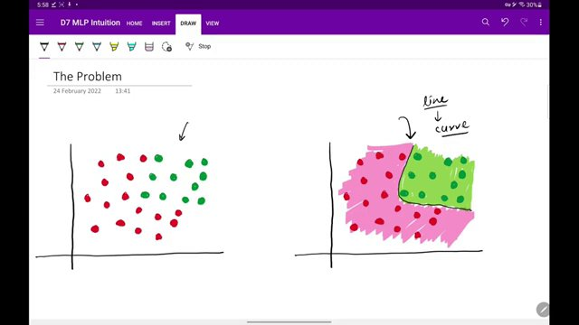

PERCEPTRON WITH SIGMOID DIAGRAM AND EQUATIONS. (at 315s)
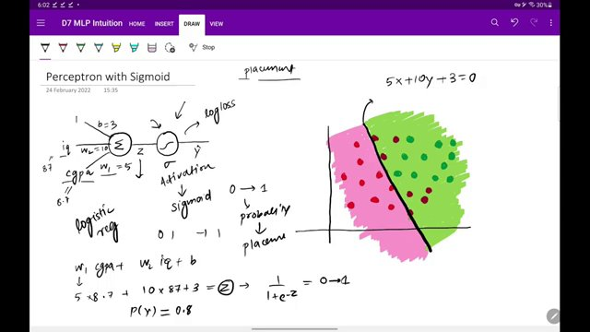

MLP DECISION BOUNDARY ILLUSTRATION. (at 495s)
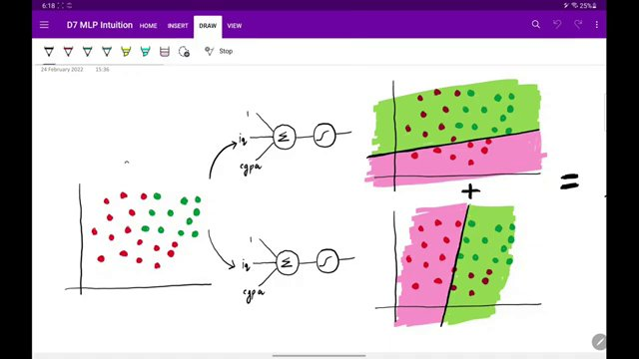

PERCEPTRON LINEAR COMBINATION AND SIGMOID FUNCTION EQUATIONS. (at 855s)
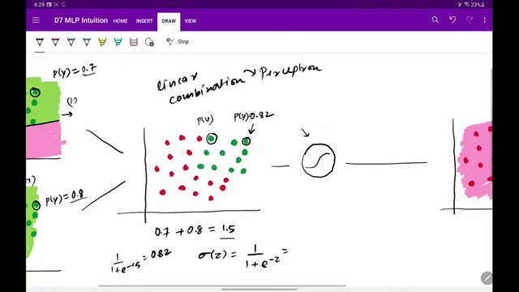

WEIGHTED DECISION BOUNDARY DIAGRAMS (at 945s)
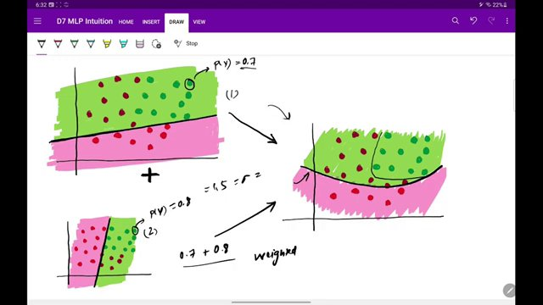

MLP DECISION BOUNDARY VISUALIZATION AND EQUATIONS. (at 1080s)
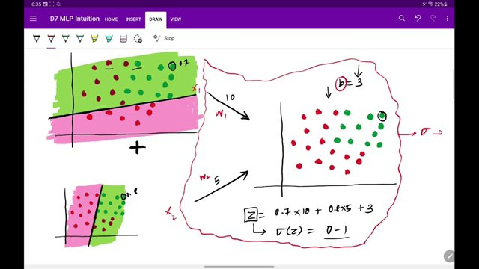

Interview question bank

*Target roles: ML Engineer / Data Scientist / AI Engineer. Questions are sourced from web pages only (not invented).*

Summary table

| Topic | # Companies | # Questions | Top sources |
|-------|-------------|-------------|-------------|
| Perceptron limitations and linear decision boundaries | 1 | 5 | apxml.com |
| Logistic regression and sigmoid activation | 0 | 0 | globalsino.com, datajourney24.substack.com |
| Multi-Layer Perceptron (MLP) and non-linear decision boundaries | 0 | 0 | apxml.com, hagan.okstate.edu |
| Combining perceptrons via linear combinations | 0 | 0 | |
| Neural network layers: input, hidden, output | 0 | 0 | |
| Neural network architecture (width, depth, inputs, outputs) | 0 | 0 | |
| Universal function approximation by neural networks | 0 | 0 | |
| Multi-class classification with neural networks | 0 | 0 | |
| Activation functions in neural networks (sigmoid vs ReLU) | 0 | 0 | |
| Geometric interpretation of logistic regression decision boundaries | 0 | 0 | |
| TensorFlow Playground for visualizing neural networks | 0 | 0 | |
| Trade-offs of larger neural networks | 0 | 0 | |
| **Total (all in bank)** | 1 | 5 | See sections below |

Coverage report

- Extracted topics: 12
- Questions with attribution: 5
- Excluded (unattributed): 4

**Topic coverage notes:**
Content centers on explaining how Multi-Layer Perceptrons overcome single-perceptron linear limitations, using logistic/sigmoid units, linear combinations across layers, and architectural variations (depth, width, inputs, outputs). TensorFlow Playground is used for geometric and empirical intuition, with brief mention of activation choices and universal approximation.

Questions by topic → company

Perceptron limitations and linear decision boundaries

**ApX Machine Learning**
- **Q:** What happens when the data isn't linearly separable?
- *Role/level:* ML Engineer / Data Scientist
- *Source:* https://apxml.com/courses/introduction-to-deep-learning/chapter-1-neural-network-foundations/perceptron-limitations
- *Evidence:* This works perfectly well for problems that are **linearly separable**... However, the power of a single-layer Perceptron ends there. What happens when the data isn't linearly separable?

The XOR Problem: A Classic Limitation

- **Q:** Can you draw a *single straight line* that separates the red points (output 0) from the blue points (output 1)?
- *Role/level:* ML Engineer / Data Scientist
- *Source:* https://apxml.com/courses/introduction-to-deep-learning/chapter-1-neural-network-foundations/perceptron-limitations
- *Evidence:* Look closely at the plot. Can you draw a *single straight line* that separates the red points (output 0) from the blue points (output 1)? No matter where you try to draw a line, you'll always find at least one point on the wrong side.

- **Q:** Why the Perceptron Fails on XOR
- *Role/level:* ML Engineer / Data Scientist
- *Source:* https://apxml.com/courses/introduction-to-deep-learning/chapter-1-neural-network-foundations/perceptron-limitations
- *Evidence:* ### Why the Perceptron Fails on XOR

The Perceptron determines its output using a weighted sum of inputs passed through a step function:

- **Q:** What happens when the data isn't linearly separable?
- *Role/level:* ML Engineer / Data Scientist
- *Source:* https://apxml.com/courses/introduction-to-deep-learning/chapter-1-neural-network-foundations/perceptron-limitations
- *Evidence:* However, the power of a single-layer Perceptron ends there. What happens when the data isn't linearly separable?

The XOR Problem: A Classic Limitation

- **Q:** Was this section helpful?
- *Role/level:* ML Engineer / Data Scientist
- *Source:* https://apxml.com/courses/introduction-to-deep-learning/chapter-1-neural-network-foundations/perceptron-limitations
- *Evidence:* As we'll see in the next section, these hidden layers allow the network to learn complex, non-linear decision boundaries, overcoming the limitations of the simple Perceptron.

Was this section helpful?

Unattributed (excluded from main list)

- **Topic:** Logistic regression and sigmoid activation — Question is present in GitHub ML interview question list but no specific tech company is mentioned in the same block, violating attribution rules. — _Explain briefly the logistic regression model and state an example of when you have used it recently?_
- **Topic:** Perceptron limitations and linear decision boundaries — Appears in a Substack newsletter as a Q&A article with no associated hiring company; cannot be tied to a real tech employer as required. — _What are the differences between a perceptron and a logistic regression model?_
- **Topic:** Neural network layers: input, hidden, output — Found in a LinkedIn post listing generic interview-style questions with no explicit company attribution in the block. — _What are the basic building blocks of a neural network?_
- **Topic:** Activation functions in neural networks (sigmoid vs ReLU) — Also from the LinkedIn deep learning basics post; no concrete tech employer given in the same content block. — _What is the difference between sigmoid, tanh, and ReLU activations?_

