YouTube Notes rKG9E6rce1c

Metadata
Created at: 2026-03-23 11:34:47
Video ID: rKG9E6rce1c

Notes

Nesterov Accelerated Gradient (NAG) vs Momentum – Concept, Math, Geometry & Keras

Optimizers Overview
- Optimizer: an algorithm used to find optimal weight values `w` that minimize the loss.
- Common baseline optimizer: Gradient Descent (GD) with variants:
- Batch Gradient Descent
- Stochastic Gradient Descent (SGD)
- Mini-batch Gradient Descent
- These vanilla GD methods can be slow, leading to the need for advanced optimizers like Momentum and NAG.

Linear Regression Demo Setup
- Problem: simple linear regression with Mean Squared Error (MSE) as cost function.
- Visualization:
- 3D error surface (MSE vs parameters `m` and `b`).
- 2D contour plot (projection of 3D surface).
- Data plot with regression line adjusting over iterations.
- Goal: start from random `(m, b)` and reach red point (true optimal `m`, `b`).

Batch Gradient Descent Behavior
- Starting from a random point in parameter space.
- Takes about 25–30 epochs (or iterations) to converge for the demo data.
- Considered relatively slow, motivating advanced techniques.

Momentum Optimizer – Intuition & Behavior
- Momentum uses a "velocity" term to accumulate past gradients:
- Fast directions are emphasized, like a ball rolling downhill.
- Visual behavior:
- On error surface, path looks like a ball rolling down, overshooting, crossing the minimum, coming back, and gradually settling.
- On contour plot, path oscillates around the valley and converges eventually.
- With `β = 0.9` (high momentum factor):
- Old velocity is given high weight.
- Leads to strong push, larger overshoot, more oscillations.
- In the shown setup, takes ~50 epochs to settle at minimum (more than plain batch GD).
- However, advantage:
- Far from the minimum, it moves very quickly towards the minimum region.
- Example: within ~3 iterations, it crosses the minimum region, versus many more for standard GD.
- Tuning `β` (decay/momentum factor):
- Reducing `β` lowers the effect of old velocity.
- Oscillations get smaller; convergence becomes smoother.
- Example: with a lower `β`, convergence epochs drop to ~38–39 vs ~50.
- Key takeaway:
- Momentum travels the long initial distance to the minimum much faster.
- Needs careful tuning of `β` to control oscillations.

Limitation of Momentum
- Main issue: oscillations around the minimum.
- On simple convex problems, can be mitigated by reducing `β`.
- On non-convex, more complex error surfaces:
- Oscillations can be more problematic.
- Can increase convergence time or cause instability.
- This motivates an improved method: Nesterov Accelerated Gradient (NAG/NAG).

What is Nesterov Accelerated Gradient (NAG)?
- NAG (referred to as NAG or "Nag"): Nesterov Accelerated Gradient.
- Conceptual summary:
- A way to implement momentum with a small modification.
- Designed to damp (reduce) oscillations while keeping advantages of momentum.
- Performance:
- Often converges faster than standard momentum.
- Reaches minima more quickly with reduced overshooting.
- High-level idea:
- Instead of computing gradient at current position, compute gradient at a "look-ahead" position (after a momentum step).
- This anticipatory step helps reduce oscillations.

Momentum – Mathematical Formulation
- Update rules (Momentum with SGD):
- Velocity update:
- `v_t = β * v_(t-1) + η * ∂L/∂w_t`
- `β`: momentum factor (decay).
- `η`: learning rate.
- `∂L/∂w_t`: gradient of loss wrt weights at time `t`.
- Weight update:
- `w_(t+1) = w_t - v_t`
- If you expand `w_(t+1)`:
- `w_(t+1) = w_t - (β * v_(t-1) + η * ∂L/∂w_t)`
- The update is a combination of:
- Old velocity term: `β * v_(t-1)`
- Current gradient term: `η * ∂L/∂w_t`
- Comparison with vanilla GD:
- Vanilla GD update: `w_(t+1) = w_t - η * ∂L/∂w_t`
- Momentum adds an extra push from the accumulated velocity.
- Geometric intuition (1D loss `L(w)`):
- At a position on the curve:
- Vanilla GD moves based only on current gradient.
- Momentum moves based on:
- Past velocity direction and magnitude.
- Current gradient direction.
- Result: larger, faster jumps in the descent direction, but can overshoot.

NAG – Mathematical Formulation from Momentum
- Key conceptual difference:
- Momentum: compute momentum and gradient at the same current position, then update once.
- NAG: first move using momentum, then compute gradient at the new ("look-ahead") position, and then update.
- Formal steps (NAG):
1. Compute look-ahead position `w_lookahead` using momentum:
- `w_lookahead = w_t - β * v_(t-1)`
- This is "where we would go" if we moved purely by momentum.
2. Compute new velocity using gradient at the look-ahead position:
- `v_t = β * v_(t-1) + η * ∂L/∂w_lookahead`
- Gradient is evaluated at `w_lookahead` (not at `w_t`).
3. Update weights:
- `w_(t+1) = w_t - v_t`
- Intuition of the decomposition:
- Step 1: apply only the momentum part to get the look-ahead point.
- Step 2: at that look-ahead point, compute gradient and adjust.
- Combined effect: update from original `w_t` using:
- The momentum "push" plus
- A gradient correction at the anticipated future location.

Geometric Intuition – Momentum vs NAG (1D Error Surface)

Momentum Geometry
- Consider loss surface `L(w)` with a minimum.
- At each point:
- Compute momentum (from past steps).
- Compute gradient at that same point.
- Take one combined step based on both.
- Example behavior:
- Starting from left side of minimum with negative slope:
- Gradient is negative, so update direction is positive.
- Momentum also points positive due to accumulated movement.
- You repeatedly move in positive direction, building strong positive momentum.
- When you overshoot past the minimum:
- Gradient flips sign (becomes positive), pushing you back.
- But momentum may still be large positive.
- Net effect:
- Still move slightly further to the right (overshoot more).
- Eventually:
- Momentum decreases, changes sign, combines with gradient to pull you back.
- You oscillate around the minimum with decreasing amplitude.
- Path:
- Start left of minimum, overshoot to the right, U-turn back, several smaller U-turns until settling at the minimum.

NAG Geometry
- Same loss surface and starting point.
- At each step:
1. Use only momentum to compute a look-ahead point:
- Move from current position to `w_lookahead`.
2. Compute gradient at `w_lookahead`.
3. Use that gradient to decide the corrective move.
- Crucial difference:
- Momentum:
- At a point near the minimum, momentum and gradient are combined at that point, possibly pushing you further past the minimum before correcting.
- NAG:
- You first move to where momentum alone would take you.
- At that new point, the gradient may already indicate that you should go in the opposite direction.
- So the next correction step is smaller or even backwards, effectively taking a "shallower" U-turn.
- Result:
- When you would overshoot with momentum, NAG "anticipates" and reduces the overshoot.
- Oscillations are damped earlier, leading to a quicker and smoother convergence.
- Visual summary:
- Momentum path: longer overshoot, larger U-turn arcs around the minimum.
- NAG path: smaller overshoot, early correction, more direct approach to the minimum.

Why NAG Reduces Oscillations
- By using gradient at the look-ahead position:
- You are effectively "seeing" future loss landscape where momentum will take you.
- If that future position lies beyond the minimum, the gradient there will point back, so the net correction is reduced or reversed.
- This anticipatory step:
- Decreases the effective step size when close to the minimum on steep sides.
- Leads to smaller, better-aligned updates.
- Reduces oscillations relative to classical momentum.

Potential Disadvantage of NAG
- NAG damps momentum around minima.
- In non-convex surfaces with multiple local minima:
- Momentum might help you "jump over" shallow local minima due to strong velocity (ball crosses valley).
- NAG, by damping oscillations and effective momentum, may not gather enough energy to cross such barriers.
- You can end up stuck in a local minimum, oscillating very close and settling there instead of reaching a better global minimum.
- So:
- NAG’s damping of oscillations can improve convergence stability.
- But it may reduce the ability to escape some local minima compared to strong momentum.

Keras Implementation of SGD, Momentum, and NAG
- In Keras, all three are controlled using the `SGD` optimizer class.
- Key parameters:
- `momentum`
- `nesterov`
- Configurations:
- Plain SGD:
- `momentum = 0.0`
- `nesterov = False`
- SGD with Momentum:
- `momentum = β` (e.g., 0.9, 0.8, etc.)
- `nesterov = False`
- Nesterov Accelerated Gradient (NAG):
- `momentum = β` (non-zero)
- `nesterov = True`
- Using these flags, you can switch between:
- Standard SGD
- Momentum SGD
- NAG SGD, all with simple parameter changes in Keras.

Key images
"BATCH GRADIENT DESCENT VISUALIZATION WITH GROUND TRUTH AND LOSS PLOTS" (at 134s)
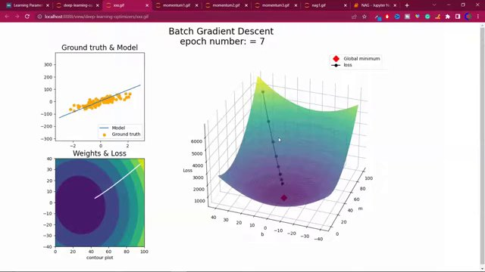

"MOMENTUM OPTIMIZER VISUALIZATIONS: GROUND TRUTH, WEIGHTS & LOSS, 3D LOSS SURFACE." (at 404s)
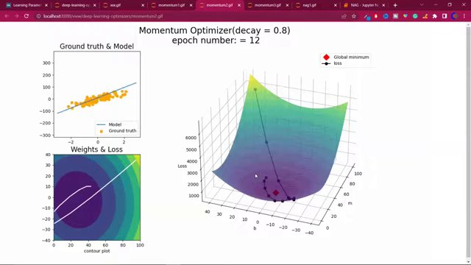

MOMENTUM EQUATION AND DECAY FACTOR EXPLANATION. (at 584s)
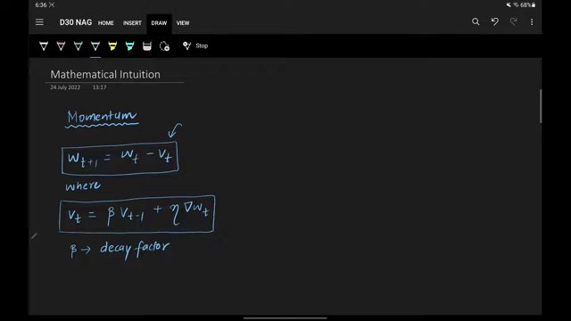

"NESTEROV ACCELERATED GRADIENT EQUATIONS AND DIAGRAM" (at 764s)
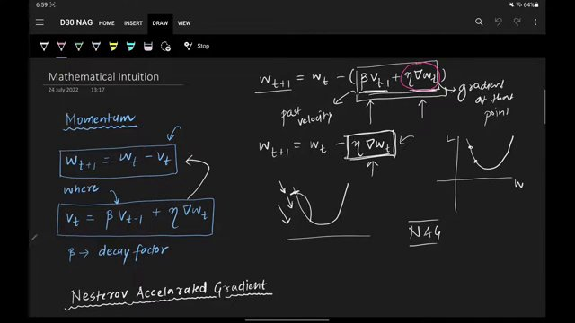

NESTEROV ACCELERATED GRADIENT EXPLANATION WITH EQUATIONS AND DIAGRAMS. (at 944s)
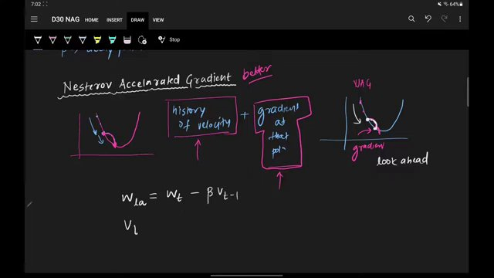

NESTEROV ACCELERATED GRADIENT EXPLANATION WITH EQUATIONS AND DIAGRAMS. (at 1034s)
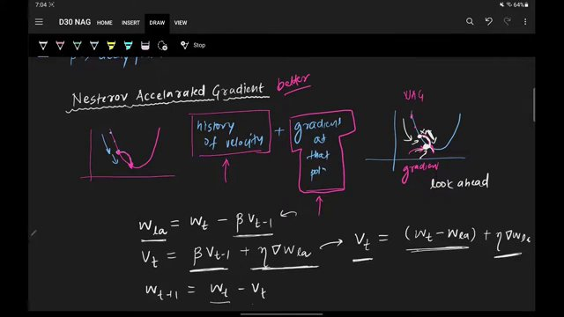

Interview question bank

*Target roles: ML Engineer / Data Scientist / AI Engineer. Questions are sourced from web pages only (not invented).*

Summary table

| Topic | # Companies | # Questions | Top sources |
|-------|-------------|-------------|-------------|
| Gradient descent variants | 11 | 14 | tryexponent.com, interviewnode.com, linkedin.com, machinelearningmastery.com, an |
| Momentum optimization | 0 | 0 | rohan-paul.com, geeksforgeeks.org |
| Nesterov Accelerated Gradient | 0 | 0 | machinelearningmastery.com, jlmelville.github.io |
| Mathematical formulation of Momentum and NAG | 0 | 0 | |
| Geometric intuition of optimization methods | 0 | 0 | |
| Linear regression error surface visualization | 0 | 0 | |
| Convergence speed and oscillations in optimizers | 2 | 2 | |
| Convex vs non-convex optimization behavior | 0 | 0 | |
| Advantages and disadvantages of NAG | 0 | 0 | |
| Hyperparameter tuning of momentum factor | 0 | 0 | |
| Keras implementation of SGD, Momentum, and NAG | 0 | 0 | |
| Optimizers as algorithms to minimize loss | 0 | 0 | |
| **Total (all in bank)** | 11 | 16 | See sections below |

Coverage report

- Extracted topics: 12
- Questions with attribution: 16
- Excluded (unattributed): 3

**Topic coverage notes:**
Content focuses on optimization in deep learning: baseline gradient descent variants, Momentum, and Nesterov Accelerated Gradient, with emphasis on their math, geometric intuition, convergence behavior (oscillations), and practical implementation in Keras for a linear regression demo. Non-convex landscapes and NAG’s trade-offs are briefly discussed.

Questions by topic → company

Convergence speed and oscillations in optimizers

**Nvidia**
- **Q:** How do neural networks learn from data?
- *Role/level:* Data Scientist
- *Source:* https://www.tryexponent.com/blog/top-deep-learning-interview-questions
- *Evidence:* ### 1. How do neural networks learn from data?
...
ℹ️

This interview question was asked at Nvidia.

**Snapchat**
- **Q:** Explain mini-batch and stochastic gradient descent
- *Role/level:* MLE
- *Source:* https://www.tryexponent.com/blog/top-deep-learning-interview-questions
- *Evidence:* Watch an MLE from Snapchat answer this interview question: "Explain mini-batch and stochastic gradient descent".

Gradient descent variants

**Amazon**
- **Q:** Describe linear regression
- *Role/level:* MLE
- *Source:* https://www.tryexponent.com/blog/top-deep-learning-interview-questions
- *Evidence:* - Watch Amazon MLE answer, "Describe linear regression".

**Apple**
- **Q:** Can you implement batch normalization using NumPy?
- *Role/level:* MLE
- *Source:* https://www.tryexponent.com/blog/top-deep-learning-interview-questions
- *Evidence:* ℹ️

This interview question was asked at Apple. "Implement batch normalization with NumPy".

**FAANG**
- **Q:** Implement Logistic Regression from scratch
- *Role/level:* Mixed
- *Source:* https://www.interviewnode.com/post/ace-your-ml-interview-50-commonly-asked-questions-at-faang-companies
- *Evidence:* ##### **1. Implement Logistic Regression from scratch**

Problem: Write a Python function to implement logistic regression using gradient descent.

- **Q:** Implement k-means clustering
- *Role/level:* Mixed
- *Source:* https://www.tryexponent.com/blog/top-deep-learning-interview-questions
- *Evidence:* - Watch Snap MLE answer, "Implement k-means clustering".

**Meta**
- **Q:** Design Instagram ranking model
- *Role/level:* MLE
- *Source:* https://www.tryexponent.com/blog/top-deep-learning-interview-questions
- *Evidence:* Sneak peek:
- Watch Meta MLE answer, "Design Instagram ranking model".

- **Q:** Design an evaluation framework
- *Role/level:* MLE
- *Source:* https://www.tryexponent.com/blog/top-machine-learning-interview-questions
- *Evidence:* 3. Design an evaluation framework. (Meta)

**Nielsen**
- **Q:** What is the difference between batch gradient descent and stochastic gradient descent (SGD)?
- *Role/level:* Data Scientist
- *Source:* https://www.linkedin.com/posts/nihar-penchala_datascience-deeplearning-interviewquestions-activity-7371013068417458176-r2K_
- *Evidence:* Here are today’s 10 interview questions:
...
8. Difference between batch gradient descent and stochastic gradient descent (SGD)?

**Nvidia**
- **Q:** Explain deep learning to non-technical stakeholders
- *Role/level:* MLE
- *Source:* https://www.tryexponent.com/blog/top-deep-learning-interview-questions
- *Evidence:* ℹ️

This interview question was asked at Nvidia. "Explain deep learning to non-technical stakeholders".

**OpenAI**
- **Q:** Explain gradient descent
- *Role/level:* MLE
- *Source:* https://www.tryexponent.com/blog/top-machine-learning-interview-questions
- *Evidence:* 1. Explain gradient descent. (OpenAI)

- **Q:** Explain gradient descent and model optimization
- *Role/level:* MLE
- *Source:* https://www.tryexponent.com/blog/top-machine-learning-interview-questions
- *Evidence:* 1. Explain gradient descent. (OpenAI)
...
https://www.tryexponent.com/questions/4359/gradient-descent-and-model-optimization

**Pinterest**
- **Q:** Explain overfitting
- *Role/level:* MLE
- *Source:* https://www.tryexponent.com/blog/top-machine-learning-interview-questions
- *Evidence:* ### 1. What is overfitting? How can you avoid it?
...
ℹ️

This question was asked at Pinterest. "Explain overfitting".

**Snap**
- **Q:** Implement k-means clustering
- *Role/level:* MLE
- *Source:* https://www.tryexponent.com/blog/top-deep-learning-interview-questions
- *Evidence:* - Watch Snap MLE answer, "Implement k-means clustering".

**Snapchat**
- **Q:** Explain mini-batch and stochastic gradient descent
- *Role/level:* MLE
- *Source:* https://www.tryexponent.com/blog/top-deep-learning-interview-questions
- *Evidence:* ℹ️

Watch an MLE from Snapchat answer this interview question: "Explain mini-batch and stochastic gradient descent".

**Spotify**
- **Q:** Design Spotify recommendation system
- *Role/level:* MLE
- *Source:* https://www.tryexponent.com/blog/top-machine-learning-interview-questions
- *Evidence:* 4. Design a recommendation system. (Spotify)

Unattributed (excluded from main list)

- **Topic:** Gradient descent variants — YouTube page mentions 'ML Interview Questions: Gradient Descent' as a video title but does not show any explicit question sentences in the visible transcript/description. — _ML Interview Questions: Gradient Descent_
- **Topic:** Momentum optimization — Rohan's article clearly states this as an interview question, but no specific company is mentioned in the same block; cannot attribute to a real tech employer as required. — _What is momentum in the context of gradient-based optimization? Write the update equations for gradient descent with momentum and explain how momentum helps accelerate convergence and can help escape _
- **Topic:** Gradient descent variants — Devinterview.io gradient-descent article is generic and not tied to a specific company name; per rules, questions without company context must be skipped. — _What are the main variants of gradient descent algorithms?_

