YouTube Notes vVS4csXRlcQ

Metadata
Created at: 2026-03-24 07:03:20
Video ID: vVS4csXRlcQ

Notes

Momentum Optimization in Deep Learning

Context: Optimization in Deep Learning
- In deep learning, a neural network predicts an output from inputs; performance is measured by a loss function.
- Loss function `L` establishes a mathematical relationship between predictions and true values (e.g., mean squared error: `L = (ŷ - y)²`).
- Loss depends on model parameters (weights `w`, biases `b`): `L = f(w, b, …)`.
- Training goal: find parameter values that minimize `L`.

Visualizations: 3 Types of Graphs

1. Loss vs Single Parameter (2D)
- Assume a very simple network with a single parameter `w` and no bias.
- Loss becomes a function of just `w`: `L = f(w)`.
- Can be plotted as a 2D curve: x-axis is `w`, y-axis is `L`.
- Shows how loss changes as a single parameter changes.

2. Loss vs Two Parameters (3D Surface)
- With two parameters (e.g., `w` and `b`), loss is `L = f(w, b)`.
- Plotted as a 3D surface: two axes for parameters, vertical axis for loss.
- For realistic networks with many parameters, the true surface is high-dimensional, but we visualize subsets (1D or 2D slices).

3. Contour Plot (2D Projection of 3D Surface)
- Contour plot is the 2D top-down projection of the 3D loss surface.
- Each contour line represents points with the same loss (same “altitude”).
- Height information (third dimension) is encoded by:
- Line positions and spacing: closer lines → steeper region; farther lines → flatter region.
- Color: e.g., yellow/brown for high altitude (high loss), blue/purple for low altitude (low loss).
- Contour plots help visualize optimization paths in 2D while representing the 3D loss landscape.

Examples of Surfaces and Their Contours
- Bowl-shaped minimum:
- 3D: looks like a smooth valley or bowl.
- Contour: concentric circles/ellipses; center is minimum (often blue).
- Saddle point surface:
- Shape rises in one direction and falls in another (e.g., like `x² - y²`).
- Contour: ellipses/hyperbolas where lines near the saddle are relatively far apart (flat region).
- Colors indicate directions of increase/decrease: high-altitude areas (orange/brown), low-altitude areas (blue).
- Tilted plane / slanted surface:
- One side high, one side low.
- Contour: elongated lines indicating consistent slope.
- Key intuition:
- Flat regions → widely spaced contours, small gradient, slow movement.
- Steep regions → tightly packed contours, large gradient, fast movement.

Convex vs Non-convex Optimization
- Convex loss (simple case):
- Single bowl-shaped minimum.
- Easy for gradient descent to find the global minimum.
- Non-convex loss (typical in deep learning):
- Complex surfaces with many valleys, hills, and flat regions.
- Visualized as irregular curves in 2D or complicated surfaces in 3D.
- In deep learning, complex architectures lead to highly non-convex loss landscapes.

Challenges in Non-convex Optimization

1. Local Minima
- Local minimum: a point where the slope (gradient) is zero and loss is smaller than its neighbors, but not the smallest globally.
- In 2D:
- If gradient descent starts near a shallow valley, it may settle there instead of reaching the deeper, global minimum.
- In 3D:
- Similar to being stuck in a small pit while a deeper pit exists elsewhere.
- Consequence:
- Network converges to sub-optimal solutions with poorer performance.

2. Saddle Points
- Saddle point: point where surface rises in some directions and falls in others.
- Gradient near saddle is small and changes very gradually.
- Issues:
- Very flat in some directions → gradients very small → training updates become tiny → extremely slow progress.
- Can get “stuck” or move very slowly in these regions.

3. High Curvature
- Curvature: how sharply the surface bends.
- Large radius → low curvature (gentle curve).
- Small radius → high curvature (sharp curve).
- High-curvature regions:
- Hard for gradient descent to navigate; steps can overshoot or oscillate.
- Very prevalent in non-convex loss surfaces.

Standard Gradient Descent Variants (Behavior on Convex Loss)

Batch Gradient Descent
- Updates weights after going through the entire dataset once.
- On a simple convex (parabolic) loss:
- Moves smoothly towards the minimum.
- Step sizes large initially, become smaller near the minimum.

Stochastic Gradient Descent (SGD)
- Updates weights after each single training example.
- Behavior:
- Path is noisy/zig-zag due to high variance in gradients from individual examples.
- Still eventually reaches near the minimum.

Mini-batch Gradient Descent
- Updates weights after each small batch of samples.
- Behavior:
- Smoother than pure SGD; more stable than single-sample updates.
- Still faster and more stochastic than full batch updates.

Motivation for Momentum
- Standard gradient descent struggles with:
- High curvature regions → oscillations and slow convergence.
- Nearly consistent (almost flat) gradients → very slow progress.
- Noisy gradients → can get trapped in local minima or wander around.
- Momentum-based optimization is introduced to:
- Speed up convergence, especially in directions with consistent gradients.
- Escape local minima.
- Navigate high-curvature regions more effectively.
- If asked “Why use momentum?”:
- Handles high curvature better.
- Speeds up movement in directions with consistent gradients.
- Helps escape local minima and makes training faster overall.

Intuition Behind Momentum

Heuristic Example: Asking for Directions
- You travel from point A to point B without knowing the route.
- You ask four people; all point in roughly the same direction.
- Because of consistent information, you gain confidence and drive faster in that direction.
- If two say “forward” and two say “back,” your confidence is lower, and you move more cautiously.
- Analogy:
- Past gradients pointing in the same direction → algorithm “trusts” that direction and increases speed.
- Inconsistent gradients → lower effective speed.

Physics-Based Example: Ball Rolling Downhill
- A ball rolling down a slope gains momentum as it moves.
- The faster it moves, the harder it is to stop immediately at a small dip.
- Name “momentum” comes from similarity with Newtonian momentum.
- Physical momentum formula: `p = m × v`.
- Assume unit mass (`m = 1`), so effectively track velocity only.
- The optimizer uses a “velocity” term that accumulates the history of gradients:
- If gradients keep pointing in the same direction, velocity grows.
- This increases step size along that direction.

Mathematical Formulation of Momentum

Standard Gradient Descent Update
- Without momentum:
- `w_{t+1} = w_t - η · ∂L/∂w_t`
- `η` is learning rate.

Momentum-based Update
- Introduce a velocity term `v_t`:
- Replace direct use of gradient by velocity:
- `w_{t+1} = w_t + v_t` (velocity includes the negative gradient direction)
- Velocity `v_t` is updated using an exponential moving average of past gradients:
- `v_t = β · v_{t-1} - η · g_t`
- `g_t = ∂L/∂w_t` (current gradient).
- `β` is the decay factor (between 0 and 1), controlling how strongly past updates influence current velocity.
- Interpretation:
- `v_t` carries a compressed “history” of past gradients.
- If many recent gradients align, `v_t` grows in that direction → acceleration.
- This is the core “momentum component”.

Connection to Exponential Moving Average
- Momentum uses exponential decay of past velocities/gradients:
- Recent steps contribute more.
- Older steps contribute less (decay controlled by `β`).
- Effective window length (rough intuition):
- Roughly around `1 / (1 - β)` steps are significantly influencing `v_t`.

Role of the Hyperparameter β

β = 0
- Velocity update becomes:
- `v_t = -η · g_t`
- Substituting into parameter update:
- `w_{t+1} = w_t - η · g_t`
- This reduces exactly to standard SGD (no momentum).
- So:
- `β = 0` → momentum behaves like vanilla SGD.

0 < β < 1
- Typical range: `β ≈ 0.5` to `0.9`, often around `0.9`.
- `β` controls:
- How fast old velocity information decays (DK factor / decay rate).
- How much past gradients affect current velocity.
- Approximate “effective length” of velocity memory:
- On the order of `1 / (1 - β)` steps.
- More recent gradients have higher influence; older gradients’ influence shrinks exponentially.

β = 1
- If `β = 1`, there is no decay:
- Velocity does not diminish over time.
- Consequences:
- The “ball” keeps spinning around; motion can persist indefinitely.
- System may reach a kind of dynamic equilibrium, oscillating and not settling.
- Hence:
- `β` is never set to exactly 1, as this can prevent convergence.

Effects of Momentum on Optimization Path

Faster Convergence
- Comparison on a valley-shaped loss:
- Without momentum:
- Large up-and-down steps across the valley; slow progress along the valley.
- With momentum:
- Vertical oscillations are reduced over time.
- Horizontal movement (towards minimum) is enhanced.
- Outcome:
- The steps become more aligned with the “valley direction”.
- Convergence to the minimum is faster.

Illustration on a Simple Surface
- Two points/paths shown:
- Blue: vanilla gradient descent (no momentum).
- Purple: gradient descent with momentum.
- Observations:
- Blue point moves with almost constant speed downwards.
- Purple point accelerates as it moves, arriving earlier at the minimum.
- First main benefit:
- Speed: momentum leads to faster training and faster convergence.

Escaping Local Minima
- Visualization with two pits:
- Small pit = local minimum.
- Big pit = global minimum.
- Behavior:
- Vanilla gradient descent (blue) falls into the small pit and gets stuck → cannot escape (insufficient speed).
- Momentum (purple) often has enough accumulated velocity to pass through the small pit and continue to the deeper global minimum.
- Second main benefit:
- Ability to escape local minima due to accumulated momentum.

Disadvantage of Momentum: Overshooting

Local Behavior Near the Optimum
- In the two-pit visualization:
- Purple ball (momentum) enters the global minimum with high speed.
- It does not stop immediately:
- It overshoots, climbs up the other side, then comes back.
- Oscillates around the minimum before finally settling as velocity decays.
- Consequence:
- Time is spent overshooting and correcting.
- While still usually faster than vanilla gradient descent, it is not always the fastest among all advanced optimizers.

Example on a 3D Valley
- Surface:
- High regions on the sides, narrow valley with a minimum.
- Contour:
- Shows a narrow curved valley.
- Behavior with momentum:
- Momentum rushes toward the valley, may cross the minimum due to high speed.
- Then oscillates back and forth along and across the valley.
- Gradually settles as old velocities decay (due to `β < 1`).
- Key issue:
- The same property that gives speed (momentum) causes overshooting and extra oscillations.
- This can slow down final convergence near the optimum relative to more refined methods.

Overall Assessment of Momentum
- Main advantages:
- Much faster convergence than vanilla SGD in most practical cases.
- Better navigation of high curvature regions.
- Better ability to escape local minima and handle noisy gradients.
- Main disadvantage:
- Overshooting and oscillation around optima due to high momentum.
- Not always the absolutely fastest method compared to more advanced optimizers that further refine or adapt momentum (to be discussed in later techniques).
- Summary characterization:
- If asked for the single most important benefit of momentum:
- Speed: momentum-based optimization is almost always faster than plain SGD/batch gradient descent.

Visual Demonstration Tool
- A web-based visualization tool shows:
- Contour plot with a global minimum and a local minimum.
- Trajectories for different optimization algorithms.
- For SGD vs momentum:
- Black curve: SGD path.
- Blue/purple curve: momentum path.
- Uses:
- Clicking on different starting points shows how each algorithm navigates the contour landscape.
- Illustrates:
- Momentum’s faster travel.
- Its ability to jump out of local minima.
- Its tendency to overshoot and oscillate before settling.
- Such tools help build intuition about how different optimizers behave and why momentum improves over vanilla methods.

Key images
3D GRAPH OF CONTACT ANGLE VS. IMPACT VELOCITY AND PARTICLE SIZE. (at 509s)
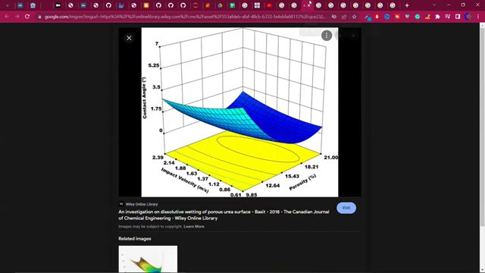

3D AND CONTOUR PLOTS OF A MATHEMATICAL FUNCTION. (at 593s)
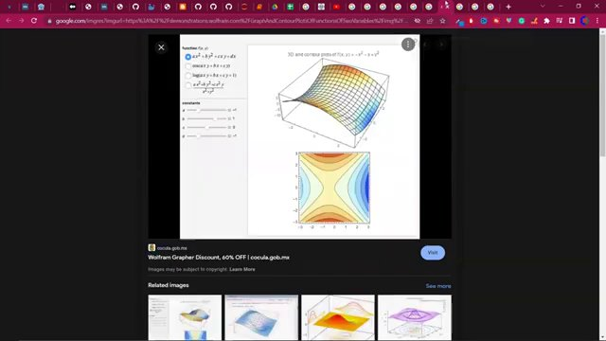

"WOLFRAM ALPHA 3D AND CONTOUR PLOT." (at 631s)
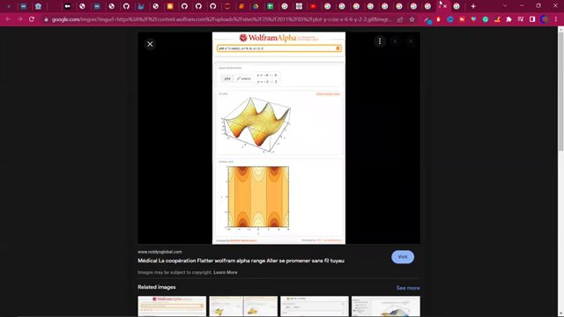

"BATCH GRADIENT DESCENT VISUALIZATION WITH GRAPHS AND 3D LOSS SURFACE." (at 978s)
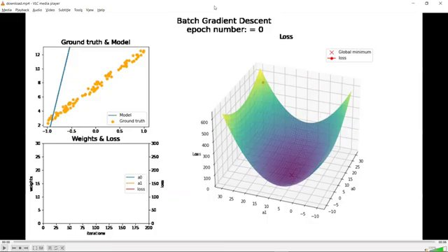

SGD WITH MOMENTUM DIAGRAM (at 1651s)
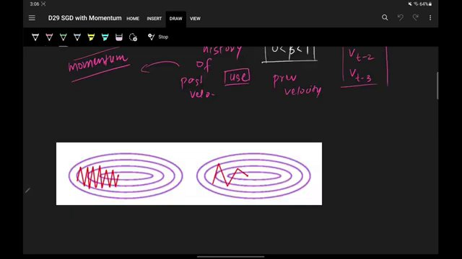

3D SURFACE PLOT DIAGRAM (at 1863s)
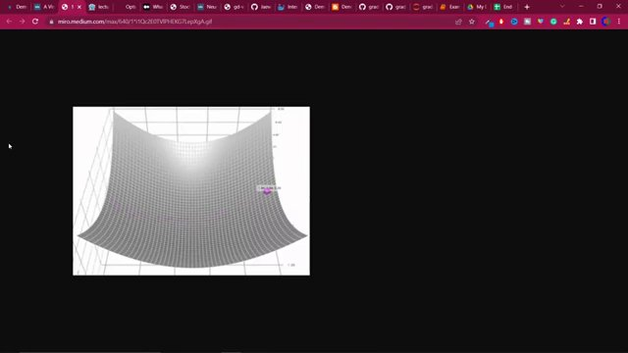

Interview question bank

*Target roles: ML Engineer / Data Scientist / AI Engineer. Questions are sourced from web pages only (not invented).*

Summary table

| Topic | # Companies | # Questions | Top sources |
|-------|-------------|-------------|-------------|
| Loss functions and neural network training objective | 1 | 1 | linkedin.com, machinelearningmastery.com, nvidia.com |
| Loss landscape visualization (2D, 3D, contour plots) | 0 | 0 | cs.umd.edu, papers.neurips.cc, aryanupadhyay.com, proceedings.mlr.press |
| Convex vs non-convex optimization in deep learning | 0 | 0 | |
| Optimization challenges: local minima, saddle points, high curvature | 0 | 0 | |
| Gradient descent variants | 3 | 7 | medium.com, github.com, analyticsarora.com, tryexponent.com, linkedin.com |
| Stochastic Gradient Descent (SGD) behavior | 1 | 1 | |
| Mini-batch Gradient Descent behavior | 0 | 0 | |
| Momentum optimization algorithm | 0 | 0 | aryanupadhyay.com, developer.nvidia.com |
| Intuition for momentum (direction consensus and physics analogy) | 0 | 0 | |
| Mathematical formulation of momentum (velocity and exponential moving average) | 0 | 0 | |
| Role of momentum hyperparameter β | 0 | 0 | |
| Benefits and drawbacks of momentum (speed, escaping local minima, overshooting) | 0 | 0 | |
| Visualization tools for optimizer trajectories on contour plots | 0 | 0 | |
| **Total (all in bank)** | 3 | 10 | See sections below |

Coverage report

- Extracted topics: 13
- Questions with attribution: 10
- Excluded (unattributed): 3

**Topic coverage notes:**
Content centers on optimization in deep learning, especially momentum: its intuition, math, hyperparameter β, and behavior vs vanilla/SGD/mini-batch gradient descent against complex loss landscapes (convex vs non-convex, local minima, saddle points, high curvature), with significant emphasis on visualizations and contour-based trajectory tools.

Questions by topic → company

Backpropagation / training objective

**General**
- **Q:** How do you understand Backpropagation? Explain the mechanism of action?
- *Role/level:* Deep Learning Engineer
- *Source:* https://medium.com/jp-tech/12-deep-learning-interview-questions-you-should-not-be-missed-part-2-8f42deeb4483
- *Evidence:* ## 5. How do you understand Backpropagation? Explain the mechanism of action?

Gradient descent variants

**Amazon**
- **Q:** Explain linear and logistic regression regression
- *Role/level:* ML Engineer
- *Source:* https://www.tryexponent.com/blog/top-machine-learning-interview-questions
- *Evidence:* 2. Explain linear and logistic regression regression. (Amazon)

**General**
- **Q:** What is gradient descent?
- *Role/level:* Data Scientist
- *Source:* https://medium.com/grabngoinfo/gradient-descent-vs-616ba269de8d
- *Evidence:* Gradient descent is a commonly asked concept in data science and machine learning interviews. Some example interview questions are

- What is gradient descent?
- What are the pros and cons of stochastic gradient descent?

- **Q:** What are the differences between batch gradient descent and mini-batch gradient descent?
- *Role/level:* Data Scientist
- *Source:* https://medium.com/grabngoinfo/gradient-descent-vs-616ba269de8d
- *Evidence:* Some example interview questions are

- What is gradient descent?
- What are the pros and cons of stochastic gradient descent?
- What are the differences between batch gradient descent and mini-batch gradient descent?

- **Q:** Explain briefly batch gradient descent, stochastic gradient descent, and mini-batch gradient descent. and what are the pros and cons for each of them?
- *Role/level:* Data Scientist
- *Source:* https://github.com/youssefHosni/Data-Science-Interview-Questions-Answers/blob/main/Machine%20Learning%20Interview%20Questions%20%26%20Answers%20for%20Data%20Scientists.md
- *Evidence:* * [Q8: Explain briefly batch gradient descent, stochastic gradient descent, and mini-batch gradient descent. and what are the pros and cons for each of them?]

- **Q:** What are the different types of Gradient Descent methods?
- *Role/level:* Data Scientist
- *Source:* https://analyticsarora.com/8-unique-machine-learning-interview-questions-about-gradient-descent/
- *Evidence:* #### **What are the different types of Gradient Descent methods?**

The methods are:

- Batch Gradient Descent...
- Stochastic Gradient Descent...
- Mini-batch Gradient Descent...

- **Q:** Difference between batch gradient descent and stochastic gradient descent (SGD)?
- *Role/level:* Deep Learning Engineer
- *Source:* https://www.linkedin.com/posts/nihar-penchala_datascience-deeplearning-interviewquestions-activity-7371013068417458176-r2K_
- *Evidence:* Here are today’s 10 interview questions:
...
8. Difference between batch gradient descent and stochastic gradient descent (SGD)?

**OpenAI**
- **Q:** Explain gradient descent
- *Role/level:* ML Engineer
- *Source:* https://www.tryexponent.com/blog/top-machine-learning-interview-questions
- *Evidence:* According to candidates, these are ten of the most frequently asked ML interview questions.

1. Explain gradient descent. (OpenAI)

Loss functions and neural network training objective

**General**
- **Q:** What is the role of loss functions in training a neural network?
- *Role/level:* Deep Learning Engineer
- *Source:* https://www.linkedin.com/posts/nihar-penchala_datascience-deeplearning-interviewquestions-activity-7371013068417458176-r2K_
- *Evidence:* Here are today’s 10 interview questions:
...
7. What is the role of loss functions in training a neural network?

Stochastic Gradient Descent (SGD) behavior

**General**
- **Q:** What are the pros and cons of stochastic gradient descent?
- *Role/level:* Data Scientist
- *Source:* https://medium.com/grabngoinfo/gradient-descent-vs-616ba269de8d
- *Evidence:* Gradient descent is a commonly asked concept in data science and machine learning interviews. Some example interview questions are

- What is gradient descent?
- What are the pros and cons of stochastic gradient descent?

Unattributed (excluded from main list)

- **Topic:** Loss functions and neural network training objective — YouTube page shows this as a video title, but no company is mentioned in title or content block and no explicit question sentence beyond the title is present to attribute to a specific tech employer. — _Machine Learning Interview Question: Outliers and Loss Functions_
- **Topic:** Loss landscape visualization (2D, 3D, contour plots) — Appears rhetorically in the NeurIPS loss landscape paper context section, not as an interview question; no interview/company framing. — _Why are we able to minimize highly non-convex neural loss functions?_
- **Topic:** Optimization challenges: local minima, saddle points, high curvature — Devinterview.io blog lists 'What challenges arise when using gradient descent on *non-convex functions*?' as an interview-style question, but no company is associated in title or content, and per instructions company must be a real tech employer, not a prep site. — _What challenges arise when using gradient descent on non-convex functions?_

