I have chosen Chrome’s dev tools. To set a break point in Chrome dev tools. You simply need to open the dev tools by pressing F12 or cmd+shift+I for Mac users. Next you locate the line of Javascript you wish to set a break on then click the 3 dots to the left of the line of code, and select “Break on” then choose your option. This will set a breakpoint in your script. 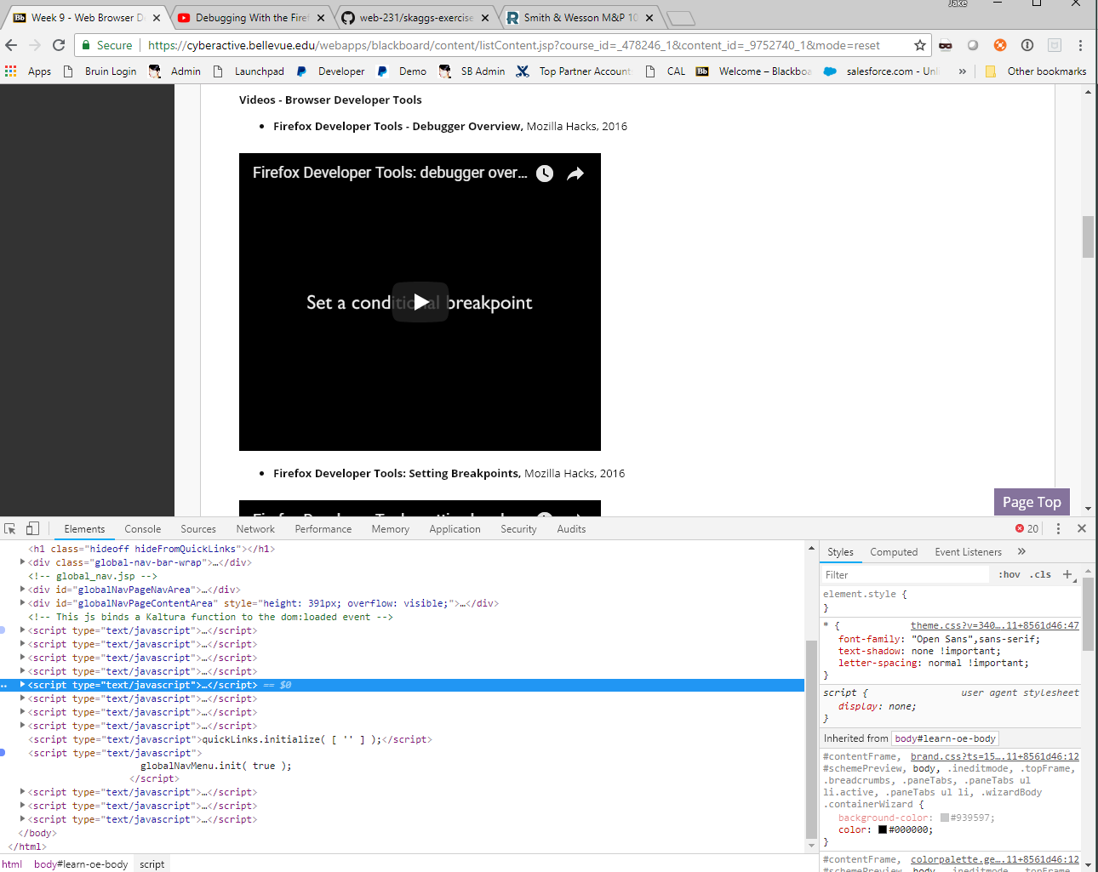

The console is very useful when debugging your Javascript. If you are not understanding why your code is not working the way you intend for it to or it’s not working at all you can use the console debugger to see what the errors are. Sometimes the errors will let you know immediately what is wrong. Sometimes not as immediate, but it will at least point you in the right direction. To access the console again just hit F12 then click on the Console tab. Many times it will default to that tab

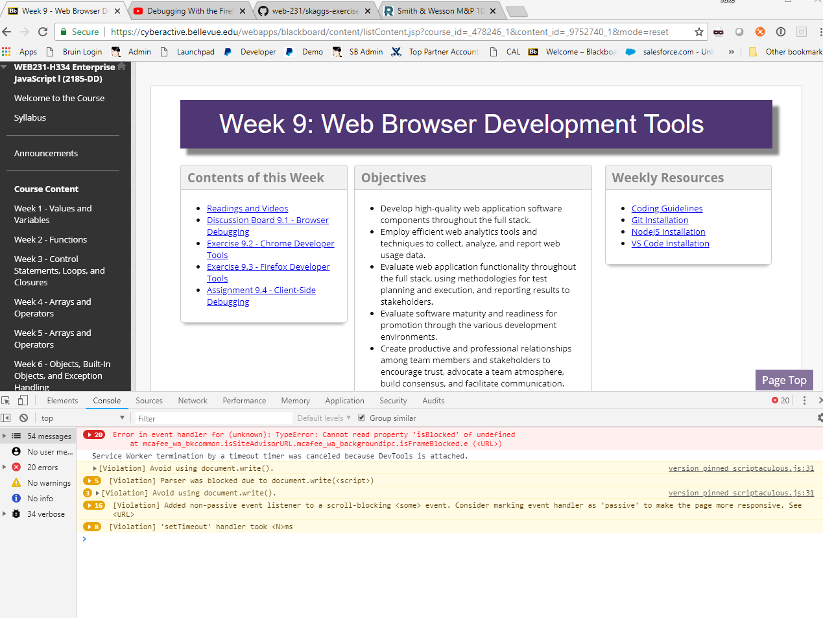

To inspect the HTML elements just click on the Elements tab once you’ve hit F12. When you hover over any of the HTML text it will highlight the part of the page that element is controlling. You can do the reverse by click on the arrow icon at very top left of the console. With this tool you can select parts on the page, and it will take you to the line of HTML that controls that part of the page.

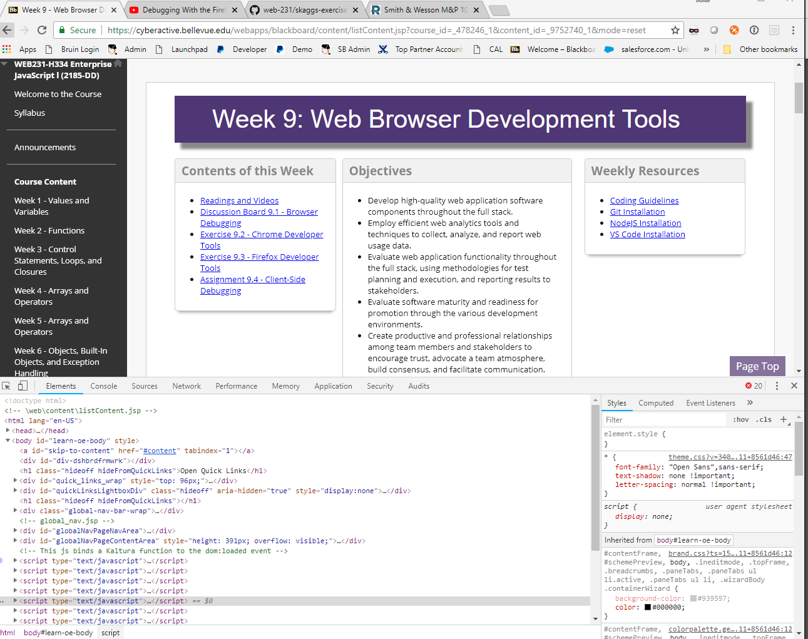

The CSS elements are on the right side of the console. Here you can edit the page on the fly. This is really helpful if you are demoing a site for a client, and they ask for color or position changes. You can make them on the fly. This does not permanently change the site because you would have to have access to the original HTML/CSS file. To do this you just need again hit F12 then make sure Elements tab is selected. The CSS will be on the right.

