
IT342-Section
SYSTEMS INTEGRATION AND ARCHITECTURE 1

FUNCTIONAL REQUIREMENTS SPECIFICATION (FRS)

Project Title: Mini App – User Registration & Authentication
Prepared By: Jascha B. Base
Date of Submission: 02/11/2026
Version: 0.0.1

Table of Contents
1. Introduction 3
1.1. Purpose 3
1.2. Scope 3
1.3. Definitions, Acronyms, and Abbreviations 3
2. Overall Description 3
2.1. System Perspective 3
2.2. User Classes and Characteristics 3
2.3. Operating Environment 3
2.4. Assumptions and Dependencies 3
3. System Features and Functional Requirements 3
3.1. Feature 1: 3
3.2. Feature 2: 3
4. Non-Functional Requirements 3
5. System Models (Diagrams) 4
5.1. ERD 4
5.2. Use Case Diagram 4
5.3. Activity Diagram 4
5.4. Class Diagram 4
5.5. Sequence Diagram 4
6. Appendices 4

Introduction

Purpose
This document provides a detailed overview of the User Authentication and Profile Management System. It serves as a blueprint for stakeholders to understand functional and non-functional requirements, with emphasis on secure access and data persistence

Scope
The system provides a secure gateway for user access to protected features. It includes:
- User registration
- Secure login
- Profile/dashboard access
- Session termination (logout)

Definitions, Acronyms, and Abbreviations
API (Application Programming Interface): Rules enabling the React frontend to communicate with the Spring Boot backend.
JWT (JSON Web Token): A compact token used for secure authentication and authorization.

Overall Description

System Perspective
The system follows a client-server architecture where the React UI handles user interaction, and the Spring Boot API manages business logic and database communication.

User Classes and Characteristics
- Guest User: Unauthenticated users who can access landing, registration, and login pages only.
- Authenticated User: Users with a valid token who can access the dashboard and profile data.

Operating Environment
- Frontend: React.js (Node.js environment), modern web browsers
- Backend: Spring Boot (Java JDK 17+)
- Database: PostgreSQL or MySQL
- Tools: VS Code / IntelliJ IDEA, Postman for API testing

Assumptions and Dependencies
- Assumption: Users have a stable internet connection to communicate with the API.
- Dependency: The system depends on the availability of the Database server for user credential verification.

System Features and Functional Requirements
Describe each major feature of the system and its functional requirements.

Feature 1:
Feature 1: User Identity Management (Registration and Login)
Description: Entry point for users to create and verify their identity.
Functional Requirements:
- Account Creation: Allow registration with unique username, email, and password.
- Credential Hashing: Hash passwords before storing in the database.
- Identity Verification: Grant access only if credentials match stored records.

Feature 2:
Feature 2: Access Control & Profile Management
Description: Manages session and protects private pages.
Functional Requirements:
- Session Authorization: Issue a secure JWT on login for dashboard access.
- Page Protection: Prevent unauthenticated access to protected profile pages.
- Secure Logout: Clear the authentication token on logout.

Non-Functional Requirements

Attribute | Requirement
Security | Protects against unauthorized access by using industry-standard hashing and token-based authentication.
Performance | Authentication and profile loading should occur within 500ms to ensure a responsive user experience.
Usability | The interface should utilize a clean layout with consistent typography like Montserrat or Playfair Display
Reliability | The database and API must maintain high availability to prevent users from being locked out.
.

System Models (Diagrams)
Insert the necessary diagrams for the system:

ERD
ERD
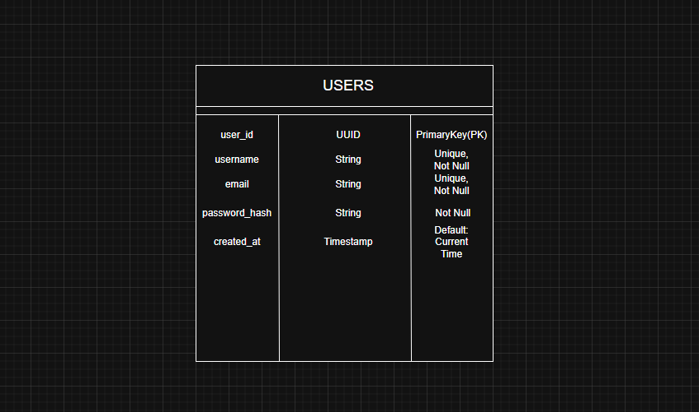

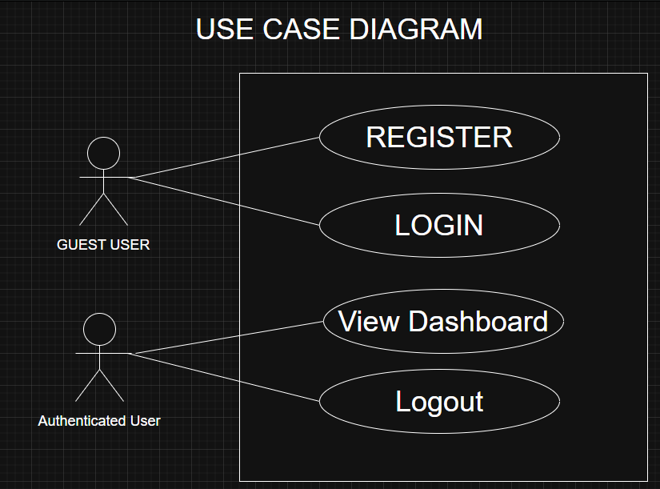
Use Case Diagram

Activity Diagram
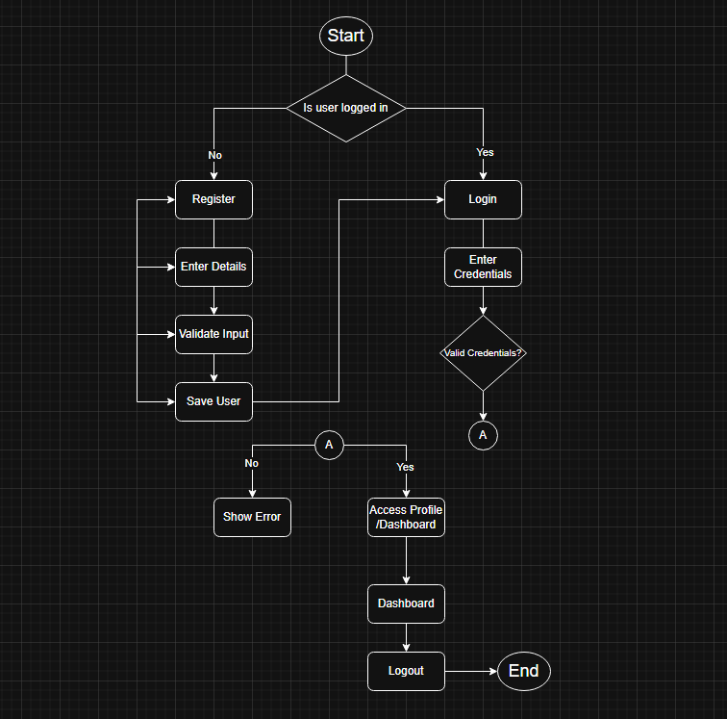

Class Diagram
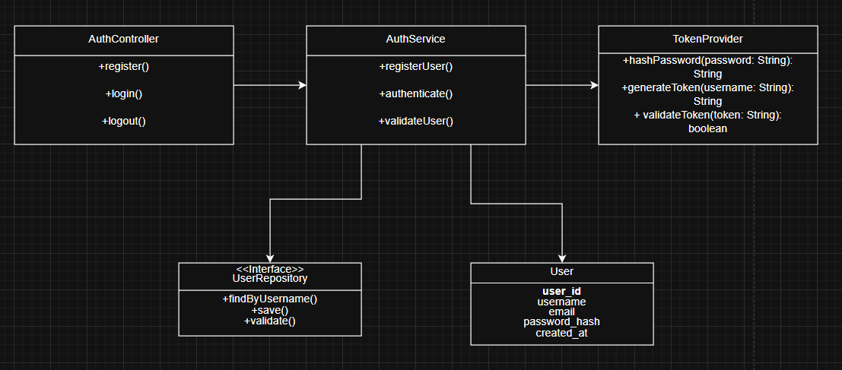

Sequence Diagram
SEQUENCE DIAGRAM
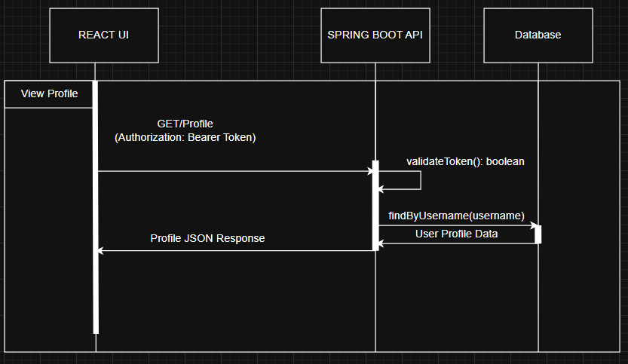

Appendices
Include any additional information, references, or support materials.
Register
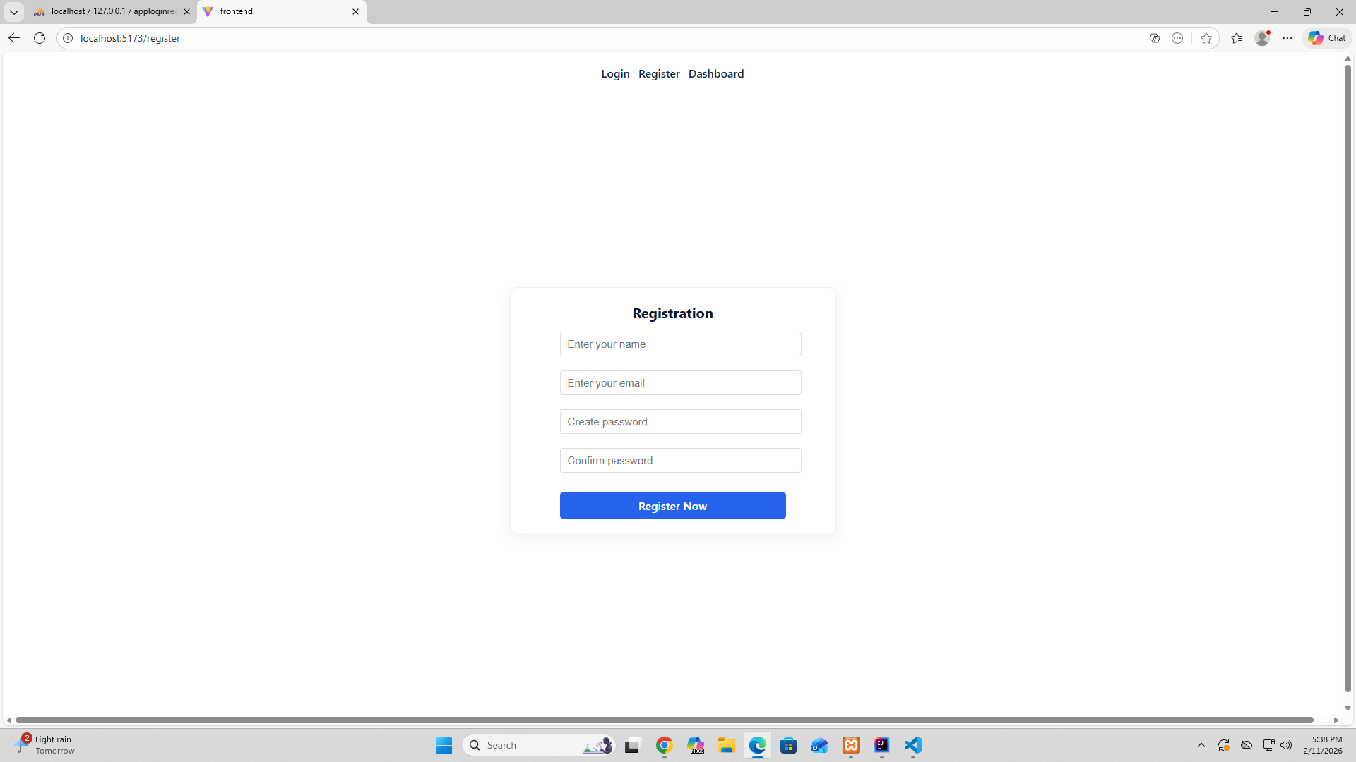

Login
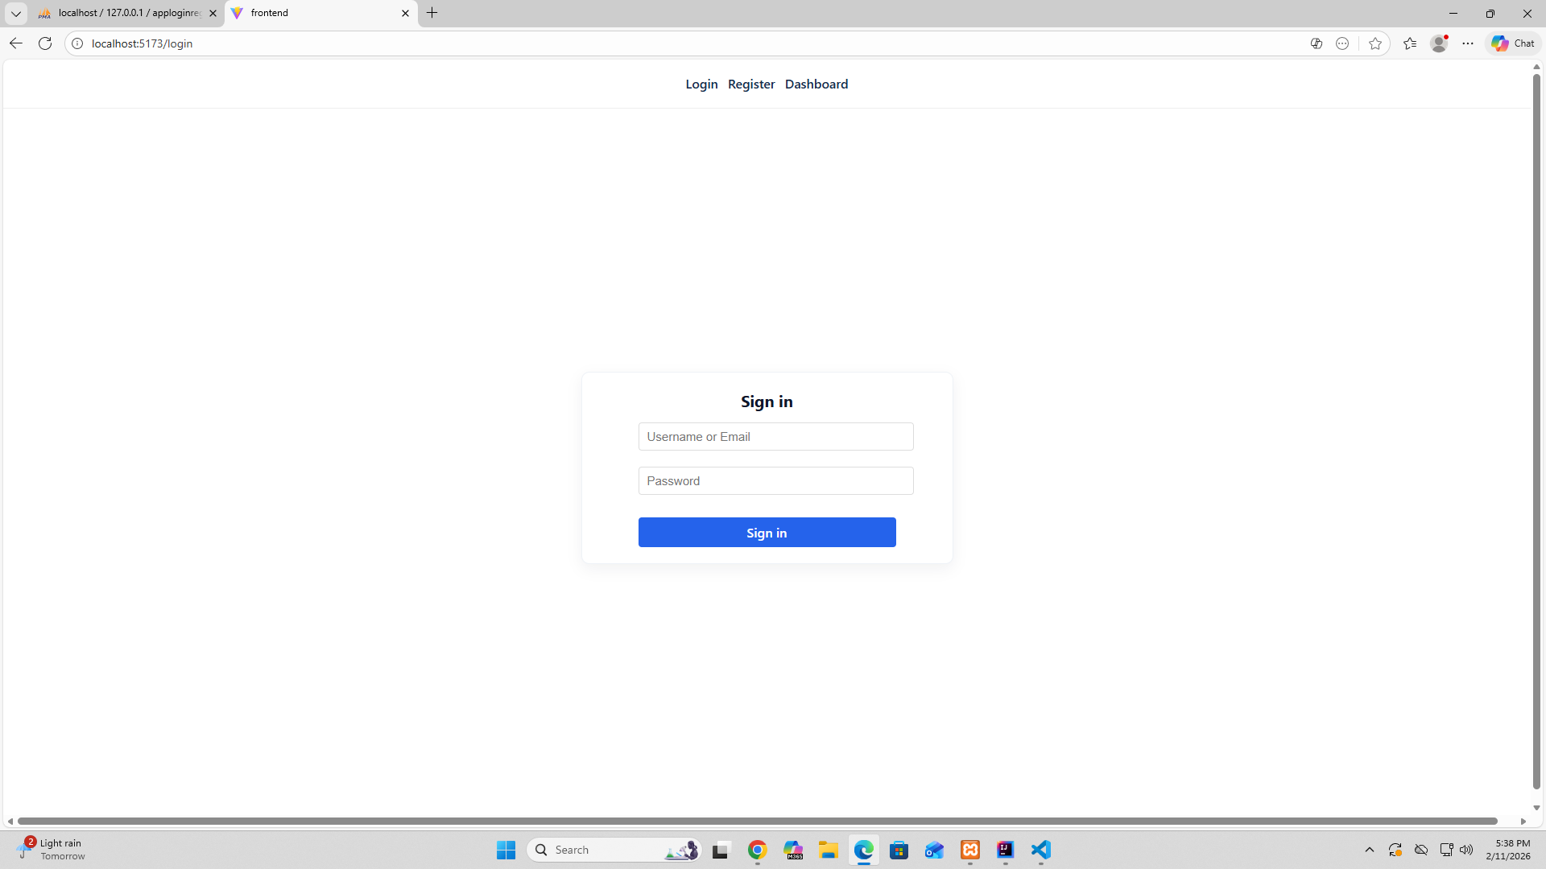

Dashboard/Profile
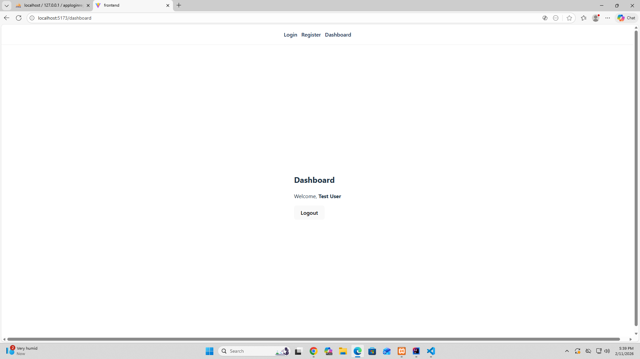

Logout result (e.g., redirected to login)
