Architecture des Systèmes d’Information
TP1 WildFly
Jérôme SKODA <contact@jeromeskoda.fr>

1) Installation

URL: http://wildfly.org/downloads/
-> Java EE7 Full & Web Distribution puis choisir ZIP
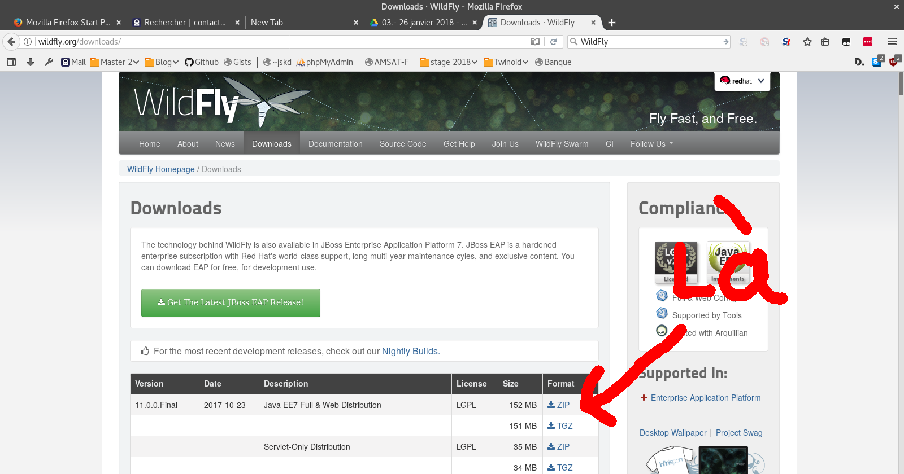
Save file
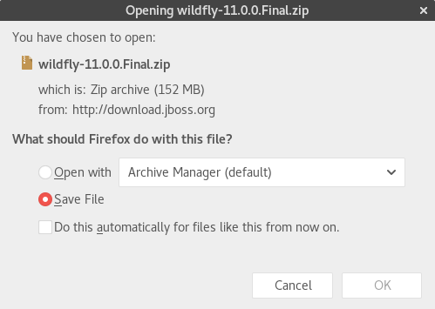

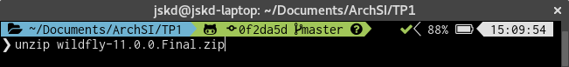
Unzip

Go to root of wildfly

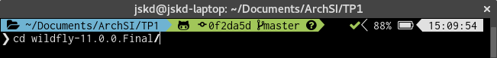
Launch standalone.sh

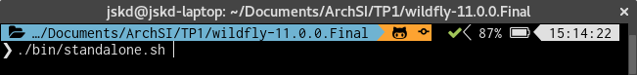
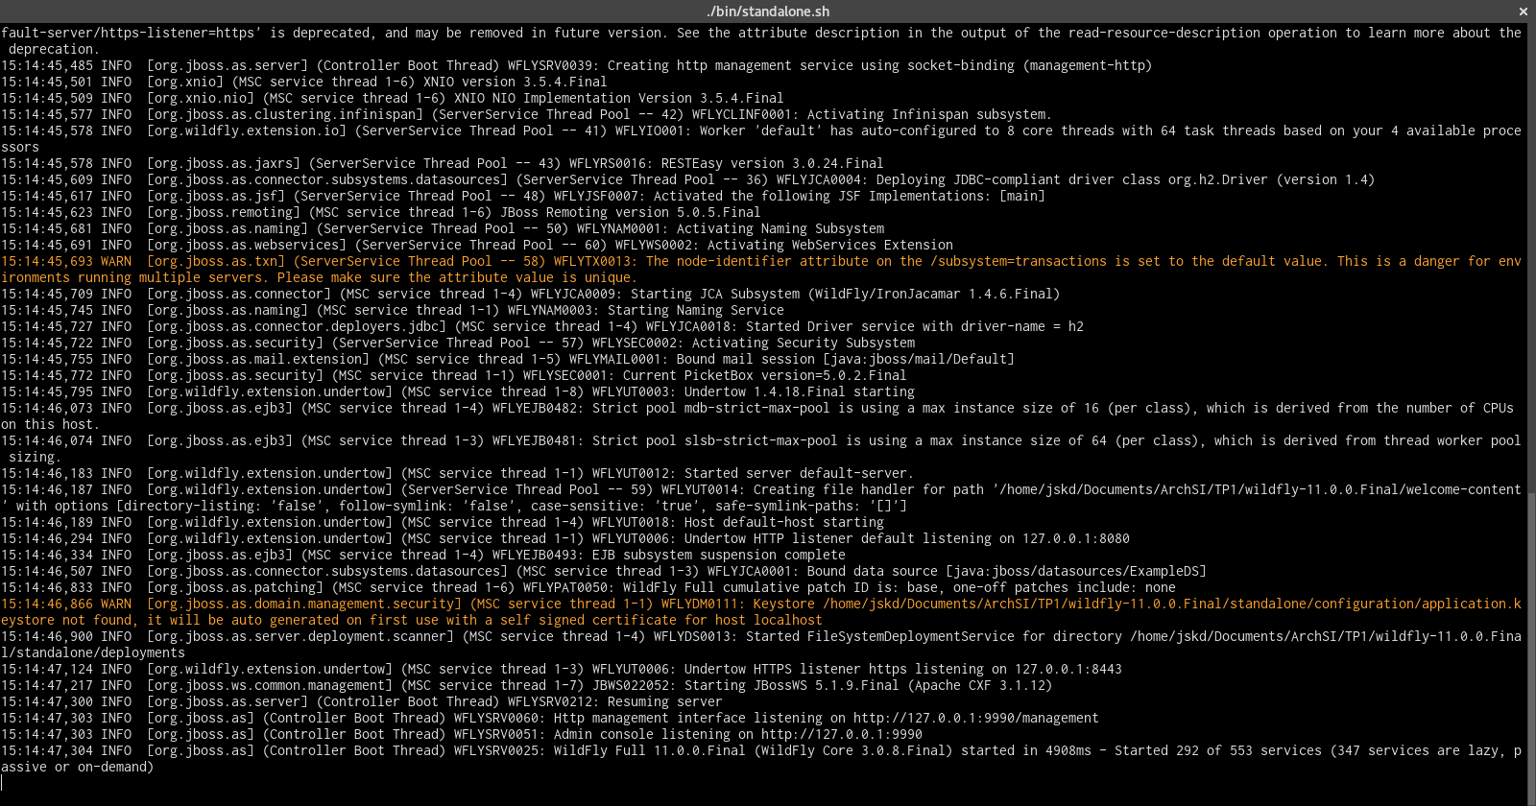
Check start sucess (time 4 908ms)

2) Add User

URL: http://127.0.0.1:9990

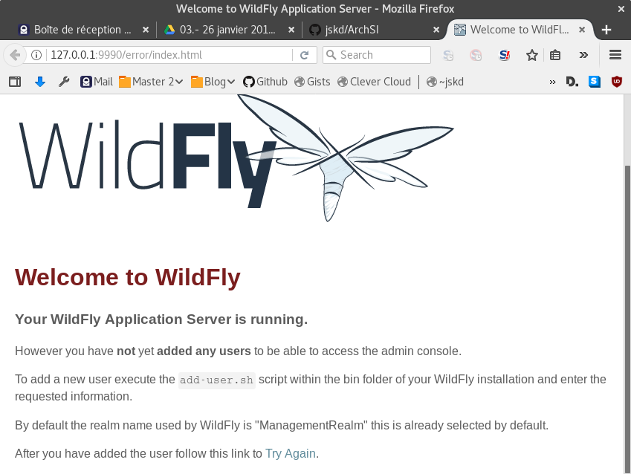
Error: No added users

Launch add-user.sh

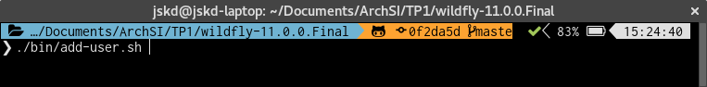
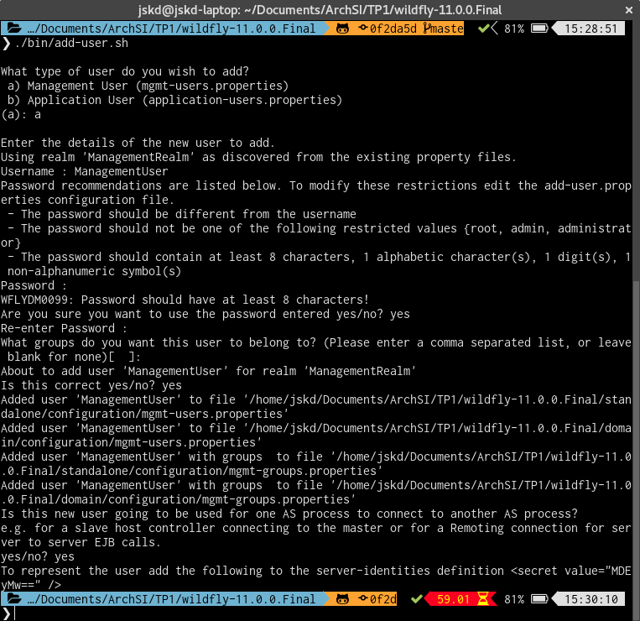

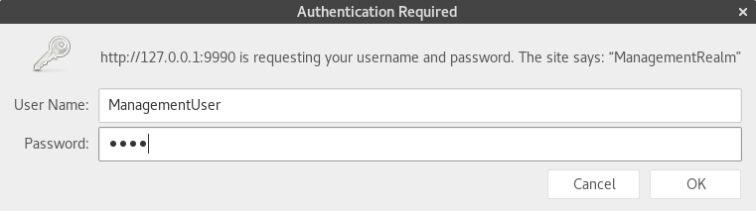
Go to: http://127.0.0.1:9990 and enter your login
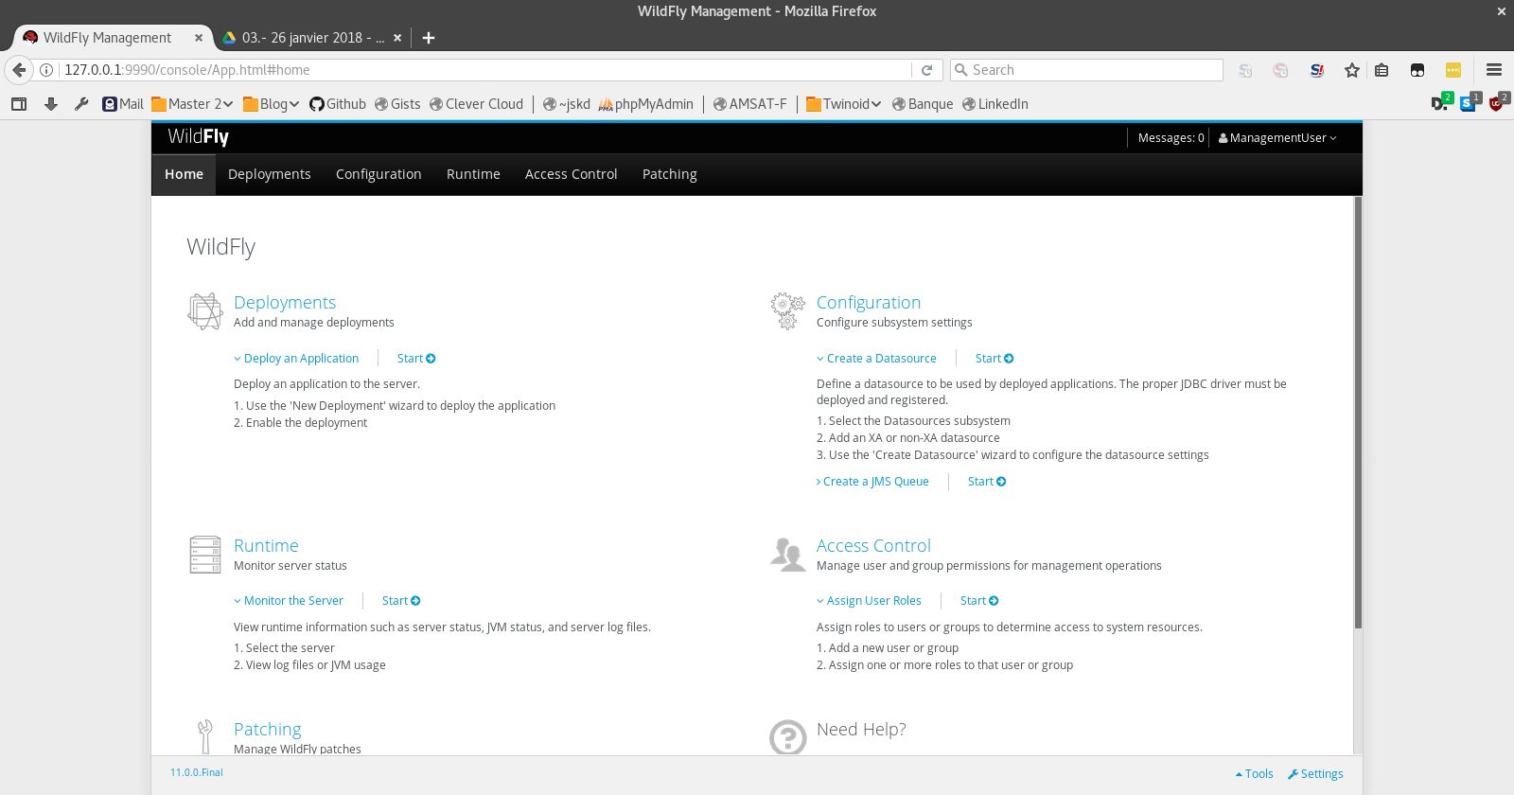
Success, you can see the interface

3) Add example (Hello world)

Go to https://github.com/wildfly/quickstart

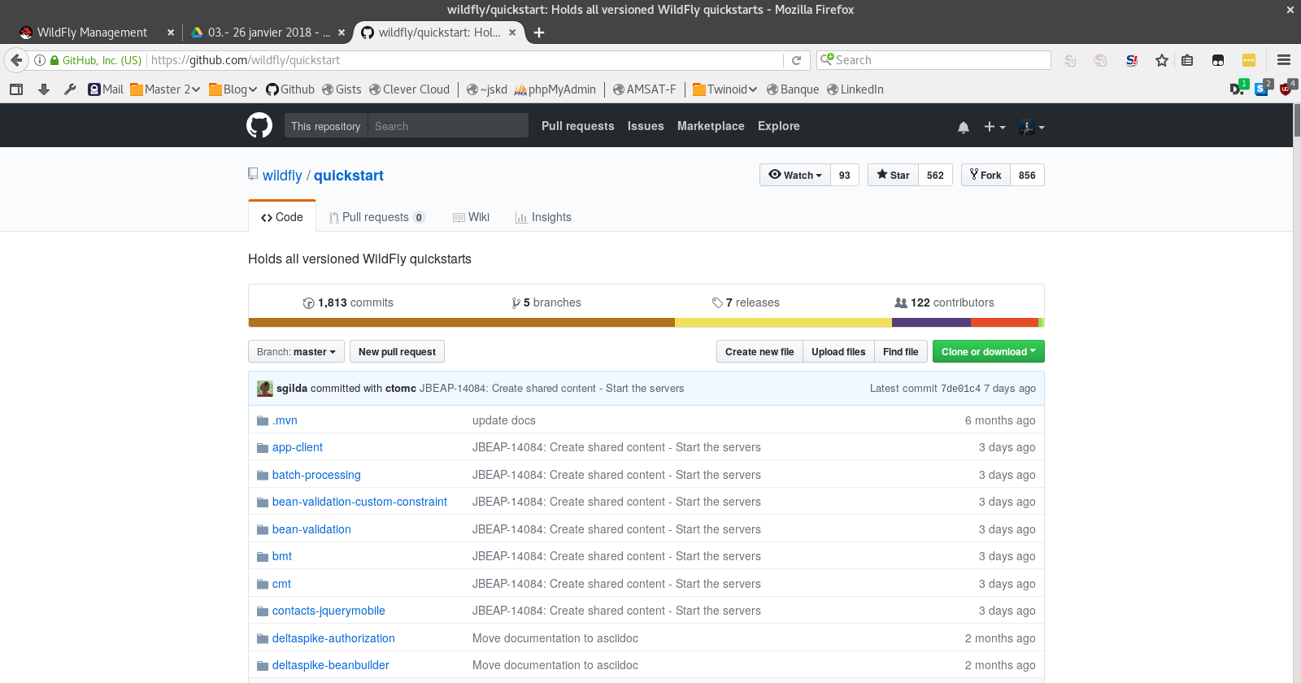
Cloner the repository

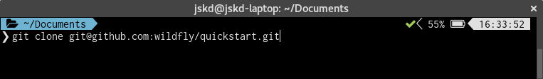
Go to helloworld example

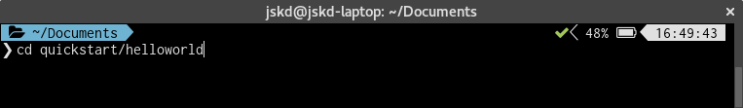

Deploy in wildfly

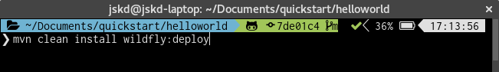
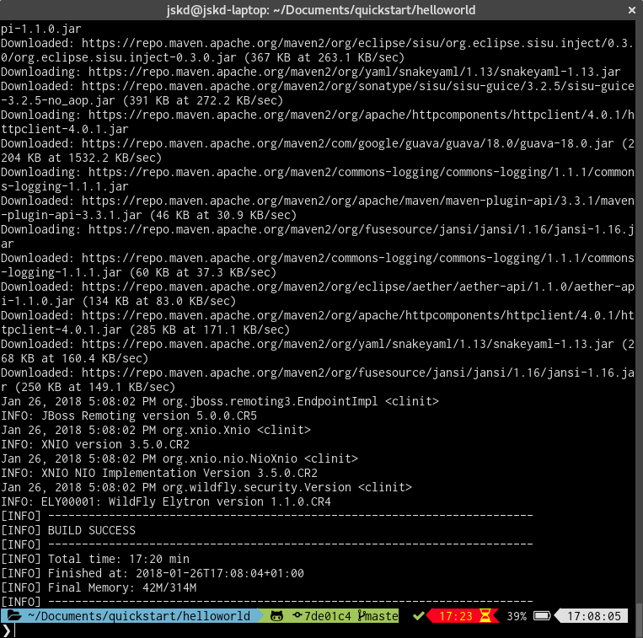
Check build sucess

Go to localhost:8080/helloworld
