Berkeley Homelessness Response: Full-Cost Overlay
Companion to the funding-flow diagram | Ancillary municipal costs | August 24, 2026
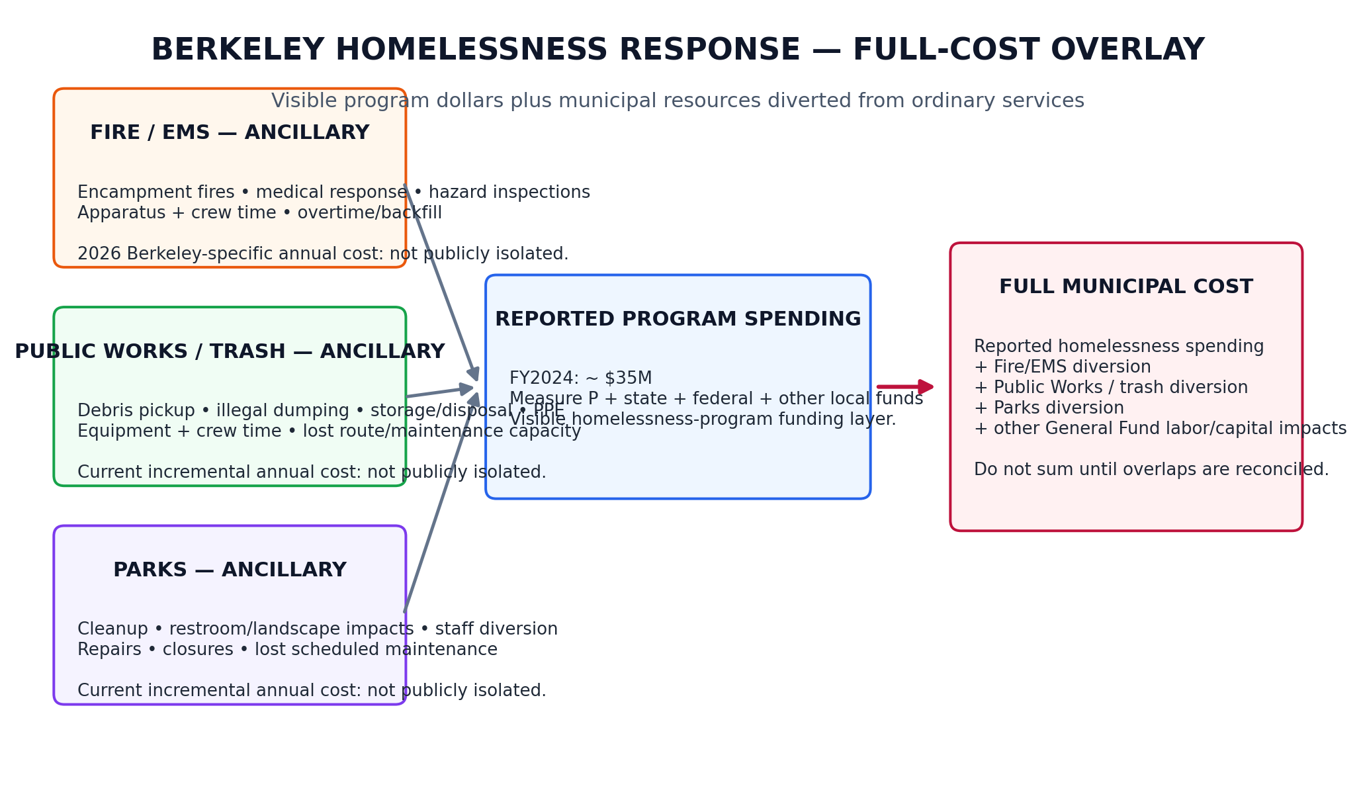
Figure 1. Conceptual accounting layer. Dollar widths are intentionally not scaled because current department-specific ancillary costs are not publicly isolated.
Bottom line: the City’s reported homelessness-program total is not the same thing as the full municipal cost of homelessness. A defensible full-cost model needs to add General Fund labor, equipment, disposal, overtime/backfill, and deferred-service costs that are triggered by encampments but booked in departmental budgets.

1. What the public record supports now
Cost / workload item | Amount | Period | What it tells us | Accounting treatment
Reported homelessness spending | ~$35.0M | FY2024 | City/Auditor figure for homelessness-related activities. Includes Measure P and other dedicated/local/state/federal sources. | Core reported total.
HRT Measure P expenditures | $1.1M | FY2024 | Includes expenses in City Manager’s Office and Police, Public Works and Parks departments. | Inside the $35M; not all HRT salaries.
General Fund HRT salaries | Not isolated | FY2024 | Auditor notes most HRT salaries were paid by the General Fund and were not included in the $35M total. | Known exclusion.
Additional homelessness-related municipal costs | Not assessed | FY2024 audit scope | Auditor explicitly says it did not assess the extent of additional costs outside the reported total. | This is the accounting gap.
PW + Parks encampment cleanup benchmark | >$580K | 2019 | City said intermittent debris removal, storage, disposal and PPE exceeded $580K and displaced normal infrastructure maintenance. | Historical benchmark only; do not treat as 2026 cost.
Encampment response volume | 107 interventions; >1M lb debris | Sep 2021–2024 budget narrative | 58 closures, 38 deep cleanings, 11 RV closures; more than 1 million pounds of debris removed. | Workload evidence, not a cost estimate.
Downtown Streets Team / Clean City baseline | $556,250/yr funding mix | FY2024 baseline contract | Measure P $225K + Zero Waste Fund $331,250 for city cleaning services, including encampment hot spots. | Not wholly encampment-specific; avoid double counting.

2. Ancillary-cost layer to add

Fire / EMS
Count encampment-attributable fire, medical and hazard-response incidents. Price crew-hours, apparatus-hours, overtime/backfill and any incremental supplies. Keep ordinary citywide baseline response separate.

Public Works / trash
Track encampment-attributable debris pickup, illegal dumping, storage, disposal, sanitation, equipment use and crew-hours. Separate already-budgeted Measure P/Clean City contracts from unfunded or General Fund diversion.

Parks, Recreation & Waterfront
Track staff-hours and contractor costs spent on encampment cleanup, restroom/landscape impacts, repairs, closures and restoration. Add the opportunity cost of scheduled park maintenance displaced by this work.

Opportunity cost / service displacement
For each department, record the planned task displaced by the encampment response. The economic cost is not only payroll already paid; it is also deferred maintenance, slower response elsewhere, overtime or contractor backfill, and accelerated asset wear.

3. Suggested full-cost calculation
Department | Annual ancillary-cost formula | Minimum data required
Fire / EMS | Σ[(crew hours × loaded labor rate) + apparatus hours + overtime/backfill + supplies] | CAD incident code/location; unit times; crew size; loaded rates; overtime/backfill records.
Public Works / trash | Σ[(crew hours × loaded rate) + vehicle/equipment hours + disposal fees + storage/PPE + contractor cost] | Work orders; tonnage/weight; disposal invoices; route/crew times; equipment rates; contracts.
Parks | Σ[(staff hours × loaded rate) + contractor/repair cost + replacement materials + overtime/backfill] | Work orders; staff time coding; repair invoices; closure/restoration logs; deferred-maintenance list.
Opportunity cost | Value of displaced scheduled work + incremental backlog/backfill attributable to encampment response | Original work plan; deferred work orders; overtime/contractor substitutions; backlog aging.

Accounting rule
Full municipal cost = reported homelessness-program spending + genuinely incremental departmental costs + attributable General Fund labor/equipment + opportunity cost of displaced services — overlaps already paid from Measure P, ERF, Zero Waste or other dedicated funds.

4. Data request that would close the gap
- Fire: all 2024–2026 incidents geocoded or coded as encampment/unhoused-related; apparatus and crew time; overtime/backfill; hazardous-material/fire-prevention inspections tied to encampments.
- Public Works / Zero Waste: encampment-specific work orders, crew-hours, equipment-hours, tonnage/weight, disposal fees, outside cleanup contracts, storage and PPE costs.
- Parks: encampment-related work orders and staff-hours; cleanup/restoration/repair spending; closures; deferred scheduled maintenance attributable to staff diversion.
- Finance/CMO: crosswalk identifying which of those costs are already included in Measure P/HRT or other homelessness totals, so the model can remove double counting.
- Auditor: a repeatable annual “full municipal cost of homelessness” schedule, reconciled to departmental ledgers and published alongside program spending and outcomes.

5. Interpretation cautions
- The 2019 >$580K Public Works/Parks figure is a historical benchmark, not a 2026 estimate.
- The Downtown Streets Team contract is not wholly encampment-specific and should not be assigned 100% to homelessness without work-order evidence.
- Fire/EMS costs cannot currently be stated responsibly as an annual Berkeley homelessness number from the public sources reviewed here.
- Ancillary costs may overlap with the $35M reported total; the purpose of the ledger crosswalk is to identify and subtract those overlaps before producing a “full cost” number.
- Opportunity cost should be shown separately from cash spending. It is economically real, but it is not necessarily an additional budget outlay in the same fiscal year.

Sources
- City of Berkeley, Comprehensive Summary of Berkeley’s Homeless Response (July 29, 2025).
- City of Berkeley Auditor, Homeless Response Team: Opportunities Exist to Strengthen Procedures and Better Track Outcomes (2025).
- City of Berkeley, Measure P Information Report: Uses for Measure P Funding (Jan. 15, 2019).
- City of Berkeley, FY2025–26 Proposed Budget / City Manager’s Office supplement (2024), Homeless Response Team narrative.
- City of Berkeley, Downtown Streets Team contract report (June 27, 2023).
- City of Berkeley, Measure P and W program/funding page and FY2025–28 Measure P forecast materials.

