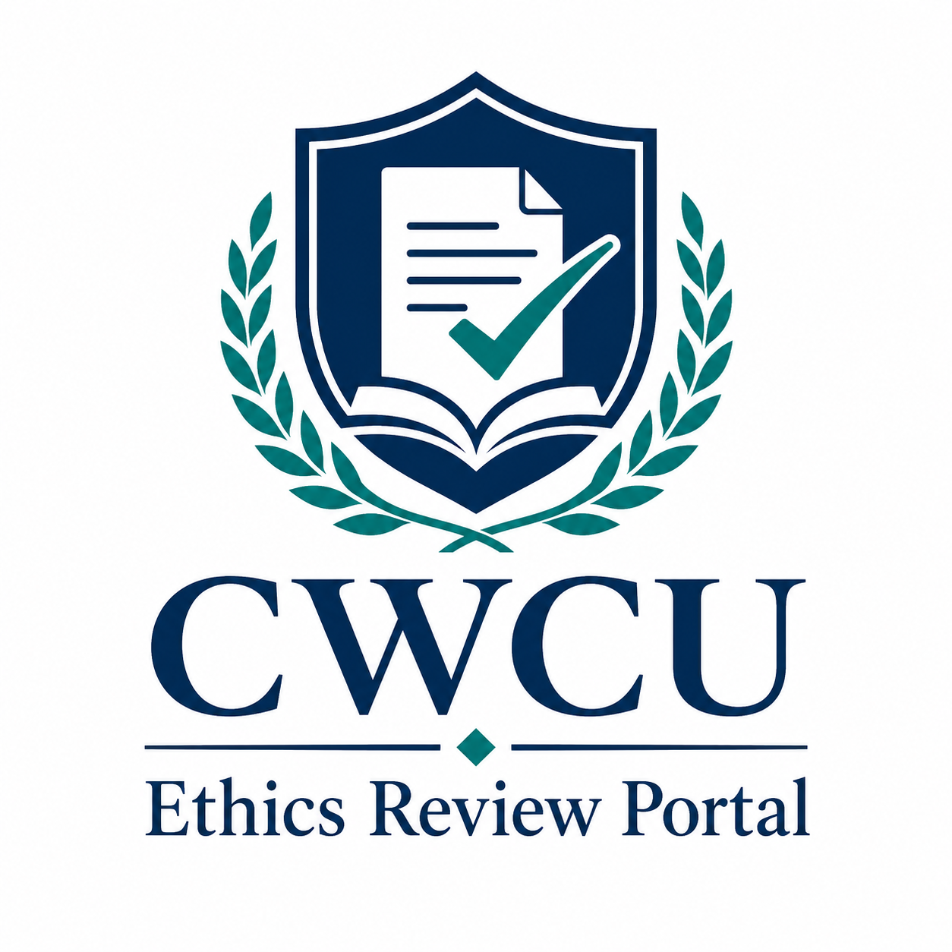
CIPTA WACANA UNIVERSITY (CWCU) ETHICS REVIEW
Research Ethics Committee
ETHICAL CLEARANCE CERTIFICATE
SURAT KETERANGAN LAYAK ETIK
Number / Nomor: [Ref. No.]
The Research Ethics Committee through the CWCU Ethics Review Portal certifies that the following research protocol has been reviewed and declared ethically acceptable for implementation.
Komite Etik Penelitian melalui CWCU Ethics Review Portal menyatakan bahwa protokol penelitian berikut telah ditelaah dan dinyatakan layak secara etik untuk dilaksanakan.
Applicant Name / Nama Pemohon | [Applicant Name]
Institution / Asal Institusi | [Institution]
Departemen/Unit / Program Studi | [Department/Unit]
Research Title / Judul Penelitian | [Research Title]
Research Type / Jenis Penelitian | [Research Type]
Research Design / Desain Penelitian | [Research Design]
Risk Category / Kategori Risiko | [Risk Category]
Decision / Keputusan | Approved
Based on administrative and ethical review, the research protocol is declared to have met the fundamental principles of ethical research, including respect for the dignity, rights, safety, welfare, confidentiality, and autonomy of research participants. This ethical review considered the appropriateness of the research objectives, procedural feasibility, proportionality of risks and benefits, clarity of informed consent, protection of personal and/or sensitive data, and safeguards for participants, including vulnerable groups where relevant.
Berdasarkan hasil penelaahan administratif dan etik, protokol penelitian tersebut dinyatakan telah memenuhi prinsip-prinsip dasar penelitian yang etis, termasuk penghormatan terhadap martabat, hak, keselamatan, kesejahteraan, kerahasiaan, dan otonomi partisipan penelitian. Telaah etik ini mempertimbangkan kesesuaian tujuan penelitian, kelayakan prosedur, proporsionalitas risiko dan manfaat, kejelasan informed consent, perlindungan data pribadi dan/atau data sensitif, serta mekanisme perlindungan terhadap partisipan, termasuk kelompok rentan apabila relevan.
This review was conducted with consideration of nationally and internationally recognized research ethics principles, including the Declaration of Helsinki, CIOMS International Ethical Guidelines, and research ethics standards emphasizing scientific value, methodological validity, informed consent, participant protection, justice, confidentiality, accountability, and research integrity.
Telaah ini dilakukan dengan mempertimbangkan prinsip-prinsip etik penelitian yang berlaku secara nasional dan internasional, termasuk Declaration of Helsinki, CIOMS International Ethical Guidelines, serta standar etik penelitian yang menekankan nilai ilmiah, validitas metodologis, persetujuan sadar, perlindungan partisipan, keadilan, kerahasiaan, akuntabilitas, dan integritas penelitian.
Date of Issue / Tanggal Penerbitan | 5 January 2025
Validity Period / Masa Berlaku | 5 January 2025 - 5 January 2026
This ethical approval applies only to the research protocol submitted to and approved by the Ethics Committee. The researcher is required to conduct the study according to the approved protocol, obtain informed consent prior to data collection, maintain confidentiality and data security, minimize risks to participants, and refrain from making substantial changes to the research design, instruments, site, participants, or procedures without notification to and/or further approval from the Ethics Committee.
Persetujuan etik ini berlaku untuk protokol penelitian sebagaimana diajukan dan disetujui oleh Komite Etik. Peneliti wajib melaksanakan penelitian sesuai dengan protokol yang telah disetujui, memperoleh informed consent sebelum pengumpulan data, menjaga kerahasiaan dan keamanan data, meminimalkan risiko terhadap partisipan, serta tidak melakukan perubahan substansial terhadap desain, instrumen, lokasi, partisipan, atau prosedur penelitian tanpa pemberitahuan dan/atau persetujuan lebih lanjut dari Komite Etik.
Verification / QR Code:  [Insert QR code or verification link here] | Issued by / Diterbitkan oleh:  CWCU Ethics Review  Chair of the Ethics Committee / Ketua Komite Etik,  [Nama Ketua Komite Etik]  [Position / ID, if applicable]

