# Assignment 1A:

# Assignment 1**B**:

# Assignment 1**C**

# Assignment 1**D**:

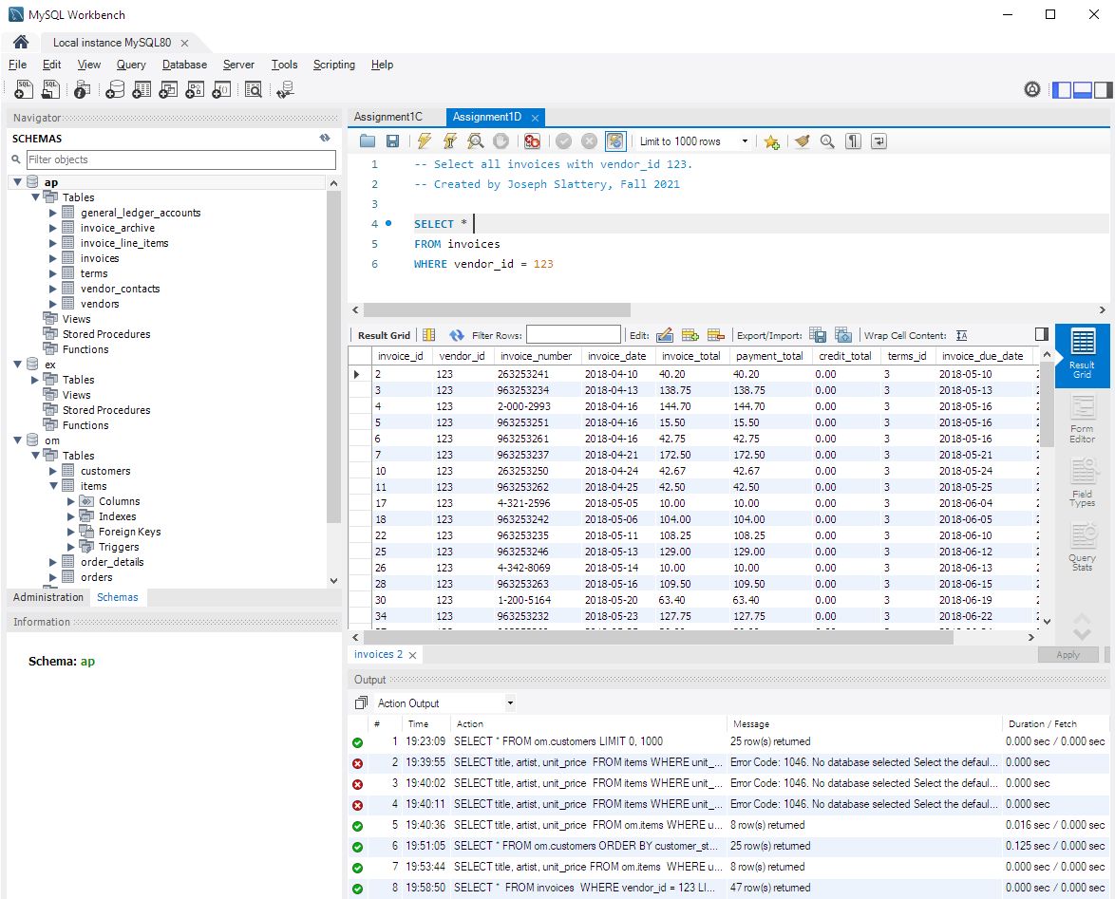

# Assignment 1**E**:

