# Project 2 – Udagram – by Jeffrey Leung

# Engineering Process and Quality

The project demonstrates an understanding of a good cloud git process:

Refer to my git repository in <https://github.com/jsleung1/cloud-developer> , It contains 2 branches (1 for master and 1 for develop):

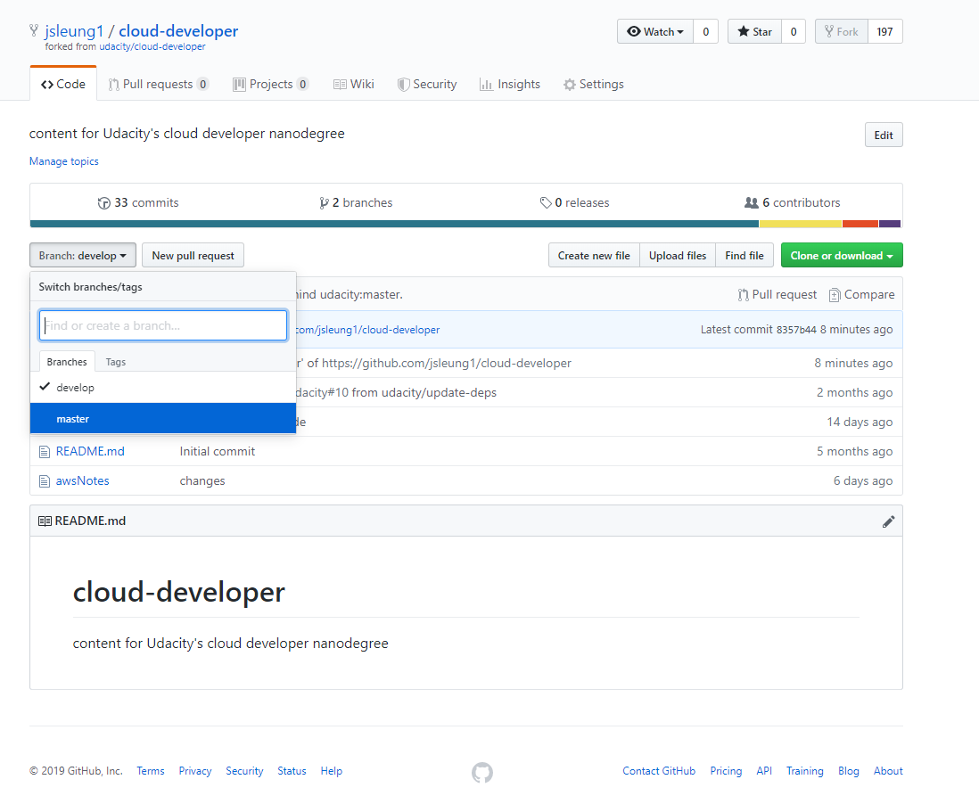

For the code and instructions of this project, please refer to:

<https://github.com/jsleung1/cloud-developer/tree/master/course-02/project/image-filter-starter-code>

# The project demonstrates an ability to use typescript and Nodejs

Please refer to the source code of the project in cloud-developer\course-02\project\image-filter-starter-code , after git clone the project ( <https://github.com/jsleung1/cloud-developer.git> )