Results 3 February 2017

**Question 1: How does species richness change over time?**

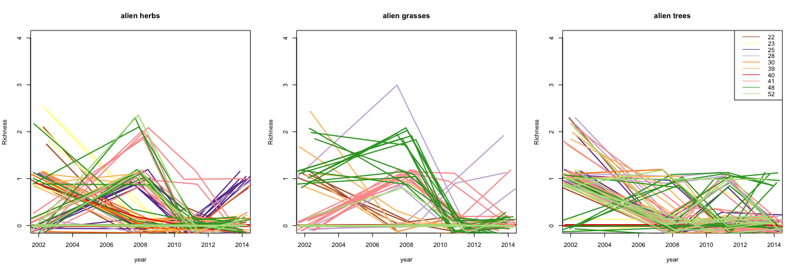

Fig. 1.1. Changes in alien species richness over time, coloured by site ID.

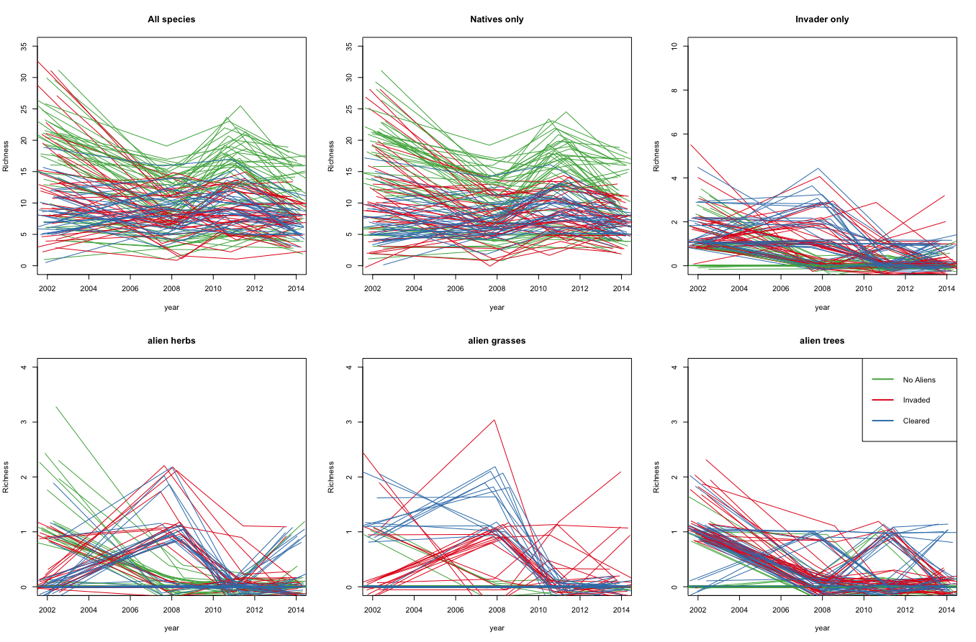

Fig. 1.2. Changes in native and alien species richness over time, coloured by treatment.

**Question 2: What are invasive species impacts on native species**

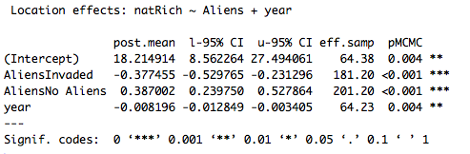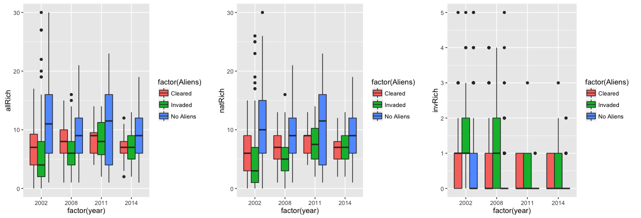

Fig. 2.1. Richness over time per treatment

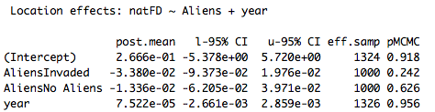

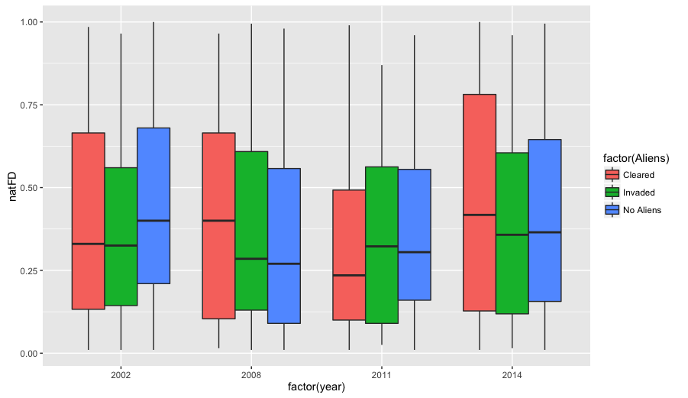

Fig. 2.2. Native species functional diversity (diversity based on growth form only) over time per treatment.