Property Explorer
Master project document: plan, features, wireframes, database schema, decisions, milestones and updates.
Document version 1A · created 11 Oct 2026 · maintained by Claude for the project owner.
Current status. Status: design review. No application code has been written yet. Everything below is a proposal awaiting the owner's approval unless marked Confirmed.

How to use this document
- This is the single source of truth for Property Explorer. Claude updates this same document (same link) as decisions are made and work progresses.
- Section 12 (Updates log) lists every change by date and version.
- Reviewers (including other AI assistants such as ChatGPT) can read it directly from its Google Docs link. Wireframes are included as images, each with a written description so the content is reviewable as text.
- Labels: Confirmed = stated by the owner. For approval = Claude's proposal. Open = needs the owner's decision.

Contents
- Product summary
- Decisions log
- Features by module
- Wireframes
- GPS on Samsung S23 Ultra
- Technology stack
- Database design
- Full vision coverage
- Milestones
- Milestone 1 acceptance tests
- Open questions
- Updates log
- Appendix A: schema.sql

1. Product summary
Property Explorer is a private working tool for a Malaysian property negotiator working mainly in Nilai and Sepang. It turns time spent driving through industrial and residential areas into a property database the owner controls, and connects that database to the owners, buyers and deals that earn commission.
It combines four systems in one connected database:
- Property business management: properties, vendors, buyers, leads, opportunities, follow-ups, tasks, calendar and deals.
- GPS property exploration: record routes, show explored roads in red, discover properties and record their exact locations and photos.
- Property intelligence and comparison: neighbouring and side-by-side units, individual availability with verification dates, combined totals for buyers who need adjoining units.
- AI and business assistance: Ask Expert specialists (with clear disclaimers) and message templates in English, Bahasa Malaysia, Chinese and Tamil.
It is not a generic listing website. The combination of road exploration, field discovery, neighbouring-unit intelligence and a connected CRM is the core of the product.

Proposed improvements (for approval)
- One contact list. The same person may be an owner on one deal and a buyer on another. A single Contacts table with roles avoids duplicates; Vendor and Buyer buttons are filtered views.
- Availability goes stale. Every availability change is logged with source and date. After a configurable period (default 30 days) an 'Available' unit is shown as 'Needs re-check'.
- Duplicate warning. Adding a property within about 30 m of an existing pin, or with a matching unit number on the same street, shows the existing record first.
- Photo inbox. Photos taken before a record exists wait in an Unassigned inbox and can be attached to the nearest property later.
- Malaysian fields. Tenure and lease expiry, land status (e.g. Bumi lot, Malay reserve), title type and number, RM per sq ft, acres, SPA and tenancy dates, SST on commission.
- Driving safety. Recording is hands-free; property entry is designed for when parked. One tap drops a pin and saves a draft.
- Personal data. Contact details fall under Malaysia's Personal Data Protection Act 2010; the design keeps them access-controlled and records when a PDPA notice was given.

2. Decisions log
# | Topic | Decision | Status
D1 | Phone | Samsung Galaxy S23 Ultra (Android). iPhone not needed for now. | Confirmed
D2 | Background GPS | Must eventually record with screen off and Waze open. Treated as unverified until tests G1–G8 pass on the owner's phone. | Confirmed
D3 | Working areas | Nilai and Sepang first. | Confirmed
D4 | Project document (Version 1A) | One 'Property Explorer' Google Doc in the owner's Google Drive holds the plan, features, wireframes, schema, decisions, milestones and updates, and is kept up to date by Claude. | Confirmed
D5 | App type | Native Android app (Capacitor) for the phone; the same app runs in a browser on the computer. Replaces the earlier 'web app first' plan because only a native app can record with the screen off. | For approval
D6 | Maps | OpenStreetMap maps via OpenFreeMap (free, no key). Google Maps and Waze for navigation hand-off only. | For approval
D7 | Backend | Supabase (PostgreSQL + PostGIS, login, photo storage), Singapore region. | For approval
D8 | Contacts | One contact list with roles; Vendor and Buyer are filtered views. | For approval
D9 | Home buttons 9–12 | Configurable placeholders until labels are confirmed from the owner's notes. | Open
D10 | Solo or team; commission split; data import | Not yet answered; design supports all options. | Open

3. Features by module
Home screen: 12 buttons in a 3 × 4 grid. Eight labels confirmed; four to be confirmed. Labels, icons, order and targets are stored in settings so they can change without redesign. The home screen also shows follow-ups due, viewings today, units needing re-check and exploration this week.
Module | What it does
To-Do | Create, edit, complete, delete tasks; deadlines, priorities, reminders; link to property, owner, buyer or deal; pending, completed, overdue; today view. Follow-ups are tasks of kind 'follow-up'.
Calendar | Viewings, site visits, meetings, follow-up appointments, deal deadlines; day, week and month views; linked to properties and contacts; reminders.
Opportunities | Potential business; buyer–property matching; stage and next action; estimated value and commission; notes, history and reminders.
Property | All property types (landed, condo, shoplot, office, factory, industrial land, agricultural land, development land, more later) with type-specific fields, map location, prices, areas, tenure, specs, photos, documents, availability with history, owners, viewings, neighbours, related buyers and opportunities.
Vendor | Owners, landlords and sellers: contact details, preferred channel and language, properties owned or represented, terms, instructions, contact history, follow-ups.
Buyer | Buyers, tenants and investors: requirements (type, areas, budget, sizes, adjoining units needed, specs, financing readiness), follow-ups, matched properties, opportunities.
GPS Assistance | Map with current location, Start / Pause / Stop recording, explored roads in red, property pins and clusters, nearby list, filters, add property from location, exploration history and progress, Google Maps / Waze hand-off.
Ask Expert | Lawyer, Banker, Financial Advisor, Tax Adviser, Accountant, Property Valuer, Wealth Planner and Agent AI. Each answer is labelled with the specialist and a disclaimer that it is general guidance, not professional advice.
Buttons 9–12 | To be confirmed.

Cross-cutting: neighbouring-unit groups and comparison, search and filters on list and map, leads, matching, deals and commission (estimated, confirmed, received; configurable rates), message templates in EN / BM / ZH / TA with placeholders for WhatsApp, offline saving with sync, privacy and backups.

4. Wireframes
Phone layouts at real proportions. Names, prices and owners are example data, not the owner's records. The same layouts adapt to a wider desktop screen.

4.1 Home dashboard
Exactly 3 columns × 4 rows of buttons: To-Do, Calendar, Opportunities, Property, Vendor, Buyer, GPS Assistance (highlighted), Ask Expert, and Buttons 9–12 shown dashed as 'label to confirm'. Above the grid: summary strip (follow-ups due, units needing re-check, km explored this week). Each tile shows a live count. Below: a large 'Start exploring' button.
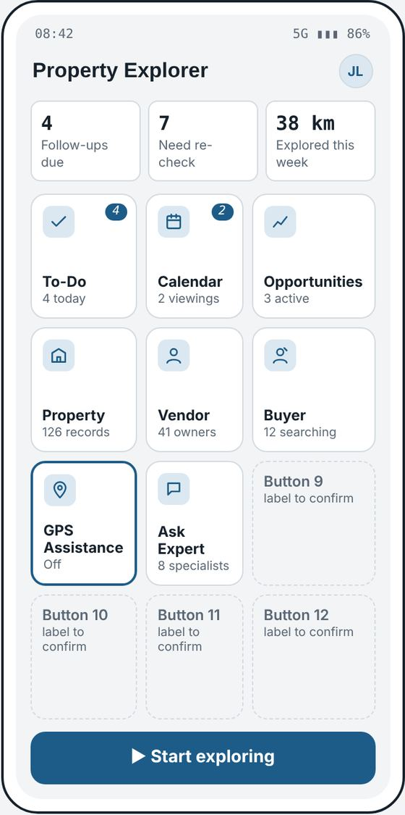
Wireframe: 4.1 Home dashboard

4.2 GPS exploration map
Full-screen map. Top: recording status pill (Recording / Paused / Off, distance) and filter chips (Factory, Shoplot, Land, Available, more). Map layers: blue dot = current location; dashed blue line = today's raw GPS route; solid red = roads already explored (matched or manually marked), kept across sessions; pins coloured green (available), amber (unknown or needs check), grey (unavailable); numbered circles = clusters. Bottom sheet: nearby properties sorted by distance, session totals, and buttons 'Add property here', Pause, Stop.
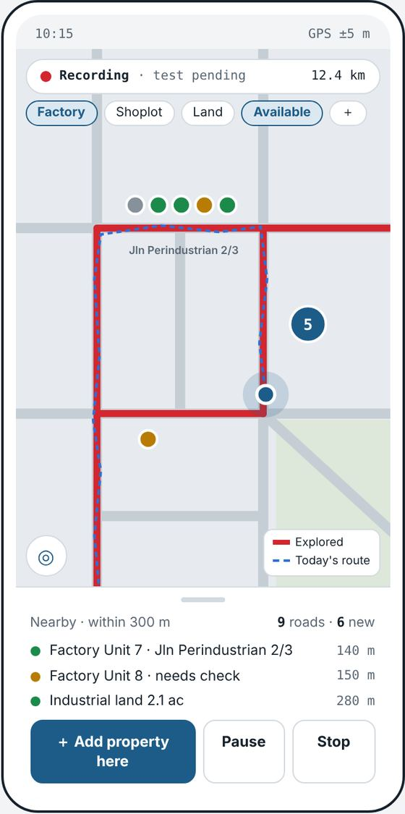
Wireframe: 4.2 GPS exploration map

4.3 Property details
Photo mosaic with cover photo and count. Title with property type and unit number (e.g. 'Semi-D Factory · Unit 7 (Lot 2/14)') and address. Availability badge with who verified it and when. Tabs: Details, Photos, Owner, Neighbours, History. Key-figure grid (asking price, land, built-up, RM psf, ceiling height, power) that changes by property type. Owner card with Call and WhatsApp. Row strip showing this unit's position among neighbours with each unit's own status. Notes. Bottom actions: Navigate, Message, Add follow-up.
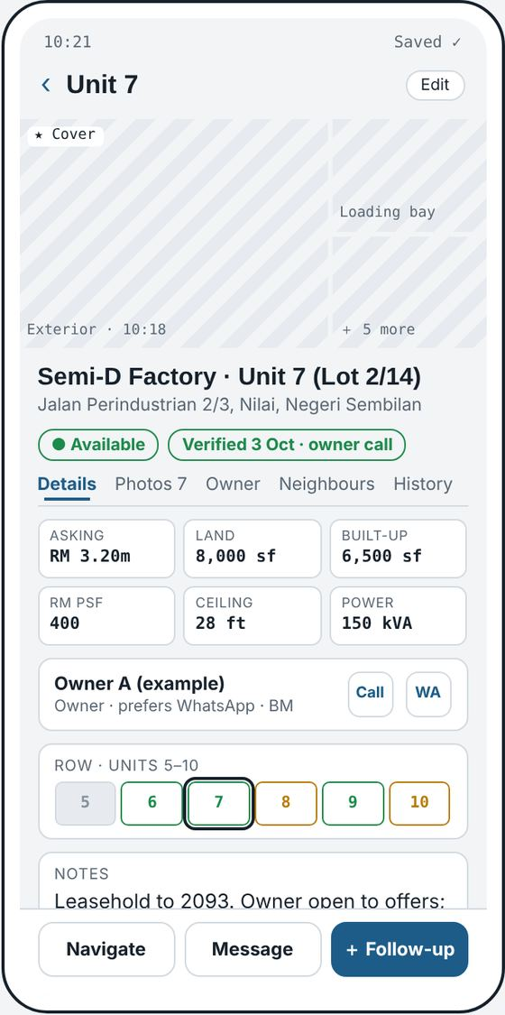
Wireframe: 4.3 Property details

4.4 Neighbouring-unit comparison
Row strip in real order; tap units to select (units 6 and 7 selected). Line listing available side-by-side pairs. Comparison grid: Unit 6, Unit 7 and Combined for status, last verified, asking price, land, built-up, RM psf, power (not summed), owner, marketed together or separately. Totals shown only when every unit has the figure; RM psf recalculated from totals. Box showing buyer requirements this pair fits (e.g. needs 2 adjoining factories, land ≥ 15,000 sq ft, budget ≤ RM 6.5m). Buttons: Share summary, Create opportunity.
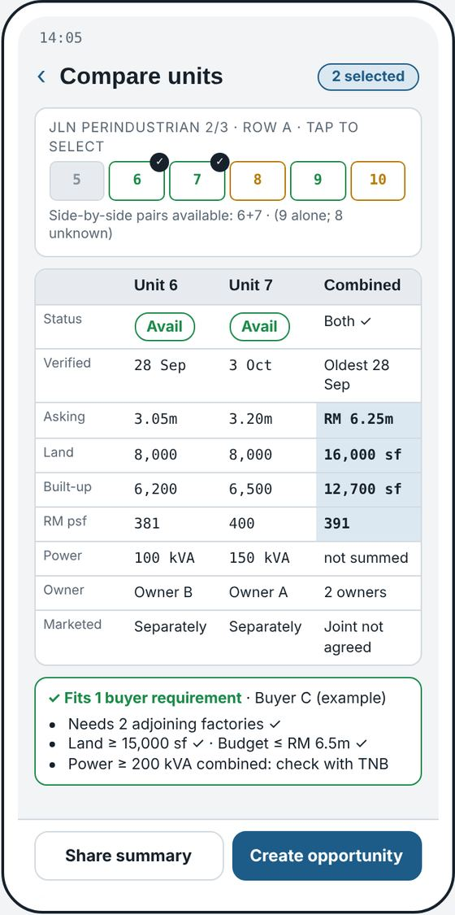
Wireframe: 4.4 Neighbouring-unit comparison

4.5a Property search results
Search box covering unit, street, lot, owner and reference; Filters button with count. List / Map toggle that keeps the same filters. Active filters as removable chips. Result count and sort (nearest, price, last verified). Result cards: thumbnail, unit and type, street, availability pill, price and RM psf, last verified date.
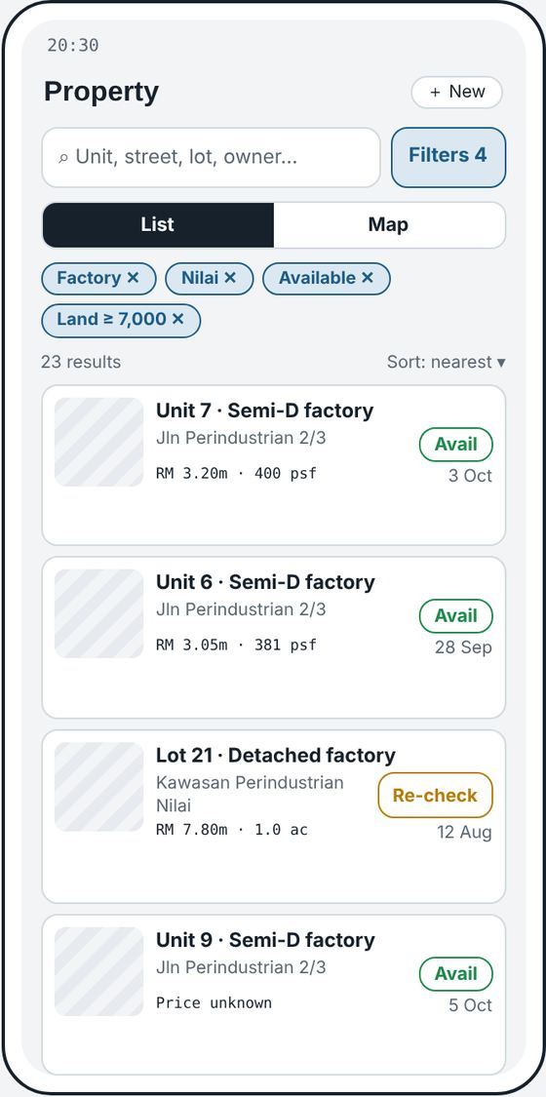
Wireframe: 4.5a Property search results

4.5b Filters
Property type chips (all categories), area chips (Nilai, Sepang, Salak Tinggi, draw on map), availability chips, toggles 'Only verified in last 30 days' and 'Adjacent available units ≥ 2', ranges for asking price, land area and built-up area, and more filters (sale / rent, tenure, vendor, group / row, updated since, ceiling / power). Button 'Show N properties'.
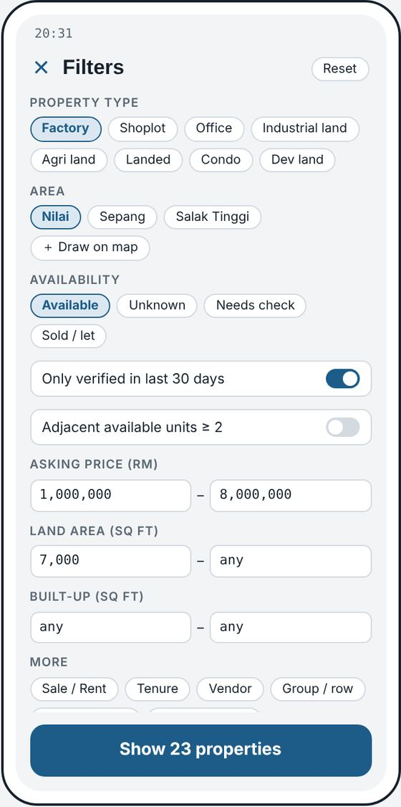
Wireframe: 4.5b Filters

5. GPS on Samsung S23 Ultra
Important. Status: NOT VERIFIED. Android allows this kind of recording, but Samsung's battery management is known to stop background apps. Background tracking will not be described as working until it passes tests G1–G8 on the owner's phone.
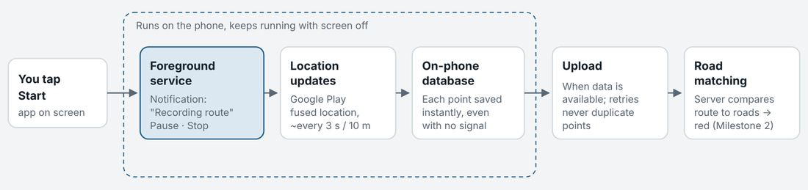
Recording pipeline: Start → foreground service with notification → Android location updates → on-phone database → upload → road matching (red roads, Milestone 2).

Implementation
- Foreground location service. Tapping Start launches an Android foreground service of type 'location'. Android requires a permanent notification while it runs, which doubles as the privacy guarantee: no notification, no recording. The notification has Pause and Stop.
- Native recorder. The screens use web technology inside a native shell (Capacitor). The recorder is a small native Kotlin component that writes each point straight to an on-phone database, because Android pauses the web layer when the screen is off. Points upload when the app is reopened and data is available; uploads never duplicate points.
- Same GPS as Waze. Both apps read Android's shared fused location provider, so Waze running does not take GPS away. Each point stores time, position, accuracy, speed, heading and whether the screen was on or off.
- Never on by itself. Recording starts only from Start. No auto-start on reboot or motion. After a restart the session is marked 'interrupted' and the app says so on next open.
- Weak signal and battery. Points worse than about 40 m accuracy are kept but excluded from road matching. Gaps stay gaps. Sampling about every 3 s or 10 m. A car charger is recommended; battery drain is measured in testing.

Permissions and Samsung settings
- Location: Precise, 'While using the app' (enough for a service the user starts). 'Allow all the time' requested only if testing shows it is needed.
- Notifications: Allow. Camera and photos: for property photos.
- Settings → Apps → Property Explorer → Battery → Unrestricted.
- Settings → Battery → Background usage limits → Never sleeping apps → add Property Explorer.
- The app checks these settings and warns if they would stop recording.

Test plan: GPS Test app first
Before the full Milestone 1, Claude builds a small GPS Test app (Start, Pause, Stop, notification, map of the route with a gap report, export). The owner drives in Nilai or Sepang. Background tracking is marked verified only after G1–G6 pass on two separate drives.
Test | What to do | Pass when
G1 | Drive 15 min with the app on screen. | Continuous route; median accuracy 10 m or better.
G2 | Start, lock the phone (screen off), drive 30 min. | Points in ≥95% of driving minutes; no gap over 60 s except known blackspots (covered car parks, tunnels).
G3 | Start, then navigate with Waze in front for 30 min. | Same as G2; Waze works normally.
G4 | As G2 with Power saving mode on. | Same as G2, or the app clearly warns that power saving stopped it.
G5 | Mobile data off for 10 min of driving, then on. | All offline points upload once; none duplicated.
G6 | Pause 5 min, resume, then Stop. | No points while paused or after Stop; notification disappears on Stop.
G7 | Swipe app away from Recent apps while recording. | Recording continues, or the interruption is reported on reopening. Silent data loss is a fail.
G8 | Restart the phone mid-session. | No silent resume; session shown as interrupted.

If tests fail: (1) adjust Samsung settings and recorder; (2) switch to a proven commercial background-location plugin (paid licence for Android; price shown to the owner before any purchase); (3) last resort, screen-on mode with the phone mounted.

6. Technology stack
Layer | Choice | Trade-off / cost
Phone app | Capacitor native Android app; screens in React + TypeScript | Installed by APK link (no Play Store needed for own use).
Desktop | Same app in Chrome | Everything except route recording.
GPS recorder | Native Kotlin foreground service + on-phone database | Must pass G1–G8 on the S23 Ultra.
Maps | MapLibre with OpenFreeMap (OpenStreetMap data) | Free, no key, no usage limits stated, but no service guarantee; self-hosting or MapTiler as backup.
Navigation | Hand-off links to Google Maps and Waze | Free.
Backend | Supabase: PostgreSQL + PostGIS, login, private photo storage, row-level security; Singapore region | Free plan for building and testing (500 MB database, 1 GB files, pauses after 1 week inactive, no automatic backups). Pro plan from US$25/month with daily backups before relying on it daily.
Offline | On-device database with upload queue; IDs created on the phone | Latest edit wins, with full history.
Photos | Compressed on phone (~400 KB + thumbnail) | About 2,500 photos per GB.
Road matching | OpenStreetMap roads for Nilai and Sepang imported into PostGIS; GPS tracks matched after each session (Milestone 2) | Thresholds tuned on real drives.
Ask Expert AI | Claude via the Anthropic API, called from the server (Milestone 5) | Needs an API account with pay-per-use billing.
Build and hosting | Private GitHub repository; GitHub Actions builds the APK and web version; free web hosting (Cloudflare Pages or Netlify) | Free.

7. Database design
PostgreSQL with PostGIS on Supabase. 39 tables and 122 foreign-key links, defined in schema.sql (Appendix A). Checked by loading into a PostgreSQL 16 test server: builds without errors; a back-dated availability entry does not overwrite a newer one; the same pair of neighbouring units cannot be stored twice. Not yet applied to any live database.

Connection checklist
Item | Tables | Connected to
Properties | properties | Site, category and type-specific fields, discovering session, photos, contacts, availability history, groups, neighbours, opportunities, deals, tasks, events, activities.
Photos | property_photos | One property (or Unassigned inbox), session, GPS position; one photo is the cover.
Owners | contacts, contact_roles, property_contacts | Contact with owner role linked to many properties, each link with terms and instructions; a property can have several contacts.
Buyers | contacts, contact_roles | Same contact list with buyer role; no duplicate people.
Buyer requirements | buyer_requirements, matches | Belong to a buyer (several per buyer); include adjoining units needed; matches point to one property or a group of adjoining units.
Availability history | availability_log | Every change per property with source and verified flag; current status set automatically from the latest entry.
Neighbouring units | property_groups, property_group_members, property_adjacency | Ordered units in a row, building or development; physical adjacency (manual or suggested, with confirmation).
GPS tracks | exploration_sessions, gps_points | Raw points per session, never edited; properties and photos remember their session.
Explored roads | road_segments, road_coverage, road_coverage_events | Nilai and Sepang road map; one coverage row per segment (no duplicates on re-drive); every match or manual correction logged.
Leads | leads | Contact, optional property or requirement, source, status, next follow-up.
Follow-ups | tasks (kind = follow_up), activities | Linked to property, contact, lead, opportunity, deal or event; one activity timeline.
Calendar appointments | calendar_events, event_attendees, viewings | Linked to property, contact, lead, opportunity, deal; one viewing can cover several units.
Deals | deals, deal_properties | From an opportunity; buyer, vendor, properties or group; booking, SPA, loan, completion or tenancy dates.
Commissions | commissions | One or more per deal; rate or fixed, SST, negotiator share, status estimated → confirmed → invoiced → received.

All tables
Group | Tables
Users and settings | workspaces, workspace_members, workspace_settings, home_tiles
Places | sites (industrial parks, tamans, buildings, streets, with optional boundary)
Property types | property_categories, property_type_fields
Properties | properties, property_contacts, availability_log, property_photos, documents
Neighbours | property_groups, property_group_members, property_adjacency
People | contacts, contact_roles, buyer_requirements, leads, matches
Business | opportunities, opportunity_properties, deals, deal_properties, commissions
Schedule and history | calendar_events, event_attendees, viewings, tasks, activities
Exploration | exploration_sessions, gps_points, road_segments, road_coverage, road_coverage_events
Communication and AI | message_templates, expert_profiles, expert_conversations, expert_messages

Built in from the start
- Privacy: every business table carries a workspace; row-level security returns records only to that workspace's members. Ready for a team later.
- Offline-safe IDs: created on the phone, so offline records never clash.
- Recovery: deletes go to 'Recently deleted' and can be restored.
- Audit: availability, road coverage and activities keep full history.

8. Full vision coverage
Every feature in the brief has a place in the architecture now, even when its screens are built later.
Feature | Ready in architecture | Screens in
12-button home | home_tiles | M1
Property records, all types | properties, categories, type fields | M1
Photos per property, inbox | property_photos, private storage | M1
Vendors and buyers | contacts, roles, links, requirements | M1
Search and filters, list + map | indexes on location, type, availability | M1
Background route recording | native recorder, sessions, gps_points | M1 (after G-tests pass)
Explored roads in red, manual marking, corrections | road_segments, road_coverage, events | M2
Exploration progress, areas completed | session totals, sites with boundaries | M2
Groups, adjacency, comparison, adjacent filter | groups, members, adjacency, matches | M3
To-Do, follow-ups, Calendar, viewings | tasks, calendar_events, viewings, activities | M4
Leads, opportunities, matching | leads, opportunities, matches | M4
Deals and commission | deals, deal_properties, commissions, settings | M4
Message templates EN / BM / ZH / TA | message_templates | M5
Ask Expert (8 specialists) | expert_profiles, conversations, messages | M5
Team access | workspaces, members, row-level security | When needed

9. Milestones
Milestone | Content | Status
M1 – GPS test | Small Android test app proving screen-off recording with Waze open on the S23 Ultra (tests G1–G8). | Awaiting approval
M1 – Field Capture | Login and private workspace; 12-tile home; Property, Vendor, Buyer, GPS Assistance working; route recording (as verified); add property from location with photos, unit no., availability, draft and duplicate warning; type-specific fields; photo inbox; contacts and buyer requirements; search and filters on list and map; offline with sync; desktop browser version; Recently deleted. | Awaiting approval
M2 – Explored roads | Road data for Nilai and Sepang; matching to red roads; manual marking and corrections; session review; progress statistics and areas. | Planned
M3 – Neighbours | Groups and rows, adjacency, comparison screen, adjacent-available filter, combined totals. | Planned
M4 – Business workflow | To-Do, Calendar, viewings, leads, opportunities, matching, deals, commission. | Planned
M5 – Communication and AI | Multilingual templates for WhatsApp; Ask Expert. | Planned
M6 – Testing and improvement | Realistic end-to-end scenarios, security review, backups. | Planned

How Milestone 1 will be run
- Code: in a private GitHub repository owned by the project owner. GitHub's free build service produces the Android APK and the desktop web version, so no developer tools are needed on the owner's computer.
- Phone: open the download link on the S23 Ultra, allow Chrome to install unknown apps once, install, sign in, grant permissions and set the Samsung battery settings.
- Computer: open the web address in Chrome and sign in with the same account.
- Optional: build on the owner's computer with Node.js and Android Studio, with step-by-step instructions.

What the owner must set up
Item | Why | Cost
GitHub account + private repository, connected to Claude | Holds code; builds the APK | Free
Supabase account and project (Singapore) | Database, login, photo storage; two keys pasted into GitHub secrets | Free for building and testing; Pro from US$25/month before daily reliance
Free web hosting (Cloudflare Pages or Netlify) | Desktop web address | Free
Samsung settings and permissions | Background recording | Free
Maps | OpenFreeMap needs no account | Free

10. Milestone 1 acceptance tests
GPS tests G1–G8 (section 5) come first. Results are reported at one of three levels: visual prototype, working, or tested on the owner's phone.
Test | Steps | Pass when
A1 | Install on S23 Ultra; sign in; sign in on computer. | Both open the same workspace.
A2 | Open the home buttons; rename button 9 in settings. | 3 × 4 grid; live modules open; others show planned milestone; rename appears.
A3 | Add three neighbouring factories from the map, each with its own unit no. and 2 photos. | Three records, correct pins, each with only its own photos.
A4 | Set one available (verified, owner call), one unknown, one sold. | Pins green, amber, grey; history shows entry and source.
A5 | Add a fourth property on the same spot. | Warning shows existing nearby records first.
A6 | Take 2 photos into the inbox; attach later. | Photos move to the chosen property; inbox empty.
A7 | Close the app mid-entry; reopen. | Draft still there.
A8 | Mobile data off; add property with photos; data on. | Appears on computer within a minute, once only.
A9 | Create an owner linked to two units; create a buyer with a requirement. | Owner page lists both units; units show owner; buyer under Buyer not Vendor.
A10 | Search 'Unit 7'; filter Factory + Available + verified in 30 days. | Correct results on list and map; filters kept when switching.
A11 | Navigate with Waze, then Google Maps. | Each opens at the right location; recording continues.
A12 | Record 20 min with screen off and Waze open; stop; reopen. | Route in Sessions with distance; properties added are linked to the session.
A13 | Delete a property; restore it. | Returns with photos, owner link, history.
A14 | Sign in with a second test account. | Sees none of the owner's data.
A15 | Add a back-dated 'available' after a newer 'sold'. | Property stays sold; older entry only in history.

11. Open questions
- Screens: do the six wireframes look right? Anything to move, add or remove?
- GPS plan: approve the native Android approach, tests G1–G8 and the fallback order?
- Database: approve the schema (checklist in section 7)?
- Accounts: can the owner set up GitHub and Supabase (about 30 minutes with instructions)?
- Home buttons 9–12: labels from the owner's handwritten notes.
- Users: just the owner, or a team / agency later?
- Commission: agency total and negotiator share recorded separately? SST applied?
- Import: any existing spreadsheets or contact lists to import?

12. Updates log
Date | Version | Change
10 Oct 2026 | Brief | Owner's master project brief received.
10 Oct 2026 | Blueprint v1 | Product understanding, feature map, first wireframes, data model, stack (web app first), open questions, first milestone.
11 Oct 2026 | Blueprint v2 | Owner confirmed Samsung S23 Ultra, background GPS with screen off and Waze, Nilai and Sepang. Stack changed to native Android (Capacitor). Six wireframes, GPS test plan G1–G8, complete schema (39 tables) checked on PostgreSQL 16, Milestone 1 scope and tests A1–A15.
11 Oct 2026 | Version 1A | Owner instruction: create and maintain a single 'Property Explorer' document in Google Drive, reviewable by ChatGPT without screenshots. This document created.

Appendix A: schema.sql
Complete database definition (review draft v1). PostgreSQL 15+ with PostGIS on Supabase.
-- =====================================================================
-- Property Explorer — complete database schema (review draft v1)
-- Target: PostgreSQL 15+ with PostGIS, hosted on Supabase.
-- Status: PROPOSAL FOR REVIEW. Not yet applied to any database.
--
-- Conventions
-- * Every business table has: id (UUID, generated on the device so
-- records created offline never collide), workspace_id, created_at,
-- updated_at, created_by, deleted_at (soft delete = recoverable).
-- * workspace_id + row-level security keeps each user's / agency's
-- records private (section 12).
-- * Links between records are real foreign keys, never free text,
-- so a task can never point at a property that does not exist.
-- * Units: areas in square feet, money in RM, distances in metres.
-- =====================================================================

create extension if not exists postgis;

-- ---------------------------------------------------------------------
-- 0. Helpers
-- ---------------------------------------------------------------------
create or replace function set_updated_at() returns trigger
language plpgsql as $$
begin
new.updated_at := now();
return new;
end $$;

-- ---------------------------------------------------------------------
-- 1. Users, workspaces and settings
-- ---------------------------------------------------------------------
-- Users themselves live in Supabase's auth.users table.
create table workspaces (
id uuid primary key default gen_random_uuid(),
name text not null,
created_at timestamptz not null default now()
);

create table workspace_members (
workspace_id uuid not null references workspaces(id) on delete cascade,
user_id uuid not null references auth.users(id) on delete cascade,
role text not null default 'member'
check (role in ('owner','admin','member','viewer')),
display_name text,
joined_at timestamptz not null default now(),
primary key (workspace_id, user_id)
);

create or replace function is_member(ws uuid) returns boolean
language sql stable security definer set search_path = public as $$
select exists (select 1 from workspace_members m
where m.workspace_id = ws and m.user_id = auth.uid());
$$;

create table workspace_settings (
workspace_id uuid primary key references workspaces(id) on delete cascade,
availability_stale_days int not null default 30,
default_commission_pct numeric(6,3), -- configurable, not hard-coded
default_negotiator_share_pct numeric(6,3),
sst_pct numeric(6,3),
duplicate_radius_m int not null default 30,
default_language text not null default 'en'
check (default_language in ('en','ms','zh','ta')),
updated_at timestamptz not null default now()
);

-- Home screen: 12 configurable buttons (labels 9-12 still to confirm)
create table home_tiles (
id uuid primary key default gen_random_uuid(),
workspace_id uuid not null references workspaces(id) on delete cascade,
slot int not null check (slot between 1 and 12),
label text not null,
icon text,
target_module text not null, -- e.g. 'todo','calendar','gps','tbd'
is_enabled boolean not null default true,
unique (workspace_id, slot)
);

-- ---------------------------------------------------------------------
-- 2. Places: industrial parks, tamans, buildings, streets
-- ---------------------------------------------------------------------
create table sites (
id uuid primary key default gen_random_uuid(),
workspace_id uuid not null references workspaces(id) on delete cascade,
parent_site_id uuid references sites(id) on delete set null,
name text not null, -- e.g. 'Nilai Industrial Park Phase 2'
kind text not null check (kind in
('region','industrial_park','taman','commercial_centre',
'building','street','development','other')),
city text,
state text,
boundary geography(MultiPolygon, 4326), -- used for "area completed"
notes text,
created_at timestamptz not null default now(),
updated_at timestamptz not null default now(),
created_by uuid default auth.uid() references auth.users(id),
deleted_at timestamptz
);

-- ---------------------------------------------------------------------
-- 3. Property types and type-specific fields
-- ---------------------------------------------------------------------
create table property_categories (
code text primary key, -- 'factory','shoplot','land_industrial'...
label text not null,
parent_code text references property_categories(code),
sort_order int not null default 0,
is_active boolean not null default true
);

create table property_type_fields (
id uuid primary key default gen_random_uuid(),
category_code text not null references property_categories(code) on delete cascade,
field_key text not null, -- key inside properties.specs
label text not null,
data_type text not null check (data_type in
('text','number','integer','boolean','select','multiselect','date')),
unit text, -- 'ft','kVA','amp','bays'...
options jsonb, -- choices for select fields
is_required boolean not null default false,
group_name text, -- 'Building','Utilities','Access'
sort_order int not null default 0,
unique (category_code, field_key)
);

-- ---------------------------------------------------------------------
-- 4. Contacts (owners, buyers, tenants... one table, many roles)
-- ---------------------------------------------------------------------
create table contacts (
id uuid primary key default gen_random_uuid(),
workspace_id uuid not null references workspaces(id) on delete cascade,
full_name text not null,
company text,
phone_primary text,
phone_alt text,
whatsapp text,
email text,
preferred_channel text check (preferred_channel in ('call','whatsapp','sms','email','in_person')),
preferred_language text check (preferred_language in ('en','ms','zh','ta')),
source text,
pdpa_notice_given_at timestamptz, -- Personal Data Protection Act record
notes text,
created_at timestamptz not null default now(),
updated_at timestamptz not null default now(),
created_by uuid default auth.uid() references auth.users(id),
deleted_at timestamptz
);

create table contact_roles (
contact_id uuid not null references contacts(id) on delete cascade,
role text not null check (role in
('owner','landlord','seller','buyer','tenant','investor',
'agent','lawyer','banker','valuer','developer','other')),
primary key (contact_id, role)
);

-- ---------------------------------------------------------------------
-- 5. Exploration (declared before properties, which reference sessions)
-- ---------------------------------------------------------------------
create table exploration_sessions (
id uuid primary key default gen_random_uuid(),
workspace_id uuid not null references workspaces(id) on delete cascade,
user_id uuid not null default auth.uid() references auth.users(id),
started_at timestamptz not null,
ended_at timestamptz,
status text not null default 'recording' check (status in
('recording','paused','completed','discarded')),
device_label text, -- 'Samsung S23 Ultra'
distance_m numeric(10,1),
point_count int,
gap_count int, -- signal gaps over 60 s, for diagnostics
site_id uuid references sites(id) on delete set null,
track geography(MultiLineString, 4326), -- simplified copy for display
matching_status text not null default 'pending' check (matching_status in
('pending','running','done','failed','skipped')),
notes text,
created_at timestamptz not null default now(),
updated_at timestamptz not null default now(),
deleted_at timestamptz
);

-- Raw GPS points. Never edited, so road matching can be re-run.
create table gps_points (
id bigint generated always as identity primary key,
workspace_id uuid not null references workspaces(id) on delete cascade,
session_id uuid not null references exploration_sessions(id) on delete cascade,
client_seq int not null, -- sequence from the phone; makes upload retries safe
recorded_at timestamptz not null,
location geography(Point, 4326) not null,
accuracy_m real,
speed_mps real,
heading_deg real,
altitude_m real,
segment_no int not null default 0, -- increments after each pause
app_state text check (app_state in ('foreground','background','screen_off')),
is_mock boolean not null default false,
unique (session_id, client_seq)
);

-- Road network for working areas (Nilai, Sepang), imported from OpenStreetMap.
-- Shared reference data, so no workspace_id.
create table road_segments (
id bigint generated always as identity primary key,
osm_way_id bigint not null,
from_node bigint not null,
to_node bigint not null,
name text,
road_class text, -- 'primary','residential','service'...
region text not null, -- 'nilai','sepang'
geom geography(LineString, 4326) not null,
length_m numeric(9,1) not null,
imported_at timestamptz not null default now(),
unique (osm_way_id, from_node, to_node)
);

-- Current exploration status of each road segment for a workspace.
-- Re-driving a road updates this row; it never creates a new road.
create table road_coverage (
id uuid primary key default gen_random_uuid(),
workspace_id uuid not null references workspaces(id) on delete cascade,
segment_id bigint not null references road_segments(id) on delete cascade,
status text not null check (status in ('explored','manual','removed')),
source text not null check (source in ('matched','manual')),
confidence numeric(4,3), -- 0..1 for matched segments
coverage_pct numeric(5,2),
times_explored int not null default 1,
first_explored_at timestamptz not null,
last_explored_at timestamptz not null,
updated_at timestamptz not null default now(),
unique (workspace_id, segment_id)
);

-- Audit trail: which session explored what, and every manual correction.
create table road_coverage_events (
id uuid primary key default gen_random_uuid(),
workspace_id uuid not null references workspaces(id) on delete cascade,
segment_id bigint not null references road_segments(id) on delete cascade,
session_id uuid references exploration_sessions(id) on delete set null,
action text not null check (action in
('matched','manual_mark','manual_unmark','correction')),
coverage_pct numeric(5,2),
confidence numeric(4,3),
created_at timestamptz not null default now(),
created_by uuid default auth.uid() references auth.users(id)
);

-- ---------------------------------------------------------------------
-- 6. Properties
-- ---------------------------------------------------------------------
create table properties (
id uuid primary key default gen_random_uuid(),
workspace_id uuid not null references workspaces(id) on delete cascade,
ref_no text, -- your own reference
name text,
category_code text not null references property_categories(code),
subtype text, -- 'semi_d','terrace','detached'...
-- identity and address
unit_no text,
lot_no text,
block text,
floor_level text,
street text,
site_id uuid references sites(id) on delete set null,
area text, -- 'Nilai','Sepang','Bandar Baru Salak Tinggi'
city text,
state text,
postcode text,
-- map position
location geography(Point, 4326),
location_accuracy_m real,
location_source text check (location_source in ('gps','manual_pin','geocoded')),
-- transaction
listing_type text not null default 'unknown'
check (listing_type in ('sale','rent','sale_or_rent','unknown')),
asking_sale numeric(14,2),
asking_rent_monthly numeric(12,2),
price_notes text,
-- size
land_area_sqft numeric(12,2),
built_up_sqft numeric(12,2),
land_dimensions text, -- '40 x 100 ft'
-- legal
tenure text check (tenure in ('freehold','leasehold','unknown')),
lease_expiry_year int,
land_status text, -- 'open','bumi_lot','malay_reserve'
title_type text, -- 'individual','strata','master'
title_no text,
zoning text,
-- type-specific fields (ceiling_ft, power_kva, bedrooms ...)
specs jsonb not null default '{}'::jsonb,
-- availability: current value, kept in step with availability_log by trigger
availability text not null default 'unknown' check (availability in
('available','unavailable','sold','rented','unknown','needs_check')),
availability_verified boolean not null default false,
availability_verified_at timestamptz,
-- origin and state
discovered_session_id uuid references exploration_sessions(id) on delete set null,
record_status text not null default 'active'
check (record_status in ('draft','active','archived')),
cover_photo_id uuid, -- FK added after property_photos
notes text,
created_at timestamptz not null default now(),
updated_at timestamptz not null default now(),
created_by uuid default auth.uid() references auth.users(id),
deleted_at timestamptz,
unique (workspace_id, ref_no)
);

-- Who is connected to a property (an owner may have many properties,
-- a property may have several contacts).
create table property_contacts (
id uuid primary key default gen_random_uuid(),
workspace_id uuid not null references workspaces(id) on delete cascade,
property_id uuid not null references properties(id) on delete cascade,
contact_id uuid not null references contacts(id) on delete cascade,
relationship text not null check (relationship in
('owner','co_owner','representative','tenant','caretaker','agent','other')),
is_primary boolean not null default false,
asking_terms text, -- owner's price / rental terms
instructions text, -- owner instructions
created_at timestamptz not null default now(),
unique (property_id, contact_id, relationship)
);

-- Full history of availability, with source, so old claims are never trusted blindly.
create table availability_log (
id uuid primary key default gen_random_uuid(),
workspace_id uuid not null references workspaces(id) on delete cascade,
property_id uuid not null references properties(id) on delete cascade,
status text not null check (status in
('available','unavailable','sold','rented','unknown','needs_check')),
verified boolean not null default false,
source text not null check (source in
('owner','agent','signboard','site_visit','listing_portal','tenant','other')),
source_contact_id uuid references contacts(id) on delete set null,
noted_at timestamptz not null default now(),
note text,
created_by uuid default auth.uid() references auth.users(id)
);

create table property_photos (
id uuid primary key default gen_random_uuid(),
workspace_id uuid not null references workspaces(id) on delete cascade,
property_id uuid references properties(id) on delete set null, -- null = Unassigned inbox
session_id uuid references exploration_sessions(id) on delete set null,
storage_path text not null,
thumb_path text,
taken_at timestamptz,
location geography(Point, 4326),
category text check (category in
('exterior','interior','access_road','site_view','signboard','document','other')),
caption text,
sort_order int not null default 0,
width_px int,
height_px int,
bytes int,
created_at timestamptz not null default now(),
created_by uuid default auth.uid() references auth.users(id),
deleted_at timestamptz
);

alter table properties
add constraint properties_cover_photo_fk
foreign key (cover_photo_id) references property_photos(id) on delete set null;

create table documents (
id uuid primary key default gen_random_uuid(),
workspace_id uuid not null references workspaces(id) on delete cascade,
property_id uuid references properties(id) on delete set null,
contact_id uuid references contacts(id) on delete set null,
deal_id uuid, -- FK added after deals
doc_type text, -- 'title','spa','tenancy','floor_plan'...
title text not null,
storage_path text not null,
created_at timestamptz not null default now(),
created_by uuid default auth.uid() references auth.users(id),
deleted_at timestamptz
);

-- ---------------------------------------------------------------------
-- 7. Neighbouring units
-- ---------------------------------------------------------------------
create table property_groups (
id uuid primary key default gen_random_uuid(),
workspace_id uuid not null references workspaces(id) on delete cascade,
name text not null, -- 'Jalan Perindustrian 2/3, Row A'
kind text not null check (kind in
('factory_row','shoplot_row','building','land_parcels','development','other')),
site_id uuid references sites(id) on delete set null,
marketing text not null default 'unknown'
check (marketing in ('together','separately','unknown')),
notes text,
created_at timestamptz not null default now(),
updated_at timestamptz not null default now(),
created_by uuid default auth.uid() references auth.users(id),
deleted_at timestamptz
);

-- Order of units in the row. A property may belong to several groups
-- (e.g. a row and a development). Availability stays on each property.
create table property_group_members (
group_id uuid not null references property_groups(id) on delete cascade,
property_id uuid not null references properties(id) on delete cascade,
position int not null,
primary key (group_id, property_id),
unique (group_id, position) deferrable initially deferred
);

-- Physical adjacency. Suggestions from pin distance stay unconfirmed until you accept them.
create table property_adjacency (
id uuid primary key default gen_random_uuid(),
workspace_id uuid not null references workspaces(id) on delete cascade,
property_a uuid not null references properties(id) on delete cascade,
property_b uuid not null references properties(id) on delete cascade,
relation text not null check (relation in
('side_by_side','back_to_back','above_below','corner','other')),
source text not null check (source in ('manual','suggested')),
confirmed boolean not null default false,
created_at timestamptz not null default now(),
check (property_a < property_b), -- stores each pair once
unique (property_a, property_b, relation)
);

-- ---------------------------------------------------------------------
-- 8. Buyers, leads, matching
-- ---------------------------------------------------------------------
create table buyer_requirements (
id uuid primary key default gen_random_uuid(),
workspace_id uuid not null references workspaces(id) on delete cascade,
contact_id uuid not null references contacts(id) on delete cascade,
title text, -- '2 adjoining factories, Nilai'
transaction text not null check (transaction in ('buy','rent','either')),
category_codes text[] not null default '{}',
preferred_areas text[] not null default '{}',
search_area geography(MultiPolygon, 4326),
budget_min numeric(14,2),
budget_max numeric(14,2),
land_min_sqft numeric(12,2),
land_max_sqft numeric(12,2),
built_up_min_sqft numeric(12,2),
built_up_max_sqft numeric(12,2),
adjoining_units_needed int not null default 1 check (adjoining_units_needed >= 1),
required_specs jsonb not null default '{}'::jsonb, -- {"power_kva":{"min":200}}
tenure_preference text,
financing_notes text,
readiness text check (readiness in ('browsing','ready','loan_approved','cash','unknown')),
status text not null default 'active'
check (status in ('active','paused','fulfilled','dropped')),
notes text,
created_at timestamptz not null default now(),
updated_at timestamptz not null default now(),
created_by uuid default auth.uid() references auth.users(id),
deleted_at timestamptz
);

create table leads (
id uuid primary key default gen_random_uuid(),
workspace_id uuid not null references workspaces(id) on delete cascade,
contact_id uuid not null references contacts(id) on delete cascade,
lead_type text not null check (lead_type in
('buyer','seller','landlord','tenant','referral','other')),
source text, -- 'signboard','referral','portal','exploration'...
property_id uuid references properties(id) on delete set null,
requirement_id uuid references buyer_requirements(id) on delete set null,
status text not null default 'new' check (status in
('new','contacted','qualified','converted','lost')),
last_contact_at timestamptz,
next_follow_up_at timestamptz,
notes text,
created_at timestamptz not null default now(),
updated_at timestamptz not null default now(),
created_by uuid default auth.uid() references auth.users(id),
deleted_at timestamptz
);

-- Saved match suggestions (a single property OR a group of adjoining units).
create table matches (
id uuid primary key default gen_random_uuid(),
workspace_id uuid not null references workspaces(id) on delete cascade,
requirement_id uuid not null references buyer_requirements(id) on delete cascade,
property_id uuid references properties(id) on delete cascade,
group_id uuid references property_groups(id) on delete cascade,
unit_ids uuid[], -- the specific adjoining units when group_id is set
score numeric(5,2),
reasons jsonb, -- which criteria matched / failed
status text not null default 'suggested' check (status in
('suggested','shortlisted','sent','rejected')),
created_at timestamptz not null default now(),
check ((property_id is not null) <> (group_id is not null))
);

-- ---------------------------------------------------------------------
-- 9. Opportunities, deals, commission
-- ---------------------------------------------------------------------
create table opportunities (
id uuid primary key default gen_random_uuid(),
workspace_id uuid not null references workspaces(id) on delete cascade,
title text not null,
kind text not null default 'sale' check (kind in ('sale','rental','other')),
stage text not null default 'identified' check (stage in
('identified','contacted','matched','viewing','negotiating','won','lost')),
lead_id uuid references leads(id) on delete set null,
requirement_id uuid references buyer_requirements(id) on delete set null,
buyer_contact_id uuid references contacts(id) on delete set null,
vendor_contact_id uuid references contacts(id) on delete set null,
group_id uuid references property_groups(id) on delete set null,
est_transaction_value numeric(14,2),
next_action text,
next_action_at timestamptz,
notes text,
created_at timestamptz not null default now(),
updated_at timestamptz not null default now(),
created_by uuid default auth.uid() references auth.users(id),
deleted_at timestamptz
);

create table opportunity_properties (
opportunity_id uuid not null references opportunities(id) on delete cascade,
property_id uuid not null references properties(id) on delete cascade,
role text not null default 'primary' check (role in ('primary','alternative')),
primary key (opportunity_id, property_id)
);

create table deals (
id uuid primary key default gen_random_uuid(),
workspace_id uuid not null references workspaces(id) on delete cascade,
opportunity_id uuid unique references opportunities(id) on delete set null,
deal_type text not null check (deal_type in ('sale','rental')),
stage text not null default 'offer' check (stage in
('offer','booking_paid','spa_signed','loan_approved',
'tenancy_signed','completed','cancelled')),
buyer_contact_id uuid references contacts(id) on delete set null,
vendor_contact_id uuid references contacts(id) on delete set null,
group_id uuid references property_groups(id) on delete set null,
transaction_value numeric(14,2),
offer_date date,
booking_date date,
spa_date date,
completion_date date,
tenancy_start date,
tenancy_months int,
next_action text,
notes text,
created_at timestamptz not null default now(),
updated_at timestamptz not null default now(),
created_by uuid default auth.uid() references auth.users(id),
deleted_at timestamptz
);

create table deal_properties (
deal_id uuid not null references deals(id) on delete cascade,
property_id uuid not null references properties(id) on delete restrict,
primary key (deal_id, property_id)
);

alter table documents
add constraint documents_deal_fk foreign key (deal_id) references deals(id) on delete set null;

-- One deal may earn more than one commission (e.g. vendor side and buyer side).
create table commissions (
id uuid primary key default gen_random_uuid(),
workspace_id uuid not null references workspaces(id) on delete cascade,
deal_id uuid not null references deals(id) on delete cascade,
payer_contact_id uuid references contacts(id) on delete set null,
basis text not null check (basis in ('rate','fixed')),
rate_pct numeric(6,3),
fixed_amount numeric(14,2),
gross_amount numeric(14,2), -- calculated by the app, stored for history
sst_pct numeric(6,3),
negotiator_share_pct numeric(6,3),
negotiator_amount numeric(14,2),
status text not null default 'estimated' check (status in
('estimated','confirmed','invoiced','received','cancelled')),
received_amount numeric(14,2),
received_at date,
notes text,
created_at timestamptz not null default now(),
updated_at timestamptz not null default now(),
check ((basis = 'rate' and rate_pct is not null) or (basis = 'fixed' and fixed_amount is not null))
);

-- ---------------------------------------------------------------------
-- 10. Calendar, viewings, tasks and follow-ups, activity history
-- ---------------------------------------------------------------------
create table calendar_events (
id uuid primary key default gen_random_uuid(),
workspace_id uuid not null references workspaces(id) on delete cascade,
title text not null,
kind text not null check (kind in
('viewing','site_visit','meeting','follow_up','deadline','other')),
starts_at timestamptz not null,
ends_at timestamptz,
all_day boolean not null default false,
location_text text,
location geography(Point, 4326),
reminder_minutes int[] not null default '{}',
property_id uuid references properties(id) on delete set null,
contact_id uuid references contacts(id) on delete set null,
opportunity_id uuid references opportunities(id) on delete set null,
deal_id uuid references deals(id) on delete set null,
lead_id uuid references leads(id) on delete set null,
external_ref text, -- future sync with phone / Google calendar
notes text,
created_at timestamptz not null default now(),
updated_at timestamptz not null default now(),
created_by uuid default auth.uid() references auth.users(id),
deleted_at timestamptz,
check (ends_at is null or ends_at >= starts_at)
);

create table event_attendees (
event_id uuid not null references calendar_events(id) on delete cascade,
contact_id uuid not null references contacts(id) on delete cascade,
primary key (event_id, contact_id)
);

-- One viewing appointment can cover several units.
create table viewings (
id uuid primary key default gen_random_uuid(),
workspace_id uuid not null references workspaces(id) on delete cascade,
event_id uuid references calendar_events(id) on delete set null,
property_id uuid not null references properties(id) on delete cascade,
buyer_contact_id uuid references contacts(id) on delete set null,
viewed_at timestamptz,
outcome text check (outcome in ('interested','not_interested','considering','no_show','pending')),
feedback text,
created_at timestamptz not null default now()
);

-- Tasks include follow-ups (kind = 'follow_up').
create table tasks (
id uuid primary key default gen_random_uuid(),
workspace_id uuid not null references workspaces(id) on delete cascade,
title text not null,
kind text not null default 'general' check (kind in
('general','follow_up','call','document','site_check','other')),
notes text,
next_action text,
due_at timestamptz,
reminder_at timestamptz,
priority text not null default 'normal' check (priority in ('low','normal','high','urgent')),
status text not null default 'open' check (status in ('open','done','cancelled')),
completed_at timestamptz,
property_id uuid references properties(id) on delete set null,
contact_id uuid references contacts(id) on delete set null,
lead_id uuid references leads(id) on delete set null,
opportunity_id uuid references opportunities(id) on delete set null,
deal_id uuid references deals(id) on delete set null,
event_id uuid references calendar_events(id) on delete set null,
created_at timestamptz not null default now(),
updated_at timestamptz not null default now(),
created_by uuid default auth.uid() references auth.users(id),
deleted_at timestamptz
);

-- One timeline shown on every linked record.
create table activities (
id uuid primary key default gen_random_uuid(),
workspace_id uuid not null references workspaces(id) on delete cascade,
occurred_at timestamptz not null default now(),
kind text not null check (kind in
('note','call','whatsapp','sms','email','meeting','viewing',
'status_change','system')),
summary text not null,
body text,
property_id uuid references properties(id) on delete set null,
contact_id uuid references contacts(id) on delete set null,
lead_id uuid references leads(id) on delete set null,
opportunity_id uuid references opportunities(id) on delete set null,
deal_id uuid references deals(id) on delete set null,
task_id uuid references tasks(id) on delete set null,
event_id uuid references calendar_events(id) on delete set null,
created_by uuid default auth.uid() references auth.users(id)
);

-- ---------------------------------------------------------------------
-- 11. Communication templates and Ask Expert
-- ---------------------------------------------------------------------
create table message_templates (
id uuid primary key default gen_random_uuid(),
workspace_id uuid not null references workspaces(id) on delete cascade,
purpose text not null check (purpose in
('owner_first_contact','availability_check','confirm_details',
'buyer_follow_up','arrange_viewing','after_viewing',
'offer_to_sell_other','property_info','other')),
language text not null check (language in ('en','ms','zh','ta')),
title text not null,
body text not null, -- placeholders like {{contact_name}}, {{unit_no}}
is_active boolean not null default true,
created_at timestamptz not null default now(),
updated_at timestamptz not null default now(),
unique (workspace_id, purpose, language, title)
);

create table expert_profiles (
code text primary key, -- 'lawyer','banker','tax','valuer','agent_ai'...
label text not null,
instructions text not null,
disclaimer text not null,
sort_order int not null default 0
);

create table expert_conversations (
id uuid primary key default gen_random_uuid(),
workspace_id uuid not null references workspaces(id) on delete cascade,
expert_code text not null references expert_profiles(code),
title text,
property_id uuid references properties(id) on delete set null,
deal_id uuid references deals(id) on delete set null,
created_at timestamptz not null default now(),
created_by uuid default auth.uid() references auth.users(id)
);

create table expert_messages (
id uuid primary key default gen_random_uuid(),
conversation_id uuid not null references expert_conversations(id) on delete cascade,
role text not null check (role in ('user','assistant')),
content text not null,
created_at timestamptz not null default now()
);

-- ---------------------------------------------------------------------
-- 12. Indexes
-- ---------------------------------------------------------------------
create index on properties using gist (location);
create index on properties (workspace_id, category_code, availability);
create index on properties (workspace_id, unit_no);
create index on property_photos (property_id);
create index on property_photos (workspace_id) where property_id is null; -- photo inbox
create index on availability_log (property_id, noted_at desc);
create index on property_contacts (contact_id);
create index on property_group_members (property_id);
create index on gps_points (session_id, client_seq);
create index on gps_points using gist (location);
create index on road_segments using gist (geom);
create index on road_segments (region);
create index on road_coverage (workspace_id, status);
create index on tasks (workspace_id, status, due_at);
create index on calendar_events (workspace_id, starts_at);
create index on leads (workspace_id, next_follow_up_at);
create index on activities (property_id, occurred_at desc);
create index on activities (contact_id, occurred_at desc);
create index on buyer_requirements (workspace_id, status);

-- ---------------------------------------------------------------------
-- 13. Triggers
-- ---------------------------------------------------------------------
-- Keep properties.availability equal to the latest availability_log entry.
create or replace function apply_availability() returns trigger
language plpgsql as $$
begin
update properties p
set availability = new.status,
availability_verified = new.verified,
availability_verified_at = case when new.verified then new.noted_at
else p.availability_verified_at end
where p.id = new.property_id
and not exists (select 1 from availability_log l
where l.property_id = new.property_id
and l.noted_at > new.noted_at);
return new;
end $$;

create trigger availability_log_apply
after insert on availability_log
for each row execute function apply_availability();

do $$
declare t text;
begin
foreach t in array array[
'sites','contacts','exploration_sessions','properties','property_groups',
'buyer_requirements','leads','opportunities','deals','commissions',
'calendar_events','tasks','message_templates','road_coverage']
loop
execute format('create trigger %I_updated_at before update on %I
for each row execute function set_updated_at()', t, t);
end loop;
end $$;

-- ---------------------------------------------------------------------
-- 14. Row-level security: members see only their workspace's records
-- ---------------------------------------------------------------------
do $$
declare t text;
begin
foreach t in array array[
'workspace_settings','home_tiles','sites','contacts','exploration_sessions',
'gps_points','road_coverage','road_coverage_events','properties',
'property_contacts','availability_log','property_photos','documents',
'property_groups','property_adjacency','buyer_requirements','leads','matches',
'opportunities','deals','commissions','calendar_events','viewings','tasks',
'activities','message_templates','expert_conversations']
loop
execute format('alter table %I enable row level security', t);
execute format('create policy %I_member on %I for all
using (is_member(workspace_id))
with check (is_member(workspace_id))', t, t);
end loop;
end $$;

-- Child tables without workspace_id: access follows their parent.
alter table workspaces enable row level security;
create policy workspaces_member on workspaces for select using (is_member(id));

alter table workspace_members enable row level security;
create policy members_self on workspace_members for select using (is_member(workspace_id));

alter table contact_roles enable row level security;
create policy contact_roles_member on contact_roles for all
using (exists (select 1 from contacts c where c.id = contact_id and is_member(c.workspace_id)))
with check (exists (select 1 from contacts c where c.id = contact_id and is_member(c.workspace_id)));

alter table property_group_members enable row level security;
create policy group_members_member on property_group_members for all
using (exists (select 1 from property_groups g where g.id = group_id and is_member(g.workspace_id)))
with check (exists (select 1 from property_groups g where g.id = group_id and is_member(g.workspace_id)));

alter table opportunity_properties enable row level security;
create policy opp_props_member on opportunity_properties for all
using (exists (select 1 from opportunities o where o.id = opportunity_id and is_member(o.workspace_id)))
with check (exists (select 1 from opportunities o where o.id = opportunity_id and is_member(o.workspace_id)));

alter table deal_properties enable row level security;
create policy deal_props_member on deal_properties for all
using (exists (select 1 from deals d where d.id = deal_id and is_member(d.workspace_id)))
with check (exists (select 1 from deals d where d.id = deal_id and is_member(d.workspace_id)));

alter table event_attendees enable row level security;
create policy attendees_member on event_attendees for all
using (exists (select 1 from calendar_events e where e.id = event_id and is_member(e.workspace_id)))
with check (exists (select 1 from calendar_events e where e.id = event_id and is_member(e.workspace_id)));

alter table expert_messages enable row level security;
create policy expert_messages_member on expert_messages for all
using (exists (select 1 from expert_conversations c where c.id = conversation_id and is_member(c.workspace_id)))
with check (exists (select 1 from expert_conversations c where c.id = conversation_id and is_member(c.workspace_id)));

-- Shared reference data: readable by any signed-in user, written only by admins via migrations.
alter table road_segments enable row level security;
alter table property_categories enable row level security;
alter table property_type_fields enable row level security;
alter table expert_profiles enable row level security;
create policy road_segments_read on road_segments for select to authenticated using (true);
create policy categories_read on property_categories for select to authenticated using (true);
create policy type_fields_read on property_type_fields for select to authenticated using (true);
create policy experts_read on expert_profiles for select to authenticated using (true);

