Licenciatura em Engenharia Informática

Relatório LAPR3

Tiago Silva (1191938)

João Marques (1192221)

Paulo Couto (1200587)

Janeiro 2022

Table of contents

US 417 3

Ultra Large Container Vessel (ULCV) 3

Panamax 3

Lake Freighter 3

US 418 5

Panamax 5

Lake Freighter 6

ULCV 7

US 419 8

Panamax 8

ULCV 9

US 420 9

Panamax 10

ULCV 10

# US 417

## Ultra Large Container Vessel (ULCV)

* Capacity: 13,092
* Length: 366.46 m
* Draft: 15.5 m
* Tonnage: 142,105 DWT
* Depth: 29.85 m
* Beam: 48.2 m

Ultra Large Container Vessel is a type of container ship. They are used to transport container between the principal ports and then use the smallest type of vessels to distribute to smallest ports.

## Panamax

The size of a Panamax vessel is limited by the original Panama canal’s lock chambers (width and length), by the depth of the water in the canal and by the height of the Bridge of the Americas since that bridge’s construction. A Panamax cargo ship would typically have a [DWT](https://en.wikipedia.org/wiki/Deadweight_tonnage) of 65,000–80,000 [tonnes](https://en.wikipedia.org/wiki/Tonne), but its maximum cargo would be about 52,500 tonnes during a transit due to draft limitations in the canal

* Capacity (TEU) : 3,001–5,100
* Length: 965 ft (294.13 m)
* Draft: 39.5 ft (12.04 m)
* Tonnage: 52,500 DWT
* Height: 190ft (57.91m)
* Beam: 32.3 m

DWT à The more heavily loaded a ship is, the lower it sits in the water. Maximum DWT is the amount of weight a ship can carry without riding dangerously low in the water.

## Lake Freighter

Lake freighters, or lakers, are bulk carrier vessels that ply the Great Lakes of North America. Since the late 19th century, lakers have carried bulk cargoes of materials such as limestone, iron ore, grain, coal, or salt from the mines and fields of the upper Great Lakes to the populous industrial areas farther east.

* Capacity – 25,300 tons
* Length – 234 meters
* Tonnage: 25,525 DWT
* Beam: 21 m
* Draft: 11m

# US 418

## Panamax

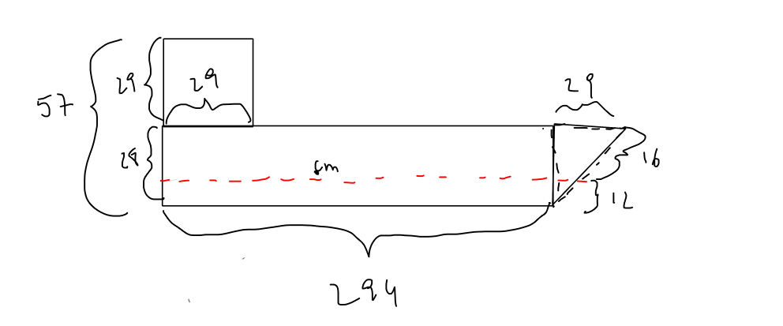

Centro de massa do *vessel* Panamax : ( 129,57 ; 14,05 )

## Lake Freighter

Centro de massa do *vessel* Lake Freighter: ( 95,49 ; 5,90 )

## ULCV

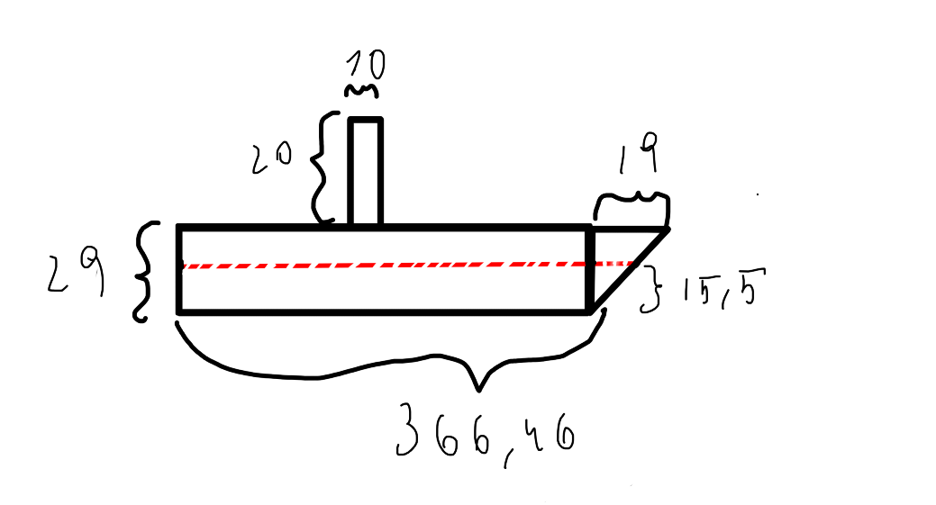

Centro de massa do *vessel* Lake Freighter : ( 175,71 ; 14,42 )

# US 419

## Panamax

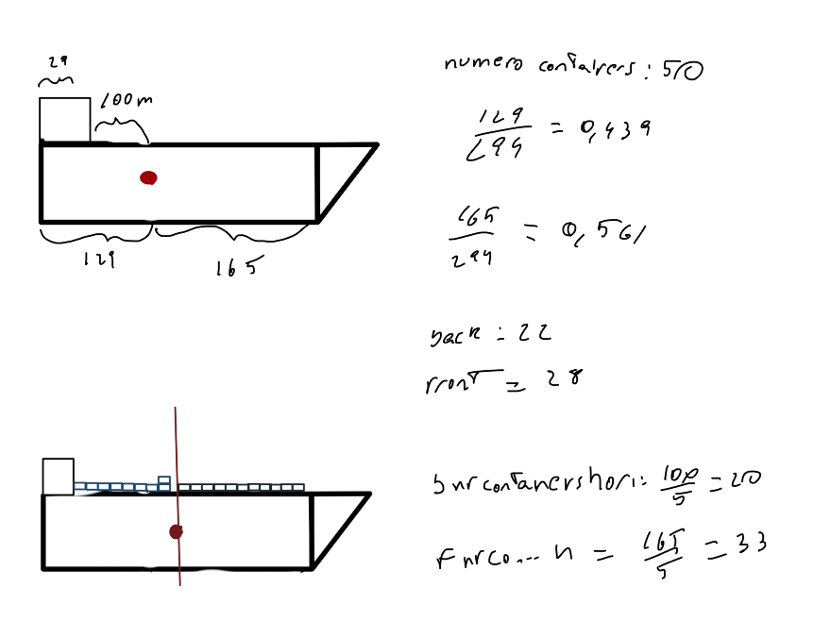

Number of containers: 50

Back percentage of the mass center: = 0,439 = 43,9 %

Front percentage of the mass center: = 0,561 = 56,1 %

Number of containers in the back of the mass center: = 22

Number of containers in the front of the mass center: = 28

Number of containers that can be placed in the horizontal, in the back of the mass center: = 20

Number of containers that can be placed in the horizontal, in the front of the mass center: = 33

## ULCV

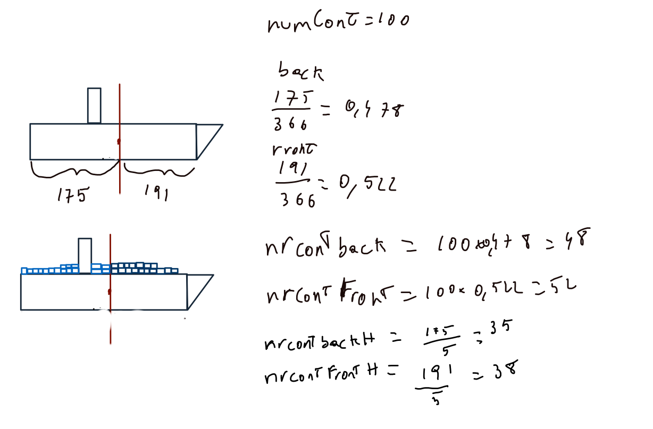

Number of containers: 50

Back percentage of the mass center: = 0,478 = 47,8 %

Front percentage of the mass center: = 0,522 = 52,2 %

Number of containers in the back of the mass center: = 48

Number of containers in the front of the mass center: = 52

Number of containers that can be placed in the horizontal, in the back of the mass center: = 35

Number of containers that can be placed in the horizontal, in the front of the mass center: = 38

# US 420

## Panamax

Wi = * w

= * 32,3

= 13.89 m

Vprisma = x 13.89 x 12,04 x 294,13

= 124354

V = (=) m = v * p (=) m = 124354x 1030 = 128084620 Kg

P = 1030 Kg/

500kg x 1000 = 500000 kg

Mtotal = 500000 + 128084620= 128 584 620Kg

V = = 124839,43

Hi =

Δh = 18.44 – 12,04 = 6.4m

## ULCV

Wi = * w

= * 48,2

= 25.03 m

Vprisma = x 15,5 x 25.03 x 366,46

= 102726.25

V = (=) m = 71086,83 x 1030 = 10 530 803,75 Kg

P = 1030 Kg/

500kg x 100 = 50000 kg

Nova massa = 50000 + 10 530 803,75 = 10580803.75 kg

V = = 102774.79

Hi =

Δh = 21.51 – 15,5 = 6.01 m

## Lake Freighter

Wi = * w

= * 21

= 18.48 m

Vprisma = x 13,49 x 11 x 234

= 36093.75

V = (=) m = v * p (=) 31762.5 x 1030 = 3271537.5 Kg

P = 1030 Kg/

Mcontainers = 500kg x 1000 = 50000 kg

Mtotal = 3271537.5 + 500000 = 3 321 537,5

V = = 31762.5

Hi =

Δh = 11,73 – 11 = 0,73m