Bidding Process

Audeh Aklouk, John Fernandez, Anna Jenkins, Julian Matthews, Jayshawn Mercedes

Project Plan

Meeting Makers is an organization that provides services to assist companies or organizations in organizing conferences and meetings in a variety of cities across the country. The organization is relatively small with 10 project managers, 7 office staff personnel, and 1 graphic designer. The employees have various responsibilities including handling participant registration, fielding questions from attendees, securing meeting spaces and hotel rooms, and planning extracurricular activities. The organization gathers information regarding the city, dates, anticipated number of attendees, price range, and external activities to arrange a bid that they propose to clients. They calculate estimated quotes and present them to clients which is essential to their success. The project bids include hotel information, registration, brochures, and extracurricular activities.

Meeting Makers relies on information technology to carry out the essential parts of the organization. They store data in an Access system. This database is located on one PC, so the staff and project managers must alternate usage of the PC to accomplish their work. The database holds specific information about the conference, attendees, and hotel.

Meeting Makers has several issues with their information system that their management has recognized. Grouping the issues into responsibility issues and inefficiency issues seems to be a logical approach. The first responsibility issue is penalty charges. Project managers continue to forget to cancel a booking when a client no longer has an interest in holding an event. The hotel that planned to host the event then penalizes Meeting Makers for not notifying or updating them of the event’s current status. This issue causes Meeting Makers to not only lose money from paying a fee, but also lose future reservations at certain hotels because of the organization’s lack of communication and dependability. The second responsibility issue is inaccuracy of data. According to Meeting Makers management, the organization lost 15 bids due to sloppiness. These bids included inadequate hotels and an inaccurate quote due to a miscalculation of the number of participants. This may have been due to employees altering data so it could be stored correctly in the software program. This issue likely contributes to the decline in the percentage of repeat customers that Marge estimates will decrease from the current 75% to 60%. Lastly, the third responsibility issue is lateness. Deadlines are not consistently being met, which doesn’t make a good impression on clients.

The main inefficiency issue is the lack of technology and computer software training. The employees do not have proficient skills in the current software programs they utilize, and they also do not have sufficient training in all of the software programs. Likely due to the lack of training, important information is not saved electronically or sent electronically. Additionally, the graphic designer doesn’t record any information anywhere, so his colleagues have a hard time preparing bids when he is away from work. This can significantly slow down the amount of time it takes to develop a bid.

By identifying the issues of the current information system, we can determine whether a new information system is necessary. In this case, a new information system could increase the quality and efficiency of Meeting Makers employees. Our team plans to identify, analyze, and deliver the system requirements, process analysis, data analysis, user interface design, and presentation of the Bidding Process Information System.

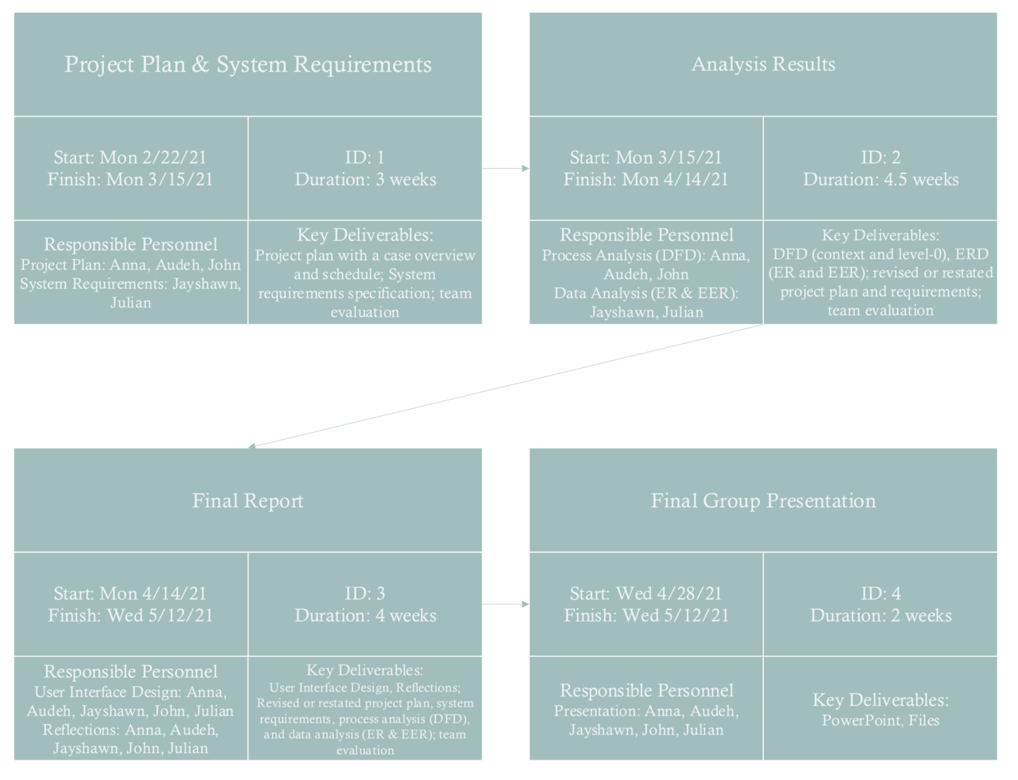

System Requirements Specification

Meeting Makers is a company that specializes in creating, organizing, and coordinating conferences and meetings. Their current system consists of multiple steps and processes. Meeting Makers gathers necessary resources to prepare a bid. The current bidding process estimates the cost of all services proposed in the bid. This includes mail registration, brochure cost, reservation cost, staff, and miscellaneous costs. Meeting Makers also sends staff to assist in running the conferences. Our team will focus on the bidding process and exclude the management part of the conference. This is because the back bone of Meeting Makers is securing hotels and determining costs. Meeting Makers will not manage anything if there is no bid in the first place.

The first functional requirement for Meeting Makers consists of calculating the total number of attendees. This is important because the number of attendees allows Meeting Makers to gauge how much space they need for the conference/meeting. Estimating the number of attendees is a necessary first step for determining the cost of the main requirements of the bidding process. Another reason getting the number of attendees is vital for the system is because this number of people coming will not determine the cost of the hotel but also the cost of all the other expenses for the conference/meeting.

The next functional requirement is determining the cost of the mail registration. This relates to the number of attendees because this is just for sending out the information for the event. This also has a part in the bidding process because it factors into the total cost.

The next functional requirement is determining the cost of the brochure. The creation of the brochure is dependent on the graphic design team and they base their ideas off of the customer’s request. Also depending on the conference size and scale, the number of pages and attendees will also cause the price to increase and decrease.

The next functional requirement is the cost of the hotel reservation. This requirement is one of the most important steps in the bidding process. This is because without a bid, there is nothing else that Meetingmakers can do. To place a bid, the hotel must talk to the client about their wants and needs for their hotel and conference. After this has been determined Meetingmakers will place multiple holds on hotels to secure a location when it is time to pay and start setting up for the conference and or meeting.

The next functional requirement is the cost for the staff for the event. This is a functional requirement because Meetingmakers needs staff to help run, maintain and organize the actual event in the hotel. The number of staff is determined by the size of the event and by the customer. This may not be the most important functional requirement but it is still very necessary for the bidding process.

The next set of requirements will be nonfunctional requirements. Meaning they have importance but overall the system could survive without them. These requirements do have importance though in the current IS system for meeting makers.

The first nonfunctional requirement is the network and file sharing. The current Meetingmakers stores all of their data on one computer inside the company. This causes problems because having only one computer makes it difficult for multiple people to do work at the same time. Acquiring multiple laptops or computers for Meetingmakers will greatly improve the efficiency and productivity of the company. Having multiple computers would allow for file sharing and this could allow for workers to have access to the information they need to do their job.

The next nonfunctional requirement is making sure all the devices within the company use the same software. This is important because using different types and ages of software causes confusion and turmoil. This is because when all the workers use different software, it becomes very difficult to file share and share data with coworkers. This is why having one software across all devices is a nonfunctional requirement.

The next nonfunctional requirement is the Database on hotels and customers. This requirement is one that creates a lot of business opportunities for Meetingmakers. Having a database allows for Meetingmakers to keep a record of all of their customers who used their service. This would allow for the customers experience, rating, and review all to be recorded in the database for reference. That information would stay in the database for reference because it would allow for Meeting Makers to see if the customer liked their service or not and whether they need to improve and change things for next time. This also improves customers relations because having this record on their allows for Meetingmakers to build on last time and try and get the customer to come back and use Meetingmakers service again.

The last nonfunctional requirement is a list of the possible extracurricular activities and cost while at the hotel. This is not a functional requirement but this part of the Meetingmakers service is vital to the customers because this is a big part of why and if they would use Meetingmakers service again in the future. When clients arrive at the hotel for the conference, they are not going to be in the meeting or event, the entire time they are there. They need things to do while not in a conference and Meetingmakers provides in their service a list of extracurricular activities for clients to do. What Meetingmakers will also do is provide costs for all of the activities so the clients can just decide what they want to do and do it instead of working out all the logistics. Having this as a part of Meetingmakers service improves the company’s customer relationships and change of returning customers.

**Interaction Worksheet**

(This form will be put on the class website for you to download and use directly)

|  |  |  |  |  |  |  |
| --- | --- | --- | --- | --- | --- | --- |
| **Date** | **Other Party** | **Communication** | **Apprx. Length** | **Topic** | **Major Decision** | **Other Notes** |
| 2/22/21 | All present | Zoom | 15 minutes | -Meeting Times  -Our Main case | -Meetings on Tuesday at 7:00pm and Friday 1:00pm (For now)  - Decided to go with Case Meeting Makers |  |
| 2/23/21 | All present | Zoom | 15 minutes | Discussing the project requirements | Finish reading the case and project objectives by next meeting |  |
| 2/28/21 | All present | Zoom | 45 minutes | -Discussing Case  -Assigning tasks to group members | -Summarize notes into one Doc  -Find out key deliverables and requirements for our IS  - brush up on Class Vocabulary |  |
| 3/2/21 | All present | zoom | 15 minutes | -Reviewing case and assignment guidelines | -Schedule meeting with professor for guidance and review |  |
| 3/7/21 | All present | Zoom | 1.5 hours | -Discussing key objectives and deliverables | -Company needs to update software  -Further training of employees in required  -Provide interface for customers to schedule appointments (website) |  |
| 3/14/21 | All present | Zoom | 30 min | -Checking project objectives before submission | -Continue finishing up the last details of the IS system  -Synthesize and finish tomorrow morning |  |
| 3/15/21 | All present | Zoom | 30 min | -Final check |  |  |