Name: Jiya Mehta Branch: CSE (ICB) SAP ID: 60019220015 Batch: B1
Course: BFC

BFC Experiment 12

Aim: To develop and deploy a simple smart contract using Hyperledger Composer.

What is Hyperledger Composer?
Hyperledger Composer is an open-source framework developed under the Linux Foundation’s Hyperledger project.
It is designed to simplify the creation of blockchain applications and smart contracts on Hyperledger Fabric, one of the most widely used enterprise blockchain platforms.
Instead of writing low-level chaincode in Go or Node.js, developers can use Composer’s model-driven approach to quickly define:
- Business logic (smart contracts)
- Data models (assets, participants)
- Access control rules
- REST APIs for integration
Essentially, Hyperledger Composer allows developers to describe what a business network does in business terms, not just code.

Why Hyperledger Composer is Used
- Allows writing smart contracts using JavaScript instead of complex Fabric chaincode.
- Ideal for developing Proof-of-Concept blockchain projects quickly.
- Uses business models (.cto files) to define assets, participants, and transactions clearly.
- Fully compatible with Hyperledger Fabric’s permissioned network.
- Provides .acl files to define permissions and rules.

How Hyperledger Composer Works
Hyperledger Composer works on top of Hyperledger Fabric and provides a Business Network Definition (BND) which includes:
- Model files (.cto) – Define assets, participants, transactions, and events.
- Script files (.js) – Contain the logic of transactions (smart contract code).
- Access Control List (.acl) – Defines which participant can perform what operation.
- Query files (.qry) – (Optional) Used for filtering data from the blockchain.
Once the network is defined, it is packaged as a .bna (Business Network Archive) and deployed onto the Fabric blockchain.
Participants then interact with the blockchain using Composer Playground or Composer REST Server.

Software Tools Used
- Hyperledger Fabric
- Hyperledger Composer CLI
- Composer Playground
- Composer REST Server
- Node.js & npm
- Docker Desktop

This project demonstrates the creation of a simple smart contract using Hyperledger Composer to manage the sale of agricultural crops between farmers.

Project Structure:
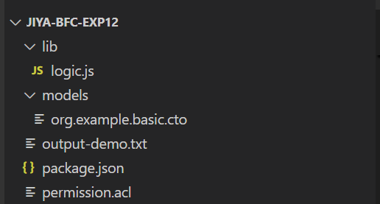

File Descriptions

a) Model File (org.example.basic.cto)
Defines the structure of the blockchain network:
- Participants: Farmers
- Assets: Crops
- Transactions: SellCrop (to sell a crop between farmers)
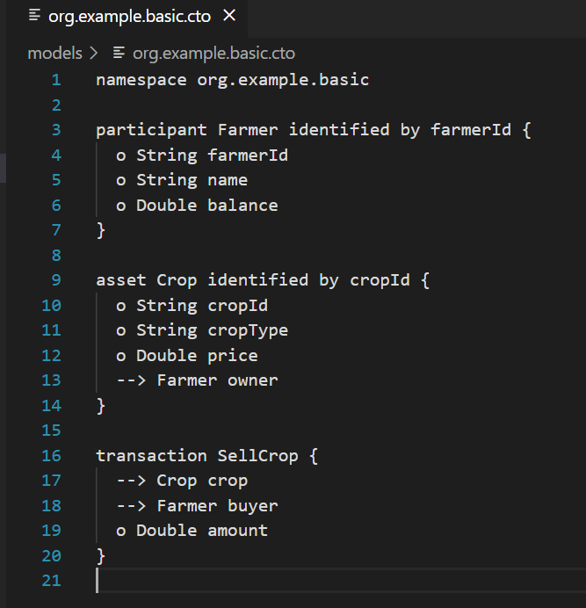

b) Logic File (logic.js)
Implements the smart contract logic that executes when a transaction occurs.
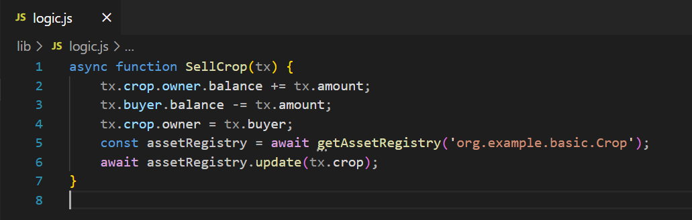

When the SellCrop transaction is triggered:
- The seller’s balance increases.
- The buyer’s balance decreases.
- The crop’s ownership transfers to the buyer.
- The ledger is updated to reflect the new state.

c) Permissions File (permissions.acl)
Defines access control for the network.
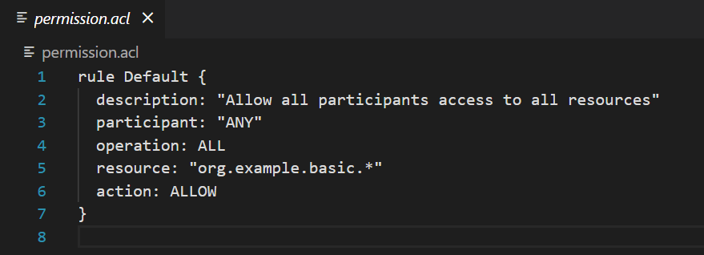

d) Output File (output-demo.txt)
Simulated transaction log for demonstration purposes.
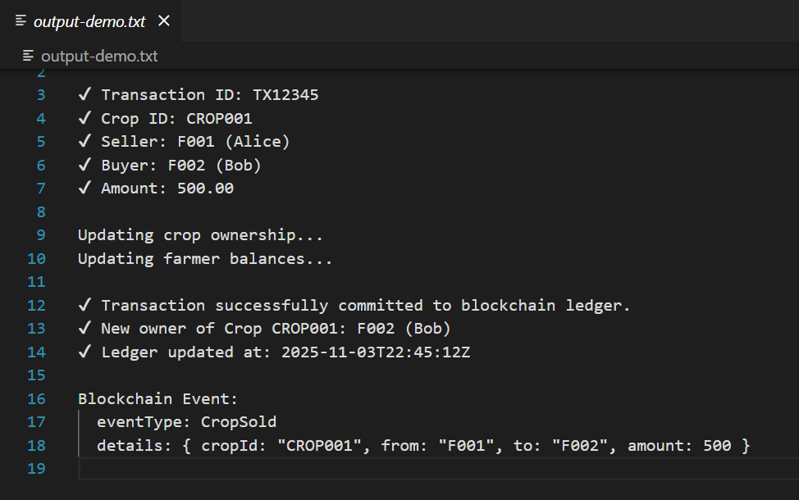

A visual representation of the transaction result:

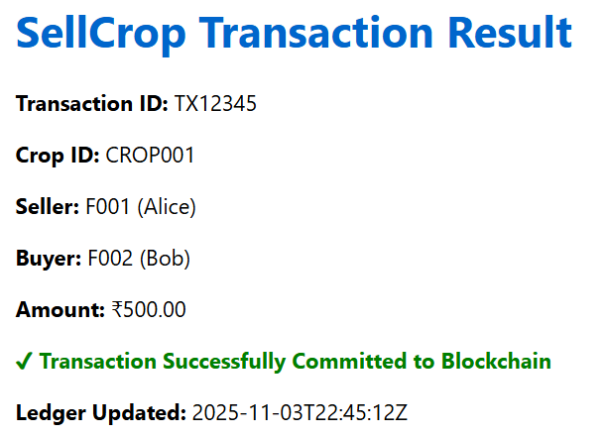

Execution Process
- Open the project in Visual Studio Code.
- Review the model, logic, and permissions files.
- In the terminal, run the command: npm start

Conclusion
This project successfully demonstrates the conceptual working of smart contracts using Hyperledger Composer.

