Evidence-aware reporting of unknown metabolite structure hypotheses
Authors: Joshua Simpson¹, [additional authors]¹
Affiliation: ¹Metabolon, Inc., Morrisville, NC, USA
Corresponding author: [email]

Abstract
Untargeted LC-MS/MS detects far more reproducible features than can be identified against authentic standards, and the remainder is routinely set aside for want of a comparable confidence statement [1,2]. We evaluated a workflow combining retrieval and de novo candidate generation, evidence-aware reranking, biochemical taxonomy assignment and MSI-style claim control across 3,897 X-compounds. Among 92 truth-verified controls, structural recovery was 47.8% at rank 1 (44/92; 95% CI 37.9–57.9%), 64.1% within the top 3 (59/92; 54.0–73.2%) and 73.9% within the top 10 (68/92; 64.1–81.8%). Leave-one-out validation showed weak aggregate-score calibration (Brier score 0.255), supporting evidence-limited rather than probability-based claims. Taxonomy results separate by provenance: 1,459 direct reference lookups are internally consistent by construction, whereas among 644 neighbor-consensus assignments with independent labels super-pathway agreement was 52.2% (48.3–56.0%) and subpathway agreement 18.8% (15.9–22.0%). Those figures are bounded: on identical structures the two taxonomies agree only 62.5% and 34.8%. Intrinsic leave-one-out validation of the neighbor-vote mechanism yielded 86.7% and 71.1%. The contribution is therefore not higher accuracy but a reporting framework that grades every feature, exposes the provenance of each claim, and withholds a structure when corroboration is insufficient, making the unidentified fraction usable instead of discarded.

Introduction
Untargeted LC-MS/MS metabolomics detects far more reproducible features than can be identified with authentic chemical standards. The unidentified remainder ("unknowns") carries substantial biological information, but communicating how confident an identification is—and what kind of identification it is—remains a central challenge [1,2]. The Metabolomics Standards Initiative (MSI) [2] and the Schymanski confidence scheme [1] formalized this as a small number of identification levels, from an exact-mass-only "level of interest" up to a standard-confirmed structure.
Matching an observed spectrum against a reference library is the established route to an identification and the most precise one available short of an authentic standard, which is why it accounts for the named fraction of an untargeted deliverable and remains the first step of the workflow reported here. What bounds it is coverage rather than performance: a structure absent from the library is outside the space a library search returns, so extending the named fraction has meant manual chemistry followed by purchase or synthesis of candidate standards, at a throughput that limits both library expansion and the discovery of dataset-specific metabolites [14]. To extend candidate generation past that coverage boundary, published approaches including MS2Query, SIRIUS, Spec2Mol, and MSNovelist were assessed using the Critical Assessment of Small Molecule Identification (CASMI) framework [12,13]. The workflow evaluated here builds on Spec2Mol-style de novo generation and adds retrieval, evidence-aware reranking, confidence reporting, MSI-style claim control, and neighbor-based biochemical taxonomy assignment.
We present a workflow that (i) predicts candidate structures for each unknown feature from its MS1/MS2 evidence, (ii) reranks candidates using library, mass, and spectral evidence, (iii) assigns a pathway and subpathway by consensus over structurally similar reference metabolites, and (iv) renders a per-compound report with an aggregate evidence score and an evidence-derived MSI-style reporting level. Our contributions are:
- Rank-aware structural validation with uncertainty, source-stratified recovery, and cross-validated confidence diagnostics.
- Provenance-aware taxonomy evaluation that separates direct database lookup, neighbor consensus, and agreement with independent labels.
- Evidence-limited reporting for every feature, with an MSI-style rubric that presents structure hypotheses only when minimum corroboration criteria are met.
Taken together, these change what an analyst can do with the unidentified fraction of a study. Rather than selecting a handful of features for manual interpretation, every feature can be ranked, placed in a biochemical context, and triaged against the same evidence standard, so the decision of where to spend confirmation effort rests on a comparable basis across the dataset.
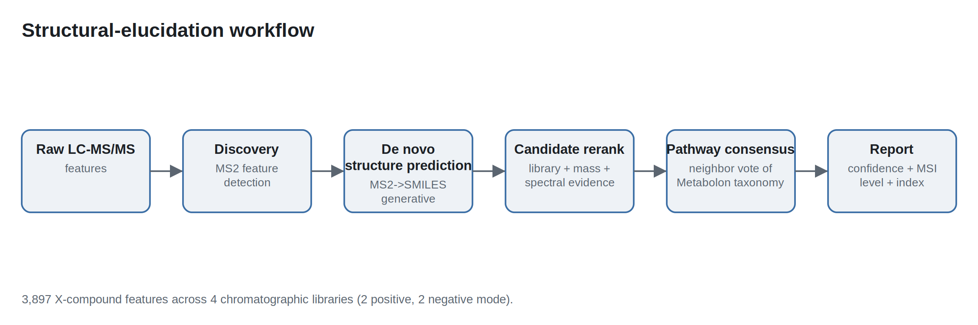
Figure 1. Evidence generation, ranking, taxonomy assignment and claim control are separable stages with distinct failure modes, so each result below can be attributed to a specific stage rather than to the pipeline as a whole. Discovery detects reproducible MS2 features; retrieval/de novo inference proposes candidate structures; reranking orders candidates by library/mass/spectral evidence; taxonomy is assigned by direct lookup or neighbor consensus; and the reporting layer computes an exploratory evidence score and an MSI-style reporting level.

Toolkit landscape (related work)
Recent MS/MS structure-elucidation tools span a spectrum from library retrieval to de novo generation, and the two ends answer different questions rather than competing on one. MS2Query [8] performs analogue and exact-match search against a pretrained GNPS-based library, ranking candidates by a learned chemical-similarity score combined with precursor mass; it is well suited to library expansion, and its coverage is set by its reference library. SIRIUS 4 [7] deterministically assigns molecular formulae from high-resolution isotope patterns and fragmentation trees (with the ZODIAC option for compounds >500 Da), predicts molecular fingerprints via CSI:FingerID, and assigns compound classes via CANOPUS [9]. Spec2Mol [10] is an encoder–decoder—analogous to speech-to-text—that reconstructs SMILES directly from spectra, so its candidate space is defined by the decoder rather than by database membership. MSNovelist [11] couples CSI:FingerID fingerprints with an encoder–decoder generator, likewise scoring independently of spectral-library membership and strong on poorly represented structural classes. The generative route trades the precision a library match confers where the compound is catalogued for reach into chemistry that is not, which is why the pipeline reported here runs both: it builds on the Spec2Mol de novo lineage and adds retrieval, evidence-aware reranking, exploratory evidence aggregation, MSI-style claim control, and pathway consensus. Because none of these tools has been benchmarked head to head against the present workflow, no accuracy comparison is made; the defensible statement is that combining the retrieval and generative routes provides additional evidence per candidate and reduces dependence on any single evidence source. Substructure-only tools (e.g., MS2LDA [15]) are complementary future work.

Results

Coverage
The workflow produces an evidence report and a biochemical taxonomy assignment for all 3,897 features. It presents a specific structure for the 2,726 L1–L3 reports (70.0%) and withholds one for the 1,171 L4–L5 reports (30.0%). Pathway provenance is direct reference lookup for 1,459 reports and neighbor consensus for 2,438. Resolving that split by assignment status gives exact reference match 1,459, strong-similarity vote 1,995, and weak-similarity backfill 443; pathway-confidence tiers are high 1,863 / medium 616 / low 1,418. The best-reference similarity has median 0.733 (p10 0.375, p90 1.0). Evidence availability is summarized in Supplementary Table S1. Coverage is therefore complete by construction: what differs between features is not whether a result exists but how much that result claims.

Structural recovery
On the 92 truth-verified controls, recovery at Tanimoto ≥0.70 is 47.8% at rank 1 (44/92; 95% CI 37.9–57.9%), 64.1% within the top 3 (59/92; 54.0–73.2%), and 73.9% within the top 10 (68/92; 64.1–81.8%; Figure 2). Rank-1 recovery is 38.1% for exact-catalog-source calls (16/42; 25.0–53.2%; median truth Tanimoto 0.506) and 56.0% for predicted-source calls (28/50; 42.3–68.8%; median 0.811). The intervals overlap, so this cohort does not resolve a difference between the two sources in either direction, and no equivalence claim is made either. What follows is narrower, and concerns how a report's source field should be read rather than how a library match performs: a candidate carrying an exact catalog source has been matched to a catalogued structure, which records where the candidate came from and is not on its own the independent corroboration an authentic standard supplies. The gap between rank-1 and top-10 recovery is itself the argument for reporting a ranked list rather than a single call, because a substantial share of correct structures are present but not first. Threshold-sensitivity results are provided in Supplementary Table S3.
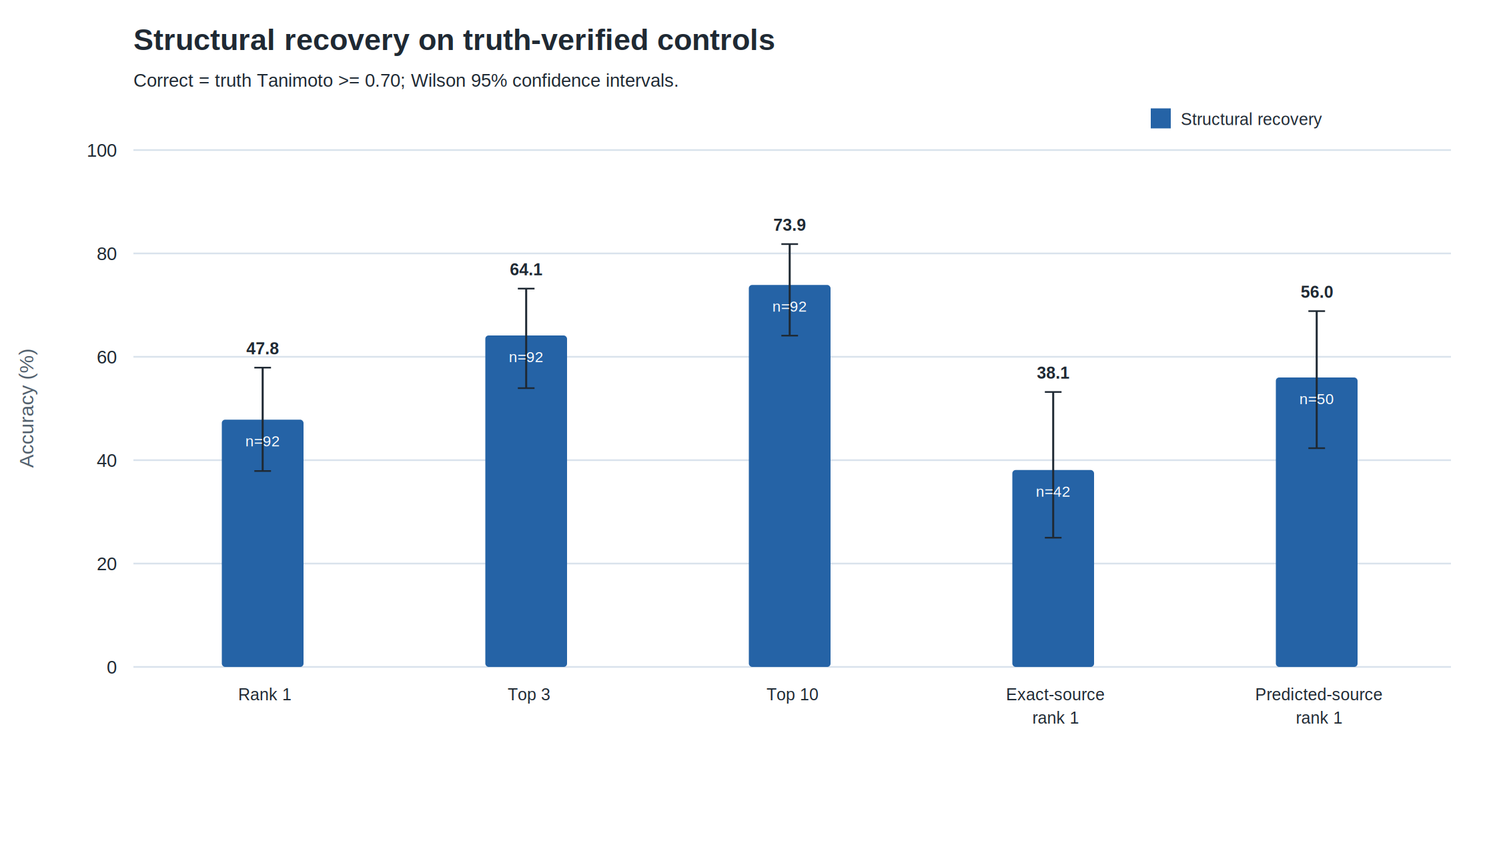
Figure 2. Recovery improves substantially from rank 1 to top 10, which justifies reporting ranked hypotheses, and the two source subgroups have overlapping intervals on a cohort of this size, which is why an exact-source call is not read as a confirmed one. Structural recovery on 92 truth-verified controls; correctness is truth Tanimoto ≥0.70; error bars are Wilson 95% confidence intervals. “Exact source” records where a candidate came from and is not authentic-standard confirmation.

Confidence tiers and MSI levels
The in-sample aggregate confidence has median 0.432 (p10 0.372, p90 0.585), but leave-one-control-out Platt validation reveals poor calibration: Brier score 0.255, calibration slope 0.056, and intercept −0.082 (Figure 3). Removing the pathway axis slightly improves Brier score to 0.253 and slope to 0.274. The aggregate score is therefore exploratory and should not be interpreted as a validated absolute probability. Selective prediction shows the practical consequence: ranking the 92 controls by leave-one-out confidence and scoring successively larger prefixes leaves rank-1 recovery essentially unchanged, at 50.0% for the most confident fifth against 47.8% for the whole cohort (Supplementary Figure S5). The score therefore does not order one feature against another, which is a stronger and more useful statement than poor calibration alone.
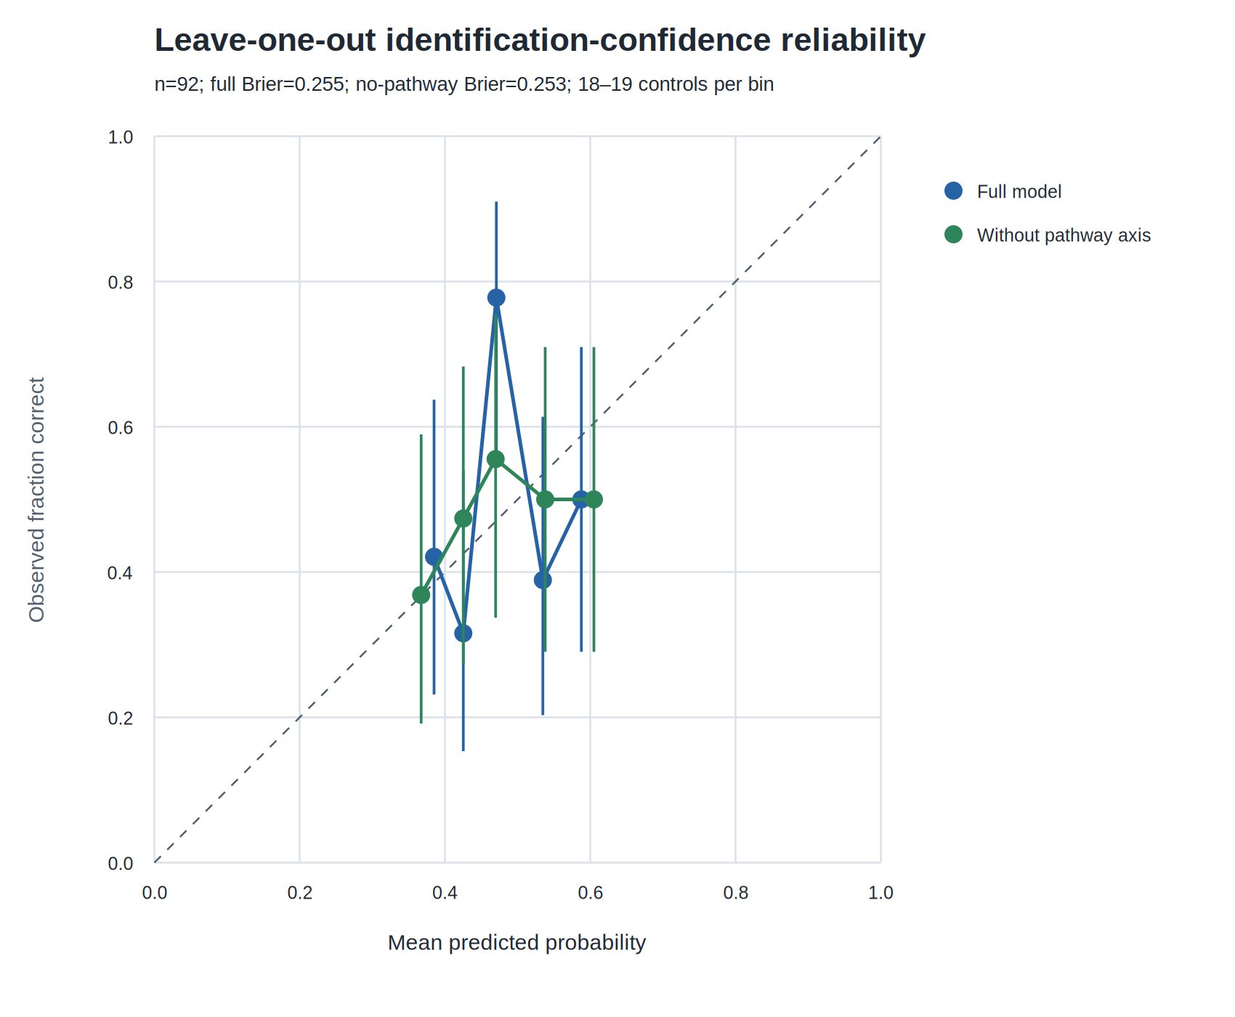
Figure 3. The aggregate score is poorly calibrated out of sample, which is the evidence for presenting it as an ordering device rather than a probability of structural correctness. Mean leave-one-out predicted probability versus observed structural correctness in five equal-count bins (n=92); error bars are Wilson 95% confidence intervals and the dashed line is perfect calibration.
The identification-confidence tier distribution is Confirmed 44 / High 0 / Moderate 1,416 / Low 1,344 / Tentative 1,093. Separately, the MSI-style reporting distribution is L1 44 / L2 193 / L3 2,489 / L4 1,165 / L5 6 (Figure 4). L4–L5 withhold a specific structure. These custom thresholds require external validation; their cross-tabulation is reported in Supplementary Table S2.
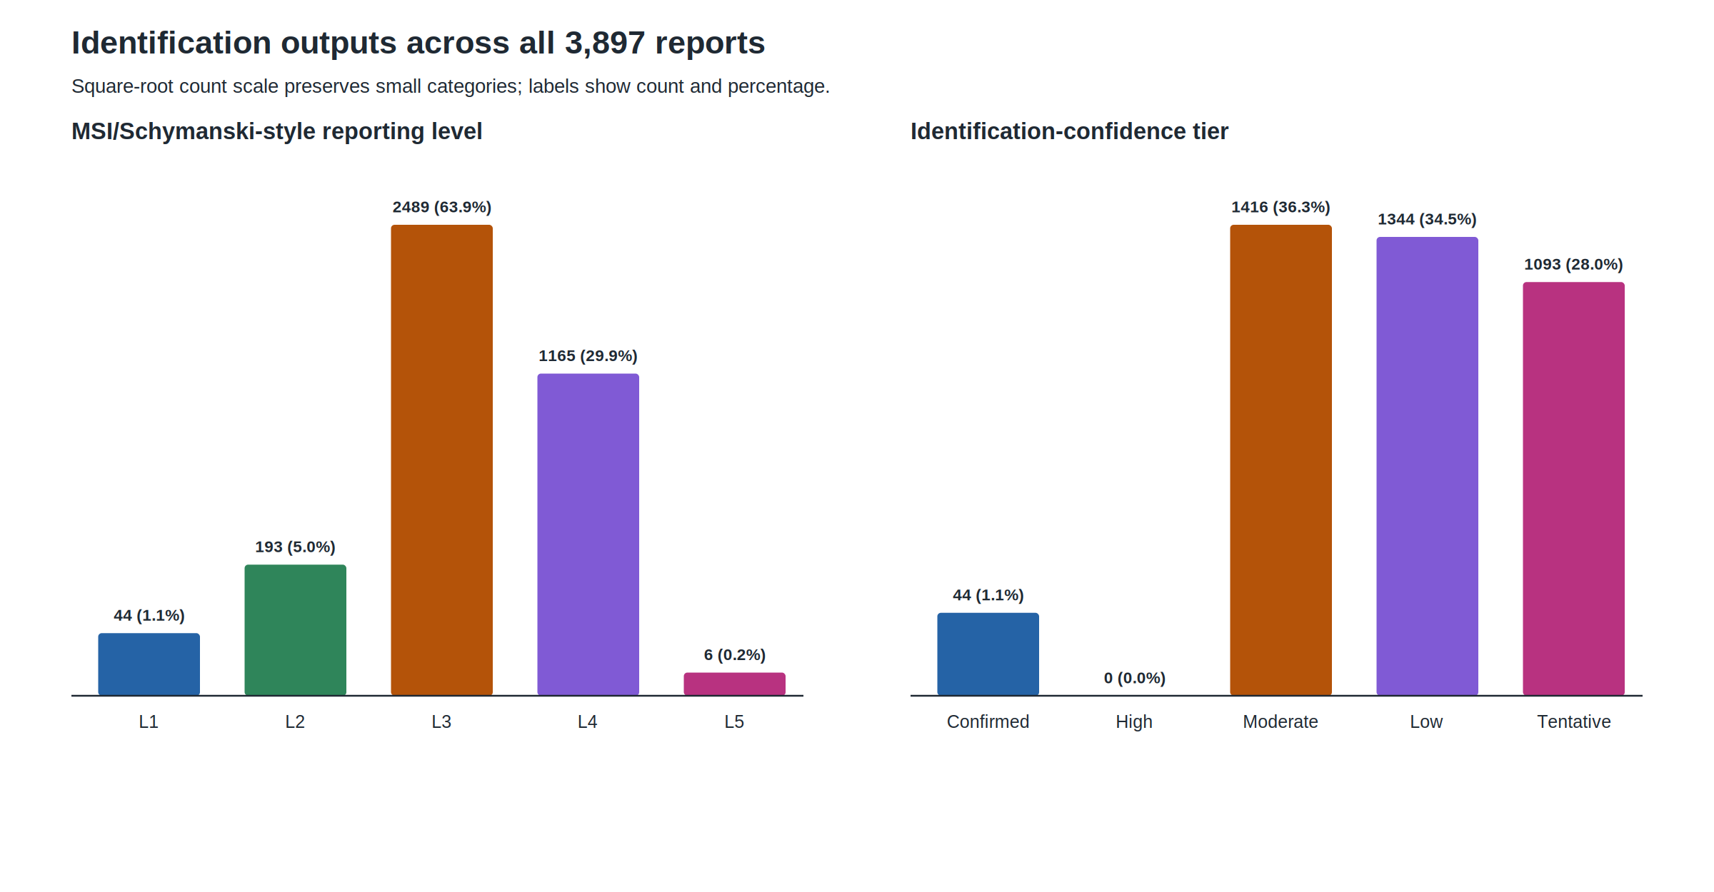
Figure 4. The rubric concentrates results in hypothesis-level categories and leaves the strongest confidence tier empty, showing that the claim-control rules bind in practice rather than only in principle. Counts and percentages across all 3,897 reports; a square-root count scale preserves small categories, and the “High” identification-confidence tier is explicitly shown as empty.

Biochemical taxonomy assignment
The delivered reports use two assignment routes that must be evaluated separately. For 1,459 compounds, an exact structure match triggers direct lookup of the reference-database taxonomy; these assignments are 100% internally consistent (95% CI 99.7–100.0%) by construction and are not an independent prediction-accuracy estimate. The remaining 2,438 reports use neighbor consensus. Among 644 neighbor-consensus controls with independent known_X labels, super-pathway agreement is 52.2% (336/644; 95% CI 48.3–56.0%) and subpathway agreement is 18.8% (121/644; 15.9–22.0%); across all 909 labelled controls, direct lookups included, the figures are 55.3% (503/909; 52.1–58.5%) and 23.5% (214/909; 20.9–26.4%). An intrinsic leave-one-out test of the neighbor-vote mechanism over 5,095 reference metabolites yields 86.7% super-pathway (4,417/5,095; 95% CI 85.7–87.6%) and 71.1% subpathway accuracy (3,623/5,095; 69.9–72.3%), but does not include all production priors and overrides (Figure 5, Table 1).
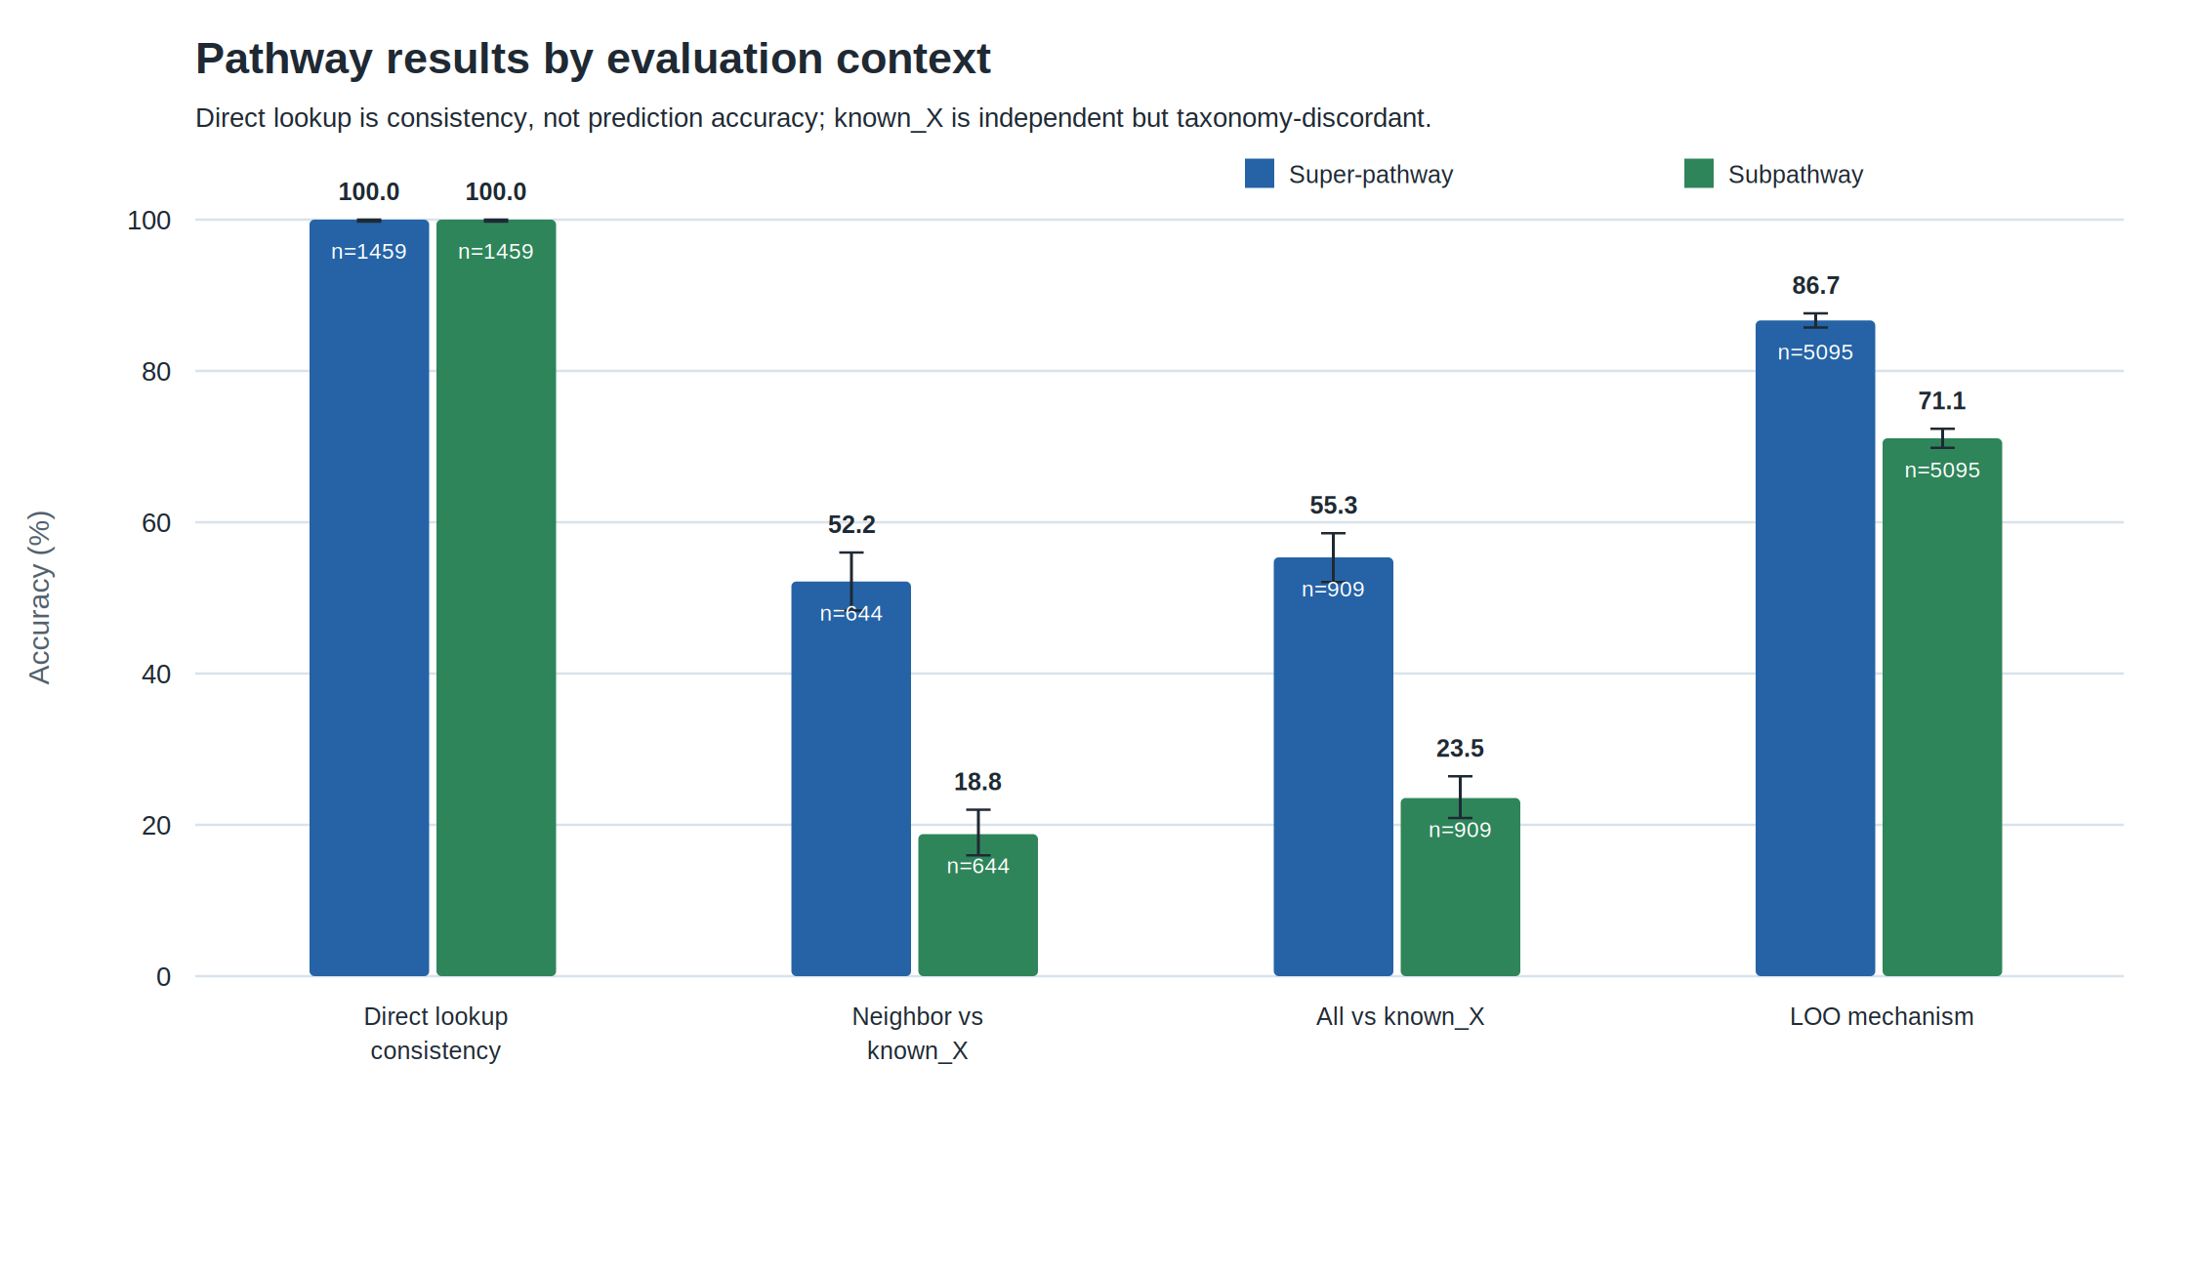
Figure 5. Apparent pathway performance depends entirely on the evaluation context, so quoting a single pathway figure without its provenance would misstate the result by tens of percentage points. Direct lookup measures taxonomy consistency; `known_X` is an independent but discordant label source; LOO validates only the neighbor-vote mechanism. Error bars are Wilson 95% confidence intervals.
Table 1. Pathway and subpathway results by evaluation context.
Evaluation | n | Super (95% CI) | Sub (95% CI)
Reference taxonomy, direct lookup (consistency only) | 1,459 | 100.0% (99.7–100.0%) | 100.0% (99.7–100.0%)
Neighbor consensus vs independent known_X | 644 | 52.2% (48.3–56.0%) | 18.8% (15.9–22.0%)
All assignments vs independent known_X | 909 | 55.3% (52.1–58.5%) | 23.5% (20.9–26.4%)
Neighbor-vote leave-one-out mechanism | 5,095 | 86.7% (85.7–87.6%) | 71.1% (69.9–72.3%)

The independent-label comparison is bounded, and not uniformly. known_X and the reference-database taxonomy are separate annotations of the same chemistry. On 267 controls whose structure is identical to a reference entry, where the label is copied and the assignment is right by construction, the two agree only 62.5% (167/267; 95% CI 56.6–68.1%) at the super-pathway level and 34.8% (93/267; 29.4–40.7%) at the subpathway level; dipeptides labeled "Amino Acid" in one taxonomy and "Peptide" in the other are typical. No predictor targeting the reference taxonomy can score above those rates against known_X. The bound is not uniform across chemical space, however: the most similar fifth of inferred assignments reaches 80.6% super-pathway agreement, above the rate measured on reference structures.
Vocabulary corrections move the numerator and the bound together. Treating amino acid and peptide as one class, a structural continuum whose mutual confusion is the largest single disagreement, raises inferred super-pathway agreement to 59.5% and its bound to 71.5%. Excluding the 181 controls whose independent subpathway label is an internal review note or an explicit non-answer, against which nothing can score, raises subpathway agreement to 23.6% and its bound to 42.7%. Neither correction changes the share of the achievable rate the predictor reaches, which stays near 83% at the super-pathway level and near 55% at the subpathway level. A maximal collapse of the commonly confused classes would reach 93.3%, but it merges four of the eight super-pathways and is reported as a bound only (Supplementary Table S8).
Agreement varies with evidence, not with library. Across the three chromatographic libraries carrying enough controls to score, super-pathway agreement is 53.2% (n=464), 43.8% (n=80) and 50.0% (n=84), every interval overlapping at both levels (Supplementary Table S9), so the pooled figures are not an average over dissimilar populations. Structural similarity is a different matter: sorting inferred assignments by best-reference similarity and scoring cumulative prefixes lifts subpathway agreement to 34.1% over the most confident fifth (Supplementary Figure S5), and agreement is monotonic by pathway-confidence tier (high 70.3%, medium 61.4%, low 36.9%; Supplementary Figure S1). Predicted super-pathway frequencies otherwise track known_X, with chemically adjacent confusions dominating (Supplementary Tables S6–S7).

Mass-mismatch failure mode
There are 598/3,897 (15.4%) rank-1 mass mismatches. Of these, 590 fall into the historical MSI-L4 deep-audit subset; the remaining eight are outside L4. A lower-ranked, strongly mass-consistent candidate exists for 523/598 overall and 519/590 in the L4 subset. This identifies a reranking opportunity, not 523 proven-correct recovered structures: the alternatives have not undergone post-gate truth validation. Rank-1 errors are often chemically meaningful (median nonzero error ~176 Da), and 248/590 L4 cases lack a computable rank-1 formula. Detailed counts appear in Supplementary Section S5.

The delivered artifact
The reporting rules described above are visible in the rendered output rather than only in the rubric (Figure 6). Each feature yields two pages built from one evidence set: a public page and an internal one. Both carry the same reporting level, the same identification-confidence tier and the same evidence cards, and they differ in how much of the candidate list each is allowed to expose — three structures against ten at Level 3, and none at all at Levels 4–5. The level therefore governs the artifact and not merely the metadata, which is what makes the withheld 1,171 reports a designed outcome rather than an absence.
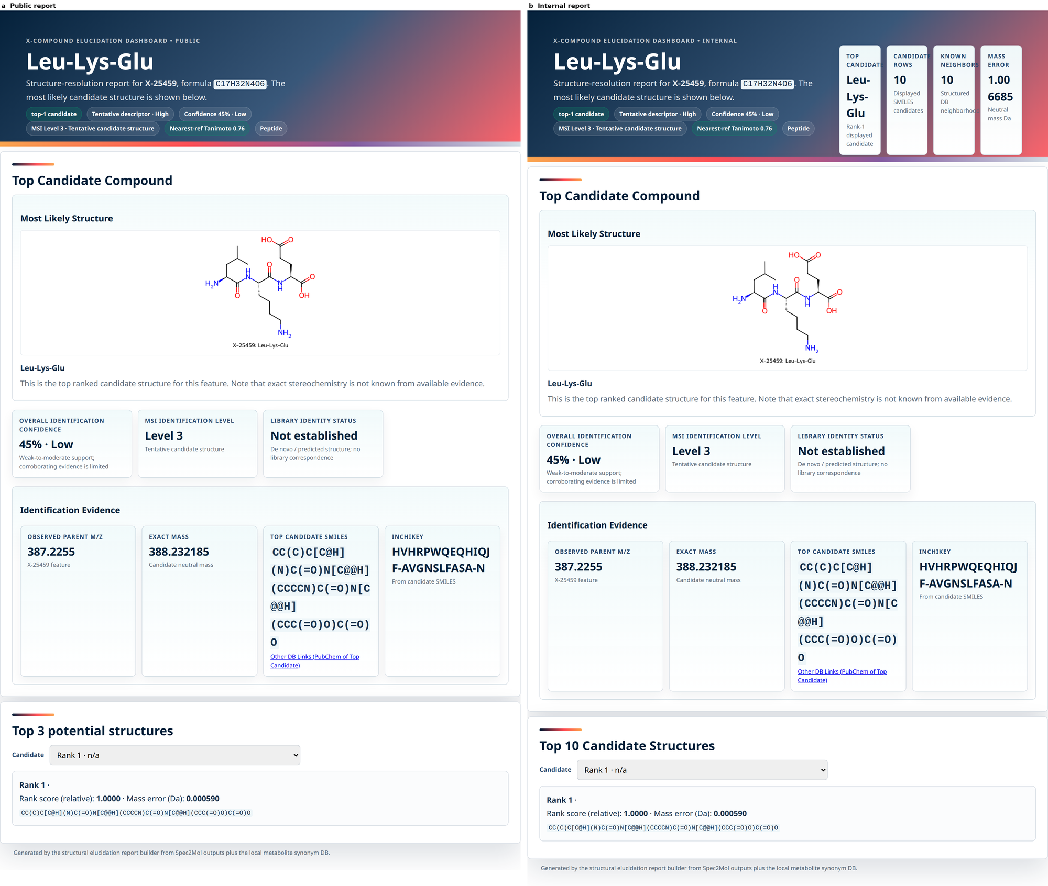
*Figure 6. The reporting level is enforced in the rendered page, so the difference between the two audiences is what may be shown rather than what was computed. Both panels are the same feature and the same evidence: a, the public page; b, the internal page, which adds triage metrics to the header and retains ten candidates where the public page shows three. The example is a demonstration control rendered by the report builder from data committed with this manuscript, not a delivered customer result; panels not populated by that reduced input are omitted.*

Discussion
Two results reframe how these outputs should be read. First, provenance is not by itself confirmation: exact-catalog-source rank-1 recovery is 38.1% (16/42; 95% CI 25.0–53.2%) on this cohort, so within these reports “exact source” records how a candidate was proposed and does not stand in for authentic-standard confirmation. The original aggregate probability is also poorly calibrated under leave-one-out validation. The defensible reporting mechanism is therefore claim limitation: L3 structures are explicitly hypotheses, while L4–L5 withhold a specific structure. The mass-mismatch cohort shows that mechanism working and its limit at once. Rank-1 calls failing the mass check are demoted to L4 rather than presented, which is the rubric behaving as intended, yet a better mass-matching alternative already sits lower in 523 of those 598 candidate lists, so the ordering is leaving recoverable structures unranked. Claim limitation contains the error; it does not correct it. This aligns with the communication intent of the Schymanski/MSI frameworks [1,2], although the custom thresholds still require external validation.
Second, taxonomy provenance is inseparable from apparent pathway performance. Direct reference lookups are internally consistent but do not test prediction, neighbor-consensus agreement with independent labels is materially lower, and mechanism-level leave-one-out is much higher. Part of that spread is annotation rather than prediction, since the two taxonomies agree only 62.5% at the super-pathway level and 34.8% at the subpathway level on identical structures. Correcting the vocabulary raises the observed rate and its bound by similar amounts and leaves the share of the achievable rate unchanged, so the corrections establish what the shortfall is not, without removing it. Because the bound is itself uneven across chemical space, ceiling-normalized figures indicate the size of the annotation effect but do not serve as an exact divisor, and the similarity-stratified curve is the better guide.
The two confidence signals the reports carry behave differently, which governs how each should be used. Pathway similarity orders assignments: between the whole cohort and its most confident fifth it gains 28 percentage points of super-pathway agreement, so withholding the least similar assignments buys agreement at a predictable cost in coverage. Identification confidence gains two points of rank-1 recovery over the same comparison and does not order features at all (Supplementary Figure S5). Prioritization guidance should therefore be offered for pathway assignments and withheld for structural calls, where the useful ordering is between candidates within a feature rather than between features.
Relative to reference-library analogue search (MS2Query), formula/fingerprint methods (SIRIUS/CANOPUS), and de novo generators (Spec2Mol/MSNovelist), this workflow's principal contribution is not a claim of state-of-the-art structural recovery. It is the integration of retrieval and generation with explicit evidence provenance, rank-aware evaluation, and reporting rules that limit unsupported structural claims. Library matching is not displaced by that integration: where a feature corresponds to a catalogued compound it remains the most direct route to an identification and supplies one of the evidence axes the reranker reads, and the workflow is aimed at the features that fall outside current coverage, whose well-corroborated hypotheses are themselves candidates for entering the library. A formal head-to-head benchmark remains necessary; until one exists, the defensible statement is that the workflow provides additional evidence per candidate, increases transparency about what each call rests on, and supports more informed prioritization of which features merit standard acquisition.

Applications
Three uses follow from the results above. Each states what an analyst can do that was previously impractical, the result that supports it, and the limitation that bounds it.
Triaging unknown features for standard acquisition or synthesis. Selection can be driven by a ranked shortlist rather than by expert intuition applied to a handful of features: the correct structure fell within the top 10 for 73.9% of truth-verified controls, so a chemist working through a short candidate list does so with a measured prior, not an unknown one. The bound is the control set itself—92 availability-selected compounds—so this is performance on that cohort, not an expected yield on new data.
Expanding reference coverage. Well-corroborated hypotheses give a defensible starting point for adding compounds to a reference library, and the MSI-style rubric identifies which reports carry enough corroboration to justify that cost. The bound is that an L3 report remains a hypothesis; promotion still requires authentic-standard confirmation.
Keeping the unidentified fraction inside biological interpretation. Because taxonomy is assigned to all 3,897 features, including the 1,171 for which no structure is presented, features associated with a phenotype can be discussed biochemically even when their structure is unresolved. The bound is taxonomy provenance: direct lookups are consistent by construction, neighbor-consensus subpathway agreement with independent labels is low, and pathway-confidence tiers should therefore prioritize rather than settle a classification.
All three depend on the report distinguishing the type of identification, the available corroborating evidence, and the unresolved ambiguity rather than presenting an unqualified structure.

Limitations
- Selected, single-organization cohorts. The 3,897-feature set and each truth subset are availability-selected and imbalanced across libraries. Specimen-level matrix/species metadata are absent from the reporting bundle, limiting generalizability and bias assessment.
- Calibration set size and performance. The confidence model was originally fit on the same 92 controls used for evaluation. Leave-one-out Brier score (0.255) and calibration slope (0.056) show that absolute probabilities are not externally calibrated; P0/P1 truth files were unavailable.
- Sparse MS2. Observed MS2 is present for only 43.6% of features; MS2 is the strongest independent corroboration, so its absence caps confidence. Broader capture and a better candidate-vs-spectrum scorer are needed.
- Taxonomy evaluation. Direct reference lookups are circular as accuracy tests. Independent labels are discordant with the reference taxonomy, agreeing only 62.5% at the super-pathway and 34.8% at the subpathway level even on identical structures, so known_X-scored results are bounded well below 100%. Minimal vocabulary corrections raise the observed rate and the bound by similar amounts without changing their ratio, and a curated crosswalk over the full subpathway vocabulary has not been attempted. One fifth of the independent subpathway labels are internal review notes or explicit non-answers rather than taxonomy terms, which is a defect in the comparison rather than in the predictor. Neighbor-consensus subpathway agreement is low even against the corrected bound. Production neighbor-builder parameters were not retained in the bundle.
- Custom MSI-style rubric. L2–L5 boundaries are operational thresholds and have not been independently validated against a sufficiently large authentic-standard cohort.
- Co-abundance correlations. Client-specific WGCNA [4] co-abundance evidence is a placeholder in the current reports (covering 13% of controls) and is not yet an independent confidence axis.
- Reproducibility constraints. Proprietary raw spectra, model checkpoints, and the reference database are not publicly deposited; exact run-environment metadata must be recovered before submission.

Conclusion
The workflow generates a complete evidence report for 3,897 unknown metabolite features and presents a specific structure for 70.0% while withholding one for the remaining 30.0%. Structural recovery reaches 47.8% at rank 1 and 73.9% within the top 10 on a small selected truth set. Pathway output is complete, but direct lookups must be separated from neighbor prediction; independent neighbor-consensus agreement is moderate at the super-pathway level and low at the subpathway level. The central result is therefore a reporting framework that exposes provenance and limits claims, rather than an assertion of uniformly accurate structural or pathway prediction. Its practical consequence is to reframe the unidentified fraction of an untargeted study from a residue that is discarded into a graded, prioritizable set of hypotheses: the workflow does not remove the confirmatory experiment, it indicates which one is worth running.

Future work
Priorities are external validation on the authoritative P0/P1 cohorts and a larger authentic-standard set; prospective testing of a hard mass gate; improved observed-MS2 coverage and candidate-spectrum scoring; and capture of real co-abundance evidence. A formal CASMI-style comparison of MS2Query, SIRIUS, Spec2Mol, and MSNovelist [8,10,11] across the prespecified benchmarking libraries is needed to support tool-selection claims. Substructure tools such as MS2LDA [15] may provide useful partial identifications when complete structures remain unresolved. Production deployment additionally requires immutable model/data provenance and evaluation of GPU scalability.

References
1. Schymanski EL, Jeon J, Gulde R, Fenner K, Ruff M, Singer HP, Hollender J. Identifying Small Molecules via High Resolution Mass Spectrometry: Communicating Confidence. Environ. Sci. Technol. 2014, 48(4):2097–2098.
2. Sumner LW, Amberg A, Barrett D, et al. Proposed minimum reporting standards for chemical analysis (Metabolomics Standards Initiative). Metabolomics 2007, 3:211–221.
3. Platt J. Probabilistic outputs for support vector machines and comparisons to regularized likelihood methods. Advances in Large Margin Classifiers 1999, 61–74.
4. Langfelder P, Horvath S. WGCNA: an R package for weighted correlation network analysis. BMC Bioinformatics 2008, 9:559.
5. Landrum G, et al. RDKit: Open-source cheminformatics. https://www.rdkit.org.
6. Bajusz D, Rácz A, Héberger K. Why is Tanimoto index an appropriate choice for fingerprint-based similarity calculations? J. Cheminform. 2015, 7:20.
7. Dührkop K, Fleischauer M, Ludwig M, et al. SIRIUS 4: a rapid tool for turning tandem mass spectra into metabolite structure information. Nat. Methods 2019, 16:299–302.
8. de Jonge NF, Louwen JJR, Chekmeneva E, et al. MS2Query: reliable and scalable MS2 mass spectra-based analogue search. Nat. Commun. 2023, 14:1752.
9. Dührkop K, Nothias L-F, Fleischauer M, et al. Systematic classification of unknown metabolites using high-resolution fragmentation mass spectra (CANOPUS). Nat. Biotechnol. 2021, 39:462–471.
10. Litsa EE, Chenthamarakshan V, Das P, Kavraki LE. An end-to-end deep learning framework for translating mass spectra to de-novo molecules (Spec2Mol). Commun. Chem. 2023, 6:132.
11. Stravs MA, Dührkop K, Böcker S, Zamboni N. MSNovelist: de novo structure generation from mass spectra. Nat. Methods 2022, 19:865–870.
12. Schymanski EL, Ruttkies C, Krauss M, et al. Critical Assessment of Small Molecule Identification 2016: automated methods. J. Cheminform. 2017, 9:22.
13. de Jonge NF, Mildau K, Meijer D, et al. Good practices and recommendations for using and benchmarking computational metabolomics metabolite annotation tools. Metabolomics 2022, 18:103.
14. Chen L, Zhang Z, Liu H, et al. Metabolite discovery through global annotation of untargeted metabolomics data. Nat. Methods 2021, 18:1377–1385.
15. van der Hooft JJJ, Wandy J, Barrett MP, Burgess KEV, Rogers S. Topic modeling for untargeted substructure exploration in metabolomics (MS2LDA). Proc. Natl. Acad. Sci. USA 2016, 113:13738–13743.

Methods

Dataset
The delivered evaluation set comprises 3,897 unique X-compound features from four internal chromatographic libraries: library 209 (negative ion, n=2,389), library 305 (negative ion, n=202), library 400 (positive ion, n=875), and library 402 (positive ion, n=431). A control present in more than one library was retained from the first library in that order (“first-library-wins”). Each report contains a discovery-derived consensus MS2 record and, where available, an observed precursor m/z and neutral-mass hypothesis. The reporting bundle does not retain specimen-level matrix, species, study-design, or original consent/IRB metadata; these are required from the source studies before journal submission.
Three non-random evaluation subsets are distinguished. Structural recovery is evaluated on all 92 controls with a nonzero truth Tanimoto value in the delivered candidate files. Independent taxonomy agreement is evaluated on 909 controls with nonempty known_X super-/subpathway labels. Reference-taxonomy consistency is evaluated on 1,466 rank-1 structures whose InChIKey skeleton occurs in the pathway reference database; 1,459 of these are direct database lookups. Selection into each subset depends on truth/reference availability and may introduce spectrum-, library-, and chemical-class bias. Authoritative P0 and P1 cohort analyses require separate source files not included in this bundle and are therefore not substituted with the 92-control set (Supplementary Methods).
The earlier internal toolkit-benchmarking design—Library 1 (2,091 known serum/plasma metabolites spanning 9 super-pathways and 135 subpathways) and Library 2 (120 internally confirmed NMD/X-compounds plus 500 CASMI 2022 compounds)—is described in the Supplementary Information as prospective validation. Its counts are not pooled with the deployed 3,897-feature evaluation.

Workflow
Discovery detects reproducible precursor features and aggregates their MS2 scans into consensus spectra. The Spec2Mol-lineage inference stack uses two complementary tracks. Track A performs cosine-nearest-neighbor retrieval from a structure embedding bank under progressive precursor-mass gates (0.05, 0.5, and 1.0 Da). Track B performs mass-conditioned—and optionally retention-index-conditioned—de novo decoding of SMILES, followed by adduct-aware mass gating. The default merge policy protects high-confidence retrieval rank 1 and jointly orders the remaining retrieval and de novo candidates; up to 10 structures per feature are retained.
The unified reranker is a shallow gradient-boosted or logistic classifier trained on candidate-level labels defined by truth Tanimoto ≥0.70, with leave-one-control-out model diagnostics and source-specific isotonic calibration. Inputs include predicted-spectrum, mass-match, formula-prior, evidence-confidence, MS2-match, NCE, forward-spectrum, generation/novelty, source-rank/density, peptide/library/biotransformation flags, and isotope/carbon-agreement features. The displayed raw “rank score” is an ordering score, not a probability of structural correctness; the separate evidence-confidence field summarizes library, mass, and spectral corroboration.
The delivered artifacts identify the pipeline lineage as pipeline_equalization_v21_clean_peptide_corrected_v1. Exact encoder/decoder checkpoint hashes, training-set snapshots, random seeds, CUDA/PyTorch versions, and EC2 hardware were not preserved in the report bundle and must be recovered from the inference run metadata before final submission. The reporting workflow then assigns pathway labels, computes identification confidence/MSI level, and renders one public and one internal HTML report per compound plus a searchable master index.

Pathway and subpathway prediction
Pathway assignment follows two routes. If the rank-1 canonical SMILES exactly matches a labeled reference structure, the corresponding Metabolon super-pathway and subpathway are copied directly (high pathway confidence, vote share 1.0). Otherwise, the production workflow imports a legacy similarity-weighted neighbor-consensus builder and records the nearest-reference similarity, vote share, assignment status, and pathway-confidence tier (high/medium/low). The report bundle does not preserve that external builder's exact neighbor count, similarity floor, weighting exponent, molecular-weight priors, SMARTS rules, or amino-acid overrides; these are required provenance inputs. The independently reproducible mechanism-level evaluation in this study uses Morgan radius-2, 2,048-bit fingerprints [5,6], k=10 neighbors, Tanimoto floor 0.30, and similarity-squared vote weights.

Identification-confidence model
The exploratory identification-confidence score combines four available-evidence axes with prespecified weights: structure similarity 0.40, mass/formula match 0.30, MS2 fragment fit 0.20, and pathway consensus 0.10. Scores are divided by the sum of available weights. A one-dimensional Platt model [3] (A=1.887, B=−1.520) was originally fit in-sample on the 92 truth-verified controls (base rate 0.478), then mapped to identification-confidence tiers at 0.65 (High), 0.48 (Moderate), and 0.38 (Low), with mass mismatch forcing Tentative. For publication validation, probabilities were recomputed by leave-one-control-out Platt fitting and evaluated by Brier score, calibration slope/intercept, and reliability bins; an ablation omitted the pathway axis. Given the small, selected truth set and poor cross-validated calibration reported below, the score is presented as exploratory evidence aggregation rather than an externally validated absolute probability.

MSI identification levels
Every report is assigned an evidence-derived Schymanski/MSI-style level (1–5): L1 authentic-standard confirmation with a truth-matching top candidate; L2 strong structural similarity (≥0.70), observed-MS2 fit (≥0.30), and strong mass fit (≥0.90); L3 a mass-consistent structure hypothesis with similarity ≥0.45; L4 molecular formula/observed mass with no adequately supported structure or a mass-rejected top candidate; and L5 exact mass only. Levels 1–3 present a structure; levels 4–5 withhold it. These thresholds are a custom reporting rubric, not an externally validated MSI classifier; the independently assigned Metabolon Level is displayed as a cross-reference.

Evaluation and reproducibility
Terms used in a specific sense here are defined in Section 2.7.
Structural recovery is reported at rank 1, top 3, and top 10 for truth-Tanimoto thresholds 0.50, 0.70, 0.85, and exact 2D structure; Tanimoto ≥0.70 is the prespecified primary threshold. Binomial proportions use Wilson 95% confidence intervals, and subgroup median similarities use 2,000 deterministic bootstrap replicates. Calibration uses leave-one-control-out Platt fitting. Authoritative P0/P1 analyses are not reported because their cohort/truth files were unavailable.
Pathway outputs are evaluated separately as: (a) reference-taxonomy consistency for rank-1 structures present in the same database, stratified by direct lookup versus neighbor assignment; (b) agreement with independent known_X labels, stratified by assignment route, reference membership, pathway-confidence tier, status, and similarity; and (c) intrinsic leave-one-out validation of the neighbor-vote mechanism over 5,095 reference metabolites. Wilson 95% intervals are reported. The leave-one-out result does not validate the full production predictor's external priors/overrides.
Following CASMI [12], four identification categories are considered in increasing importance: (1) adduct annotation, (2) elemental formula, (3) compound/structure class, and (4) 2D chemical structure—with 2D structure as the primary metric, scored rank-independently (a correct call means the true structure appears among a tool's top-k candidates). Here, the 2D-structure category maps to structural recovery and the structure-class category to biochemical taxonomy assignment; adduct- and formula-level accuracy were not independently benchmarked and are reserved for the prospective four-toolkit study.

Glossary of key terms
Several words in this field are used loosely enough that a result can be misread without them being pinned down, and four of them are the difference between a validated claim and a circular one. This section fixes the sense each carries here.
Evaluation. Recovery is the rate at which a candidate meeting the truth-similarity threshold appears within the top k for a control whose structure is independently known. Accuracy is used only where a prediction is scored against a label withheld from the mechanism that produced it, as in the leave-one-out pathway evaluation. Agreement denotes concordance with an independent label source (known_X) that is itself imperfect. Consistency denotes concordance with the same reference database a value was copied from, which by construction cannot measure prediction.
What a result claims. An identification is a claim about compound identity graded by an MSI-style level. An annotation is any label attached to a feature, including taxonomy. A structure hypothesis is a proposed structure explicitly not asserted as confirmed. An authentic standard is a purchased or synthesized reference compound run under the same conditions, the evidence that settles an identity and the only basis for Level 1 here. Identification-confidence tiers grade structural evidence and are not interchangeable with pathway-confidence tiers, which grade taxonomy assignment.
Where a candidate comes from. A reference library is a catalogue of compounds with measured spectra and curated metadata. Retrieval, or library matching, proposes candidates by searching that catalogue for the entries a spectrum most resembles; an analogue search relaxes the match so structurally related catalogue entries are returned when the compound itself is absent. De novo generation proposes structures without requiring catalogue membership, so its reach is set by the generator rather than by coverage. Catalog provenance, reported as an exact source, records that a candidate was proposed by matching a catalogued structure; it describes the route a candidate arrived by and is distinct from confirmation against an authentic standard.

Software and reproducibility
The final delivered reports were produced with eight report-generation workers from four per-library rerank CSVs (3,897 generated; no failures; elapsed time 2,864.84 s). Evidence was subsequently enriched from observed-m/z, observed-MS2, synonym, Metabolon-Level, and WGCNA sidecars, followed by idempotent HTML patches for confidence, candidate-score labeling, and consensus-glyph spacing. Public reports exclude observed fragment-ion detail (audited leaks=0); internal reports retain aggregate MS2 evidence. Compact audit JSON/CSV artifacts, source hashes, and a one-command regeneration script accompany the manuscript. The complete inference environment and proprietary spectra/reference database require controlled-access deposition.

Data and code availability
Per-compound HTML reports, the searchable master index, audit code, compact aggregate audit artifacts, figure-generation tooling, and the exploratory confidence/MSI implementation are versioned in the project repository. Raw proprietary spectra, model checkpoints, and the full reference database require controlled access. [REQUIRED BEFORE SUBMISSION: add repository release/DOI, software license, controlled-access request process, and immutable report-bundle checksum.]

Acknowledgements
[REQUIRED: acknowledge data-generation, curation, chemistry, and computational-infrastructure contributors.]

Funding
[REQUIRED: identify internal/external funding or state that no specific funding was received.]

Author contributions
Joshua Simpson: conceptualization, methodology, software, formal analysis, investigation, visualization, and writing—original draft. [REQUIRED: add all authors and CRediT roles.]

Competing interests
The authors are affiliated with Metabolon, Inc. [REQUIRED: confirm employment/equity and complete the journal-specific disclosure.]

Ethics and human subjects
No new biospecimens were collected for this computational study. It reanalyzed derived spectral features and reference-library metadata from prior internal workflows. [REQUIRED: confirm de-identification and the consent/IRB or exemption governing the source studies before submission.]

