Blacksburg Wine Lab Web Programming Project Summary

My idea for project 1 was originally to redesign the blacksburgwinelab.com website, because it is a local business that uses WordPress and stock templates for the hosting. My goal for redesigning this website is to increase the functionality, aesthetic, and longevity of the website. At this project’s current state, I do not think it is suitable as a full replacement for the current website, but this project does have several major improvements. Some of the new features I added to the website include the preview able menus and featured regions as well as placing a reservation online. The primary issue with pushing this project to production on blacksburgwinelab.com is that all the bootstrap and JavaScript must be forked into WordPress, also some issues will eventually come up when elements used in the website become outdated or unsupported. Without a dedicated webmaster to keep the page up to date, the website would eventually become obsolete. The advantage of using WordPress over a custom-made project like this is the ease of use to updating the website with new images, information, and packages. The other major advantage is that templates on WordPress are often kept up to date, whereas in this project, it is written in HTML 5; someday when HTML 6 is released, WordPress will make updating the templated almost flawless for its users.

If I were to push this project to Blacksburgwinelab.com, some of the changes I would make is changing the CSS, so it is better suited on mobile devices rather than just desktop browsers. I would also clean up the JavaScript functions to speed up the site speed on client end and remove any comments/console logs from the code.

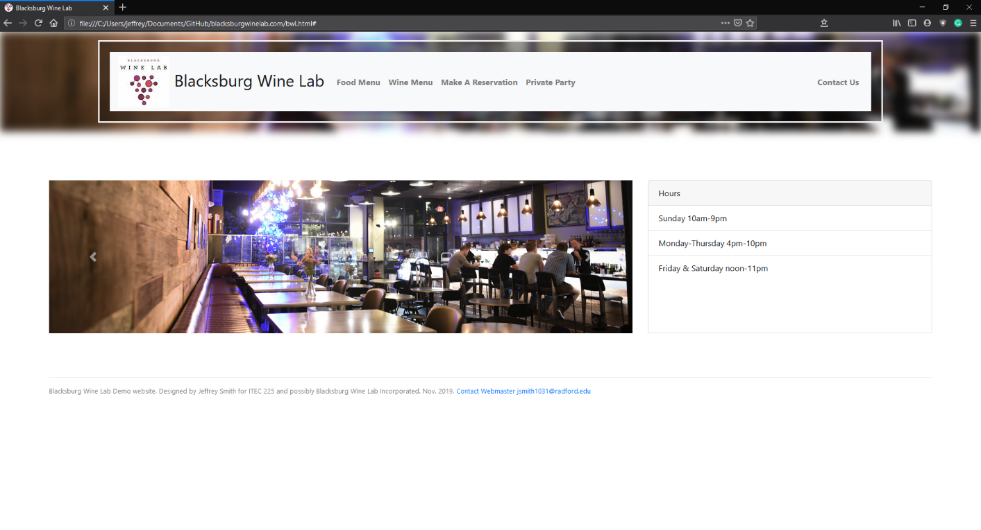Screenshots

Landing page with reactive menu buttons in navigation bar and a carousel for cycling through images from the restaurant. The navigation bar uses a bootstrap navbar with a custom blurred background image being the navbar. This navbar stays static for the website since there is technically only one page. Each “link” in the navigation bar is really a JavaScript function that replaces all the elements in the lower part of the website with new elements. For my over-all design of the website, I focused on keeping CSS values as percentages rather than pixels to make this website easier to port over for viewability on mobile devices and different resolutions. I also used Bootstraps rows and columns on every page of the website, keeping to common ratios through the site for a better aesthetic. Most of the pages use a col-4 & col-8 layout, or a col-6 & col-6 layout. So that the elements are either split down the middle or given a ratio of thirds. I found bootstrap to be very easy for this once I got used to have a 12-column pattern.

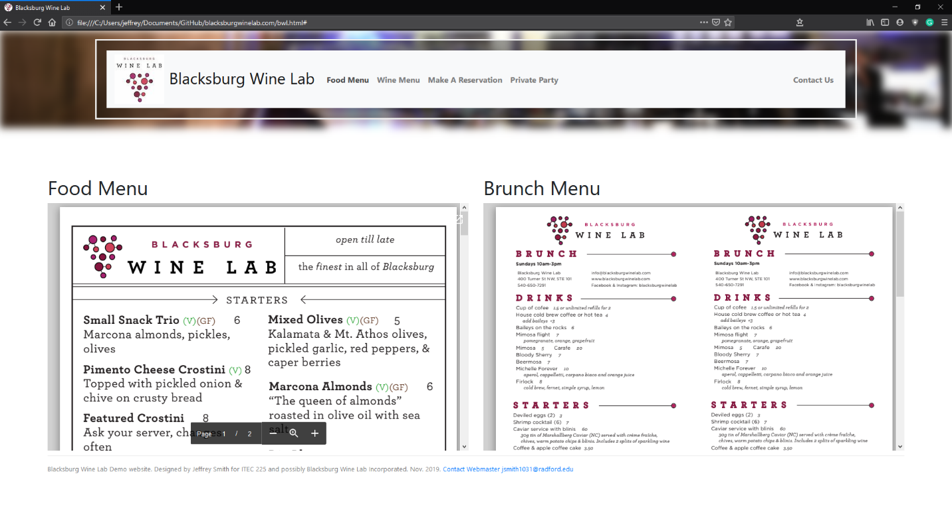

Food menu page with a ‘iFrame’ JavaScript package used to import .pdf files from the original Blacksburg wine lab website. I found that many of the tutorials online for displaying a pdf in browser and in website are out of date, because many web browsers (Chrome, Firefox, and Opera) have mostly disabled this functionality due to major security concerts with the vulnerabilities in .PDF files.

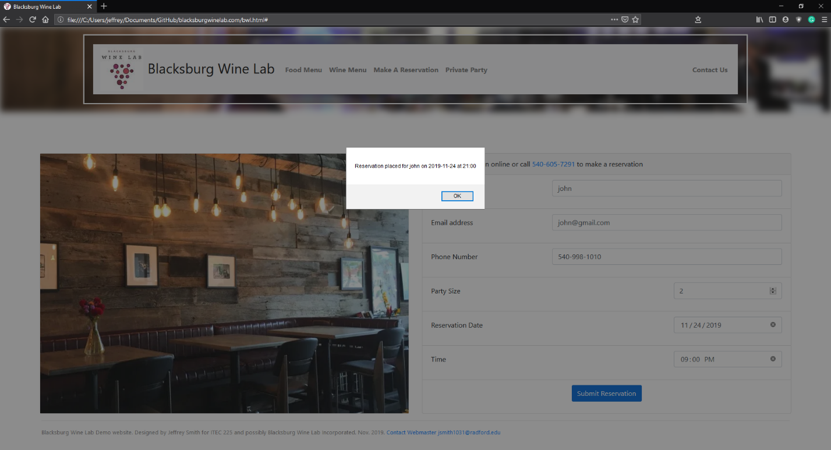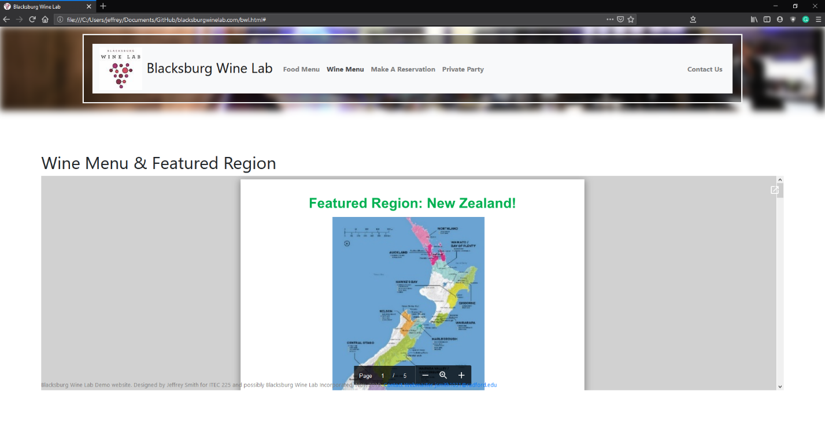Wine menu page is very similar to the food menu page, except that this page is using a .docx rather than .pdf file for viewing. I found that if I use the google doc viewer with iFrame and embed the files through google docs, I can avoid the headache of trying to display a word docx using a different JavaScript package.

The reservation page is the major implementation of JavaScript in this website. It uses 3 functions for placing a reservation. First function checks that all the fields have been filled out. Second function checks that the date for the reservation is in the future, since we do not want any reservations placed for in the past. The third function checks the time that the reservation is placed for by grabbing the day of the week from the reservation date and checking it with the restaurant hours. If there are any issues with the reservation, an alert is displayed with details about their reservation error.

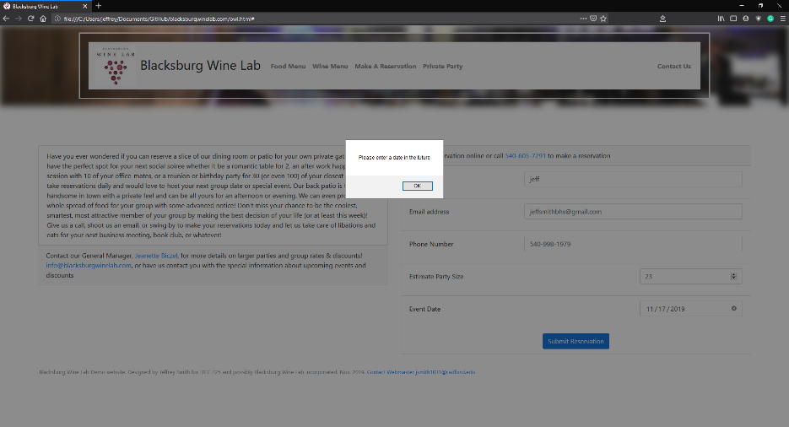The party reservation page is like the regular reservation page, except that is has a different core JavaScript function for placing reservation since less information is required. This function demonstrates the cohesion in the website by reusing some of the JavaScript functions such as checking that the date is valid on the reservation.

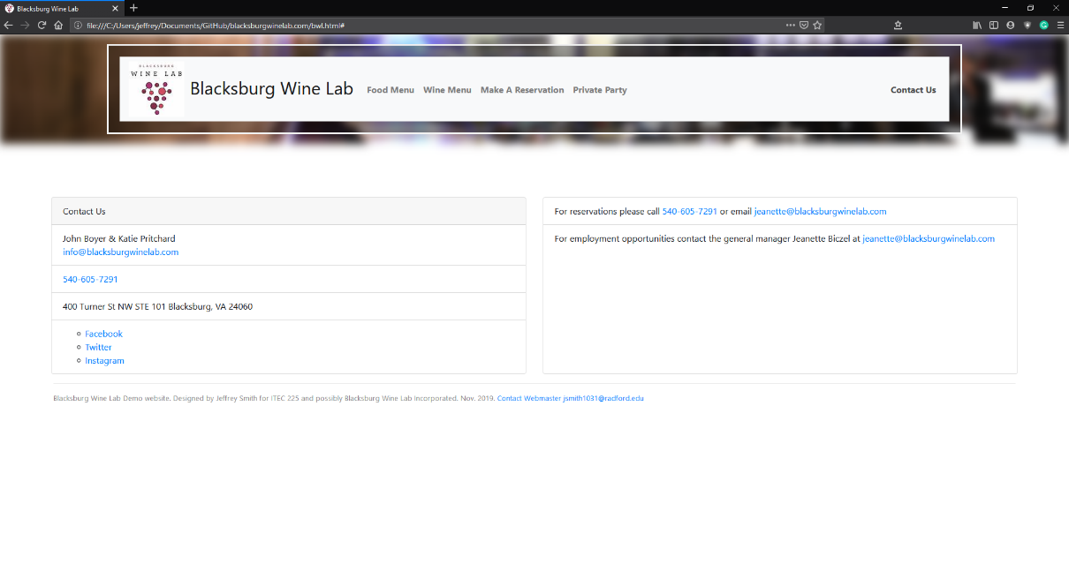The contact page is a simple page with hyperlinks for the telephone numbers, emails, and social media links in the page.

Sources:

* Embedding a PDF in page <https://stackoverflow.com/questions/291813/recommended-way-to-embed-pdf-in-html>
* Blurred background image <https://www.w3schools.com/howto/howto_css_blurred_background.asp>
* Bootstrap Carousel <https://getbootstrap.com/docs/4.0/components/carousel/>
* Bootstrap Card <https://getbootstrap.com/docs/4.0/components/card/>
* Bootstrap Navbar <https://getbootstrap.com/docs/4.0/components/navbar/>
* Bootstrap Forms <https://getbootstrap.com/docs/4.0/components/forms/>